|  |  |  |
| --- | --- | --- |
|  |  |  |
|  | |  |
| Vodafone Czech  System Documentation  This document describes the application overview, important installations & operational information. | |  |
| Application: Phoenix | |  |

|  |
| --- |
|  |

Authors: Jan Bird

Version: 1.9.5.26

Date: 17-May-2024

Table of Contents

1. Introduction 14

1.1 Purpose 14

1.2 Key stakeholders 14

2. Application overview 15

2.1 Technology Stack 15

2.2 System Context 16

2.3 External Interfaces 17

2.3.1 Inbound Interfaces 17

2.3.2 Outbound Interfaces 20

3. Data Model 21

3.1 Logical Data Model 21

3.2 Physical Database Design 21

3.2.1 Schema RMSTOOL_OWN@IBMTEST 22

3.2.1.1 Procedure RMSTOOL_ADD_USER_PRC 22

3.2.1.2 Table RMSTOOL_CONFIG 22

3.2.1.3 Table RMSTOOL_CASH_REG 22

3.2.1.4 Table RMSTOOL_GROUP_REF 22

3.2.1.5 Table RMSTOOL_HISTORY_REF 23

3.2.1.6 Table RMSTOOL_IGNORED_IL_ALARMS_REF 23

3.2.1.7 Table RMSTOOL_INV_GROUP 23

3.2.1.8 Table RMSTOOL_INV_TOKEN_REF 24

3.2.1.9 Table RMSTOOL_LIVE_REF 24

3.2.1.10 Table RMSTOOL_LOG 25

3.2.1.11 Table RMSTOOL_LOG_ARCH 26

3.2.1.12 Table RMSTOOL_PROCESS_LOCK 26

3.2.1.13 Table RMSTOOL_PROCESS_REF 26

3.2.1.14 Table RMSTOOL_RANGE_REF 26

3.2.1.15 Table RMSTOOL_SESSION 27

3.2.1.16 Table RMSTOOL_SESSION_ARCH 28

3.2.1.17 Table RMSTOOL_USER_GROUP 28

3.2.1.18 Table RMSTOOL_USER_REF 28

3.2.1.19 Table RMSTOOL_V2_CLEANSING_QUEUE 29

3.2.1.20 Trigger RMSTOOL_TR_CONFIG_CHG 30

3.2.1.21 Trigger RMSTOOL_TR_EVENTID 30

3.2.1.22 Trigger RMSTOOL_TR_PROCESS_LOCK_CHG 30

3.2.1.23 Trigger RMSTOOL_TR_TERM_CHG 30

3.2.1.24 View RMSTOOL_LOG_VW_FULL 30

3.2.1.25 View RMSTOOL_LOG_VW_MEDIUM 30

3.2.1.26 View RMSTOOL_ESIM_RANGES_VW 31

3.2.2 Schema RMSTOOL_USR@IBMTEST 31

3.2.3 Schema ARBOR@<ARBOR_ADMIN_DB> 31

3.2.3.1 Kenan System Configuration 31

3.2.3.2 Procedure INVD_TMP_TERM_MSISDN_PRC 31

3.2.3.3 Procedure INVD_TMP_TERM_MSISDN_UPD 32

3.2.3.4 Synonym PHOENIX_CIEMV3 32

3.2.3.5 Synonym PHOENIX_CIEMV4 32

3.2.3.6 Table INVD_TMP_TERM_INV 32

3.2.3.7 Table INVD_TMP_TERM_MSISDN_IN 33

3.2.3.8 Table INVD_TMP_TERM_MSISDN_LOG 33

3.2.4 Schema VF_CONFIG@<ARBOR_ADMIN_DB> 34

3.2.4.1 Table VF_INVENTORY_NOTIFICATION – Extended Privileges 34

3.2.5 Schema ILABATCH_OWN @<INSTANTLINK_DB> 34

3.2.5.1 Table BATCH_PROVISIONING – New Index 34

4. User Interface 35

4.1 Login Form 35

4.2 Main Form 35

4.2.1 Main Grid 36

4.2.1.1 Navigation 39

4.2.1.2 Saving / Loading / Copying Grid Data 39

4.2.1.3 Reloading Grid Data 40

4.2.2 Buttons 40

4.2.2.1 Cleansing Button 40

4.2.2.2 Outages Button 41

4.2.2.3 Reserve Button 41

4.2.2.4 Mass Pair Button 41

4.2.2.5 Refresh Button (Menu) 41

4.2.2.5.1 Location Dispatcher (RMS API views) 42

4.2.2.5.2 Instant Link (reconfig) 42

4.2.2.5.3 Smart Overview (data cache) 42

4.2.2.5.4 Invoice Breakdown (data cache) 43

4.2.2.5.5 Peklo 43

4.2.2.5.6 Reload Environment 43

4.2.2.6 Clear Grid Button 43

4.2.2.7 Legend Button 43

4.2.3 Docks 44

4.2.3.1 Info Dock 44

4.2.3.1.1 Role Differences 44

4.2.3.2 Lock Dock 45

4.2.3.3 Warning Dock 45

4.2.4 Other Controls 45

4.2.4.1 Environment Combo Box 45

4.2.4.2 Attribute Combo Boxes 46

4.2.4.2.1 Role Differences 47

4.2.4.3 Mini-Log & Event Log 47

4.2.4.4 Status Icons (DB / SSH) 48

4.2.5 Admin Controls 49

4.2.5.1 Announce Update Button 49

4.2.5.2 Environment Lockdown Checkbox 49

4.2.5.1 Allow Invalid Items Checkbox 49

4.2.5.1.1 Role Differences 49

4.3 Status Forms 49

4.4 Inventory Operations 50

4.4.1 Inventory Import 50

4.4.1.1 Standard Import 50

4.4.1.2 Additional Import Options 51

4.4.1.2.1 Form-specific button controls 51

4.4.1.3 Notepad 52

4.4.1.3.1 Form-specific button controls 52

4.4.1.4 Inventory Item Tokens 52

4.4.1.5 Row Parsing Rules 54

4.4.1.5.1 1. A row with paired triplet 55

4.4.1.5.2 Different inventory kinds on separate rows 55

4.4.1.5.3 Multiple inventory items of the same kind on the same row 55

4.4.2 Manual Inventory Insert/Edit 55

4.4.3 Bulk Attributes Update 55

4.4.4 Inventory Reservation 56

4.4.5 Inventory Mass Pairing 58

4.4.5.1 Process Overview 60

4.4.5.2 Role Differences 60

4.4.6 Inventory Cleansing 61

4.4.6.1 Cleansing Tasks Overview 61

4.4.6.2 Cleansing Options 62

4.4.6.3 Cleansing Progress 63

4.4.6.4 Process Overview 64

4.4.6.5 Role Differences 65

4.4.6.6 Skip Waiting for Instant Link 65

4.4.6.7 Disabled Cleansing Tasks 65

4.5 Kenan Operations 66

4.5.1 RMS Status 66

4.5.1.1 Output Data 66

4.5.1.2 Data Set “Basic” 67

4.5.1.3 Data Set “Extended” 67

4.5.1.4 Data Set “eSIM Attributes” 68

4.5.1.5 Data Set “OneNumber” 69

4.5.1.6 Process Overview 70

4.5.1.7 Role Differences 70

4.5.2 Kenan RMS API Status 70

4.5.2.1 Output Data 70

4.5.2.2 Process Overview 71

4.5.2.3 Role Differences 71

4.5.3 Kenan Adapter Calls 71

4.5.3.1 Complex 71

4.5.3.1.1 Reserve & Couple 71

4.5.3.2 Universal 72

4.5.3.2.1 InventoryModifyElementStatus 72

4.5.3.3 MSISDN/SIM 72

4.5.3.3.1 InventoryCouplingElements 72

4.5.3.3.2 InventoryCouplingContainer 73

4.5.3.3.2.1 Form-specific button controls 74

4.5.3.3.3 Internal Migration 74

4.5.3.4 ISDN 75

4.5.3.4.1 InventoryElementUpdate 75

4.5.3.4.2 Internal Migration 76

4.5.4 Mass Pairing Status 76

4.5.4.1 Output Data 76

4.5.4.2 Process Overview 78

4.5.4.3 Role Differences 78

4.5.5 Kenan Payments & Refills 78

4.5.5.1 Output Data 78

4.5.5.2 Data Set “Payments” 78

4.5.5.2.1 Process Overview 79

4.5.5.3 Data set “Refills” 80

4.5.5.3.1 Process Overview 80

4.5.5.4 Role Differences 81

4.5.6 eSIM Notifications 81

4.5.6.1 Output Data 81

4.5.6.1.1 Process Overview 82

4.5.6.2 Role Differences 82

4.5.7 Fetch missing OneNumber pairs 82

4.5.7.1.1 Process Overview 83

4.5.7.2 Role Differences 83

4.5.8 Kenan Audit 83

4.5.8.1 Controls 84

4.5.8.1.1 Search Filter Fields 84

4.5.8.1.2 Additional Buttons 85

4.5.8.1.1 Additional Keyboard Shortcuts 85

4.5.8.2 Output Data 85

4.5.8.3 Process Overview 87

4.5.8.4 Role Differences 87

4.5.8.5 Terminating Subscriber in Kenan 87

4.5.8.6 Parsing Tibco BW Instance ID 88

4.5.8.6.1 Process Overview 89

4.5.9 Kenan A2S Actions / Collection Events Status 89

4.5.9.1 Output Data 90

4.5.9.2 Data Set “All” 90

4.5.9.3 Data Set “Pending” 91

4.5.9.4 Data Set “Parameters” 92

4.5.9.5 Process Overview 92

4.5.9.6 Role Differences 92

4.5.10 Kenan RC Status 93

4.5.10.1 Output Data 93

4.5.10.2 Process Overview 94

4.5.10.3 Role Differences 94

4.5.11 Kenan Contracts Status 94

4.5.11.1 Output Data 95

4.5.11.2 Process Overview 95

4.5.11.3 Role Differences 96

4.5.12 Kenan Account Extended Data Status 96

4.5.12.1 Output Data 96

4.5.12.2 Process Overview 97

4.5.12.3 Role Differences 97

4.5.13 Kenan Rating (CDR Data) Status 97

4.5.13.1 Output Data 97

4.5.13.2 Data Set “Successful” 97

4.5.13.2.1 Form-specific button controls 98

4.5.13.2.2 Process Overview 99

4.5.13.1 Data Set “Failed” 99

4.5.13.2 Data Set “Failed (Extended)” 100

4.5.13.2.1 Process overview 101

4.5.13.3 Role differences 101

4.5.14 Kenan Billing & Collections 101

4.5.14.1 Controls 102

4.5.14.2 Output Data 105

4.5.14.3 Role Differences 108

4.5.14.4 Setting NRC as not-billable 108

4.5.14.4.1 Process Overview 108

4.5.14.4.2 Role Differences 108

4.5.14.5 Inserting NRC 109

4.5.14.5.1 Process Overview 110

4.5.14.5.2 Role Differences 110

4.5.14.6 Running NRC Batch Loader 110

4.5.14.6.1 Process Overview 110

4.5.14.6.2 Role Differences 111

4.5.14.7 Change Bill Period 111

4.5.14.7.1 Process Overview 111

4.5.14.7.2 Role Differences 111

4.5.14.8 Insert Payment / Reverse Payment 111

4.5.14.8.1 Process Overview 112

4.5.14.8.2 Role Differences 113

4.5.14.9 Payment Allocation 113

4.5.14.9.1 Process Overview 113

4.5.14.9.2 Role Differences 113

4.5.14.10 Running Rating modules (COM, MCAP, CAP) 113

4.5.14.10.1 Process Overview 113

4.5.14.10.2 Role Differences 114

4.5.14.11 Running Billing module (BIP) 114

4.5.14.11.1 Process Overview 115

4.5.14.11.2 Role Differences 116

4.5.14.12 Collection Management 116

4.5.14.12.1 Running Collections 116

4.5.14.12.1.1 Process Overview 116

4.5.14.12.1.2 Role Differences 116

4.5.14.12.2 Running Collections in specific mode 116

4.5.14.12.2.1 Process Overview 117

4.5.14.12.3 Rescheduling Collection Events 117

4.5.14.12.3.1 Process Overview 118

4.5.14.12.4 Suspending Collection Scenario 118

4.5.14.12.4.1 Process Overview 118

4.5.14.12.5 Resuming Collection Scenario 118

4.5.14.12.5.1 Process Overview 119

4.5.14.12.6 Skipping Preceding Collection Events 119

4.5.14.12.7 Changing Collection Events Status 119

4.5.14.12.8 Stepping Over Collection Events 120

4.5.14.12.8.1 Process Overview 121

4.5.14.12.9 Curing an Account 121

4.5.15 Changing account morale (ACI Before-unsafe) 122

4.5.15.1 Process Overview 122

4.5.15.2 Role Differences 122

4.5.16 Kenan Collection History 123

4.5.16.1 Role Differences 123

4.5.16.2 Changing account morale to Bad (ACI Before-safe) 123

4.5.16.2.1 Process Overview 125

4.5.17 Kenan Account Backdating 125

4.5.17.1 Common Issues 126

4.5.17.2 Example & Explanation 127

4.5.17.3 Process Overview 127

4.5.17.4 Role Differences 128

4.5.18 Kenan Invoicing (INEXT) 128

4.5.18.1 Controls 129

4.5.18.1.1 Layout 129

4.5.18.1.2 Form-specific controls 129

4.5.18.2 Output Data 131

4.5.18.2.1 All Tabs 131

4.5.18.2.2 Invoices, Credit Notes Tab 133

4.5.18.2.3 Dunning Letters Tab 136

4.5.18.3 Role Differences 137

4.5.18.4 Registering Prepaid for Invoicing 137

4.5.18.4.1 Process Overview 137

4.5.18.5 Specifying INEXT run parameters 138

4.5.18.6 Running document formatting module (INEXT) 138

4.5.18.6.1 Process Overview 141

4.5.18.6.2 Role differences 142

4.5.18.7 Sending XML to Xerox 142

4.5.18.7.1 Process Overview 142

4.5.18.7.2 Role differences 142

4.5.18.8 Uploading STD Requests to Kenan 142

4.5.18.8.1 Process Overview 143

4.5.18.8.1.1 Role Differences 143

4.5.18.9 Backing Out an Invoice 143

4.5.18.9.1 Process Overview 144

4.5.18.9.2 Role Differences 144

4.5.18.10 Running SMS Launcher module 144

4.5.18.10.1 Process Overview 145

4.5.18.10.2 Role Differences 146

4.5.18.11 Displaying Invoice QR Code 146

4.5.18.11.1 Process Overview 146

4.5.18.11.2 Role Differences 147

4.5.18.12 Setting / Clearing image done flag 147

4.5.18.12.1 Process Overview 147

4.5.18.12.2 Role Differences 147

4.5.18.13 Changing of Due Date 147

4.5.18.13.1 Process Overview 148

4.5.18.13.2 Role Differences 148

4.5.18.14 Reset Document Formatting 148

4.5.18.14.1 Process Overview 148

4.5.18.14.2 Role Differences 149

4.5.18.15 Reset Issued Invoice Notification 149

4.5.18.15.1 Process Overview 149

4.5.18.15.2 Role Differences 149

4.5.18.16 XML / PDF File Operations 149

4.5.18.16.1 Process Overview 150

4.5.18.16.1.1 eArchive Document Download 150

4.5.18.16.1.2 eArchive Process Lock Status Check 151

4.5.18.16.2 Role Differences 151

4.5.18.17 Create SIPO Confirmation File for an Invoice 151

4.5.18.17.1 Role Differences 152

4.6 Tibco Operations 152

4.6.1 EHC Task Events (EHC Status) 152

4.6.1.1 Controls 152

4.6.1.1.1 Search Filter Fields 152

4.6.1.1.2 Additional Controls 154

4.6.1.1.3 Additional Buttons 154

4.6.1.1.4 Additional Keyboard Shortcuts 155

4.6.1.2 Output Data 155

4.6.1.3 Process Overview 156

4.6.1.4 Role Differences 157

4.6.1.5 Tibco Event Reprocessing 157

4.6.1.5.1 Role Differences 157

4.6.2 Tibco SMS History 157

4.6.2.1 Data Set “Basic” 158

4.6.2.2 Data Set “Extended” 159

4.6.2.3 Process Overview 160

4.6.2.4 Role Differences 160

4.6.3 STP Status 160

4.6.3.1 Controls 161

4.6.3.2 Output Data 161

4.6.3.3 Process Overview 162

4.6.3.4 Role Differences 162

4.6.3.5 Archiving Sales Transactions 162

4.6.3.5.1 Process Overview 162

4.6.3.5.2 Role Differences 163

4.6.3.6 Unlocking Business Orders 163

4.6.3.6.1 Process Overview 164

4.6.3.6.2 Role Differences 164

4.6.4 Cross Reference Status 165

4.6.4.1 Output Data 165

4.6.4.2 Process Overview 166

4.6.4.3 Role Differences 166

4.6.5 IMEI Change Event (JMS) 166

4.6.5.1 IMEI Change 166

4.6.5.1.1 Controls 167

4.6.5.1.2 Process Overview 169

4.6.5.1.3 Role Differences 170

4.6.6 Restriction Instance Change Event (JMS) 170

4.6.6.1.1 Controls 171

4.6.6.1.2 Process Overview 172

4.6.6.1.3 Role Differences 172

4.7 Siebel Operations 173

4.7.1 Siebel Status 173

4.7.1.1 Controls 173

4.7.1.2 Output Data 173

4.7.1.3 Data Set “Products” 174

4.7.1.3.1 Process Overview 174

4.7.1.4 Data set “Orders” 175

4.7.1.4.1 Process Overview 176

4.7.1.5 Accelerate Scheduled Request Items 176

4.7.1.5.1 Process Overview 177

4.7.1.6 EHC Task Events Status 178

4.7.1.7 Cancel All Orders 178

4.7.1.8 Role Differences 178

4.7.2 Siebel Product Catalog 178

4.7.2.1 Controls 179

4.7.2.1.1 Additional Buttons 179

4.7.2.2 Output Data 179

4.7.2.3 Process Overview 180

4.7.2.4 Role Differences 180

4.7.3 Change MSISDN in WTTx Order 180

4.7.3.1 Controls 182

4.7.3.2 Process Overview 182

4.7.3.3 Role differences 182

▪ Change MSISDN in OneNumber Order 182

4.7.3.4 Controls 184

4.7.3.5 Process Overview 185

4.7.3.6 Role differences 185

4.7.4 Accelerate Scheduled Request Items 185

4.7.4.1 Controls 187

4.7.4.2 Process Overview 187

4.7.4.3 Role Differences 187

4.7.5 Update Average Revenue 188

4.7.5.1 Controls 189

4.7.5.2 Process Overview 189

4.7.5.3 Role Differences 189

4.7.6 Update UPC Migration Attributes 189

4.7.6.1 Controls: 191

4.7.6.2 Process Overview 191

4.7.6.3 Role Differences 191

4.7.7 Update Date of Birth Validation Flag 192

4.7.7.1 Controls 193

4.7.7.2 Process Overview 193

4.7.7.3 Role Differences 193

4.8 CUR Operations 193

4.8.1 Password Management 193

4.8.1.1 Getting Current Passwords 193

4.8.1.1.1 Process Overview 195

4.8.1.2 Setting New Passwords 195

4.8.1.2.1 Process Overview: 196

4.8.1.3 Role Differences 196

4.9 Java Operations 196

4.9.1 Location Dispatcher Status 196

4.9.1.1 Process Overview 197

4.9.1.2 Role Differences 197

4.9.2 Profile Cache Status 197

4.9.2.1 Process Overview 198

4.9.2.2 Role Differences 198

4.9.3 BMG SMS History 198

4.9.3.1 Output Data 199

4.9.3.2 Process Overview 199

4.9.3.3 Role Differences 200

4.9.4 IMEI Repository – EIR Notification 200

4.9.5 IMEI Repository – TAC Catalog 200

4.9.5.1 Controls 200

4.9.5.1.1 Search Filter Fields 200

4.9.5.1.2 Additional Buttons 201

4.9.5.2 Output Data 202

4.9.5.3 Process Overview 202

4.9.5.4 Role Differences 202

4.9.6 Send MO to SMS Self Care 202

4.9.6.1 Controls 203

4.9.6.2 Process Overview 203

4.9.6.3 Role Differences 203

4.9.7 Reload eSIM Ranges 203

4.9.7.1 Process Overview 204

4.9.7.2 Role Differences 204

4.10 Network Operations 204

4.10.1 UMF Status (SurePay) 204

4.10.1.1 Controls 205

4.10.1.2 Process Overview 206

4.10.1.3 Role Differences 206

4.10.2 OMM & DMA Status 206

4.10.2.1 Controls 207

4.10.2.2 Output Data 207

4.10.2.3 Process Overview 208

4.10.2.4 Role Differences 208

4.10.2.5 Setting Data Usage 208

4.10.2.5.1 Process Overview 208

4.10.3 MNP Status 208

4.10.3.1 Output Data 208

4.10.3.2 Data Set “ČAU” 209

4.10.3.2.1 Process Overview 210

4.10.3.1 Data Set “Orders” 210

4.10.3.1.1 Process Overview 211

4.10.3.2 Role Differences 211

4.10.4 Instant Link 211

4.10.4.1 Routing Status 211

4.10.4.1.1 Output Data 211

4.10.4.1.2 Data Set “Basic” 212

4.10.4.1.2.1 Process Overview 213

4.10.4.1.3 Data Set “Extended” 213

4.10.4.1.3.1 Process Overview 214

4.10.4.1.4 Role Differences 214

4.10.4.2 Special Resources Status 214

4.10.4.2.1 Controls 215

4.10.4.2.2 Output Data 215

4.10.4.2.3 Process Overview 216

4.10.4.2.4 Role Differences 216

4.10.4.2.5 Extending Instant Link White Lists 216

4.10.4.3 Alarms 217

4.10.4.3.1 Process Overview 218

4.10.4.3.2 Role Differences 218

4.10.4.4 Routing Profiles 218

4.10.4.4.1 Output Data 219

4.10.4.4.2 Process Overview 219

4.10.4.4.3 Role Differences 220

4.10.5 Recharge Prepaid 220

4.10.5.1 Process Overview 221

4.10.5.2 Role Differences 221

4.10.6 Network Cleansing Batch Status 221

4.10.6.1 Process Overview 222

4.10.6.2 Role Differences 222

4.11 EBS Operations 223

4.11.1 EBS Status 223

4.11.1.1 Output Data 223

4.11.1.2 Process Overview 223

4.11.1.3 Role Differences 224

4.11.2 EBS Status – Available Virtual eSIM’s 224

4.11.2.1 Output Data 224

4.11.2.2 Data Set “Basic” 224

4.11.2.3 Data Set “Extended” 225

4.11.2.4 Process Overview 226

4.11.2.5 Role Differences 226

4.11.3 User Cash Register Status 226

4.11.3.1 Controls 227

4.11.3.2 Output Data 227

4.11.3.3 Process Overview 228

4.11.3.4 Role Differences 228

4.11.3.5 Opening Cash Registers 228

4.11.3.5.1 Process Overview 228

4.11.3.5.2 Role differences 229

4.12 OLC Operations 229

4.12.1 Subscriber Status 229

4.12.1.1 Output Data 229

4.12.1.2 Process Overview 230

4.12.1.3 Role Differences 231

4.12.2 MSISDN Synchronization 231

4.12.2.1 Process Overview 231

4.12.2.2 Role Differences 231

4.13 Other Operations 231

4.13.1 Peklo Status 231

4.13.1.1 Output Data 232

4.13.1.2 Process Overview 233

4.13.1.3 Role Differences 233

4.13.2 Phoenix Cleansing Blacklist Status 233

4.13.2.1 Output Data 234

4.13.2.2 Process Overview 234

4.13.2.3 Role Differences 234

4.13.3 OKU Code Generator 234

4.13.3.1 Process Overview 235

4.13.3.2 Role Differences 235

4.13.4 MAC Address Generator 235

4.13.4.1 Process Overview 236

4.13.4.2 Role Differences 236

4.13.5 Outage Notifier Integration 236

4.14 Admin Operations 236

4.14.1 Inventory Range Operations / Bulk Upload 236

4.14.1.1 Controls 238

4.14.1.2 Preconfigured Ranges 238

4.14.1.2.1 Process Overview 239

4.14.1.3 Custom Range 239

4.14.1.4 Detecting Gaps in RMS Inventory Ranges 239

4.14.1.4.1 Controls 241

4.14.1.4.2 Process Overview 241

4.14.1.5 Range Import 241

4.14.1.5.1 Role Differences 242

4.14.2 Inventory Recycling 242

4.14.2.1 Overview 242

4.14.2.2 Obtaining Recyclable Inventory 242

4.14.2.2.1 Controls 244

4.14.2.2.1.1 Additional Buttons 244

4.14.2.2.2 Process Overview 245

4.14.2.2.3 Role Differences 245

4.14.2.3 Cleansing 245

4.14.2.4 Refreshing Peklo 246

4.14.3 SSH Console 246

4.14.3.1 Controls 247

4.14.3.1.1 Additional Buttons 247

4.14.3.2 Role Differences 247

4.14.4 DB Connections Status 247

4.14.4.1 Role Differences 248

4.14.5 Test Connections 248

4.14.5.1 Role Differences 249

4.14.6 Show Oracle client version 250

4.14.6.1 Role Differences 250

4.14.7 Environment Restrictions 250

4.14.7.1 Configuring Environment Warning Message 250

4.14.7.2 Environment Lockdown 251

4.14.7.2.1 Process Overview 251

4.14.7.2.2 Role Differences 251

4.14.7.3 Disabling Cleansing Tasks 251

4.14.7.4 Configuring Ignorable InstantLink Alarms 251

4.14.8 Advanced Context Menu 252

4.14.8.1 Role Differences 252

4.14.8.2 Fetch submenu 252

4.14.8.2.1 Generate Missing ICCID’s 253

4.14.8.2.1.1 Process Overview 253

4.14.8.2.2 Fix invalid ICCID’s 253

4.14.8.2.2.1 Process Overview 253

**NOTE:** Generated ICCID values have their final digit populated according to Luhn algorithm so that their checksum is correct. 253

4.14.8.3 Clear submenu 253

4.14.8.4 Merge submenu 254

4.14.8.5 Modify Kenan submenu 255

4.14.8.5.1 Direct Kenan DB Updates 255

4.14.8.5.2 Kenan Constraints 257

4.14.8.6 Administration submenu 257

**4.14.8.6.1** Phoenix Inventory Groups Administration 257

4.14.8.6.1.1 Process Overview 257

4.14.8.6.2 Peklo Blacklists Administration 258

4.14.8.6.2.1 Process Overview 258

4.15 Working Form 258

4.15.1 Controls 259

4.15.2 Forced Application Termination 259

4.16 System Menu 259

4.16.1 About Form 259

4.16.2 System Documentation 260

4.17 Bundled Applications 261

4.17.1  Phoenix Updater 261

4.17.2  Peklo Refresher 261

4.17.2.1 Main form 262

4.17.2.2 Configuration 262

4.17.3  Outage Notifier 262

4.17.3.1 Main Form 262

4.17.3.2 Options 263

4.17.3.3 Selecting Environments 264

4.17.3.4 Notifications 264

4.17.3.5 Configuration 266

5. Insights 267

5.1 Process Locks and Notifications 267

5.1.1 Process Lock Notification 267

5.1.1.1 Lockable Modules 267

5.1.2 Instance Termination Notification 268

5.1.3 Environment Warning Message Notification 268

5.1.4 Version Update Notification 268

5.2 History Model 268

5.2.1 Forms supporting History 269

5.3 Inventory Cleansing Model 270

5.3.1 Cleansing Approach 270

There are two types of cleansing that are utilized in Phoenix: 270

5.3.2 Cleansing Tasks 270

5.3.2.1 Pre-cleansing Validations 272

5.3.2.2 Connection Check 272

5.3.2.3 InstantLink Routing (White Lists) 273

5.3.2.4 System Cleansing 274

5.3.2.4.1 KENAN+RMS cleansing 274

5.3.2.4.2 EBS cleansing 276

5.3.2.4.3 OMM cleansing 276

5.3.2.4.4 DMA cleansing 277

5.3.2.4.5 BMA cleansing 277

5.3.2.4.6 STP cleansing 277

5.3.2.4.7 MVNO cleansing 278

5.3.2.4.8 RCRPAY cleansing 278

5.3.2.4.9 RSPROXY cleansing 278

5.3.2.4.10 CROSSREF (Cross Reference) cleansing 279

5.3.2.4.11 PROFCACHE (Profile Cache) cleansing 279

5.3.2.4.12 CUR cleansing thread 279

5.3.2.4.13 VFCONFIG cleansing 279

5.3.2.4.14 SIEBEL cleansing 280

5.3.2.4.15 MTE cleansing 280

5.3.2.4.16 ACR cleansing 280

5.3.2.4.17 MNP cleansing 281

5.3.2.4.18 HARPAGON cleansing 281

5.3.2.4.19 SMDP+ (ESIM) cleansing 281

5.3.2.4.20 SDS cleansing thread 283

5.3.2.4.21 RCS cleansing thread 283

5.3.2.5 Network Cleansing 283

5.3.2.5.1 mtasSubscription service 285

5.3.2.5.2 dnsSubscription service 285

5.3.2.5.3 imsSubscription service 285

5.3.2.5.4 epsSubscription service 286

5.3.2.5.5 curContentFilter service 286

5.3.2.5.6 gprsProfile service 286

5.3.2.5.7 ocsProfile service 287

5.3.2.5.8 ocsUserAccess service 287

5.3.2.5.9 pcrfProfile service 287

5.3.2.5.10 profile service (HLR) 287

5.3.2.5.11 portedNumber service (FNR) 287

5.3.2.5.12 sms2email service 288

5.3.2.5.13 mms service 288

5.3.2.5.14 voiceMail service 288

5.3.2.5.15 atosGroupCli service 288

5.3.2.5.16 atosCallQueuing service 288

5.3.2.5.17 atosExt service 289

5.3.2.5.18 umpSipCred service 289

5.3.2.5.19 umpHardware service 289

5.3.2.5.20 smscMultidevice service 289

5.3.2.6 Inventory Upload 290

5.3.2.6.1 RMS upload 290

5.3.2.6.2 EBS upload 291

5.3.2.7 Finalization 292

5.3.2.7.1 OLC sync 292

5.3.2.8 Grid Reload 292

5.3.3 Recovery Scenarios 292

5.3.3.1 Failure during System Cleansing 292

5.3.3.2 Failure during Network Cleansing 293

5.3.3.3 Stuck Network Cleansing 293

5.3.3.4 Failure during Inventory Upload 293

5.3.3.5 Stuck Tasks – Generic Advices 293

5.3.4 Adding of a New System to Cleansing 294

5.3.5 Cleansing Restrictions 294

5.4 Inventory Recycling Model 295

5.5 Application Initialization 296

5.6 Environment Initialization 297

5.7 Logging 301

6. Operational Environment 302

6.1 Operational Model 302

6.1.1 New User Account Procedure 302

6.1.2 Client Installation Procedure 302

6.1.2.1 Enable JMS messaging (optional) 302

6.1.2.2 Using Oracle instant client (optional) 302

6.1.3 Client Runtime Requirements 303

6.1.4 Application Configuration 303

6.2 Update Repository 303

6.3 Source Repository 304

6.4 Release Deployment 304

6.5 Phoenix Updater 304

6.6 Detailed Security Design 305

6.6.1 Communication Ports and Firewall Settings 305

6.6.2 Access Rights 306

6.6.2.1 User Roles 306

6.6.2.2 Domain Authorization 306

6.6.2.3 Inventory Authorization 307

6.6.2.4 User Views 307

6.6.3 Data Retention and Data Purging Policy 307

6.7 Configuration 308

6.7.1 Application Configuration 308

6.7.1.1 Parameter Value Forwarding 308

6.7.1.2 Parameter Value Commenting 308

6.7.1.3 Configuration Entries – General Section 309

6.7.1.4 Configuration Entries – Environment Sections 310

6.7.1.5 Configuration Entries – Kenan Specific Section 315

6.7.1.6 Configuration Entries – EBS Specific Section 315

6.7.1.7 Configuration Entries – InstantLink Specific Section 317

6.7.1.8 Configuration Entries – Tibco Specific Section 318

6.7.2 Inventory Configuration 318

6.7.2.1 Inventory Ranges Configuration 318

6.7.2.2 EBS Product Routing Configuration 318

6.7.2.3 Inventory Groups Configuration 319

6.7.3 User Configuration 320

6.7.3.1 Adding New User 320

6.7.3.2 Suspending User 320

6.7.4 Bundled Applications Configuration 320

6.7.4.1 Outage Notifier Configuration 320

6.7.4.2 Peklo Refresher Configuration 321

6.8 Licensing Model 321

6.8.1 Licence Key Configuration 321

6.8.2 Licence Expiration Reminder 321

# Introduction

System Documentation details all the essential features of an application. It describes the application summary, technical environment, operational and installation information.

## Purpose

The purpose of System Documentation is to provide a blueprint on high-level shared vision and scope of the application black lists for the development teams as well as facilitate orientation for new members who will be using the application. It also acts as a reference point while considering any new design alternatives or system enhancements.

This document provides reference to all additional documents and manuals that will aid in understanding the reasons behind the development/technical decisions.

## Key stakeholders

Mention the target audience who are expected to refer to this document.

| **Role** | **Name** |
| --- | --- |
| Test Managers (s) | Karel Svrček (IBM), Michal Tomášek (VF) |
| Test Leads (s) | Upon discretion of the respective test managers |
| Testers (s) |
| Project Manager |
| Architect (s) |
| Business Owner |
| Release Manager |
| Developer (s) |

# Application overview

Originally, testing ranges assigned to IBM were very small. Back then, there was a semi-automatic cleansing process in place that would restore the inventory in Kenan and RMS that involved Excel and a shell script provided by Accenture company in Filip project.

Test inventory cleansing in other systems was either performed by a manual process (e.g., SurePay) requiring email communication among handful of Vodafone teams governing each such system, or it was not implemented at all. In other words, it was all long and painful.

It was discovered that Kenan cleansing inherited from Accenture did not cover all cleansing scenarios as expected and also lead to various data inconsistencies in Kenan, so an internal application called RMS Tool was developed in 2013 by an IBM Kenan tester in order to clean the inventory in Kenan and RMS properly, along with a secondary goal to automate various tasks that IBM Kenan Testing Team was repeatedly dealing with, such as time-consuming Kenan collection scenarios processing to name one.

Later on, it became of a need to have the possibility to clean the inventory not only in Kenan but also in other systems on testing environment making it fully reusable in ordering. The original RMS Tool was renamed to Phoenix and upgraded to achieve cleansing among all systems governed by IBM.

Subsequentially, it was decided by IBM Testing Team management that Phoenix should be extended in a way to fulfill also testing requirements related to other systems being tested by IBM Testing Team, not only Kenan, so additional functions were sequentially added up to the application.

Then, an agreement was made between IBM Testing Team and Vodafone Testing Team management in order to allow Vodafone testers to also benefit from a limited set of functions that Phoenix provides, mainly to allow them to clean their own inventory. At this time, Phoenix was also extended with extra user roles and inventory whitelists to ensure that every tester is only allowed to clean their own inventory items.

Currently, Phoenix serves as an internal testing tool used by testing teams in both IBM and Vodafone to quickly fulfill a plethora of various testing tasks, such as test inventory cleansing, uploading, fetching and displaying data from test DB’s, quick updates of testing data, encapsulation of common billing and invoicing tasks in Kenan, etc.

Phoenix is continuously developed and maintained by IBM Kenan Testing Team.

As an internal testing tool, it must not be used in production environment.

**NOTE:** While originally system testing was provided to Vodafone by IBM, impact on Phoenix was analyzed internally in IBM Testing Team and changes were implemented as deemed necessary.

Since pretty much all testing services were already handed over to Vodafone, IBM is now often not aware of the upcoming projects and their possible impact on Phoenix, regarding preservation of its current functionality or its extending. It’s now up to Vodafone Testing Team to analyze ongoing projects and consult the impact with Phoenix development in order to keep the application working as expected so that all testing teams can continue to benefit from it.

## Technology Stack

This section gives insight to the list of technologies used for design, development, testing, and implementation purpose.

| **Components/ Systems** | **Technology Used** |
| --- | --- |
| Phoenix | **Development:** Delphi, PL/SQL  **Connectivity:** Oracle, SSH, SFTP, HTTP, SOAP, REST, JMS |

## System Context

System Context describes the environment in which the system functions and details the information flow between the application and the external entities. It defines the first level of external dependencies depicting information that cross the application boundary such as, inputs, outputs, technology, controls, and transaction flows (if any).

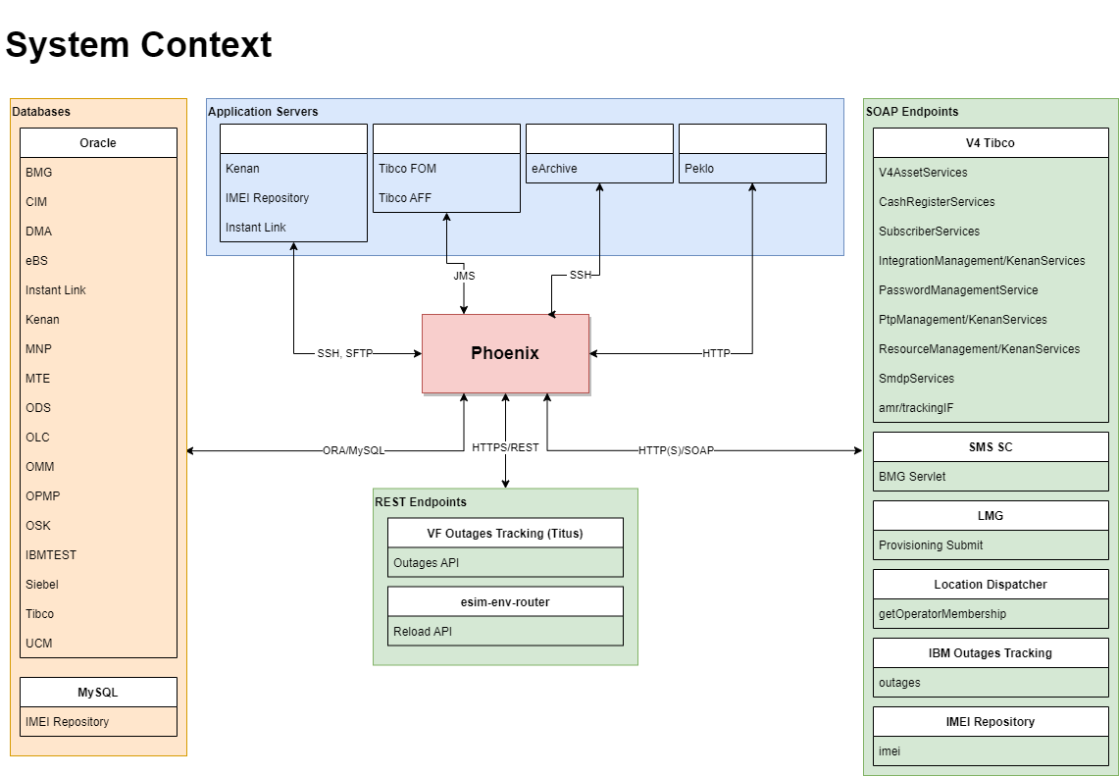

*System Context Diagram*

## External Interfaces

### Inbound Interfaces

This chapter details all the external and legacy interfaces that are consumed by the application.

The table in this section will identify all the external interfaces that are accepted by this application (both legacy and external components, like user and other systems):

|  |  |  |  |  |  |
| --- | --- | --- | --- | --- | --- |
| Name | Type /Protocol | Schema/  User/Auth | Database / Endpoint | | |
| SYS2 | INT | PRE |
| Databases | | | | | |
| BMG DB | Oracle | RMSAPI_OWN  IMEI_LOAD_OWN  PROFILE_OWN | BMGUAT2 | BMGSY2_TAF | BMGPRE_TAF |
| CIM DB | Oracle | INVENTORY_USR | V4TFSY2S | V4TF1INT | V4TFPRE_TAF |
| DMA DB | Oracle | DMA_OWN | DMASYS2_TAF | DMAINT_TAF | DMAPRE_TAF |
| EBS DB | Oracle | TESTING | EBS2SYS2SRV | EBS2INTSRV | EBS2PRESRV |
| IMEI Repository DB | MySQL | imei | l5ucms35:23306 imeirepository | l5ucms35:23306 imeirepository | l5ucms35:23306 imeirepository |
| InstantLink DB | Oracle | ILINK_OWN  ILABATCH_OWN | ILSYS2SRV | ILINTSRV | ILPRE |
| Kenan DB | Oracle | ARBOR  VF_CONFIG | V4KE2TS  V4K22TS  V4K42TS | V4KETIN  V4K2TIN  V4K4TIN | V4K1TPR  V4K2TPR  V4K3TPR  V4K4TPR |
| MNP DB | Oracle | MNP_OWN| MNPPROXY_OWN  TESTING | PDB_V4TCSYS2.sntd001.de1vcn022236o1.oraclevcn.com | MNPINT_TAF | MNPPRE_TAF |
| MTE DB | Oracle | MTE_OWN | MTESYS2SRV | MTEINTSRV | MTEPRESRV |
| ODS DB | Oracle | TIBCOLOG_OWN  TIBCO_LOG_OWN | V4TSSYS2.sntd001.de1vcn022236o1.oraclevcn.com | V4TSINT.sntd001.de1vcn022212o2.oraclevcn.com | PDB_V4ODPREN |
| OLC DB | Oracle | OLC_OWN  PHOENIX_USR | OLCUAT3_TAF | OLCUAT2_TAF | OLCACC2_TAF |
| OMM DB | Oracle | OGW11  OGW13  OGW15 | OMMT_RW | | |
| OPMP DB | Oracle | PHOENIX_USR | OP3TST_TAF | OP2TST_TAF | OP1TST_TAF |
| OSK DB | Oracle | RCRPAY_OWN | OSKSY2_TAF | OSK_UAT2 | OSKPRE_TAF |
| IBMTEST DB | Oracle | IBMTEST  RMSTOOL_OWN  RMSTOOL_USR | IBMTEST | IBMTEST | IBMTEST |
| Siebel DB | Oracle | XMSISDNUPDATE | V4SBSYS2.sntd001.de1vcn022213o1.oraclevcn.com | V4SBINT.sntd001.de1vcn022214o1.oraclevcn.com | V4SBLPRE |
| Tibco DB | Oracle | BMA_OWN  CROSSREF_OWN  HARPAGON_OWN  MVNO_OWN  RSPROXY_OWN  STP_OWN  TIBCOINT | PDB_V4TA2SYS | PDB_V4TAINT | PDB_V4TAPRE_TAF |
| UCM DB | Oracle | UCM_OWN | UCMDEV_TAF | | |
| SOAP Endpoints – V4 Tibco | | | | | |
| V4AssetServices | HTTP/SOAP | N/A | v4tibco-sys2.vfcz.dc-ratingen.de:11203 | cz0121yr.vfcz.dc-ratingen.de:11203 | v4tibco-acc2.vfcz.dc-ratingen.de:11203 |
| CashRegisterServices | HTTP/SOAP | N/A | v4tibco-sys2.vfcz.dc-ratingen.de:7700 | cz0121yr.vfcz.dc-ratingen.de:7700 | v4tibco-acc2.vfcz.dc-ratingen.de:7700 |
| SubscriberServices | HTTP/SOAP | V4TIB_BW_WSC_SY2  V4TIB_BW_WSC_INT  V4TIB_BW_WSC_PRE | v4tibco-sys2.vfcz.dc-ratingen.de:7710 | cz0121yr.vfcz.dc-ratingen.de:7710 | v4tibco-acc2.vfcz.dc-ratingen.de:7710 |
| IntegrationManagement/KenanServices | HTTP/SOAP | V4TIB_BW_WSC_SY2  V4TIB_BW_WSC_INT  V4TIB_BW_WSC_PRE | v4tibco-sys2.vfcz.dc-ratingen.de:11650 | cz0121yr.vfcz.dc-ratingen.de:11650 | v4tibco-acc2.vfcz.dc-ratingen.de:11650 |
| PasswordManagementService | HTTP/SOAP | testing | v4tibco-sys2.vfcz.dc-ratingen.de:11204 | cz0121yr.vfcz.dc-ratingen.de:11204 | v4tibco-acc2.vfcz.dc-ratingen.de:11204 |
| PtpManagement/KenanServices | HTTP/SOAP | V4TIB_BW_WSC_SY2  V4TIB_BW_WSC_INT  V4TIB_BW_WSC_PRE | v4tibco-sys2.vfcz.dc-ratingen.de:11650 | cz0121yr.vfcz.dc-ratingen.de:11650 | v4tibco-acc2.vfcz.dc-ratingen.de:11650 |
| ResourceManagement/KenanServices | HTTP/SOAP | V4TIB_BW_WSC_SY2  V4TIB_BW_WSC_INT  V4TIB_BW_WSC_PRE | v4tibco-sys2.vfcz.dc-ratingen.de:11650 | cz0121yr.vfcz.dc-ratingen.de:11650 | v4tibco-acc2.vfcz.dc-ratingen.de:11650 |
| SmdpServices | HTTPS/SOAP | testing | v4tibco-sys2.vfcz.dc-ratingen.de:11985 | cz0121yr.vfcz.dc-ratingen.de:11985 | v4tibco-acc2.vfcz.dc-ratingen.de:11985 |
| amr/trackingIF | HTTP/SOAP | smsservices | v4tibco-sys2.vfcz.dc-ratingen.de:11219 | cz0121yr.vfcz.dc-ratingen.de:11219 | v4tibco-acc2.vfcz.dc-ratingen.de:11219 |
| SOAP Endpoints – Other Publishers | | | | | |
| SMS SC API | HTTP/SOAP | N/A | s5java36.oskarmobil.cz:38080 | s5java36.oskarmobil.cz:8080 | s5java36.oskarmobil.cz:48080 |
| IMEI Repository API | HTTP/SOAP  HTTP | N/A | s5java35:8580 | s5java35:8580 | s5java35:8580 |
| LMG server API | HTTP/SOAP | N/A | 10.21.112.37:7300 | 10.21.112.162:7300 | 10.21.112.34:7300 |
| Location Dispatcher API | HTTP/SOAP | N/A | s5java36.oskarmobil.cz:6180 | s5java36.oskarmobil.cz:6170 | s5java36.oskarmobil.cz:6160 |
| IBM Outages API | HTTP/SOAP | N/A | l5ucms35:8088 | | |
| REST Endpoints | | | | | |
| VF Outages API (Titus) | HTTPS/REST | N/A | cztitus.oskarmobil.cz:443 | | |
| eSIM Env Router API | HTTPS/REST | N/A | czbff3vr.oskarmobil.cz:12025  czltm2vr.oskarmobil.cz:12025 | | |
| Application Servers | | | | | |
| Kenan Application Server | SSH/SFTP | arbor  (key auth) | arbor@czksysls.vfcz.dc-ratingen.de:22 | arbor@czkintls.vfcz.dc-ratingen.de:22 | arbor@czkpr1ls.vfcz.dc-ratingen.de:22 |
| IMEI Repository Application Server | SSH/SFTP | testing  (key auth) | s5java35:22 | s5java35:22 | s5java35:22 |
| InstantLink Application Server | SSH/SFTP | testing  (key auth) | czcil2vr.oskarmobil.cz:22 | czcil1vr.oskarmobil.cz:22 | czcil1vr.oskarmobil.cz:22 |
| eArchive  Application  Server | SSH | tibco | l5ucms36.oskarmobil.cz:22 | l5ucms36.oskarmobil.cz:22 | l5ucms36.oskarmobil.cz:22 |
| Peklo Application Server | HTTP | N/A | l5self35.oskarmobil.cz:80 | l5self35.oskarmobil.cz:80 | l5self35.oskarmobil.cz:80 |
| Tibco EMS  FOM Server | JMS | admin | acz51z3s.vfcz.dc-ratingen.de:7522 | aczfil10s-z1.vfcz.dc-ratingen.de:7522 | aczemsac.vfcz.dc-ratingen.de:7622 |
| Tibco EMS  AFF Server | JMS | admin  testing | acz51z3s.vfcz.dc-ratingen.de:7222 | aczfil10s-z1.vfcz.dc-ratingen.de:7222 | aczemsac.vfcz.dc-ratingen.de:7222 |

### Outbound Interfaces

Oracle DBMS Alerts are used by Phoenix instances to communicate among each other in real time, and also among Phoenix and its bundled applications.

# Data Model

Data Model describes the relationship between data elements and its structures. It details the data exchange in an application.

To represent the business and the system requirements, two types of data modeling techniques - logical data model and physical data model, have been detailed further.

## Logical Data Model

This chapter details the network of entities and relationships which is a persistent record made by the system representing business information structures and rules. It is the conceptual aspect of data requirement used as a blueprint to create physical database design.

It can be represented by an ER Diagram (Entity-Relationship Model) giving a snapshot of data structures or that represents the interrelationship between various entities in a database*.*

Below is depicted ER Diagram of the application schema **RMSTOOL_OWN**.

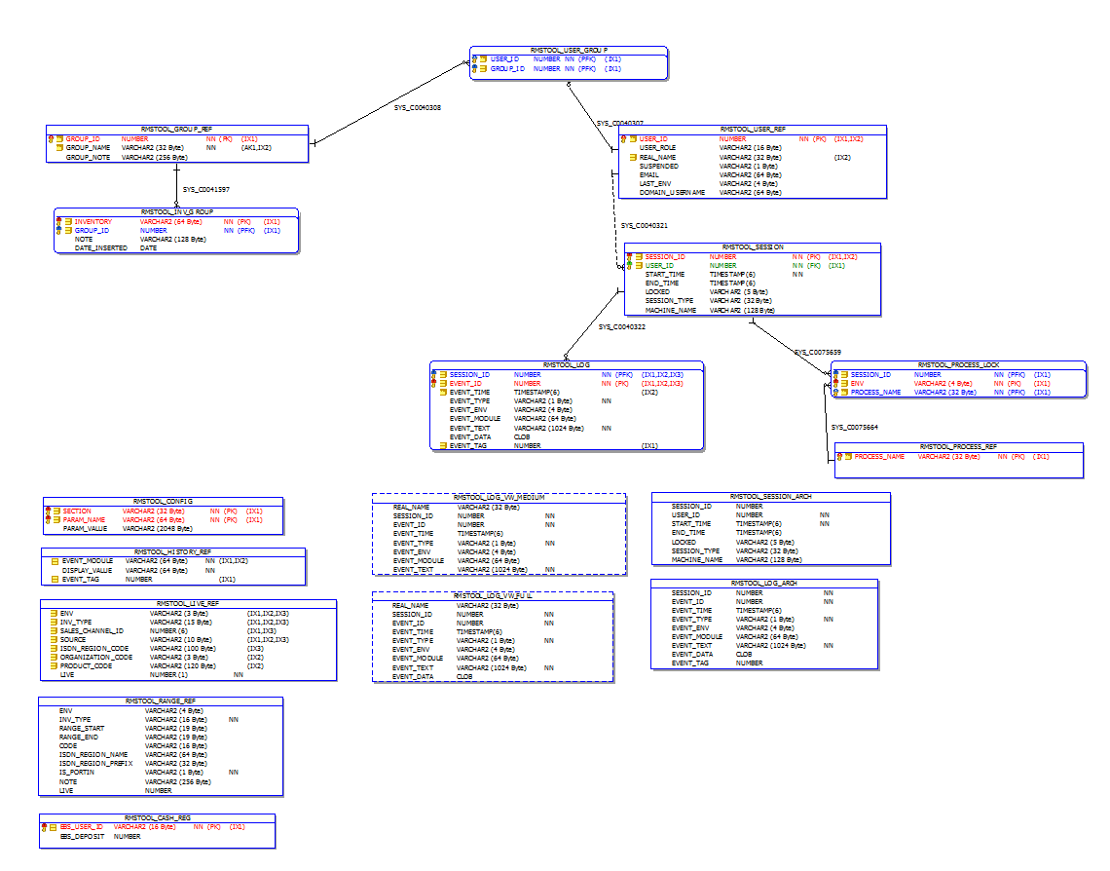

Entity-Relationship Diagram – application schema RMSTOOL_OWN

## Physical Database Design

The Physical Database Design maps the logical data model to the target database management system (DBMS) in a manner that meets the system’s performance requirements. The Physical Database Design converts logical or conceptual data constructs (e.g., entities) to physical storage constructs (e.g., tables, files, and cylinders) of the target DBMS and secondary storage medium. The Physical Database Design is composed of the Data Definition Language (DDL) that implements the database, an information model representing the physical structures and data elements making up the database, and entries in the data dictionary documenting the structures and elements of the design.

### Schema RMSTOOL_OWN@IBMTEST

Main application schema. Holds base database objects of the application. Tablespace RMSTOOL_DATA.

##### Procedure RMSTOOL_ADD_USER_PRC

Used to create new user account.

**Grants:** none

PROCEDURE RMSTOOL_OWN.RMSTOOL_ADD_USER_PRC (

in_real_name RMSTOOL_USER_REF.REAL_NAME%TYPE,

in_user_role RMSTOOL_USER_REF.USER_ROLE%TYPE,

in_email RMSTOOL_USER_REF.EMAIL%TYPE,

in_domain_username RMSTOOL_USER_REF.DOMAIN_USERNAME%TYPE,

in_inv_group RMSTOOL_USER_GROUP.GROUP_ID%TYPE

)

##### Table RMSTOOL_CONFIG

Configurable. Holds main application configuration.

**Indexes:** Primary Key on SECTION, PARAM_NAME

**Foreign Keys**: none

**Triggers:** RMSTOOL_TR_CONFIG_CHG

**Grants:** none

|  |  |  |  |
| --- | --- | --- | --- |
| **Column Name** | **Data Type** | **Description** | **Null** |
| SECTION | VARCHAR2 (32) | Configuration section or environment name |  |
| PARAM_NAME | VARCHAR2 (64) | Configuration entry name |  |
| PARAM_VALUE | VARCHAR2 (2048) | Configuration entry value | Null |

##### Table RMSTOOL_CASH_REG

Configurable. Holds initial deposit amounts for EBS cash registers.

**Indexes:** Primary Key on EBS_USER_ID

**Foreign Keys**: none

**Triggers:** none

**Grants:** none

|  |  |  |  |
| --- | --- | --- | --- |
| **Column Name** | **Data Type** | **Description** | **Null** |
| EBS_USER_ID | VARCHAR2 (16) | User identifier in EBS |  |
| EBS_DEPOSIT | NUMBER | Initial deposit amount in CZK | Null |

##### Table RMSTOOL_GROUP_REF

Configurable. Holds test inventory group definitions.

**Indexes:** Primary Key on GROUP_ID

**Foreign Keys**: none

**Triggers:** none

**Grants:** none

|  |  |  |  |
| --- | --- | --- | --- |
| **Column Name** | **Data Type** | **Description** | **Null** |
| GROUP_ID | NUMBER | Inventory group identifier |  |
| GROUP_NAME | VARCHAR2 (32) | Inventory group name. Unique |  |
| GROUP_NOTE | VARCHAR2 (256) | Inventory group comment | Null |

##### Table RMSTOOL_HISTORY_REF

Internal. Maps history event module name to display name shown in History form.

**Indexes:**

* RMSTOOL_HISTORY_IDX1 (EVENT_MODULE, EVENT_TAG)
* RMSTOOL_HISTORY_IDX2 (EVENT_MODULE)

**Foreign Keys**: none

**Triggers:** none

**Grants:** none

|  |  |  |  |
| --- | --- | --- | --- |
| **Column Name** | **Data Type** | **Description** | **Null** |
| EVENT_MODULE | VARCHAR2 (64) | History event module identifier. Unique |  |
| DISPLAY_VALUE | VARCHAR2 (64) | Display value. Unique |  |
| EVENT_TAG | NUMBER | History event tag | Null |

##### Table RMSTOOL_IGNORED_IL_ALARMS_REF

Configurable. Holds configuration of InstantLink alarm types to be ignored.   
After table content is changed, environment must be reloaded in Phoenix.

See documentation to InstantLink table ILINK_OWN.ALARMS for details.

**Indexes:** none

**Foreign Keys**: none

**Triggers:** none

**Grants:** none

|  |  |  |  |
| --- | --- | --- | --- |
| **Column Name** | **Data Type** | **Description** | **Null** |
| ENV | VARCHAR2 (3) | Environment on which the filter should be applied. NULL for all environments. | Null |
| ENABLED | VARCHAR2 (1) | Enables/disables the filter.  Set to “1” or “Y” to enable, or other value to disable.  Default “1”. | Null |
| HOST | VARCHAR2 (256) | InstantLink host that produced the alarm (server) | Null |
| ORIGIN | VARCHAR2 (256) | InstantLink alarm origin (module) | Null |
| SEVERITY | VARCHAR2 (256) | InstantLink alarm severity | Null |
| ERROR_CODE | VARCHAR2 (256) | InstantLink alarm error code | Null |
| DETAILS | VARCHAR2 (1024) | InstantLink alarm additional text | Null |
| NOTE | VARCHAR2 (512) | Custom comment. Free text.  Default NULL. | Null |

##### Table RMSTOOL_INV_GROUP

Configurable. Maps test inventory item to test inventory group.

**Indexes:** Primary Key on INVENTORY, GROUP_ID

**Foreign Keys**: GROUP_ID must exist in INVENTORY_GROUP_REF(GROUP_ID)

**Triggers:** none

**Grants:** none

|  |  |  |  |
| --- | --- | --- | --- |
| **Column Name** | **Data Type** | **Description** | **Null** |
| INVENTORY | VARCHAR2 (64) | Test inventory identifier  (MSISDN-like identifiers in format <MSISDN>  SIM-like identifiers in format <IMSI>:<ICCID> |  |
| GROUP_ID | NUMBER | Assigned inventory group |  |
| NOTE | VARCHAR2 (128) | Custom comment | Null |
| DATE_INSERTED | DATE | Date of insertion. Default SYSDATE | Null |

##### Table RMSTOOL_INV_TOKEN_REF

Configurable. Holds simple inventory token configuration for sequence-based (non-RMS-originated) inventory.

Keep the inventory prefix configuration consistent with Peklo to avoid issues during inventory import.

* INV_TYPE 🡪 IBMTOOL.PEKLO_SPECIAL_RESOURCES_DEF.RESOURCE_TYPE
* PREFIX 🡪 IBMTOOL.PEKLO_SPECIAL_RESOURCES_DEF.PREFIX_IL_<ENV>

**Indexes:** none

**Foreign Keys**: none

**Triggers:** none

**Grants:** none

|  |  |  |  |
| --- | --- | --- | --- |
| **Column Name** | **Data Type** | **Description** | **Null** |
| ENV | VARCHAR2 (4) | Environment to which the definition belongs. |  |
| INV_TYPE | VARCHAR2 (16) | Type of sequence-based inventory to which the token belongs, e.g.:   * FAKESIM * PRFBB * PRVTV * PRADSL * CRAL |  |
| PREFIX | NUMBER | Inventory token prefix |  |
| LENGTH | NUMBER | Inventory token length |  |

##### Table RMSTOOL_LIVE_REF

Configurable. Holds main application configuration.

**Indexes:**

* IDX_LIVE_REF_1 (ENV, INV_TYPE, SALES_CHANNEL_ID, SOURCE)
* IDX_LIVE_REF_2 (ENV, INV_TYPE, SALES_CHANNEL_ID, SOURCE, ISDN_REGION_CODE)
* IDX_LIVE_REF_3 (ENV, INV_TYPE, SOURCE, ORGANIZATION_CODE, PRODUCT_CODE)

Primary Key on SECTION, PARAM_NAME

**Foreign Keys**: none

**Triggers:** none

**Grants:** none

|  |  |  |  |
| --- | --- | --- | --- |
| **Column Name** | **Data Type** | **Description** | **Null** |
| ENV | VARCHAR2 (3) | Environment to which the range is restricted to. NULL if shared. | Null |
| INV_TYPE | VARCHAR2 (15) | Type of RMS-based inventory to which the range belongs:   * MSISDN * ISDN * IMSI | Null |
| SALES_CHANNEL_ID | NUMBER (6) | Value of SALES_CHANNEL_ID attribute in RMS | Null |
| SOURCE | VARCHAR2 (10) | Source code to which the range belongs  (V2, V4, etc. Keep NULL to disregard.) | Null |
| ISDN_REGION_CODE | VARCHAR2 (100) | ISDN geographical range code. NULL for inventory types other than ISDN. (BLU1, 010, GRN, etc.) | Null |
| ORGANIZATION_CODE | VARCHAR2 (3) | EBS Organization code. NULL for inventory types other than IMSI. | Null |
| PRODUCT_CODE | VARCHAR2 (120) | EBS Product code. NULL for inventory types other than IMSI. | Null |
| LIVE | NUMBER (1) | Live flag. Describes if the range is expected to contain inventory items with specific InstantLink routing profile. In Phoenix GUI, a warning flag is displayed if items’ actual routing profile does not match.   * 0 = NON-LIVE * 1 = LIVE |  |

##### Table RMSTOOL_LOG

Internal. Holds application log entries.

**Indexes:** Primary Key on SESSION_ID, EVENT_ID

* RMSTOOL_LOG_IDX (SESSION_ID, EVENT_ID, EVENT_TIME)
* RMSTOOL_LOG_IDX2 (SESSION_ID, EVENT_ID, EVENT_TAG)

**Foreign Keys**: SESSION_ID must exist in RMSTOOL_SESSION(SESSION_ID)

**Triggers:** RMSTOOL_TR_EVENTID

**Grants:** none

|  |  |  |  |
| --- | --- | --- | --- |
| **Column Name** | **Data Type** | **Description** | **Null** |
| SESSION_ID | NUMBER | Session that logged the event |  |
| EVENT_ID | NUMBER | Log event identifier |  |
| EVENT_TIME | TIMESTAMP (6) | Log event timestamp |  |
| EVENT_TYPE | VARCHAR2 (1) | Log event type:   * I = Information * W = Warning * E = Error * X = SQL command execution * D = Debug |  |
| EVENT_ENV | VARCHAR2 (4) | Environment where the event was logged | Null |
| EVENT_MODULE | VARCHAR2 (64) | Module that initiated the log event | Null |
| EVENT_TEXT | VARCHAR2 (1024) | Log event description |  |
| EVENT_DATA | CLOB | Log event data (optional) | Null |
| EVENT_TAG | NUMBER | Optional log event tag 1 = History data | Null |

##### Table RMSTOOL_LOG_ARCH

Internal. Holds archived application log entries.

**Indexes:** none

**Foreign Keys**: none

**Triggers:** none

**Grants:** none

**Columns:** See RMSTOOL_LOG

##### Table RMSTOOL_PROCESS_LOCK

Internal. Holds currently acquired process locks.

**Indexes:** Primary Key on SESSION_ID, ENV, PROCESS_NAME

**Foreign Keys**:

* SESSION_ID must exist in RMSTOOL_SESSION(SESSION_ID)
* PROCESS_NAME must exist in RMSTOOL_PROCESS_REF(PROCESS_NAME)

**Triggers:** RMSTOOL_TR_PROCESS_LOCK_CHG

**Grants:** none

|  |  |  |  |
| --- | --- | --- | --- |
| **Column Name** | **Data Type** | **Description** | **Null** |
| SESSION_ID | NUMBER | Identifier of session that acquired the process lock |  |
| ENV | VARCHAR2 (4) | Environment the process is locked on |  |
| PROCESS_NAME | VARCHAR2 (32) | Locked process name |  |

##### Table RMSTOOL_PROCESS_REF

Internal. Holds lockable process definitions.

**Indexes:** Primary Key on PROCESS_NAME

**Foreign Keys**: none

**Triggers:** none

**Grants:** none

|  |  |  |  |
| --- | --- | --- | --- |
| **Column Name** | **Data Type** | **Description** | **Null** |
| PROCESS_NAME | VARCHAR2 (32) | Lockable process definition |  |

##### Table RMSTOOL_RANGE_REF

Configurable. Holds test inventory range definitions.

**Indexes:** none

**Foreign Keys**: none

**Triggers:** none

**Grants:** IBMTEST (SELECT, INSERT, DELETE)

|  |  |  |  |
| --- | --- | --- | --- |
| **Column Name** | **Data Type** | **Description** | **Null** |
| ENV | VARCHAR2 (4) | Environment to which the range belongs.  Set to NULL if the range is shared on multiple environments. Set to XXX to ignore the range (comment). | Null |
| INV_TYPE | VARCHAR2 (16) | Type of RMS-based inventory to which the range belongs:   * MSISDN * ISDN * IMSI * ESIM |  |
| RANGE_START | VARCHAR2 (19) | Starting position in the range  (MSISDN-like identifiers in format 420nnnnnnnnn  IMSI-like identifiers in format 23003nnnnnnnnnn) | Null |
| RANGE_END | VARCHAR2 (19) | Ending position in the range  (MSISDN-like identifiers in format 420nnnnnnnnn  IMSI-like identifiers in format 23003nnnnnnnnnn) | Null |
| CODE | VARCHAR2 (16) | One of the following:   * For non-ISDN ranges: Source code to which the range belongs  (V2, V4, etc. Keep NULL to disregard.) * For ISDN ranges: Geographical range code (BLU1, 010, GRN, etc.) | Null |
| ISDN_REGION_NAME | VARCHAR2 (64) | One of the following:   * For ISDN ranges: ISDN region name.  (e.g., “Vysočina”) * For ESIM ranges: eSIM type in the range. (“VIRTUAL” or “VOUCHER”) * For other ranges: NULL | Null |
| ISDN_REGION_PREFIX | VARCHAR2 (32) | One of the following:   * For ISDN ranges: ISDN region prefix. (e.g., 4202, 42059) * For non-ISDN ranges: NULL | Null |
| IS_PORTIN | VARCHAR2 (1) | Number portability flag. (Y / N) |  |
| NOTE | VARCHAR2 (256) | Free text describing details of the range (originator, purpose, date, etc.). | Null |
| LIVE | NUMBER | Live flag. Describes if the range is expected to contain inventory items with specific InstantLink routing profile. In Phoenix GUI, a warning flag is displayed if items’ actual routing profile does not match.   * 0 = NON-LIVE * 1 = LIVE * -1 = disregard (ignore)   Set to -1 for mixed or shared ranges to disregard. | Null |
| ICCID_START | VARCHAR2 (19) | One of the following:   * For ESIM ranges: Starting ICCID of the range. * For other ranges: NULL | Null |
| ICCID_END | VARCHAR2 (19) | One of the following:   * For ESIM ranges: Ending ICCID of the range. * For other ranges: NULL | Null |

##### Table RMSTOOL_SESSION

Internal. Holds application session entries.

**Indexes:** Primary Key on SESSION_ID

* RMSTOOL_LOG_IDX3 on SESSION_ID, USER_ID

**Foreign Keys**: USER_ID must exist in RMSTOOL_USER_REF(USER_ID)

**Triggers:** RMSTOOL_TR_TERM_CHG

**Grants:** none

|  |  |  |  |
| --- | --- | --- | --- |
| **Column Name** | **Data Type** | **Description** | **Null** |
| SESSION_ID | NUMBER | Session identifier. Unique |  |
| USER_ID | NUMBER | User identifier that initiated the session |  |
| START_TIME | TIMESTAMP (6) | Session start time |  |
| END_TIME | TIMESTAMP (6) | Session end time. NULL for ongoing sessions | Null |
| LOCKED | VARCHAR2 (5) | External kill switch flag | Null |
| SESSION_TYPE | VARCHAR2 (32) | Internal session type   * DEBUG * INIT * PRIVATE * REGULAR * RELEASE * UNAUTHORIZED * UPDATER | Null |

##### Table RMSTOOL_SESSION_ARCH

Internal. Holds archived application session entries.

**Indexes:** none

**Foreign Keys**: none

**Triggers:** none

**Grants:** none

**Columns:** See RMSTOOL_SESSION

##### Table RMSTOOL_USER_GROUP

Configurable. Maps user to test inventory group.

**Indexes:** Primary Key on USER_ID, GROUP_ID

**Foreign Keys**:

* USER_ID must exist in RMSTOOL_USER_REF(USER_ID)
* GROUP_ID must exist in RMSTOOL_GROUP_REF(GROUP_ID)

**Triggers:** none

**Grants:** none

|  |  |  |  |
| --- | --- | --- | --- |
| **Column Name** | **Data Type** | **Description** | **Null** |
| USER_ID | NUMBER | User identifier |  |
| GROUP_ID | NUMBER | Inventory group identifier |  |

##### Table RMSTOOL_USER_REF

Configurable. Holds user account configuration.

**Indexes:** Primary Key on USER_ID

* RMSTOOL_USR_IDX on USER_ID, REAL_NAME

**Foreign Keys**: none

**Triggers:** none

**Grants:** none

|  |  |  |  |
| --- | --- | --- | --- |
| **Column Name** | **Data Type** | **Description** | **Null** |
| USER_ID | NUMBER | User identifier. Unique |  |
| USER_ROLE | VARCHAR2 (16) | Application role assigned to the user role   * ADMIN * NULL * LEAD * TESTING-IBM * TESTING-V2 * TESTING-VF   NULL for users without role. | Null |
| REAL_NAME | VARCHAR2 (32) | Full name of the user (e.g., “John Doe”).  Displayed in process locks details dialog. | Null |
| SUSPENDED | VARCHAR2 (1) | Defines if the user is suspended.  Set to “Y” to revoke access to Phoenix for an existing user. | Null |
| EMAIL | VARCHAR2 (64) | User corporate e-mail address | Null |
| LAST_ENV | VARCHAR2 (4) | Testing environment that was last accessed by the user. Offered to the user as default upon next logon. | Null |
| DOMAIN_USERNAME | VARCHAR2 (64) | Domain username of the user in VF-ROOT domain. Used during login authorization. | Null |

##### Table RMSTOOL_V2_CLEANSING_QUEUE

Dynamic. Holds inventory items to be cleansed by external system (Jenkins automation) during V2 cleansing and their external cleansing status.

**Indexes:**

* IDX_V2_ENV on ENV
* IDX_V2_CREATED on CREATED_DATE
* IDX_V2_MSISDN on MSISDN
* IDX_V2_STATUS on STATUS

**Foreign Keys**: none

**Triggers:** none

**Grants:** RMSTOOL_USR (SELECT, UPDATE)

|  |  |  |  |
| --- | --- | --- | --- |
| **Column Name** | **Data Type** | **Description** | **Null** |
| ENV | VARCHAR2 (3 Byte) | Testing environment identifier.  Possible values: SY2, INT, PRE |  |
| BATCH_ID | VARCHAR2 (15 Byte) | Internal cleansing batch identifier.  Format: YYYYMMDDHH24MISS. |  |
| MSISDN | VARCHAR2 (12 Byte) | MSISDN to be cleansed by 3rd party. |  |
| STATUS | NUMBER | External cleansing status:   * 0 = Pending * 1 = In Progress * 2 = Finished * 3 = Error   Updated by external system. |  |
| CREATED_DATE | DATE | Datetime the record was created. |  |
| LAST_MODIFIED_DATE | DATE | Datetime the record was last updated.  Populated by external system. | Null |
| ERROR_DESCR | VARCHAR2 (1024 Byte) | Error description in case of failed external cleansing.  NULL in case of successful external cleansing.  Populated by external system. | Null |

##### Trigger RMSTOOL_TR_CONFIG_CHG

Internal. Triggers respective DMBS alert upon selected configuration change.

**Table:** RMSTOOL_CONFIG

**Type**: AFTER INSERT OR UPDATE

##### Trigger RMSTOOL_TR_EVENTID

Internal. Generates EVENT_ID value for new log entry.

**Table:** RMSTOOL_LOG

**Type**: BEFORE INSERT

##### Trigger RMSTOOL_TR_PROCESS_LOCK_CHG

Internal. Triggers respective DMBS alert upon process lock change.

**Table:** RMSTOOL_PROCESS_LOCK

**Type**: AFTER INSERT OR DELETE

##### Trigger RMSTOOL_TR_TERM_CHG

Internal. Triggers respective DMBS alert upon session kill switch change.

**Table:** RMSTOOL_SESSION

**Type**: AFTER INSERT OR UPDATE

##### View RMSTOOL_LOG_VW_FULL

Holds application log entries extended with full name of the respective users.

**Grants:** none

|  |  |  |  |
| --- | --- | --- | --- |
| **Column Name** | **Data Type** | **Description** | **Null** |
| REAL_NAME | VARCHAR2 (32) | Full name of the user |  |
| SESSION_ID | NUMBER | Log entry session identifier |  |
| EVENT_ID | NUMBER | Log entry event identifier. Unique per session |  |
| EVENT_TIME | TIMESTAMP (6) | Log entry insertion date. Default SYSTIMESTAMP |  |
| EVENT_TYPE | VARCHAR2 (1) | Log entry type |  |
| EVENT_ENV | VARCHAR2 (4) | Log entry environment identifier | Null |
| EVENT_MODULE | VARCHAR2 (64) | Log entry module name | Null |
| EVENT_TEXT | VARCHAR2 (1024) | Log entry text |  |
| EVENT_DATA | CLOB | Log entry data | Null |

##### View RMSTOOL_LOG_VW_MEDIUM

Exposes application log entries extended with full name of the respective users to RMSTOOL_USR user. Does not contain detailed log data CLOB’s.

**Grants:** RMSTOOL_USR (SELECT)

|  |  |  |  |
| --- | --- | --- | --- |
| **Column Name** | **Data Type** | **Description** | **Null** |
| REAL_NAME | VARCHAR2 (32) | Full name of the user |  |
| SESSION_ID | NUMBER | Log entry session identifier |  |
| EVENT_ID | NUMBER | Log entry event identifier. Unique per session |  |
| EVENT_TIME | TIMESTAMP (6) | Log entry insertion date. Default SYSTIMESTAMP |  |
| EVENT_TYPE | VARCHAR2 (1) | Log entry type |  |
| EVENT_ENV | VARCHAR2 (4) | Log entry environment identifier | Null |
| EVENT_MODULE | VARCHAR2 (64) | Log entry module name | Null |
| EVENT_TEXT | VARCHAR2 (1024) | Log entry text |  |

##### View RMSTOOL_ESIM_RANGES_VW

Exposes limited Phoenix eSIM ranges configuration to RMSTOOL_USR user. The view is intended to be used by a java application “*esim-env-router*” that retrieves eSIM notifications from SM-DP+ platform and routes/dispatches them to given testing environment. This is part of an initiative aiming on allowing use of standalone (not overlapping) eSIM ranges on the testing environments.

**Grants:** RMSTOOL_USR (SELECT)

|  |  |  |  |
| --- | --- | --- | --- |
| **Column Name** | **Data Type** | **Description** | **Null** |
| ENV | VARCHAR2 (4) | Environment to which the range belongs.  XXX value means the range is not to be used. **NOTE:** Phoenix environment SY2 is decoded to SYS2 for esim-env-router. | Null |
| ICCID_START | VARCHAR2 (19) | Starting ICCID of the range | Null |
| ICCID_END | VARCHAR2 (19) | Ending ICCID of the range | Null |

### Schema RMSTOOL_USR@IBMTEST

Application user schema used for limited access to Phoenix data.

Can read:

* limited application log presented in view RMSTOOL_LOG_VW_MEDIUM.
* limited eSIM ranges configuration presented in view RMSTOOL_ESIM_RANGES_VW.

### Schema ARBOR@<ARBOR_ADMIN_DB>

Holds auxiliary objects related to Kenan and RMS cleansing. Tablespace ARBOR_DATA.

Presence of the below objects is checked before Kenan cleansing begins and error is raised if any of them is missing.

**NOTE:** Object names are what they are from historical purposes (trend initiated by the primordial Accenture cleansing routine introduced with V4 world in project FILIP).

##### Kenan System Configuration

To ensure that subsequent provisioning will not truncate activation dates in Kenan and cleaned inventory can be re-used on the same day, value of attribute trunc_si_ext_id_date must be set to 0 in Kenan configuration table SYSTEM_PARAMETERS.

This only needs to be done once on each Kenan testing environment.

##### Procedure INVD_TMP_TERM_MSISDN_PRC

Internal. Terminates (sets inactive dates) a list of MSISDN’s present in input table INVD_TMP_TERM_MSISDN_IN in following Kenan tables:

* CUSTOMER_ID_EQUIP_MAP_VIEW (this will also trigger update in CUSTOMER_ID_EQUIP_MAP)
* EXTERNAL_ID_EQUIP_MAP_VIEW (this will also trigger update in EXTERNAL_ID_EQUIP_MAP)
* VF_CONFIG.VF_PROD_INST

**Grants:** none

PROCEDURE ARBOR.INVD_TMP_TERM_MSISDN_PRC (

in_run_mode IN VARCHAR2,

in_debug BOOLEAN DEFAULT FALSE

)

|  |  |
| --- | --- |
| **Parameter Name** | **Description** |
| in_run_mode | Run mode   * SCAN – Only scans the MSISDN’s, does not actually terminate * CLEAN – Terminates the MSISDN’s |
| in_debug | If TRUE, additional processing details are logged to DBMS output |

##### Procedure INVD_TMP_TERM_MSISDN_UPD

Internal. Updates partial Kenan termination status in table INVD_TMP_TERM_MSISDN_LOG for input MSISDN.

**Grants:** none

PROCEDURE ARBOR.INVD_TMP_TERM_MSISDN_UPD (

in_msisdn IN VARCHAR2,

in_status_column_name IN VARCHAR2,

in_value IN VARCHAR2,

in_err_msg IN VARCHAR2

)

|  |  |
| --- | --- |
| **Parameter Name** | **Description** |
| in_msisdn | MSISDN row in table INVD_TMP_TERM_MSISDN_LOG to update |
| in_status_column_name | Column name in table INVD_TMP_TERM_MSISDN_LOG to update |
| in_value | New value   * A = Active * D = Deactivated |
| in_err_msg | Error message. Optional |

##### Synonym PHOENIX_CIEMV3

Internal. Links to table ARBOR.CUSTOMER_ID_EQUIP_MAP_VIEW on Kenan customer server 3.

##### Synonym PHOENIX_CIEMV4

Internal. Links to table ARBOR.CUSTOMER_ID_EQUIP_MAP_VIEW on Kenan customer server 4.

##### Table INVD_TMP_TERM_INV

Internal. Holds input list of inventories to be cleansed in Kenan. Used by Kenan admin DB and RMS cleansing thread.

**Indexes:** EXTERNAL_ID, INVENTORY_ID+INVENTORY_ID_RESETS, INVENTORY_TYPE_ID

**Foreign Keys**: none

**Triggers:** none

**Grants:** none

|  |  |  |  |
| --- | --- | --- | --- |
| **Column Name** | **Data Type** | **Description** | **Null** |
| EXTERNAL_ID | VARCHAR2 (19 Byte) | External ID of the inventory in RMS. | Null |
| INVENTORY_TYPE_ID | NUMBER | Inventory type ID of the inventory in RMS. | Null |
| INVENTORY_ID | NUMBER | Inventory ID of the inventory in RMS. | Null |
| INVENTORY_ID_RESETS | NUMBER | Inventory ID resets of the inventory in RMS. | Null |
| CONT99 | NUMBER | Container ID of type 99 container. NULL for Non-OneNumber inventory. | Null |
| CONT100 | NUMBER | Container ID of type 100 container. NULL for inventory other than MSISDN. | Null |
| CONT101 | NUMBER | Container ID of type 101 container.  NULL for not paired inventory. | Null |

##### Table INVD_TMP_TERM_MSISDN_IN

Internal. Holds input list of MSISDN’s to be terminated in Kenan.

**Indexes:** Primary Key on MSISDN

**Foreign Keys**: none

**Triggers:** none

**Grants:** none

|  |  |  |  |
| --- | --- | --- | --- |
| **Column Name** | **Data Type** | **Description** | **Null** |
| MSISDN | VARCHAR2 (12) | MSISDN identifier. Unique |  |
| SKIP | VARCHAR2 (1) | Skip flag. Set to “Y” to skip the MSISDN. | Null |

##### Table INVD_TMP_TERM_MSISDN_LOG

Internal. Holds Kenan MSISDN termination result flags.

**Indexes:** Primary Key on MSISDN

**Foreign Keys**: none

**Triggers:** none

**Grants:** none

|  |  |  |  |
| --- | --- | --- | --- |
| **Column Name** | **Data Type** | **Description** | **Null** |
| MSISDN | VARCHAR2 (12) | MSISDN identifier. Unique |  |
| STATUS_EIEMV | VARCHAR2 (1) | Termination status in EXTERNAL_ID_EQUIP_MAP_VIEV   * A = Active * D = Deactivated | Null |
| STATUS_CIEMV3 | VARCHAR2 (1) | Termination status in CUSTOMER_ID_EQUIP_MAP_VIEW@CUSTOMER_DB_3   * A = Active * D = Deactivated | Null |
| STATUS_CIEMV4 | VARCHAR2 (1) | Termination status in CUSTOMER_ID_EQUIP_MAP_VIEW@CUSTOMER_DB_4   * A = Active * D = Deactivated | Null |
| STATUS_VPI | VARCHAR2 (1) | Termination status in VF_CONFIG.VF_PROD_INST   * A = Active * D = Deactivated | Null |
| PROCESSED_DT | DATE | Date the entry was processed | Null |
| ERR_MSG | VARCHAR2 (2048) | Error details in case of failure. NULL if successful. | Null |

### Schema VF_CONFIG@<ARBOR_ADMIN_DB>

Holds auxiliary objects related to eSIM RMS cleansing.

##### Table VF_INVENTORY_NOTIFICATION – Extended Privileges

User ARBOR must be granted SELECT and DELETE privileges on table VF_CONFIG. VF_INVENTORY_NOTIFICATION so that old eSIM notifications can be properly selected and removed during eSIM cleansing process.

GRANT SELECT, DELETE ON VF_INVENTORY_NOTIFICATION TO ARBOR

### Schema ILABATCH_OWN @<INSTANTLINK_DB>

Holds auxiliary objects related to inventory cleansing on network elements.

##### Table BATCH_PROVISIONING – New Index

New index must be added on table BATCH_PROVISIONING on column BATCH_ID that is used in repeated Phoenix query of network cleansing status to avoid full table scans and unnecessary excessive DB load:

CREATE INDEX ILABATCH_OWN.IDX_BATCH_PROV_BATCHID ON ILABATCH_OWN.BATCH_PROVISIONING

(BATCH_ID)

LOGGING

TABLESPACE IL_DATA_CTL

PCTFREE 10

INITRANS 2

MAXTRANS 255

STORAGE (

INITIAL 64K

NEXT 1M

MINEXTENTS 1

MAXEXTENTS UNLIMITED

PCTINCREASE 0

BUFFER_POOL DEFAULT

)

NOPARALLEL;

# User Interface

This chapter describes graphical user interface of the application and overview of all operations accessible in the GUI from the user perspective. High-level technical overview is also included where of benefit to the user.

## Login Form

Upon application start, user must authorize with their domain credentials, and select a test environment to initialize:

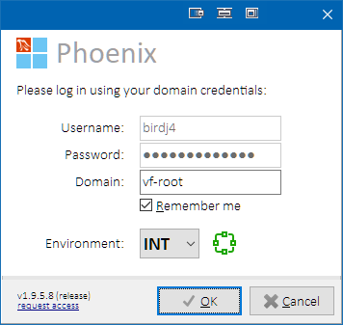

*Login form*

If the user does not wish to enter their credentials at every application start, they can choose their credentials to be remembered by checking **Remember me** checkbox. Remembered credentials also enable automatic login 5 seconds after the login form is displayed.

**Only configured users who are not suspended and have assigned role are allowed access.**

If the user is not yet registered, they can click on the **request access** link to open an Outlook form with preconfigured message text to be sent to the application administrators.

See User Configuration and User Roles chapters for technical details on the user management.

See Domain Authorization chapter for technical details of the domain authorization process.

## Main Form

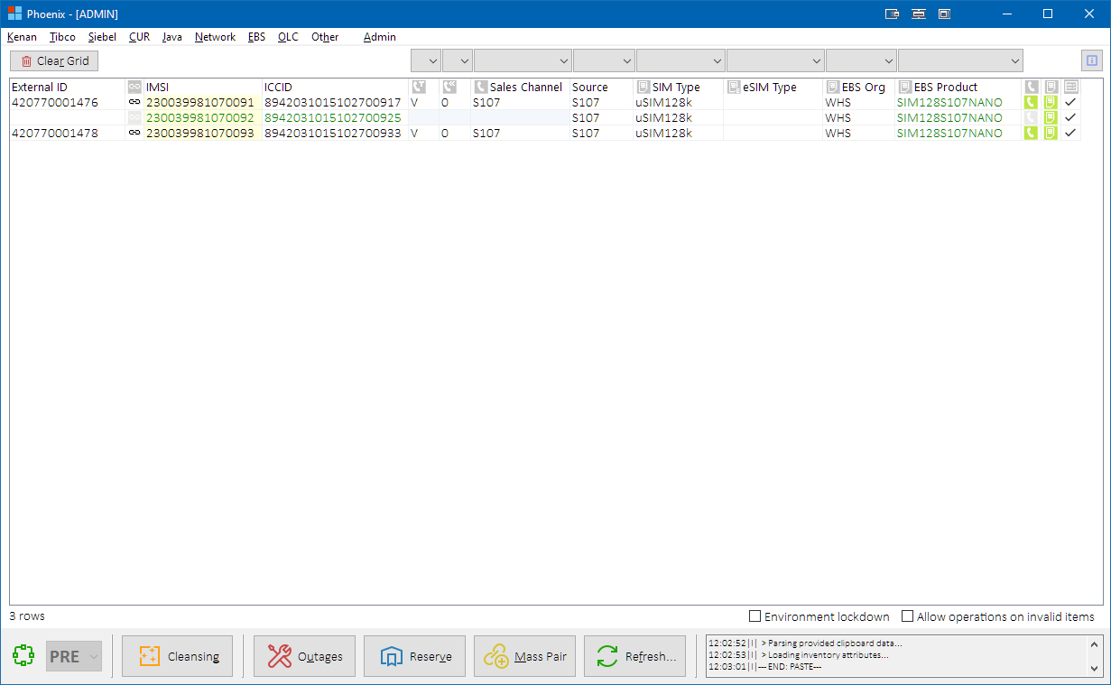

*Main form with several inventory present in the main grid*

### Main Grid

Following subchapters describe which visible columns of the main grid are used by which inventory type, and their detailed meanings.

Following inventory item kinds are supported in the main grid:

|  |  |  |
| --- | --- | --- |
| **Inventory Item Kind** | **Source System** | **Description** |
| MSISDN-kind | RMS | RMS-based external ID’s of MSISDN type (i.e., MSISDN, ISDN) |
| Siebel Sequences | Sequence-based external ID’s (e.g., FakeSIM, ADSL, ICT, FBB, VTV, CaseID, Marketplace, etc.).  **NOTES:**   * In Phoenix, these may be also named as “special resources”. * Sequence-based identifiers that are not assigned as external ID’s to Kenan account or subscriber during provisioning, are not supported in the main grid (e.g., PRVPNFIRM etc.). |
| SIM-kind | RMS +  EBS | SIM- or eSIM-card-related RMS-based external ID’s (i.e., IMSI, ICCID). ICCID must also be present in EBS warehouse.  **NOTE:** MVNO eSIM’s are not stored in EBS. |
| Others | Various | Special cases – only for specific operations (MAC addresses, PBX numbers |

Depending on inventory item kinds present in the grid row, some columns may be not applicable. Such cells are grayed out. Following table depicts which columns are used by which inventory items:

|  |  |  |
| --- | --- | --- |
| **Column name** | **Inventory Item Kind** | **Description** |
| **External ID** | MSISDN-kind Others | RMS- or sequence-based External ID of an MSISDN-kind inventory.  If RMS status is **Available**, the value is displayed in green color. |
| ***Pair*** | MSISDN -like SIM-kind | Flag for coupling/pairing status of the row inventory.  **Color Legend:**   |  |  | | --- | --- | |  | Inventory is not paired. | |  | Inventory is paired. | |  | Inventory is paired + forms primary OneNumber pair. | |  | Inventory is paired + forms secondary OneNumber pair. | |  | Inventory is paired differently (cross-pairing).  Check RMS Status for details. | |
| **IMSI** | SIM-kind | RMS inventory external ID of IMSI type. If RMS status is **Available**, the value is displayed in green color. |
| **ICCID** | SIM-kind | RMS inventory external ICCID parameter. If RMS status is **Available**, the value is displayed in green color. |
| ***Service Type*** | MSISDN-kind | RMS inventory Service Type of the inventory in RMS. Available values:   * V = Voice * D = Data * F = Fax |
| ***Is Donated*** | MSISDN-kind | RMS inventory IS_DONATED flag (for ported-in inventory) Available values: 0 / 1 |
| **Sales Channel** | MSISDN-kind | RMS inventory Sales Channel (e.g., CONSUMER/BUSINESS/etc.) |
| **Source** | MSISDN-kind SIM-kind | RMS inventory Source (e.g., V4/V2/S106/etc.).  **NOTE:** This is a shared column for MSISDN and SIM source.  If a row contains MSISDN and SIM inventory with different sources, MSISDN source is displayed in the main grid. In such cases, either import SIM to a separate row, or check RMS Status form for SIM details. |
| **SIM Type** | SIM-kind | RMS inventory SIM Type (e.g., uSIM128k).  Picked from RMS record with INVENTORY_TYPE_ID=3. |
| **eSIM Type** | SIM-kind | RMS inventory eSIM Type (e.g., Virtual-eSIM).  Picked from RMS record with INVENTORY_TYPE_ID=6.  If RMS status is **Available**, the value is displayed in green color. |
| **EBS Org** | SIM-kind | EBS Organization (e.g., S02) for the SIM. |
| **EBS Product** | SIM-kind | EBS Product Name (e.g., SKPOST128LTE) for the SIM.  If EBS status is **In Stock**, the value is displayed in green color. |
| ***MSISDN Status*** | MSISDN-kind Others | Calculated flag for validity of row data that belong to MSISDN-kind inventory on given row.  **Color Legend:**   |  |  | | --- | --- | |  | Inventory was not detected on given row. | | // | Inventory is routed as NON-LIVE. | | // | Inventory is routed as LIVE. | | // | Inventory is routed as CUSTOM (to individually configured network elements). | | // | Inventory routing is invalid (usually some inventory format is missing). | | // | Inventory is not routed (goes to DUMMY network elements). | | // | Inventory is unauthorized for current user’s role. (Either the inventory is not whitelisted for current user’s role, or the inventory is present on a cleansing black list.) See Inventory Authorization for more details. |   **Symbol Legend:**   |  |  | | --- | --- | |  | Inventory is MSISDN | |  | Inventory is ISDN | |  | Inventory is external i.e., of a non-RMS origin (FakeSIM, ADSL/FBB, ICT, MAC, etc.) |   Hovering mouse over the icon will reveal more details. |
| ***SIM Status*** | SIM-kind | Calculated flag for validity of row data that belong to SIM-kind inventory on given row (e.g., valid/warning/error).  **Color Legend:**   |  |  | | --- | --- | | / | Inventory was not detected on given row. | | / | Inventory is routed as NON-LIVE. | | / | Inventory is routed as LIVE. | | / | Inventory is routed as CUSTOM (to individually configured network elements). | | / | Inventory routing is invalid (usually some inventory format is missing). | | / | Inventory is not routed (goes to DUMMY network elements). | | / | Inventory is unauthorized for current user’s role. (Either the inventory is not whitelisted for current user’s role, or the inventory is present on a cleansing black list.) See Inventory Authorization for more details. |   **Symbol Legend:**   |  |  | | --- | --- | |  | Inventory is SIM (INVENTORY_TYPE_ID=3) | |  | Inventory is eSIM (INVENTORY_TYPE_ID=3+6) |   Hovering mouse over the icon will reveal more details. |
| ***Row Status*** | All | Calculated flag for overall row validity.  **Icon Legend:**   |  |  | | --- | --- | |  | OK Row data is valid. | |  | NEEDS REFRESH Row data are inaccurate due to recent changes. | |  | WARNING Row contains minor data issues that should be resolved. | |  | ERROR Row contains major data issues that must be resolved. | |  | UNAUTHORIZED Row contains unauthorized inventory item.  See Inventory Authorization for more details. |   Hovering mouse over the icon will reveal more details. |

**HINTS:**

**Colored cells:**

* Green text means the inventory is in Available status in RMS and/or EBS.
* Ivory cell background means the value was provided as user input (pasted in or modified by user).
* White cell background means the value was fetched from DB

**Row hints:**

Hover mouse cursor over MSISDN, SIM or ICCID column to display a cell hint with additional information about the inventory, such as BA and CA identifiers, group identifiers, subscriber identifiers etc.:

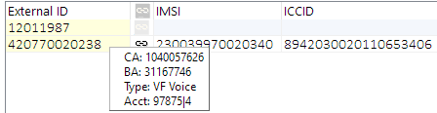

*Main grid row hint example*

##### Navigation

Main grid can be navigated using standard keyboard keys or mouse.

Select multiple rows by holding down shift while navigating through the rows.

Press **CTRL+G** to go to a specific row:

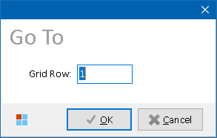

*Go To form*

##### Saving / Loading / Copying Grid Data

Main grid content can be copied out as a structured text table with **TAB**-separated values into clipboard. If no rows are selected, then the whole grid is copied. If some rows are selected, then only selected rows are copied. Grid content can also be saved to and loaded from a text file.

|  |  |
| --- | --- |
| **Shortcut** | **Description** |
| **CTRL+C** | Copy all columns to clipboard |
| **ALT+CTRL+C** | Copy only MSISDN, IMSI and ICCID columns to clipboard |
| **SHIFT+CTRL+C** | Copy all columns to clipboard, without headers and separator lines |
| **SHIFT+CTRL+ALT+C** | Copy only MSISDN, IMSI and ICCID columns to clipboard, without headers and separator lines |
| **CTRL+S** | Save grid to a text file |
| **CTRL+O** | Load grid from a text file |
| **CTRL+H** | Opens History form so that user can quickly choose to re-import recently imported inventory.  See History Model for more details on how History is handled. |

##### Reloading Grid Data

Main grid data can be refreshed by one of the following ways:

|  |  |
| --- | --- |
| **Shortcut** | **Description** |
| **CTRL+R** | All inventory attributes are reloaded from DB |
| **SHIFT+CTRL+R** | Only Row Status column is recalculated |

### Buttons

Following button controls are present on the main form:

|  |  |
| --- | --- |
| **Button Caption** | **Description** |
| **Clear Grid** | Clears data in the main grid.  See Clear Grid Button for more details. |
| ***Legend*** | Shows Legend form describing meaning of icons displayed in the main grid.  See Legend Button for more details. |
| **Cleansing** | Opens Cleansing Processing Options form. Used to set further options of inventory cleansing process. See Cleansing Button for more details. |
| **Outages** | Displays information about known outages on current test environment  See Outages Button for more details. |
| **Reserve** | Opens Mass Reservation form. Used to mass-reserve inventory from Peklo. See Reserve Button for more details. |
| **Mass Pair** | Opens Mass Pairing form. Used to mass-pair inventory in Kenan. See Mass Pair Button for more details. |
| **Refresh** | Opens menu with systems that can be refreshed / synced:  See [Refresh Button (Menu)](#_Refresh_Button_(Menu)) for more details. |
| **Announce Update** | Announces application update to users.  See Announce Update Button for more details.  **NOTE:** The button is only visible to users with ADMIN role and only if a PRIVATE session (unannounced new build) of Phoenix is running. |

##### Cleansing Button

Press **Cleansing** button to open Cleansing Processing Options form in order to provide further details to cleansing process to be launched.

See Inventory Cleansing for more details on the cleansing process.

##### Outages Button

Press **Outages** button to check whether there are any ongoing announced outages related to selected test environment. Some operations can be unavailable or require explicit user confirmation during ongoing outage. Users should align their next steps accordingly.

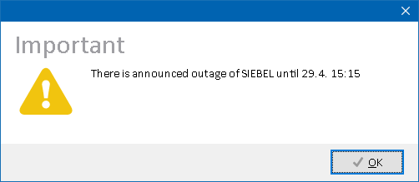

*An ongoing announced outage*

##### Reserve Button

Press  **Reserve** button to open Inventory Mass Reservation form in order to mass-reserve inventory from Peklo and import it to Phoenix main grid.

See Inventory Reservation for more details on the reservation process.

##### Mass Pair Button

Press  **Mass Pair** button to open Mass Pairing Properties form in order to provide further details to mass paring process to be launched.

See Inventory Mass Pairing for more details on the mass pairing process.

##### Refresh Button (Menu)

Press  **Refresh** button to open pop-up menu with systems for which refresh or sync operation is available.

|  |  |
| --- | --- |
| **Menu Item** | **Description** |
| **Location Dispatcher** | RMS API views used by Location Dispatcher will be refreshed.  See [Location Dispatcher (RMS API views)](#_Location_Dispatcher_(RMS) for more details. |
| **Instant Link** | InstantLink will BST tables will be reloaded.  See [Instant Link (reconfig)](#_Instant_Link_(reconfig)) for more details.  *(assumed obsolete now as new IL white lists are DB-based)* |
| **Smart Overview** | WSC Data Cache SO tables will be refreshed so that it contains last 10.000 accounts created in Kenan.  See [Smart Overview (data cache)](#_Smart_Overview_(data) for more details. |
| **Invoice Breakdown** | WSC Data Cache IBD tables will be refreshed so that the cache contains all invoices generated by INEXT in last 30 days.  See [Invoice Breakdown (data cache)](#_Invoice_Breakdown_(data) for more details.  *(assumed obsolete now as WSC Data Cache was replaced by some new VF solution – details are unknown – currently hidden in the menu, candidate to remove permanently)* |
| **Peklo** | Peklo Refresher will launch to refresh inventory materialized views in Peklo.  This is necessary after inventory attributes manipulation e.g., in Kenan, to ensure that Peklo offers correct inventory to testers.  Following Peklo refresh mode are available:   * Quick Refresh – MSISDN’s * Quick Refresh – MSISDN’s & SIM’s * Quick Refresh – HW * Full Refresh   See Peklo for more details. |
| **Reload Environment** | Test environment is reloaded in Phoenix (same as during application start, or as if the user has selected a new test environment in the Environment combo box).  See Reload Environment for more details. |

###### Location Dispatcher (RMS API views)

***Process overview:***

1. Log into **RMSAPI_OWN** schema
2. Refresh following materialized views:
   * + **MV_INVD_MAIN**
     + **MV_INVD_MAIN_EXT_DATA**
     + **MV_INVD_VIEWS**

###### Instant Link (reconfig)

***Process overview:***

1. Log into IL server
2. Reload BST tables by executing ****ctl_control reconfig**** command.

###### Smart Overview (data cache)

***Process overview:***

A. Customer servers:

1. Identify 10.000th newest account in Kenan (order by **ACCOUNT_NO**).
2. Log into schema **WSC_DATA_CACHE_CUSTOM**.
3. Reset sequences in table **SMART_OVERVIEW_CAP_SEQS**.
4. Delete current calculated unbilled usage in table **SMART_OVERVIEW_SUBSCRIBER** for all newer accounts.
5. Prepare data by calling stored procedure **SO_DATA_CACHE_JOB.SMART_OVERVIEW_MAIN**.

B. Admin server:

1. Log into **WSC_DATA_CACHE** schema.
2. Upload data from each customer server by calling **SO_DATA_CACHE_UPLOAD_API.SMART_OVERVIEW_UPLOAD** stored procedure.

**NOTE:** 10.000 accounts threshold is currently hardcoded as constant **C_SO_NUMBER_OF_ACCOUNTS**.

###### Invoice Breakdown (data cache)

***Process overview:***

Customer servers:

1. Fetch earliest invoice from Kenan (**BILL_INVOICE**) in last 30 days (order by **BILL_REF_NO**)
2. Log into schema **WSC_DATA_CACHE_CUSTOM**
3. Clear table **IBD_BID**
4. Insert found invoice as the new starting point into table **IBD_BID**
5. Run stored procedure **IBD_ETL_PKG.LOAD_IBD_BID** to populate table IBD_BID with all newer invoices

**NOTE:** 30 days threshold is currently hardcoded as constant **C_IBD_INV_AGE**.

###### Peklo

***Process overview:***

A standalone application Peklo Refresher (PEKLO_REFRESHER.EXE) is launched with command line options reflecting type of refresh which the user had selected and target test environment. Once the refresh is complete, a notification is sent back to Phoenix to inform the user. Phoenix can be closed while Peklo Refresher is running.

See Peklo Refresher for more details about the application functionality, or Peklo documentation for more details about Peklo itself.

###### Reload Environment

***Process overview:***

Following tasks are performed during environment reload:

* Inventory black list is reloaded from DB
* Inventory white list is reloaded from DB
* Attributes of the inventory currently present in the main grid are reloaded from the respective databases in following steps/groups:
  + Kenan IMSI data, Kenan accounts data
  + Kenan coupling data
  + Remaining Kenan attributes, Kenan groups, EBS data, IL data, Cross Reference data
  + Configuration reference data
* Main grid is reloaded to reflect newly fetched data

##### Clear Grid Button

All data in the main grid are cleared. Additional confirmation from user is requested before clearing to avoid accidental data loss.

##### Legend Button

Press **Legend** button to open a form briefly explaining icons, symbols and colors used in the main grid.

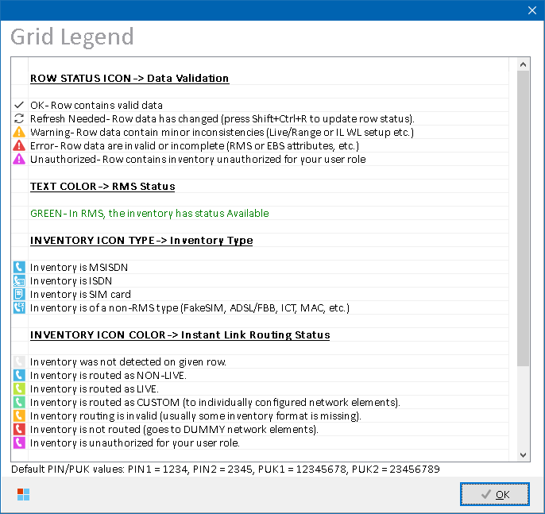

*Legend form*

### Docks

##### Info Dock

Info dock above the main grid displays information about available application update. When clicked, it will start application updater.



*Info Dock*

###### Role Differences

User with ADMIN role can dismiss the Info Dock without invoking the application update by clicking on it with right mouse button.

##### Lock Dock

Lock dock below the main grid displays alphabetically ordered names of modules that are currently locked by other users. Locked modules cannot be used until the originating user has unlocked them.



*Lock Dock - locked modules*

Click on any locked module name to show additional information about users and sessions that own the locks:

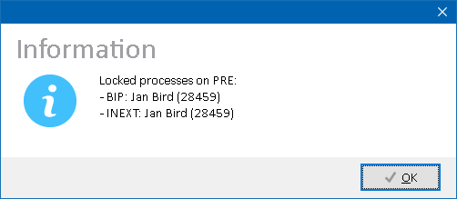

*Locked processes dialog*

Users with ADMIN role can also lock down the whole environment. Locked environment cannot be initialized.

**

*Lock Dock – locked environment*

See Multi-User Model for more details on lockable modules.

##### Warning Dock

Warning dock below the main grid displays current warning message that application administrator has configured for current test environment, such as long-term outage of some system, unavailability of some processes, etc.



*Warning Dock with sample message*

See Configuring Environment Warning Message for more details.

### Other Controls

##### Environment Combo Box

Click on the environment combo box to select a testing environment to work in. After an environment is selected, it will be initialized. Accompanying globe icon color displays environment initialization status. Environment can only be changed when main grid is empty to avoid mixing of inventory from different environments.

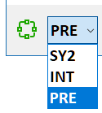

*Environment combo box*

**Globe Icon Color Legend:**

|  |  |
| --- | --- |
|  | Environment is successfully initialized. |
|  | Environment selection is not available or initialization status is unknown. |
|  | Environment is not initialized. Restrictions will apply. |

After environment is selected, a set of initialization routines is performed in order to retrieve support data from the environment (e.g., configuration parameter values, Kenan lookup values, etc.). Following Working form is displayed to the user during this process:

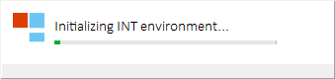

*Environment initialization in progress*

**NOTE:** If selected environment has not yet been initialized on the given day, then *Initializing…* text is replaced with *Waking up…* in theWorking form during the initialization toindicate that the process might take some more time.

See Environment Initialization for more details on the environment initialization process.

**HINT:** Use following keyboard shortcuts to quickly change among the environments:

|  |  |
| --- | --- |
| **Shortcut** | **Description** |
| **ALT+1** | Change environment to SY2 |
| **ALT+2** | Change environment to INT |
| **ALT+3** | Change environment to PRE |

**NOTE:** Environment cannot be changed if there are data present in main grid. Clear the grid first in order to change environment.

##### Attribute Combo Boxes

A set of attribute combo boxes is present above the main grid. These allow user with ADMIN role to bulk-update given RMS or EBS attribute in all selected rows of the main grid at once.   
  
Select target rows in the main grid, then choose a value from attribute combo box. The value will be applied to all selected rows.



*Attribute combo boxes*

###### Role Differences

|  |  |  |  |  |  |
| --- | --- | --- | --- | --- | --- |
| **Action / Role** | **ADMIN** | **LEAD** | **TESTING-VF** | **TESTING-IBM** | **TESTING-V2** |
| **Access to Attribute Combo Boxes** | Y | N | N | N | N |

See Bulk Attributes Update for more details.

##### Mini-Log & Event Log

Mini-log memo in the bottom-right corner of the main form display last 3 log messages so that the user can see progress of current operation without opening the Event Log form.

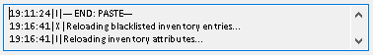

*Mini-log content*

Double-clicking on the mini-log memo will open the Event Log form. Main form position is shifted to the left top corner of the screen so that it remains fully visible together with the Event Log form.

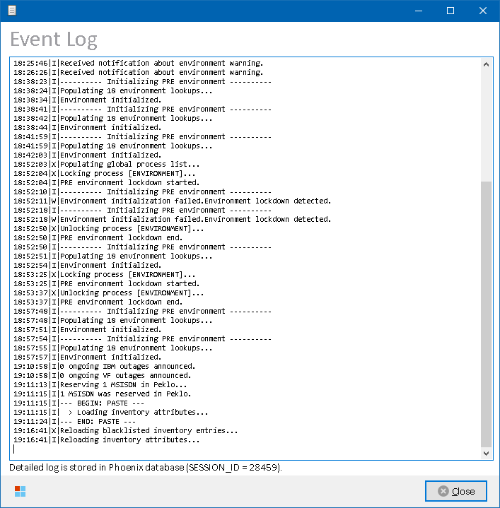

See Logging for more details about logging mechanism.

##### Status Icons (DB / SSH)

Conventionally placed on the right side of the mini-log memo, two additional icons also display current SQL or SSH activity:

SSH icon is displayed during ongoing or incoming SSH traffic.



*SSH activity icon*

SQL icon is displayed during ongoing SQL operation:



*SQL activity icon*

### Admin Controls

Some controls in the Main form are only visible to users with ADMIN role.

##### Announce Update Button

Press  **Announce Update** button to announce availability of the updated version to other users.

The button is only accessible if the application detects that its version is newer than the one currently configured.

See Release Deployment for more details.

##### Environment Lockdown Checkbox

Check the **Environment Lockdown** checkbox to lock the environment from being used. Locked environment cannot be initialized.



*Environment Lockdown check box*

##### Allow Invalid Items Checkbox

Check the **Allow Invalid Items** checkbox to allow operations on inventory items that were considered Invalid during validations.



*Allow Invalid Items check box*

If the checkbox is not checked, such inventory is skipped. This is to prevent users from uploading of invalid inventory items to target systems. Main grid rows containing invalid inventory items are flagged with red exclamation mark icon in the Row Status column.

###### Role Differences

|  |  |  |  |  |  |
| --- | --- | --- | --- | --- | --- |
| **Action / Role** | **ADMIN** | **LEAD** | **TESTING-VF** | **TESTING-IBM** | **TESTING-V2** |
| **Access to Announce Update button** | Y | N | N | N | N |
| **Access to Environment Lockdown checkbox** | Y | N | N | N | N |
| **Access to Allow Invalid Items checkbox** | Y | N | N | N | N |

## Status Forms

This chapter only describes common controls that can be found in all status forms across the application. Deviations from these are described in chapters dedicated to the respective status forms.

Status forms fetch data from databases and present them to user in format of data set loaded to a grid view:

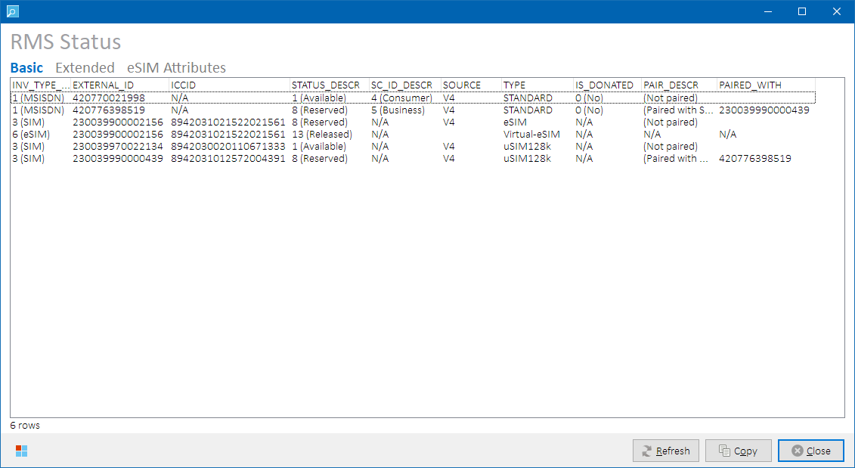

*Status form example (RMS Status form)*

Some status forms offer user to choose from multiple data sets, like in the example above:

* **Basic** (returns basic set of data)
* **Extended** (usually contains all columns from the Basic data set and also additional columns)
* ***Specific*** (name and data set content vary per status form)

Data set names can vary per status forms.

Following common button controls are present on status forms:

|  |  |
| --- | --- |
| **Button Caption** | **Description** |
| **Refresh** | Reloads the data set. |
| **Copy** | Copies the grid content to clipboard as a structured text table with **TAB**-separated values into clipboard. If no rows are selected, then the whole grid is copied. If some rows are selected, then only selected rows are copied.  **HINT:** Hold SHIFT while clicking on the **Copy** button (or press **SHIFT+CTRL+C**) to copy only the data rows without header and footer. |
| **Close** | Closes the status form. |

## Inventory Operations

### Inventory Import

Inventory import means populating Phoenix main grid with inventory items and retrieving their attributes from the respective systems. The process differs for users with ADMIN and other roles, where ADMIN users can define additional options during the import. The same Inventory Item Tokens and Row Parsing Rules are then used in both options.

##### Standard Import

Users with roles different from ADMIN can choose one of the following ways to import inventory into the main grid:

|  |  |
| --- | --- |
| **Import Source** | **Action** |
| **Clipboard** | Move mouse cursor over main grid, and press right mouse button or **CTRL+V** to proceed with input data present in system clipboard. |
| **File** | Press **CTRL+O** to proceed with a custom text file containing inventory identifiers. |

**NOTE:** Additional Import Options form is displayed to users with ADMIN role. See Additional Import Options for more details.

Input data are checked and – if inventory identifiers are detected – they are imported into the main grid. Text that is not identified as inventory identifier or attribute value is ignored. Missing inventory attributes are fetched from respective databases.

Row parsing rules:

Input rows are preserved, so if the user wish to have the identifiers present on the same row in the grid, they need to have them on the same row when copying them to clipboard. This is important when pasting paired triplets (i.e., MSISDN, IMSI and ICCID identifiers that belong together) – if each identifier was pasted on a separate row, it would result in duplicate rows as for each identifier, the other two would be fetched from the DB.

##### Additional Import Options

Import Options form is displayed to users with ADMIN role where following additional import options are available:

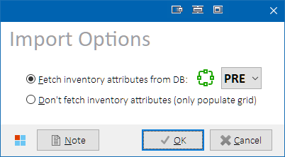

*Import Options form*

ADMIN user can choose whether to fetch inventory attributes from selected environment, or to populate main grid with detected inventory identifiers only.

###### Form-specific button controls

|  |  |
| --- | --- |
| **Button**  **Caption** | **Description** |
| **Note** | Appends clipboard content to embedded notepad memo with current timestamp, and opens Notepad form. Use when additional editing is required before importing inventory. |

##### Notepad

Press **CTRL+N** to open Notepad form. The form contains free-text memo that can be edited before importing inventory into the main grid.

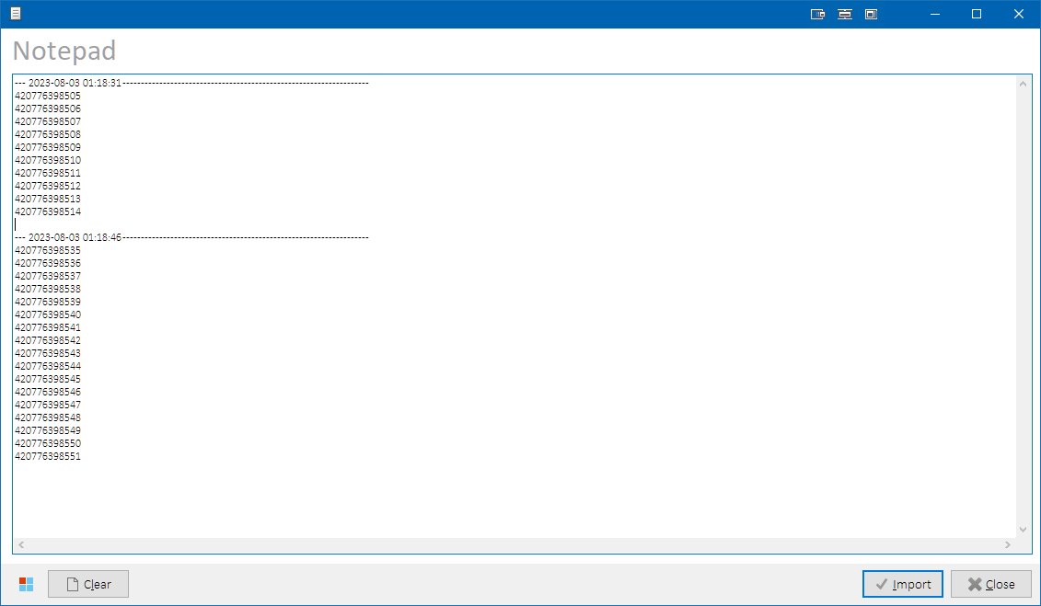

*Notepad form*

Edit memo content as needed, then press **Import** button to start inventory import.

###### Form-specific button controls

|  |  |
| --- | --- |
| **Button**  **Caption** | **Description** |
| **Clear** | Clears notepad memo content. |
| **Import** | Starts inventory import using notepad memo content. |

##### Inventory Item Tokens

Input data are parsed for so-called tokens that represent inventory item or inventory attribute. Some token types must contain specific prefix, and some are detected by their alphanumeric format even without a specific prefix. Tokens of higher entities, such as CA or BA identifiers are converted to the respective inventory items they encapsulate.

Following inventory item tokens are supported, and detected in the following order:

|  |  |  |
| --- | --- | --- |
| **Token Kind** | **Token Detection Rules** | **Populated Main Grid Column(s)** |
| **Convertible Tokens** (will be converted to one or multiple inventory items) | | |
| **BW Instance (prefixed)** | Value format: BW=([0-9]{39})  (numeric value, 39 digits long)  **NOTE:** The value is converted to a list ofMSISDN, IMSI and/or ICCID tokens found in message body of the particular BW instance in Tibco log. | n *  MSISDN|IMSI|ICCID |
| **Order Number (prefixed)** | Value format: ORDER=1-NNNNNNNNNN  (N = numeric character)  **NOTE:** The value is converted to a list of MSISDN tokens found in the particular Siebel order. | n * MSISDN |
| **Order Number** | Value format: 1-NNNNNNNNNN  (N = numeric character)  **NOTE:** The value is converted to a list of MSISDN tokens found in the particular Siebel order. | n * MSISDN |
| **Order ID (prefixed)** | Value format: ORDER=1-AAAAAA  (A = alphanumeric character)  **NOTE:** The value is converted to a list of MSISDN tokens found in the particular Siebel order. | n * MSISDN |
| **Order ID** | Value format: 1-AAAAAA  (A = alphanumeric character)  **NOTE:** The value is converted to a list of MSISDN tokens found in the particular Siebel order. | n * MSISDN |
| **CA (prefixed)** | Value format: CA=10NNNNNNNN (N = numeric character)  **NOTE:** The value is converted to a list of MSISDN tokens found on the particular CA in Kenan. | n * MSISDN |
| **CA** | Value format: 10NNNNNNNN (N = numeric character)  **NOTE:** The value is converted to a list of MSISDN tokens found on the particular CA in Kenan. | n * MSISDN |
| **BA (prefixed)** | Value format: BA=3NNNNNNN (N = numeric character)  **NOTE:** The value is converted to a list of MSISDN tokens found on the particular BA in Kenan. | n * MSISDN |
| **BA** | Value format: 3NNNNNNN (N = numeric character)  **NOTE:** The value is converted to a list of MSISDN tokens found on the particular BA in Kenan. | n * MSISDN |
| **Account No (prefixed)** | Value format: ACCOUNT_NO=([0-9]{1,9})\|[3-4]{1} (N = numeric character)  Value before pipe separator is Kenan account number.  Value after pipe separator is Kenan customer server ID.  **NOTE:** The value is converted to a list of MSISDN tokens found on the particular account in Kenan.  **SAMPLE VALUE:** ACCOUNT_NO=110740|4 | n * MSISDN |
| **Account No** | Value format: ([0-9]{1,9})\|[3-4]{1} Value before pipe separator is Kenan account number.  Value after pipe separator is Kenan customer server ID.  **NOTE:** The value is converted to a list of MSISDN tokens found on the particular BA in Kenan.  **SAMPLE VALUE:** 110740|4 | n * MSISDN |
| **Numeric Range** | Value format: ([0-9]){9,15}\:([0-9]){9,15}  Value before colon separator is range start number.  Value after colon separator is range end number.  Both values must have the same length.  Range start value must be lesser than range end value.  **NOTE:** The value is converted to a list of MSISDN or IMSI tokens contained in the range.  **SAMPLE VALUE:** 230039900002380:230039900002479 | n * MSISDN|IMSI |
|  |  |  |
| **Non-Convertible Tokens** (representing single inventory items) | | |
| **MSISDN (prefixed)** | Value format: MSISDN=<numeric_value> | MSISDN |
| **MSISDN** | Value format: 420NNNNNNNNN (N = numeric character) | MSISDN |
| **VTV** | Value format: 9NNNNNNN  (N = numeric character) | MSISDN |
| **FakeSIM** | Value format: 12NNNNNN  (N = numeric character) | MSISDN |
| **CaseID** | Value format: 11NNNNNN  (N = numeric character) | MSISDN |
| **Marketplace** | Value format: 11NNNNNN – TODO!!!  (N = numeric character) | MSISDN |
| **PBX** | Value format: NNNNNNN_NNNN  (N = numeric character) | MSISDN |
| **ADSL/FBB/ICT** | Value format: 9NNNNNN  (N = numeric character) **NOTE:** It’s the shortest supported numeric-only value for the MSISDN column, so it must be detected after all other numeric values that might represent a MSISDN (or similar external ID) to avoid incorrect substring detections. | MSISDN |
| **MAC** | Value format: HH:HH:HH:HH:HH:HH or HH-HH-HH-HH-HH (H = hexadecimal character = 0-9, A-F) | MSISDN |
| **IMSI (prefixed)** | Value format: IMSI=<numeric_value> | IMSI |
| **IMSI** | Value format: 23003NNNNNNNNNN  (value length 15, N = numeric character) | IMSI |
| **ICCID (prefixed)** | Value format: ICCID=<numeric_value> | ICCID |
| **ICCID** | Value format: 89420NNNNNNNNNNNNNN  (value length 19, N = numeric character) | ICCID |

Following prefixed inventory attribute tokens are supported (and detected in the following order):

|  |  |  |
| --- | --- | --- |
| **Inventory Attribute Token Type** | **Token Detection Rules** | **Target Inventory Grid Column(s)** |
| **Source** | Value format: SOURCE=<alphanumeric_value> | Source |
| **Sales Channel** | Value format: SALES_CHANNEL=<alphanumeric_value> | Sales Channel |
| **Service Type** | Value format: SERVICE_TYPE=<V|D|F> (V=VOICE / D=DATA / F=FAX) | Service Type |
| **SIM Type** | Value format: SIM_TYPE=<alphanumeric_value> | SIM Type |
| **EBS Organization** | Value format: EBS_ORG=<alphanumeric_value> | EBS Org |
| **EBS Product** | Value format: EBS_PRODUCT=<alphanumeric_value> | EBS Product |
| **Is Donated** | Value format: IS_DONATED=<0|1> (0 = not donated, 1 = donated) | Is Donated |

##### Row Parsing Rules

By default, input data are parsed by rows. Each row is then checked for a presence of the aforementioned inventory tokens. If multiple tokens of the same kind are extracted from the same row, the row is split at the starting position of the second same-of-the-kind token instance as there can be a maximum of 1 inventory token of each kind (MSISDN / SIM / IMSI) present on the same row in the input grid.

**Examples:**

###### 1. A row with paired triplet

**Input data:**

MSISDN: [420770081864] paired with SIM [IMSI: 230039970082409, ICCID: 8942030020111064090]

* one row is imported into the main grid:



But if the input data were provided on separate rows e.g., like this:

###### Different inventory kinds on separate rows

**Input data:**

420770081864

230039970082409

8942030020111064090

* three rows would be imported into the main grid:



###### Multiple inventory items of the same kind on the same row

**Input data:**

420770081865 420770081866 420770081867

* If multiple inventory identifiers of the same kind are detected, they are split to separate rows:



### Manual Inventory Insert/Edit

User with ADMIN role can insert specific values into main grid cells directly without having to paste them from clipboard:

* Press **INSERT** to insert a new grid row
* Navigate to MSISDN/IMSI/ICCID field and press **ENTER** to enter cell edit mode. Insert or update value in the cell, then press **ENTER** again to exit cell edit mode.

### Bulk Attributes Update

User with ADMIN role can use Attribute combo boxes above the main grid to bulk-update values in the respective columns. The combo boxes are only enabled on an initialized environment as they contain values from lookup tables that are populated during environment initialization. On different environment a different set of values may be available.



*Attribute combo boxes*

When a row is selected in the main grid, attribute combo boxes’ values are populated with values from the selected row. To update multiple rows, first select them in the main grid (using SHIFT or CONTROL while selecting), then use attribute combo boxes to set desired attribute values. Updated grid cells will have ivory background to indicate that a custom value is present.



**NOTE:** Some attribute value combinations are not allowed. Value selection in one of the combo boxes can cause content reload in other combo boxes. This is to avoid configuring of invalid inventory.

Following restrictions apply:

* For each Source, only allowed “matching” EBS Organization and EBS Products are offered

For example, if S101 Source is selected, then only S101-related EBS Organizations and Products are offered. Even after then, some combinations can still be considered as invalid during validation.

### Inventory Reservation

Inventory Reservation process reserves test inventory in Peklo application. Unlike from Peklo GUI, where the inventory items must be reserved one-by-one, Phoenix allows for a large number of inventory items to be mass-reserved during single operation.

Open Inventory Mass Reservation form in order to mass-reserve inventory of given type from Peklo and import it to Phoenix main grid:

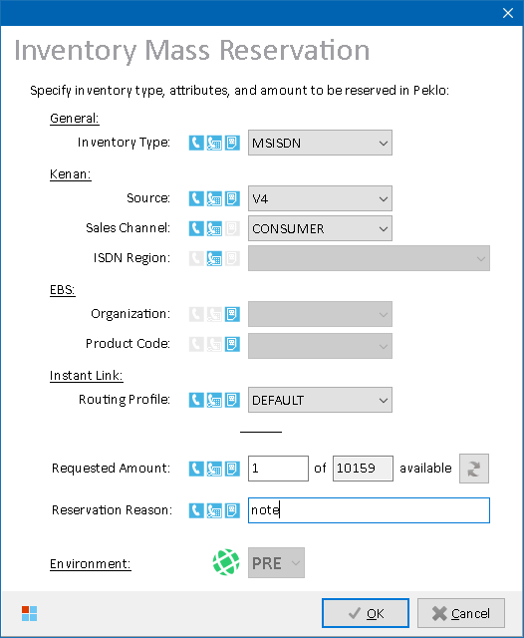

*Inventory Mass Reservation form*

Specify inventory type and its additional attributes. Following inventory types are supported:

1. MSISDN
2. ISDN
3. IMSI (SIM and eSIM are distinguished by EBS product)
4. HW (only certain EBS products)

Icons by the attributes depict which values must be selected for given inventory type. Then, amount of inventory meeting your conditions and currently available in Peklo is displayed.

Enter requested amount of inventory to reserve, fill in a reservation note and press **OK** to start mass-reservation process. After inventory items are retrieved from Peklo, they are imported into the main grid, from where they can be worked with further.

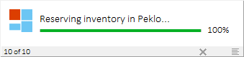

*Working form during Peklo mass-reservation*

**NOTES:**

* Prior reservation, available inventory amount must be retrieved from Peklo. If values of attributes that are necessary to retrieve the available amount are missing, ****N/A**** is displayed in available amount edit box and inventory reservation cannot be proceeded with.
* Some combinations of values are not allowed. EBS Organizations and Products combo box content is based either on the selected inventory type (for HW inventory) or selected Source value (for MSISDN/ISDN/SIM inventory).
* Select **DEFAULT** routing profile to reserve LIVE or NON-LIVE inventory. Inventory with final routing profile (either LIVE or NON-LIVE) will be provided according to Peklo configuration for the selected combination of inventory type and attributes. Custom routing profiles must be selected namely.
* Standard Peklo rules apply to the reserved inventory (e.g., if the inventory is not used by midnight of the day of the reservation, it will be returned back to the test inventory pool during Peklo midnight refresh, and can then be reserved by someone else later).

***Process overview:***

MSISDN/ISDN reservations:

1. Log into IBMTEST schema (Peklo)
2. For each requested MSISDN or ISDN:
   * Run stored procedure **PEKLO_API_PKG.GET_AVAILABLE_MSISDN_2** to retrieve amount of available inventory with selected attributes
   * Run stored procedure **PEKLO_API_PKG.ALLOCATE_MSISDN** to reserve the inventory.
3. Import retrieved data to main grid

SIM reservations:

1. Log into IBMTEST schema (Peklo)
2. For each requested SIM card:
   * Run stored procedure **PEKLO_API_PKG.GET_AVAILABLE_SIM_2** to retrieve amount of available inventory with selected attributes
   * Run stored procedure **PEKLO_API_PKG.ALLOCATE_SIM** to reserve the inventory.
3. Import retrieved data to main grid

HW reservations:

1. Log into **IBMTEST** schema (Peklo)
2. For each requested HW:
   * Run stored procedure **PEKLO_API_PKG.ALLOCATE_HARDWARE** to reserve the inventory.
3. Import retrieved data to main grid

### Inventory Mass Pairing

Mass-pairing process will couple the inventory items and set them status Reserved in RMS. It also generates a batch containing info about the mass-paired items to be further processed in Tibco/Siebel.

Main grid must contain enough inventory that is not coupled and in status Available in RMS. Rows can either contain both MSISDN and SIM inventory (*combined*), or just one of the two inventory kinds (*separate*). If there are separate MSISDN and SIM rows in the main grid, they will be merged together after user confirmation before the mass pairing starts.

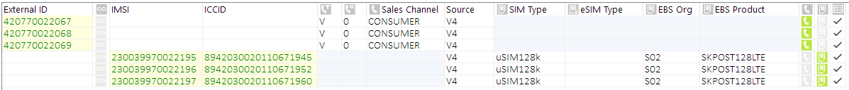

*Separate MSISDN and SIM rows before merge*

**

*Combined MSISDN and SIM rows after merge*

All inventory in the main grid must either be of non-MVNO or MVNO kind as these cannot be paired together. MSISDN and SIM inventory to be paired must also have the same Source in RMS.

After input data preparation in the main grid, press **Mass Pair** button to open Mass Pairing Properties form.

If preliminary inventory checks succeed, a Mass Pairing Properties form is displayed, where user can specify following additional attributes, otherwise an error message is displayed to the user, and mass pairing process is canceled.

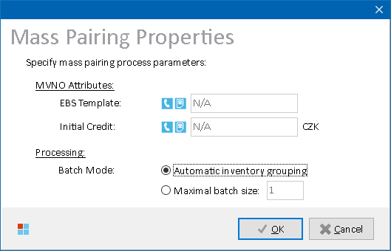

*Mass Pairing Properties form*

User can customize the way the output mass pairing tables **VF_CONFIG.VF_MASS_PAIRING** or **VF_CONFIG.VF_MASS_PAIRING_MVNO** are populated as follows:

|  |  |
| --- | --- |
| **Option** | **Description** |
| **EBS template** | Customtext value to be inserted into column **EBS_TEMPLATE** (applicable to MVNO pairing only) |
| **Initial Credit** | CustomNumber value to be inserted into column **INITIAL_CREDIT** (applicable to MVNO pairing only) |
| **Batch Mode** | Alters the way the mass pairing batches are handled. Each batch has its own **BLOCK_NAME** value:   * **Automatic:** Mass-paired inventory is split to batches automatically depending on gaps in sorted MSISDN and SIM external ID ranges. If there’s a gap found, a new batch is automatically created. * **Maximal batch size:** Batch size will be restricted to user-specified size even if there are no gaps in the MSISDN and SIM external ID ranges. |

After pressing **OK**, the actual mass pairing process begins. When finished, Mass Pairing Status form is opened to present process output to the user.

Mass Pairing Status table can also be accessed by main menu: **Kenan 🡪 Mass Pairing Status.**

See Mass Pairing Status for more details.

**NOTES:**

* eSIM resources cannot be mass-paired
* Mass pairing can be disabled in configuration for certain MVNO sources
* This only completes Kenan part of the whole mass pairing process (inventory preparation in RMS). Additional actions in Tibco or Siebel may be necessary.

##### Process Overview

1. Check invalid inventory items in the main grid
2. Check if count of MSISDN equals to count of SIM in the main grid
3. Show additional mass pairing options form
4. In case of MVNO pairing, check if given operator is disallowed from mass pairing (operator ID’s are configurable)
5. Download current mass pairing configuration file settings.properties from Kenan  
   (default location: $ARBORDATA/customscript/inventoryscript/masspairing/bin/, or $ARBORDATA/customscript/inventoryscript/masspairingMVNO/bin/ for MVNO mass pairing, where $ARBORDATA value is configurable)
6. Log current values of the following parameters in the downloaded mass paring configuration file:  
   - currentMSISDNType  
   - currentSIMType  
   - currentSource  
   - category
7. Reload current Kenan attributes of the inventory to mass pair (in case they changed after the grid was populated)
8. Check if inventory in the main grid is eligible to mass pairing i.e.,  
   - MSISDN type known  
   - SIM type is known  
   - Source is known  
   - Category is either 4 (CONSUMER) or 5 (BUSINESS)  
   - MSISDN status = 1 (Available)  
   - SIM status = 1 (Available)  
   and log warnings about inventory that cannot be mass paired.
9. Split the inventory to mass pair to groups that can be processed in a single mass pairing run. Inventory matching the following rules are assigned to the same group:  
   - same MSISDN type  
   - same SIM type  
   - same Source  
   - same Category  
   - MSISDN sequence is uninterrupted  
   - IMSI sequence is uninterrupted  
   - group size <= selected maximum batch size
10. For each row in the main grid:
    1. If group id differs from previously processed group id, update mass pairing configuration file with new values and upload it to Kenan server (skipped if current configuration file already contains values matching with those in the group to be processed)
    2. Execute Kenan script MassPairing.sh (or MassPairingMVNO.sh for MVNO mass pairing) for given MSISDN and SIM.
11. Show Mass Pairing status form

##### Role Differences

|  |  |  |  |  |  |
| --- | --- | --- | --- | --- | --- |
| **Action / Role** | **ADMIN** | **LEAD** | **TESTING-VF** | **TESTING-IBM** | **TESTING-V2** |
| **Access to Mass Pairing** | Y | Y | Y | Y | N |

### Inventory Cleansing

Have inventory items present in the main grid, then press **Cleansing** button.

If pre-cleansing validations succeed, a Cleansing Processing Options form is displayed, where user can set cleansing tasks to be executed and their further options, otherwise an error message is displayed to the user, and cleansing process is canceled.

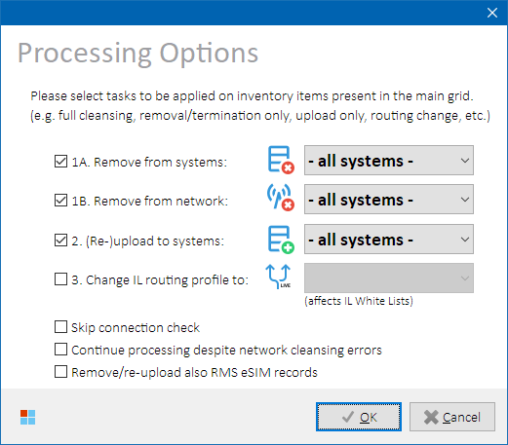

*Cleansing Processing Options form*

##### Cleansing Tasks Overview

Cleansing process consists of following tasks, that user can select to include in or exclude from the cleansing process by checking their appropriate check boxes:

|  |  |
| --- | --- |
| **Cleansing Task** | **Description** |
| **Connection Check** | Preparation task ensuring that critical cleansing components are functional and accessible.  **Can optionally be skipped.**  See Connection Check for more details. |
| **System Cleansing** | Task that cleanses inventory items in target systems by executing database commands or SOAP requests.  In the combo box, the user can select one of the following cleansing targets:   * All systems (full cleansing) * Selected systems (partial cleansing) * A single target system (partial cleansing)   See System Cleansing for more details. |
| **Network Cleansing** | Task that cleanses inventory items on network elements using Instant Link batch interface.  In the combo box, the user can select one of the following cleansing targets (network services):   * All systems (full cleansing) * Selected systems (partial cleansing) * A single target system (partial cleansing)   See Network Cleansing for more details. |
| **Inventory**  **Upload** | Task that re-uploads inventory items to originating systems (RMS, EBS)  In the combo box, the user can select one of the following cleansing targets:   * All systems (full upload) * Selected systems (partial upload) * A single target system (partial upload)   See Inventory Upload for more details. |
| **Finalization** | Task that performs post-cleansing operations.  **Automatically executed** if System Cleansing or Inventory Upload tasks were selected. |
| **InstantLink**  **Routing** | Task that updates inventory items’ routing profile in Instant Link white lists.  In the combo box, the user can select one of the following options:   * A specific routing profile (one of the ones that are configured in Instant Link) * Delete (routing profile will be removed from IL WL)   See [InstantLink Routing (White Lists)](#_InstantLink_Routing_(White) for more details. |
| **Grid Reload** | Inventory attributes in the main grid are refreshed to reflect the changes performed in previous cleansing tasks.  **Always executed.** |

##### Cleansing Options

Depending on their role, user can also choose one of the following additional options:

* **Skip connection check:** Connection check before cleansing process begins will be skipped. This might however lead to connection errors during System Cleansing task execution that could have been found out before the task was even started.
* **Continue processing despite network cleansing errors**: If selected, Upload and Routing tasks will be carried over even if there were errors during Network Cleansing task. This will ensure that the cleansed inventory is re-uploaded back to RMS and EBS. Network Cleansing can then be re-executed as a standalone task, if needed.
* **Remove/re-upload RMS eSIM records:** If selected, during RMS inventory records representing eSIM (i.e., of INVENTORY_TYPE_ID = 6) will be included in cleansing process and removed from RMS and/or re-uploaded to RMS as requested by the user.

**IMPORTANT:** This is only needed when a new eSIM range is to be inserted into RMS, or a defective old eSIM range must be removed from RMS. Because of this, the option is not allowed during regular cleansing when both System Cleansing and System Upload tasks are selected to avoid inconsistencies between RMS and SMDP in cases when SMDP cleansing was not successful but yet the eSIM record would be re-uploaded to RMS as Available.

If unchecked, eSIM records are still included in cleansing in a way where only their record status is aligned in RMS to reflect SMDP cleansing result, but the records themselves are not deleted and/or re-created.

**Improper usage will lead to data inconsistencies between RMS and SMDP!**

Press **OK** button to start the cleansing process.

##### Cleansing Progress

Depending on the inventory amount and selected cleansing tasks, the duration can vary from several minutes to several hours and cannot be exactly estimated. Execution and progress of individual cleansing tasks is displayed in Working form and in the mini-log memo. Press **LOG** button in the Working form to open Event log form with more details.

|  |  |
| --- | --- |
| **Cleansing Task** | **Description** |
| **System Cleansing** | * Inventory is being removed from impacted systems: |
| **Network Cleansing** | Phoenix is waiting for Instant Link to process submitted network requests. As this could be a very time-consuming task, a percentage and a progress bar are displayed:    See also Skip Waiting for Instant Link for an alternative. |
| **Upload** | * RMS – Inventory is being uploaded by Resource Loader module: * Depending on user role, SSH console form can also be displayed to watch the progress by clicking on the  **SSH** button. * EBS – Upload to EBS can take up to 5 minutes, depending on how the concurrent job responsible for the inventory processing is scheduled. For that reason, a timer is presented to the user while Phoenix is waiting for EBS to process the uploaded inventory: |
| **Routing** | * Routing profiles are being updated in Instant Link white lists: |
| **Grid Reload** | Inventory attributes are being reloaded in the main grid: |

After cleansing is finished, the user is instigated to refresh Peklo as well, so that cleaned inventory can immediately be offered to testers. If not done, Peklo will be refreshed at midnight and the inventory will be available to testers on the next day.

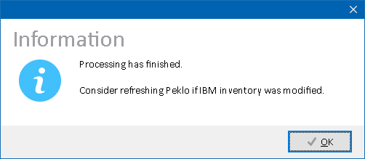

##### Process Overview

See Inventory Cleansing Model for more details on the cleansing process.

##### Role Differences

|  |  |  |  |  |  |
| --- | --- | --- | --- | --- | --- |
| **Action / Role** | **ADMIN** | **LEAD** | **TESTING-VF** | **TESTING-IBM** | **TESTING-V2** |
| **Access to Cleansing** | Y | Y | Y | N | Y |
| Enable / Disable Cleansing Tasks | Y | N | N | N | N |
| Change combo box values: cleansing / upload | Y | Always ALL SYS | Always ALL SYS | N | Always ALL SYS |
| Change combo box values: IL routing | Y | Always ALL SYS | Always ALL SYS | N | Always ALL SYS |
| Skip connection check | Y | Y | N | N | N |
| Continue despite network errors | Y | Y | Always ON | N | Always ON |
| Remove/re-upload eSIM RMS records | Y | N | N | N | N |
| Access to SSH Console form | Y | Y | N | Y | N |

##### Skip Waiting for Instant Link

Network Cleansing task can be time consuming especially when the batch contains tens of thousands of requests which is quite common e.g., during Inventory Recycling runs. While Network Cleansing task is running, user can optionally press **SKIP** button in the Working form to make Phoenix stop waiting for the Instant Link to finish processing of the Network Cleansing batch and proceed with other selected tasks (i.e., Upload and/or Routing). Network Cleansing will continue running in the background.

Users with ADMIN or LEAD role can check their Network Cleansing batch status individually later at any time. See Network Cleansing Batch Status for more details.

**IMPORTANT:** Even if other cleansing tasks are already finished,do not refresh Peklo until Network Cleansing task is finished as well. Otherwise, errors may occur during network provisioning if tester reserves an inventory in Peklo that has not yet been fully cleansed and they use it in a provisioning order.

##### Disabled Cleansing Tasks

If systems needed for cleansing process to finish properly are experiencing longer-than-expected difficulties or are unavailable, Phoenix admin can temporarily disable some or all impacted cleansing tasks. This is visualized in the Cleansing Processing Options form as follows:

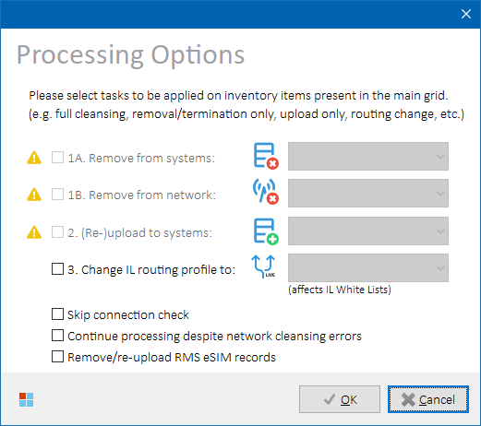

*Cleansing Processing Options form – disabled cleansing tasks*

In such situations, Phoenix admin usually also publishes an environment warning message with more details about the issue. See Warning Dock for more details.

## Kenan Operations

### RMS Status

Select **Kenan 🡪 RMS Status** in the main menu to open RMS Status form. Current RMS status of inventory items on selected rows in the main grid will be displayed. If no rows are selected in the main grid, then all rows are processed.

##### Output Data

Following data sets are available to display:

|  |  |
| --- | --- |
| **Data Set** | **Description** |
| **Basic** | Basic RMS details are displayed.  See Data Set “Basic” for more details. |
| **Extended** | Extended RMS details are displayed.  See Data Set “Extended” for more details. |
| **eSIM Attributes** | eSIM-specific extended attributes are displayed.  See Data Set “eSIM Attributes” for more details. |

**HINT:** When switching between **Basic** and **Extended** data sets, EXTERNAL_ID on selected rows are stored internally, and in the new data set rows with the same EXTERNAL_ID values are selected again.

Output columns vary per selected data set. Please refer to Kenan system documentation for more details on the column meanings and values.

##### Data Set “Basic”

Basic RMS details like status, source, type etc. and pairing data are displayed.

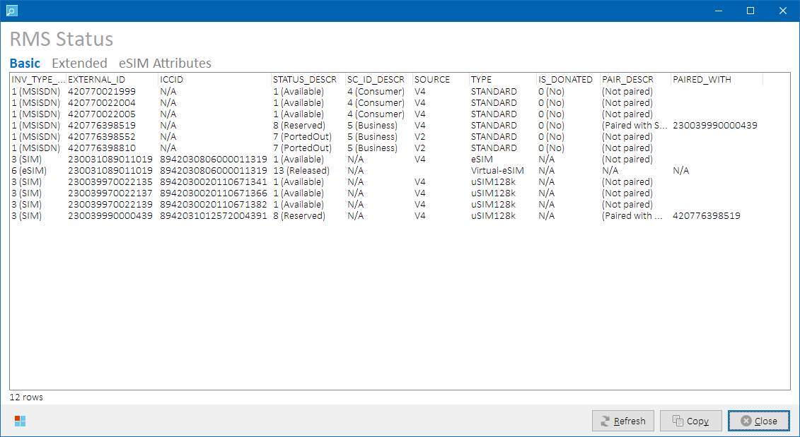

*RMS Status form – data set “****Basic****”*

Following output columns are returned:

|  |
| --- |
| **Column Name** |
| INV_TYPE_DESCR |
| EXTERNAL_ID |
| ICCID |
| STATUS_DESCR |
| SC_ID_DESCR |
| SOURCE |
| TYPE |
| IS_DONATED |
| PAIR_DESCR |
| PAIRED_WITH |

##### Data Set “Extended”

Extended RMS details are displayed, incl. inventory history states, dates, and container ID.

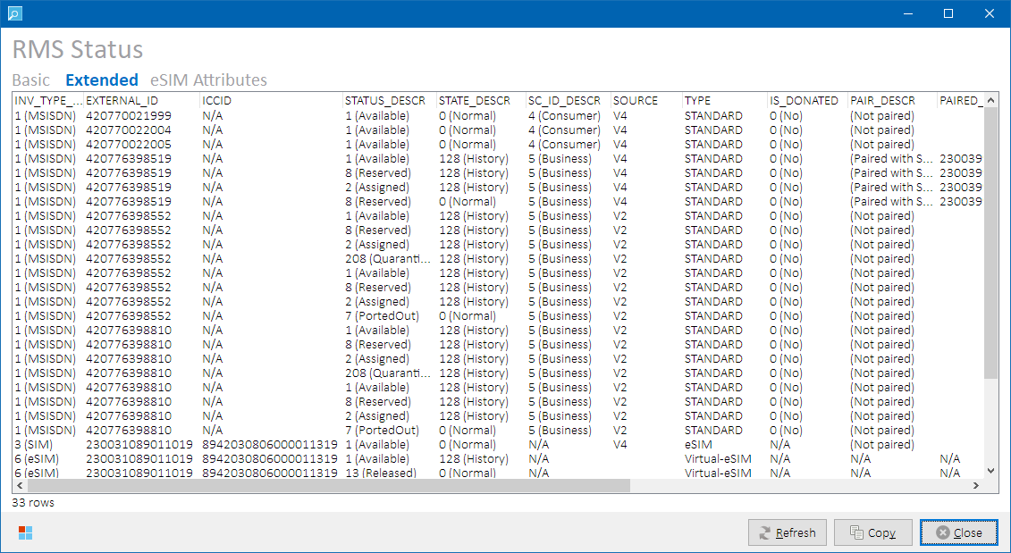

*RMS Status form – data set “****Extended****”*

Following output columns are returned:

|  |
| --- |
| **Column** |
| INV_TYPE_DESCR |
| EXTERNAL_ID |
| ICCID |
| STATUS_DESCR |
| STATE_DESCR |
| SC_ID_DESCR |
| SOURCE |
| TYPE |
| IS_DONATED |
| PAIR_DESCR |
| PAIRED_WITH |
| TOP_LEVEL_CONTAINER_ID |
| VIEW_START_DT |
| VIEW_END_DT |
| INVENTORY_ID |
| PAIR_INVENTORY_ID |

##### Data Set “eSIM Attributes”

eSIM-specific extended attributes are displayed.

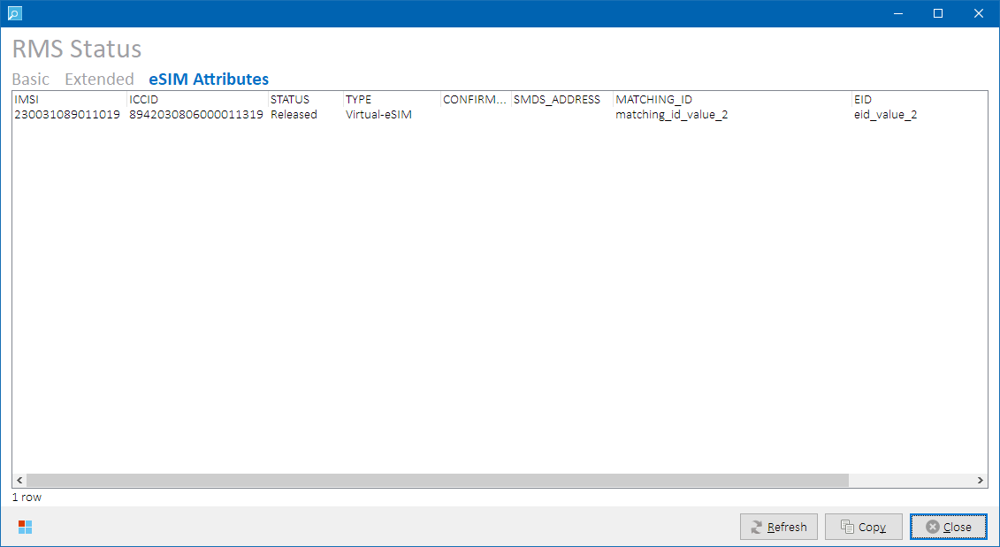

*RMS Status form – data set “****eSIM Attributes****”*

Following output columns are returned:

|  |
| --- |
| **Column / Data Set** |
| IMSI |
| ICCID |
| STATUS |
| TYPE |
| NOTIFICATION_DATE |
| CONFIRMATION_CODE |
| SMDS_ADDRESS |
| MATCHING_ID |
| EID |
| SMDPFQDN |

##### Data Set “OneNumber”

Inventory that belongs to the same OneNumber RMS container as inventory on selected row(s) in the main grid is displayed along with its OneNumber pair type (Primary/Secondary).

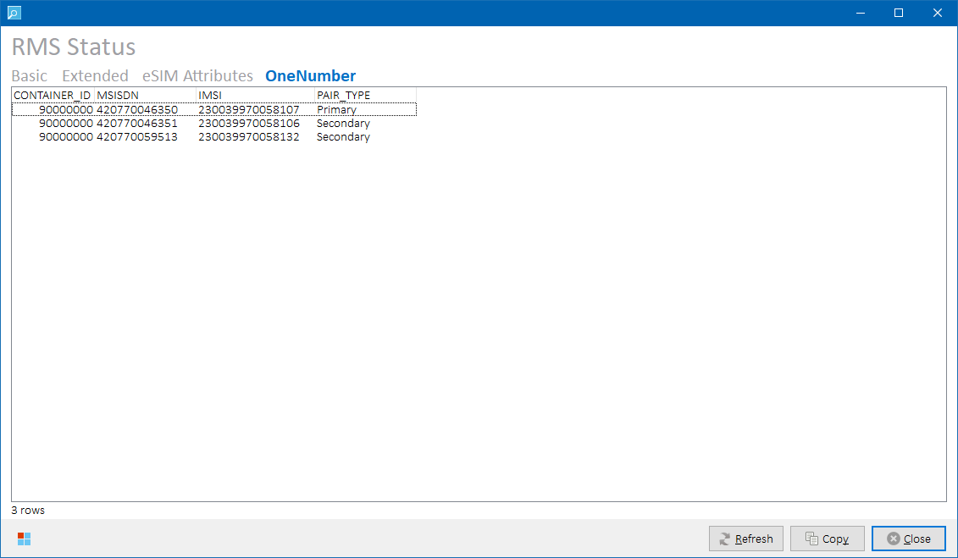

*RMS Status form – data set “****OneNumber****”*

Following output columns are returned:

|  |
| --- |
| **Column / Data Set** |
| CONTAINER_ID |
| MSISDN |
| IMSI |
| PAIR_TYPE |

##### Process Overview

Kenan core RMS tables are queried for status of the inventory present in the main grid.

Output columns vary per selected data set.

##### Role Differences

|  |  |  |  |  |  |
| --- | --- | --- | --- | --- | --- |
| **Action / Role** | **ADMIN** | **LEAD** | **TESTING-VF** | **TESTING-IBM** | **TESTING-V2** |
| **Access to RMS Status** | Y | Y | Y | Y | Y |

### Kenan RMS API Status

Select **Kenan 🡪 RMS API Status** from the main menu. Status of MSISDN inventory items on selected rows in the main grid will be displayed. If no rows are selected in the main grid, then all rows are processed.

##### Output Data

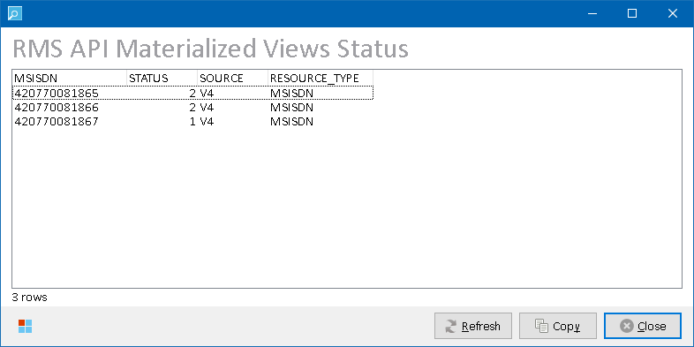

*RMS API Status form*

Following output columns are returned:

|  |  |
| --- | --- |
| **Column** | **Description** |
| MSISDN | External id of the subscription |
| STATUS | RMS status value |
| SOURCE | RMS source value |
| RESOURCE_TYPE | Contains MSISDN or ISDN value |

Please refer to Kenan and Location Dispatcher system documentation for more details on the column values.

**NOTE:** SIM inventory items are not applicable to this status view.

##### Process Overview

RMS API view **RMS_API.MV_RMS_RESOURCES** is queried for current status of the MSISDN inventory present in the main grid. This view is used by Location Dispatcher.

##### Role Differences

|  |  |  |  |  |  |
| --- | --- | --- | --- | --- | --- |
| **Action / Role** | **ADMIN** | **LEAD** | **TESTING-VF** | **TESTING-IBM** | **TESTING-V2** |
| **Access to RMS API Status** | Y | Y | N | Y | Y |

### Kenan Adapter Calls

Selected SOAP operations of Kenan Adapter are available from Phoenix to perform various operations on the inventory in the main grid.

##### Complex

Sequenced Kenan Adapter operations.

###### Reserve & Couple

In the main grid, select row(s) with populated MSISDN and SIM that exist in RMS and have Available status. Then select **Kenan 🡪 RMS Kenan 🡪 Reserve & Couple** to invoke following sequence of SOAP operations for each selected row:

1. InventoryModifyElementStatus
2. InventoryCouplingElements

Inventory will be reserved and then coupled in RMS. Main grid will be refreshed to reflect updated inventory status.

**NOTE:** Standard RMS status transition matrix restrictions apply.

##### Universal

Kenan Adapter operations applicable to MSISDN, SIM and ISDN inventory types.

###### InventoryModifyElementStatus

In the main grid, select row(s) with inventory that exist in RMS. Then select **Kenan 🡪 RMS Kenan 🡪 InventoryModifyElementStatus 🡪 (inventory type to work with).**

|  |  |
| --- | --- |
| **Menu Item** | **Description** |
| **All selected** | All inventory on selected rows will be processed. |
| **MSISDN only** | Only MSISDN inventory on selected rows will be processed. |
| **ISDN only** | Only ISDN inventory on selected rows will be processed. |
| **SIM only** | Only SIM inventory on selected rows will be processed. |

Then, select desired status in the Attribute Dialog form and press **OK.**

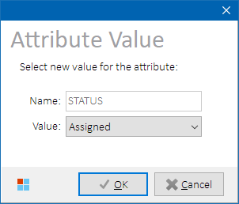

*Attribute Dialog form*

SOAP operation InventoryModifyElementStatus will be invoked and inventory status will be updated in RMS. Main grid will be refreshed to reflect updated inventory status.

**NOTE:** Standard RMS status transition matrix restrictions apply.

##### MSISDN/SIM

Kenan Adapter operations that require both MSISDN and SIM.

###### InventoryCouplingElements

In the main grid, select row(s) with inventory that exist in RMS. Then select **Kenan 🡪 RMS Kenan 🡪 (*MSISDN/SIM*) InventoryCouplingElements 🡪 (*OperationType:DisconnectionReason*).**

|  |  |
| --- | --- |
| **Menu Item** | **Description** |
| **Couple** | Inventory will be coupled in RMS.   * Operation Type = Coupling   RMS status will be set to Assigned. |
| **Decouple:Terminate** | Inventory will be decoupled in RMS as follows:   * Operation Type = Decoupling * Disconnection Reason = Termination   RMS status will be set to Aging. |
| **Decouple:PortOut** | Inventory will be decoupled in RMS as follows:   * Operation Type = Decoupling * Disconnection Reason = MNPPortOut   RMS status will be set to PortedOut. |
| **V2 Decouple:Service** | Inventory will be decoupled in RMS as follows:   * Operation Type = Decoupling * Disconnection Reason = SERVICE   RMS status will be set to QuarantineForRepatriationOut **NOTE:** To be used with V2 inventory only. |

SOAP operation InventoryCouplingElements will be invoked as described in the above table. Main grid will be refreshed to reflect updated inventory status.

**NOTE:** Standard RMS status transition matrix restrictions apply.

###### InventoryCouplingContainer

Use to assign two inventory pairs to a mutual OneNumber top level container in RMS. The container itself will also be created if it does not exist already.

In the main grid, select exactly two rows meeting following conditions in RMS:

1. Both rows contain paired MSISDN and SIM  
   **– and –**
2. Both rows are currently either not part of a OneNumber container ( )   
   **– or –**

Exactly one of the rows is currently primary pair in a OneNumber container ( )

Then select **Kenan 🡪 RMS Kenan 🡪 (*MSISDN/SIM*) InventoryCouplingContainer.** OneNumber Container Pairing form will be displayed:



*OneNumber Container Pairing form*

Verify that presented values are correct (swap the pairs if needed), and press **OK** button to continue**.**

SOAP operation InventoryCouplingContainer will be invoked with following Operation Reason values:

* Activation (if none of the two pairs is a primary OneNumber pair)
* Update (if one of the two pairs is already existing primary OneNumber pair)

Main grid will be refreshed to reflect updated inventory status.

Form-specific button controls

|  |  |
| --- | --- |
| **Button Caption** | **Description** |
| **Swap** | Swaps primary and secondary MSISDN and ICCID values.  **NOTE:** Only available if none of the two pairs is a primary OneNumber pair. |

###### Internal Migration

In the main grid, select row(s) with inventory that exist in RMS. Then select **Kenan 🡪 RMS Kenan 🡪 (*MSISDN/SIM*) Internal Migration 🡪 (*internal migration step*).**

|  |  |
| --- | --- |
| **Menu Item** | **Description** |
| **V2 🡪 V4 migration** | |
| **1. Decouple: MigrationToV4** | Inventory will be decoupled in RMS as follows.   * Operation Type = Decoupling * Disconnection Reason = MIGRATION TO V4   RMS status will be set to Reserved, and source to V4. |
| **2. Couple: MigrationToV4** | Inventory will be coupled in RMS as follows:   * Operation Type = Coupling * Disconnection Reason = MIGRATION TO V4   RMS status will be set to Assigned. |
| **V4 🡪 V2 migration** | |
| **1. Decouple: MigrationToV2** | Inventory will be decoupled in RMS as follows:   * Operation Type = Decoupling * Disconnection Reason = MIGRATION TO V2   RMS status will be set to Aging (MSISDN) / Quarantined (SIM), and source to V2. |
| **2. Couple: MigrationToV2** | Inventory will be coupled in RMS as follows:   * Operation Type = Coupling * Disconnection Reason = MIGRATION TO V2   RMS status will be set to Assigned. |

SOAP operation InventoryCouplingElements will be invoked as described in the above table. Main grid will be refreshed to reflect updated inventory status.

**NOTE:** Standard RMS status transition matrix restrictions apply.

##### ISDN

Kenan Adapter operations only applicable to ISDN’s.

###### InventoryElementUpdate

In the main grid, select row(s) with inventory that exist in RMS. Then select **Kenan 🡪 RMS Kenan 🡪 (*ISDN*) InventoryElementUpdate 🡪 (*OperationType:OperationReason*).**

|  |  |
| --- | --- |
| **Menu Item** | **Description** |
| **Activation: Activation** | ISDN inventory status will be changed in RMS as follows:   * Operation Type = Activation * Operation Reason = Activation   RMS status will be set to Assigned. |
| **Termination: Termination** | ISDN inventory status will be changed in RMS as follows:   * Operation Type = Termination * Operation Reason = Termination   RMS status will be set to Aging. |
| **Termination: PortOut** | ISDN inventory status will be changed in RMS as follows:   * Operation Type = Termination * Operation Reason = PortOut   RMS status will be set to PortedOut. |
| **Termination: Storno** | ISDN inventory status will be changed in RMS as follows:   * Operation Type = Termination * Operation Reason = Storno   RMS status will be set to Available. |
| **Termination: Cancellation** | ISDN inventory status will be changed in RMS as follows:   * Operation Type = Termination * Operation Reason = Cancellation   RMS status will be set to Prereserved. |
| **Termination: Relocation** | ISDN inventory status will be changed in RMS as follows:   * Operation Type = Termination * Operation Reason = Relocation   RMS status will be set to Parked. |

SOAP operation InventoryElementUpdate will be invoked as described in the above table. Main grid will be refreshed to reflect updated inventory status.

**NOTE:** Standard RMS status transition matrix restrictions apply.

###### Internal Migration

In the main grid, select row(s) with inventory that exist in RMS. Then select **Kenan 🡪 RMS Kenan 🡪 (*ISDN*) Internal Migration 🡪 (*internal migration step*).**

|  |  |
| --- | --- |
| **Menu Item** | **Description** |
| **V2 🡪 V4 migration** | |
| **1. Termination: MigrationToV4** | ISDN inventory status will be changed in RMS as follows:   * Operation Type = Termination * Operation Reason = MIGRATION_TO_V4   RMS status will be set to Reserved, and source to V4. |
| **2. Activation: MigrationToV4** | ISDN inventory status will be changed in RMS as follows:   * Operation Type = Activation * Operation Reason = MIGRATION_TO_V4   RMS status will be set to Assigned. |
| **V4 🡪 V2 migration** | |
| **1. Termination: MigrationToV2** | ISDN inventory status will be changed in RMS as follows:   * Operation Type = Termination * Operation Reason = MIGRATION_TO_V2   RMS status will be set to Aging (MSISDN) / Quarantined (SIM), and source to V2. |
| **2. Activation: MigrationToV2** | ISDN inventory status will be changed in RMS as follows:   * Operation Type = Activation * Operation Reason = MIGRATION_TO_V2   RMS status will be set to Assigned. |

SOAP operation InventoryElementUpdate will be invoked as described in the above table. Main grid will be refreshed to reflect updated inventory status.

**NOTE:** Standard RMS status transition matrix restrictions apply.

### Mass Pairing Status

Select **Kenan 🡪 Mass Pairing Status** in the main menu to open Mass Pairing Status form. Mass pairing status of inventory items on selected rows in the main grid will be displayed. If no rows are selected in the main grid, then all rows are processed.

**NOTE:** The same form is also displayed after Mass Pairing process is finished.   
See Inventory Mass Pairing for details on the Mass Pairing process.

##### Output Data

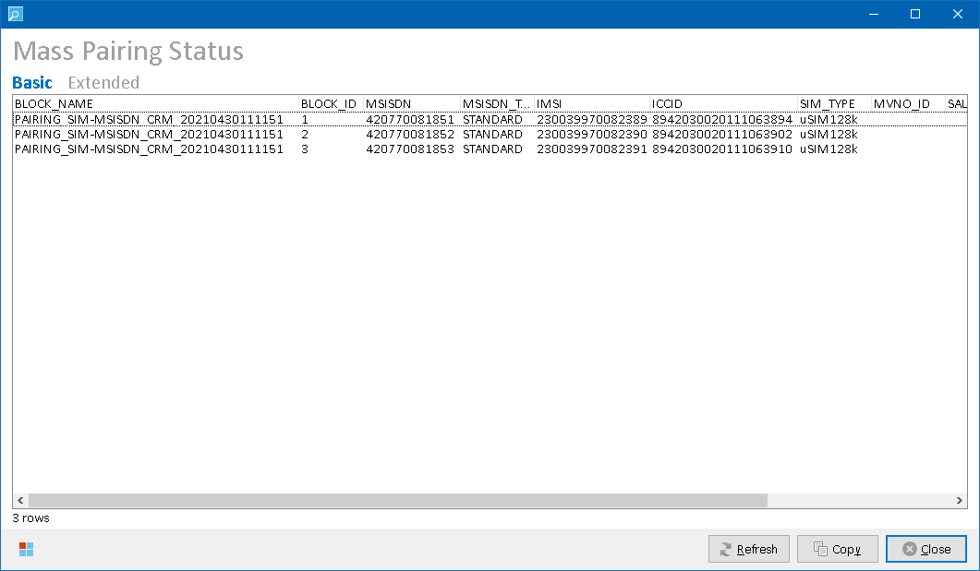

*Mass Pairing Status form –* ***Basic*** *data set*

Following data sets are available to display:

|  |  |
| --- | --- |
| **Data Set** | **Description** |
| **Basic** | Basic information about mass pairing status |
| **Extended** | Extended information about mass pairing status (columns from **Basic** data set are also present). |

Output columns vary per selected data set. Please refer to Kenan system documentation for more details on the column values.

Following output columns are returned:

|  |  |  |
| --- | --- | --- |
| **Column / Data Set** | **Basic** | **Extended** |
| BLOCK_NAME | Y | Y |
| BLOCK_ID | Y | Y |
| MSISDN | Y | Y |
| MSISDN_TYPE | Y | Y |
| IMSI | Y | Y |
| ICCID | Y | Y |
| SIM_TYPE | Y | Y |
| MVNO_ID | Y | Y |
| SALES_CHANNEL | Y | Y |
| EBS_TEMPLATE | Y | Y |
| CA | **N** | Y |
| BA | **N** | Y |
| CRM_STATUS | **N** | Y |
| NETWORK_STATUS | **N** | Y |
| TIBCO_STATUS | **N** | Y |
| EXTRACTED | **N** | Y |
| INITIAL_CREDIT | **N** | Y |
| DATE_INS | **N** | Y |

##### Process Overview

Kenan tables VF_CONFIG.VF_MASS_PAIRING and VF_CONFIG.VF_MASS_PAIRING_MVNO are queried for mass pairing status of the inventory present in the main grid.

##### Role Differences

|  |  |  |  |  |  |
| --- | --- | --- | --- | --- | --- |
| **Action / Role** | **ADMIN** | **LEAD** | **TESTING-VF** | **TESTING-IBM** | **TESTING-V2** |
| **Access to Mass Pairing Status** | Y | Y | Y | Y | N |

### Kenan Payments & Refills

Select **Kenan 🡪 Payments & Refills** in the main menu to open Kenan Payments Status form. Payments related to BA of first selected row in the main grid (if opened from Main menu), or BA currently open in Collections form (if opened from Collections form) will be displayed.

In case of undetermined BA, an empty form is displayed. Then, user needs to enter custom entity identifier into the Filter edit box in the upper-right corner of the form and press **Enter** to load the data set. Following identifiers are supported:

|  |  |
| --- | --- |
| **Identifier** | **Description** |
| Billing Account External ID (BA) | Billing account (BA) external ID. |
| MSISDN | MSISDN of the subscriber |

##### Output Data

Following data sets are available to display:

|  |  |
| --- | --- |
| **Data Set** | **Description** |
| **Payments** | Displays payments present in Kenan DB, related to provided identifier.  See Data Set “Payments” for more details. |
| **Refills** | Displays refills present in Kenan DB, related to provided identifier.  See Data set “Refills” for more details.  **Row Color Legend:**   |  |  | | --- | --- | | GREEN | Refill status is 2 (COMPLETED). | | RED | Refill status is 4 (API_ERROR) or 5 (MISSING_ROUTE_INFO) | | BLACK | Other order states. | |

Output columns vary per selected data set.

##### Data Set “Payments”

Displays payments present in Kenan DB, related to provided identifier.

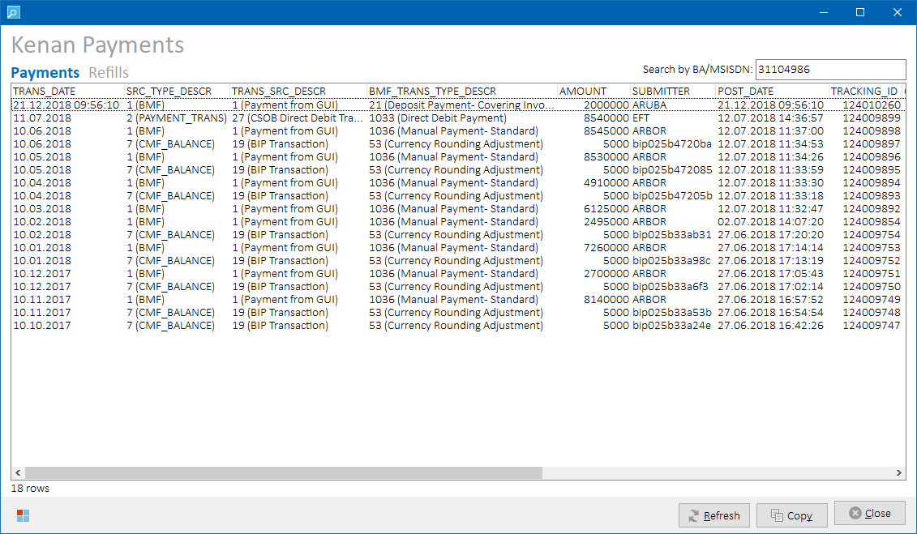*Kenan Payments Status form – data set “****Products****”*

Data set is sorted by TRANS_DATE DESC.

Following output columns are returned:

|  |
| --- |
| **Column** |
| TRANS_DATE |
| SRC_TYPE_DESCR |
| TRANS_TYPE_DESCR |
| BMF_TRANS_TYPE_DESCR |
| AMOUNT |
| SUBMITTER |
| POST_DATE |
| TRACKING_ID |
| ORIG_TR_ID |
| DISTRIB_AMT |
| NO_BILL |
| ACTION_CODE |
| PAY_METHOD |
| PP_STATUS |
| PP_CLEARING_HOUSE_ID |

Please refer to Kenan system documentation for more details on the column values.

###### Process Overview

Following Kenan tables are queried for payment status:

BMF

BMF_TRANS_DESCR

DESCRIPTIONS

TRANS_SOURCE_VALUES

PAYMENT_PROFILE

##### Data set “Refills”

Displays refills processed by Kenan Refiller module, related to provided identifier.

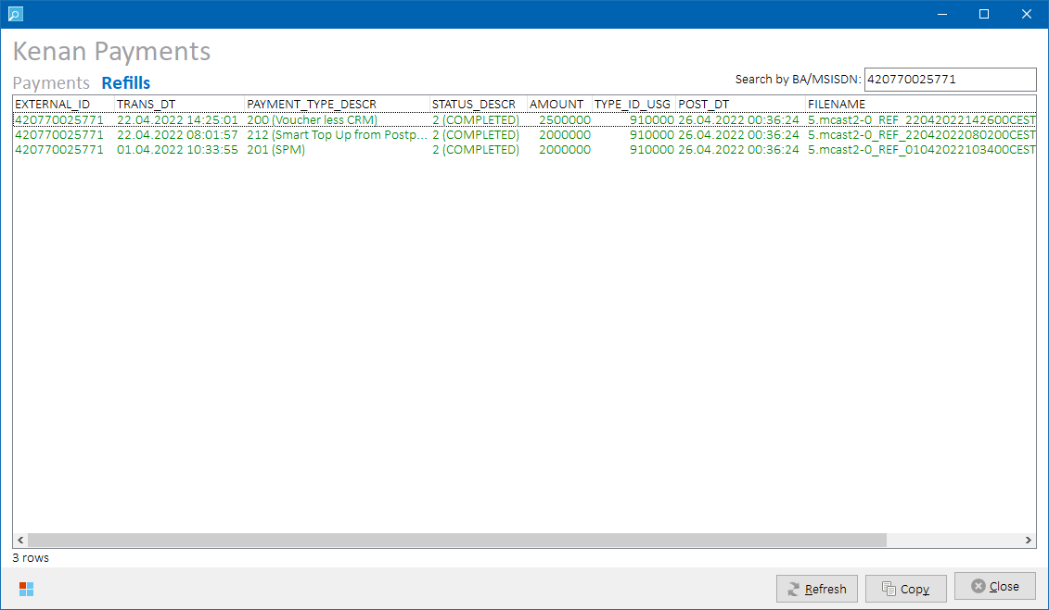

*Kenan Payments Status form – data set “****Refills****”*

Data set is sorted by EXTERNAL_ID, TRANS_DT DESC.

Following output columns are returned:

|  |
| --- |
| **Column** |
| EXTERNAL_ID |
| TRANS_DT |
| PAYMENT_TYPE_DESCR |
| STATUS_DESCR |
| AMOUNT |
| TYPE_ID_USG |
| POST_DT |
| FILENAME |

Please refer to Kenan system documentation for more details on the column values.

###### Process Overview

Following Kenan tables are queried for refill status:

REFILLER_DATA

REFILLER_STATUS

BMF_TRANS_DESCR

DESCRIPTIONS

##### Role Differences

|  |  |  |  |  |  |
| --- | --- | --- | --- | --- | --- |
| **Action / Role** | **ADMIN** | **LEAD** | **TESTING-VF** | **TESTING-IBM** | **TESTING-V2** |
| **Access to Payments & Refills Status** | Y | Y | N | Y | N |

### eSIM Notifications

In the main grid, select rows containing eSIM, then select **Kenan 🡪 eSIM Notifications** in the main menu to open eSIM Notification Status form. Details of notifications received in Kenan via Tibco from SMDP+ platform will be displayed.

##### Output Data

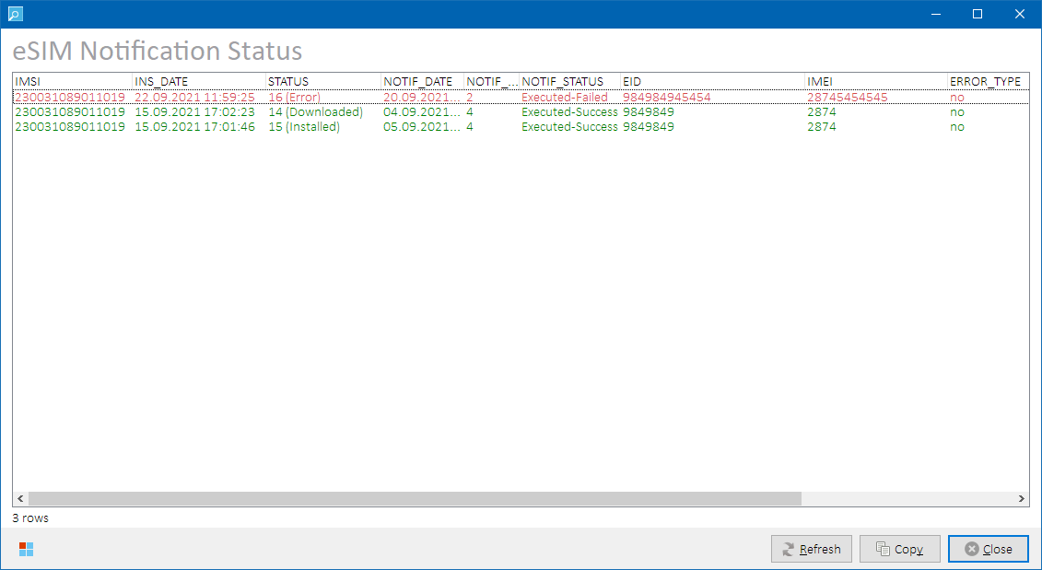

*Kenan eSIM Notification Status form*

**Row Color Legend:**

|  |  |
| --- | --- |
| GREEN | Notification with SUCCESS status. |
| RED | Notifications with FAILED status. |

**NOTE:** Given main grid row contains eSIM if its *eSIM Type* column is populated. See Main Grid for more details.

Following output columns are returned:

|  |  |
| --- | --- |
| **Column** | **Description** |
| IMSI | IMSI identifier |
| INS_DATE | Date the notification was inserted to Kenan |
| STATUS | Notification status ID and description |
| NOTIF_DATE | Notification date from SMDP+ |
| NOTIF_POINT | Notification point from SMDP+ |
| NOTIF_STATUS | Notification status |
| EID | EID identifier |
| IMEI | IMEI identifier |
| ERROR_TYPE | Error type from SMDP+ |
| ERROR_DESCRIPTION | Error description from SMDP+ |

Please refer to Kenan system documentation for more details on the output column meanings and values.

###### Process Overview

Following Kenan tables are queried for notification details for given IMSI:

INVD_MAIN

INVS_STATUS_VALUES

VF_CONFIG.VF_INVENTORY_NOTIFICATION

##### Role Differences

|  |  |  |  |  |  |
| --- | --- | --- | --- | --- | --- |
| **Action / Role** | **ADMIN** | **LEAD** | **TESTING-VF** | **TESTING-IBM** | **TESTING-V2** |
| **Access to eSIM Notifications Status** | Y | Y | N | Y | N |

### Fetch missing OneNumber pairs

In the main grid, select one or more rows containing a OneNumber pair (i.e., there’s  icon for primary OneNumber pair, or  icon for secondary OneNumber pair displayed in the grid).

Then, select **Kenan 🡪 Fetch missing OneNumber pairs** in the main menu to import additional OneNumber pairs under the same OneNumber container that are not already present in the grid.

If primary OneNumber pair was selected, all its secondary pairs will be imported.

If secondary OneNumber pair was selected, its primary pair will be imported.

If any pair is already present in the grid, it will not be imported again.

**NOTE:** In the grid, all missing pairs are inserted below already existing data.

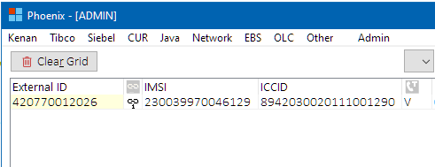

*Main grid content with single primary OneNumber pair present.*

🡪

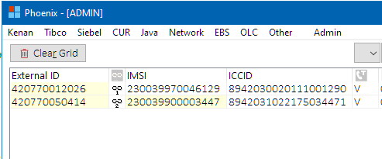

*Main grid content after previously missing secondary OneNumber pair was fetched.*

If all OneNumber pairs are already present in the grid, a corresponding dialog will be displayed:

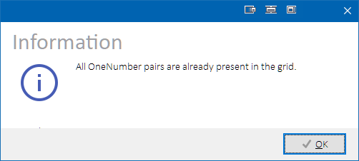

###### Process Overview

1. Iterate through selected rows in the main grid.
2. If grid row contains primary or secondary OneNumber pair, fetch missing OneNumber pairs and store them.
3. Populate all previously stored missing OneNumber pairs in the main grid.

Following Kenan tables are queried for OneNumber relationships:

INVD_MAIN

INVD_RELATIONSHIP_INV

INVD_RELATIONSHIP_CONT

INVD_CONTAINERS_EXT_DATA

##### Role Differences

|  |  |  |  |  |  |
| --- | --- | --- | --- | --- | --- |
| **Action / Role** | **ADMIN** | **LEAD** | **TESTING-VF** | **TESTING-IBM** | **TESTING-V2** |
| **Access to Fetch missing OneNumber pairs** | Y | Y | Y | Y | N |

### Kenan Audit

Select **Kenan 🡪 Audit** from the main menu to search in Kenan audit tables. Kenan audit tables contain data about requests coming to Kenan from Kenan Adapter and their processing status. If rows with MSIDN, IMSI or ICCID values are selected in the main grid while Kenan Audit form is opening, the values will be prefilled as filter items in the *Filter* search box.

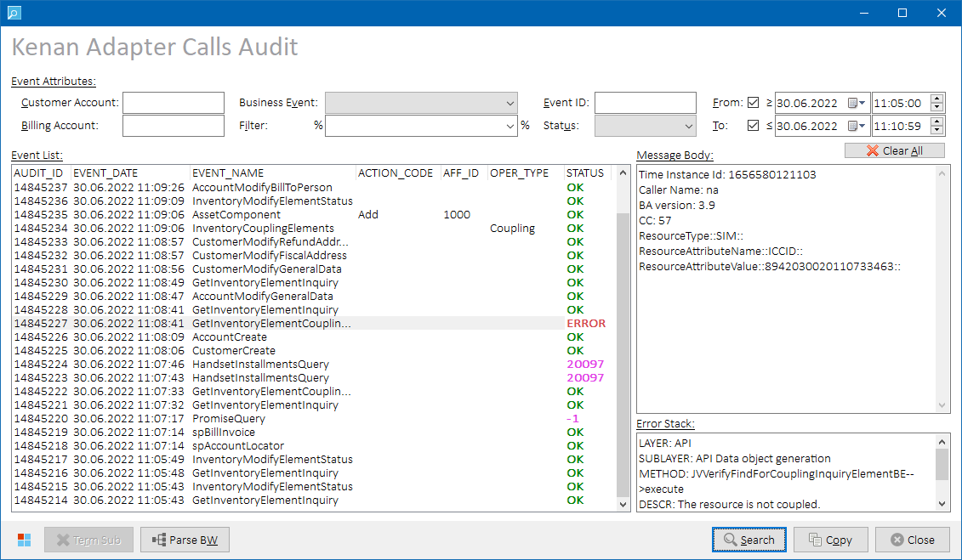 *Kenan Audit form*

##### Controls

###### Search Filter Fields



User can apply additional search conditions using following filter edit boxes on top of the form:

|  |  |
| --- | --- |
| **Filter Edit Box** | **Description** |
| **Customer Account** | Show only events related to given Customer Account |
| **Billing Account** | Show only events related to given Billing Account |
| **Business Event** | Show only events of given type (only known Business Event types are offered) |
| **Filter** | Show only events containing given string in their body.  If one or more rows were selected in the main grid before invoking Kenan Audit form, following values from the selected rows are pre-filled in the combo box drop down menu:   * **MSISDN** * **IMSI** * **ICCID** |
| **Event ID** | Show only event with given ID |
| **Status** | Show only event with given status:   * **(empty)** – do not filter by status * **OK** – show only successfully processed event * **ERROR** – show only erroneous events |
| **From Time** | Show only events that came to Kenan between specified dates and times. If checked, respective from/to datetime condition is included in the search.  **NOTES:**   * Default From Time value is today 00:00:00. * Default To Time value is today 23:59:59. |
| **To Time** |

All search values are case-sensitive.

Search-filter-fields-related controls:

|  |  |
| --- | --- |
| **Caption** | **Description** |
| **Clear All** | Clears all search filter fields. |

###### Additional Buttons

|  |  |
| --- | --- |
| **Caption** | **Description** |
| **Search** | Retrieves a list of events matching with provided search conditions and populate them to the *Event List* grid on the left side of the form. Events are sorted by their AUDIT_ID (i.e., also by date) in descending order |
| **Copy** | Copies the *Event List* grid content to clipboard as a structured text table with **TAB**-separated values into clipboard. If no rows are selected, then the whole grid is copied. If some rows are selected, then only selected rows are copied.   **HINT:** Hold **ALT** while clicking on the **Copy** button (or press **ALT+CTRL+C**) to include also additional event data from *Message Body* and *Error Stack* memos. While the **ALT** key is pressed down, **Copy** button caption changes to **“Copy+”** to indicate that extended set of data is going to be copied to clipboard. |
| **Term Sub** | Allows user to terminate Subscriber in Kenan. Only allowed if a subscriber-adding business event is selected.  See Terminating Subscriber in Kenan for more details. |
| **Parse BW** | Allows user to find Kenan business event by Tibco BW instance ID, so that the concrete Kenan business event can be easily searched for.  See Parsing Tibco BW Instance ID for more details. |

###### Additional Keyboard Shortcuts

|  |  |
| --- | --- |
| **Key** | **Description** |
| **Numpad +** | If single row is selected in the *Event List* grid, value of selected cell will be copied to search filter field assigned to selected column. |
| **Numpad -** | If single row is selected in the *Event List* grid, and there’s a search filter field assigned to selected column, respective search filter field will be cleared. |
| **Numpad \*** | If single row is selected in the *Event List* grid, all search filter fields will be cleared and value of selected cell will be copied to search filter field assigned to selected column. |
| **Numpad /** | All search filter fields will be cleared. |

##### Output Data

Following event attributes are present in the *Event List* grid:

|  |  |
| --- | --- |
| **Column Name** | **Description** |
| AUDIT_ID | ID of the event |
| EVENT_DATE | Datetime of the event |
| EVENT_NAME | Type of the event |
| ACTION_CODE | Action code in the event (if present) – e.g., **Add, Delete, Update** etc. |
| AFF_ID | Numeric AFF identifier in the event (if present)  **HINT:** Hover mouse cursor over the number to show hint with AFF description: |
| OPER_TYPE | Operation type in the event (if present) – e.g., **Coupling**, **Decoupling** etc. |
| STATUS | Processing status of the event. |

*Message Body* memo on the right side of the form will contain full body of the first message from the list. Click on an event in the *Event List* grid to load its body in the *Message Body* memo.

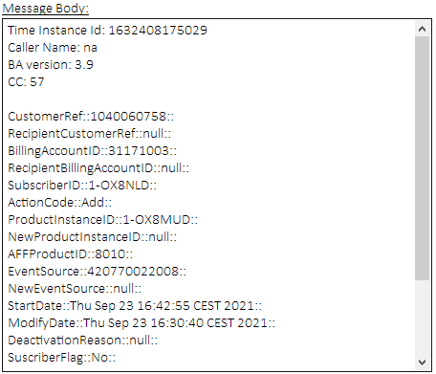

*Message Body memo example*

If an event with **ERROR** status is selected in the *Event List* grid, additional *Error Stack* memo is shown below the *Message Body*.

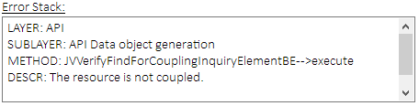

*Error Stack memo example*

##### Process Overview

Kenan audit tables **VF_CONFIG.VF_AUDIT** and **VF_CONFIG.VF_ERROR_LOG** are queried for business events matching user-defined filter criteria.

##### Role Differences

|  |  |  |  |  |  |
| --- | --- | --- | --- | --- | --- |
| **Action / Role** | **ADMIN** | **LEAD** | **TESTING-VF** | **TESTING-IBM** | **TESTING-V2** |
| **Access to Kenan Audit** | Y | Y | N | Y | N |

##### Terminating Subscriber in Kenan

In the *Event List* grid, select a successfully processed event that resulted in adding of a new subscriber to Kenan, i.e., having:

* EVENT_NAME = AssetComponent
* ACTION_CODE = Add
* AFF_ID = (referring to a subscriber type)

and press **Term Sub** button.  
  
Additional subscriber properties will be loaded from database, and then Subscriber Termination Properties form will be displayed:

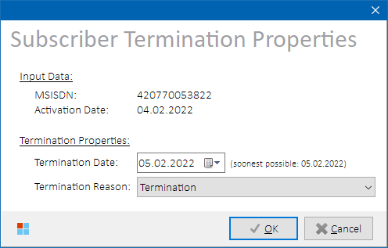

*Subscriber Termination Form*

Termination date picker is pre-filled with the soonest possible subscriber termination date (see notes below).

Termination reason combo box is pre-filled with the most common termination reason “Termination”.

Select termination date and termination reason values, then press **OK** to Continue.

Kenan Adapter **AssetComponent:Delete** business event will be triggered as follows:

* EndDate = <selected termination date>
* DeactivationReason = <selected termination reason>

Remaining mandatory attribute values are copied from the originally selected **AssetComponent:Add** event.

**NOTES**

* It is not possible to enter termination date that is:

1. lower or equal to account activation date
2. lower or equal to account last cutoff date (for billed accounts)
3. lower or equal to subscriber activation date
4. lower or equal to TRANS_DATE of subscriber CDR records

* The subscriber is effectively terminated by midnight, so it’s no longer active in Kenan at the selected termination date. For example, a termination date 1.1.2022 means the subscriber will stop being active in Kenan at 31.12.2021 23:59:59.

If the subscriber is already terminated, a similar dialog will be presented to the user:

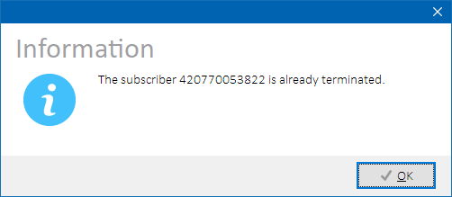

*Subscriber already terminated dialog*

##### Parsing Tibco BW Instance ID

Sometimes, only Tibco BW instance ID without additional values like BA or timestamp is available. For such cases, Phoenix offers “translation” of the BW instance ID to corresponding Kenan Audit BE event.

Press **Parse BW** button to open Tibco BW Instance Lookup form.

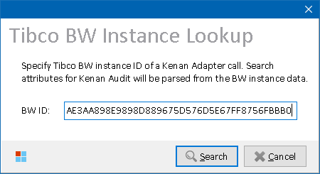

*Tibco BW Instance Lookup form*

Enter a Tibco BW instance ID and press **Search** button to analyze it. If found instance matches the criteria below, its data is parsed to the Kenan Audit filter edit boxes and corresponding Kenan business event will be searched for.

###### Process Overview

BW instance data is retrieved from Tibco log table TIBCO_LOG_BW. If the instance is found and meets the following criteria:

* (target = 'Kenan' AND engine_name = 'connectors_Kenan')  
  or
* target = 'KenanAdapter'

its data is parsed to the following Kenan Audit filter edit boxes as depicted in the below mapping table:

|  |  |
| --- | --- |
| **Filter Edit Box** | **Description** |
| **Customer Account** | **customerReference** element value |
| **Billing Account** | **billingAccountIdentifier** element value |
| **Business Event** | **EVENT** value of the instance log record |
| **Contains** | * **actionCode** or **affProductIdentifier**/**AFFProductID** element value * or MSISDN/IMSI/ICCID representing numeric token found in **XMLBODY**   *(whichever value is found first)* |
| **Event Date** | **TIMESTAMP** value of the instance log record |
| **Event Time** |

### Kenan A2S Actions / Collection Events Status

A2S actions are Kenan actions related to collection processing in Kenan. Each collection event in Kenan has associated one or several A2S actions that are processed by external systems (Tibco, ACI AFTER, INEXT/DUNNINGLETTER, etc.).

In the main grid, select a row with known BA that is in collections, then select **Kenan 🡪 A2S Actions** in the main menu to open A2S Actions Status form. Or, enter ID of a BA in collections directly into the top-right edit box of the A2S Actions Status form and press **Enter**. Collection events with their associated A2S actions will be displayed.

**NOTE:** To check if BA is known for given main grid row, hover mouse cursor over MSISDN, SIM or ICCID column value to display a cell hint with additional row information. See Main Grid for more details.

##### Output Data

Following data sets are available to display:

|  |  |
| --- | --- |
| **Data Set** | **Description** |
| **All** | All actions are displayed.  See Data Set “All” for more details. |
| **Pending** | Only actions with status <> **Done** are displayed  See Data Set “Pending” for more details. |
| **Parameters** | Action parameters and their values are displayed for all actions  See Data Set “Parameters” for more details. |

Output columns vary per selected data set. Please refer to Kenan system documentation for more details on the column meanings and values.

**HINT:** When switching among A2S data sets, INSTANCE_ID on selected rows are stored internally, and in the new data set rows with the same INSTANCE_ID values are selected again.

##### Data Set “All”

All actions are displayed.

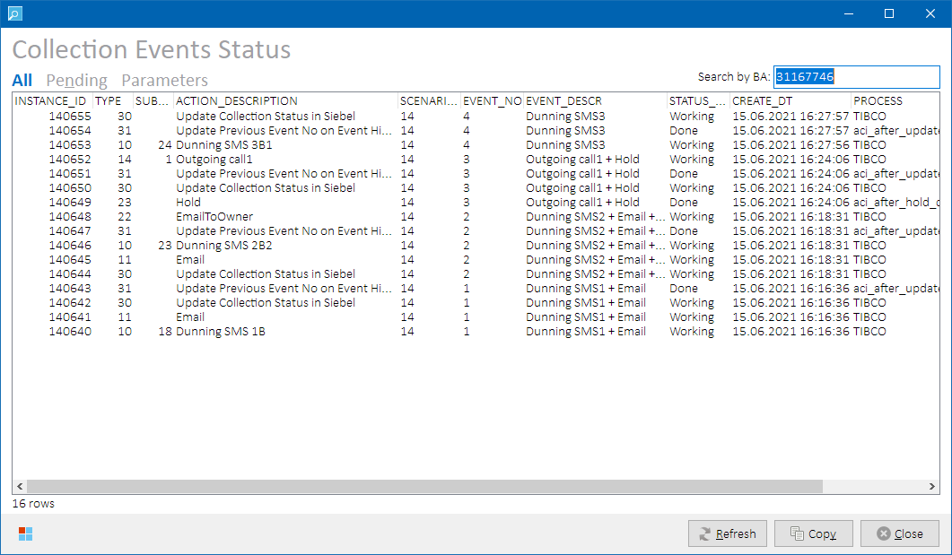

*A2S Actions / Collection Events Status form – data set “****All****”*

Following output columns are returned:

|  |
| --- |
| **Column** |
| INSTANCE_ID |
| TYPE |
| SUBTYPE |
| ACTION_DESCRIPTION |
| SCENARIO_ID |
| EVENT_NO |
| EVENT_DESCR |
| STATUS_DESCR |
| CREATE_DT |
| PROCESS |

**NOTE:** Phoenix will also check that all action types that are supposed to be processed by Tibco (i.e., having PROCESS=TIBCO) are configured in Tibco table TIBCOINT.KENAN_EVENTS_PRIORITY, and displays a warning message if an action type is not configured:

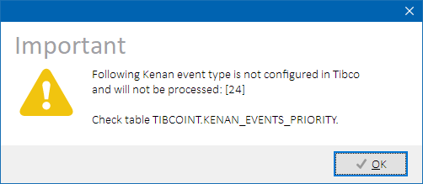

*Unconfigured A2S action type detected in Tibco*

##### Data Set “Pending”

Only actions with status <> **Done** are displayed

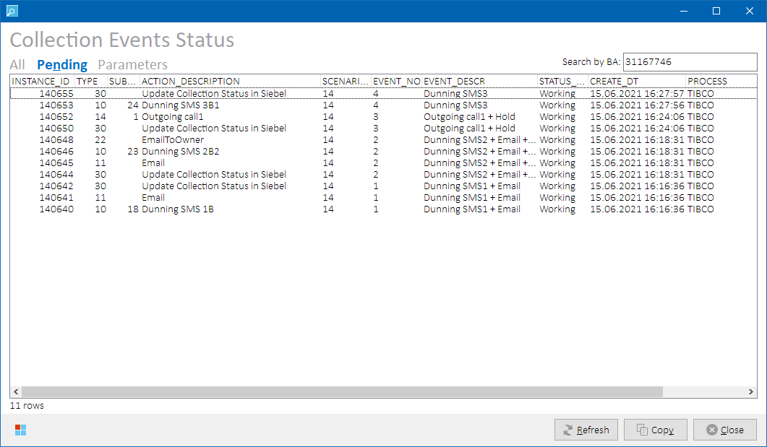

*A2S Actions / Collection Events Status form – data set “****Pending****”*

Output columns are the same as in the **All** data set.

##### Data Set “Parameters”

Action parameters and their values are displayed for all actions.

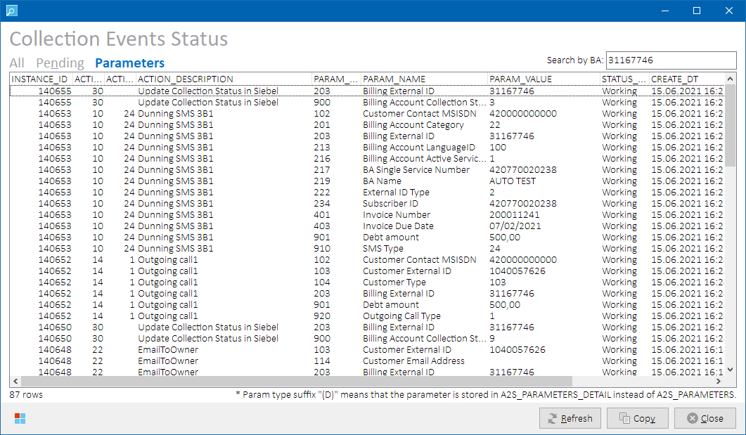

*A2S Actions / Collection Events Status form – data set “****Parameters****”*

Following output columns are returned:

|  |
| --- |
| **Column** |
| INSTANCE_ID |
| ACTION_TYPE |
| ACTION_SUBTYPE |
| ACTION_DESCRIPTION |
| PARAM_TYPE |
| PARAM_NAME |
| PARAM_VALUE |
| STATUS_DESCR |
| CREATE_DT |
| PROCESS |

##### Process Overview

Kenan tables VF_CONFIG.A2S_PARAMETERS and VF_CONFIG.A2S_PARAMETERS_DETAIL are queried for A2S action details of provided BA.

Tibco table TIBCOINT.KENAN_EVENTS_PRIORITY is queried for existence of A2S action types processed by Tibco.

##### Role Differences

|  |  |  |  |  |  |
| --- | --- | --- | --- | --- | --- |
| **Action / Role** | **ADMIN** | **LEAD** | **TESTING-VF** | **TESTING-IBM** | **TESTING-V2** |
| **Access to A2S Actions Status** | Y | Y | N | Y | N |

### Kenan RC Status

In the main grid, select a row with known BA, then select **Kenan 🡪 Recurring Charges (RC’s)** in the main menu to open Kenan Recurring Charges Status form. Details of Kenan RC’s associated with the provided BA or its subscribers will be displayed:

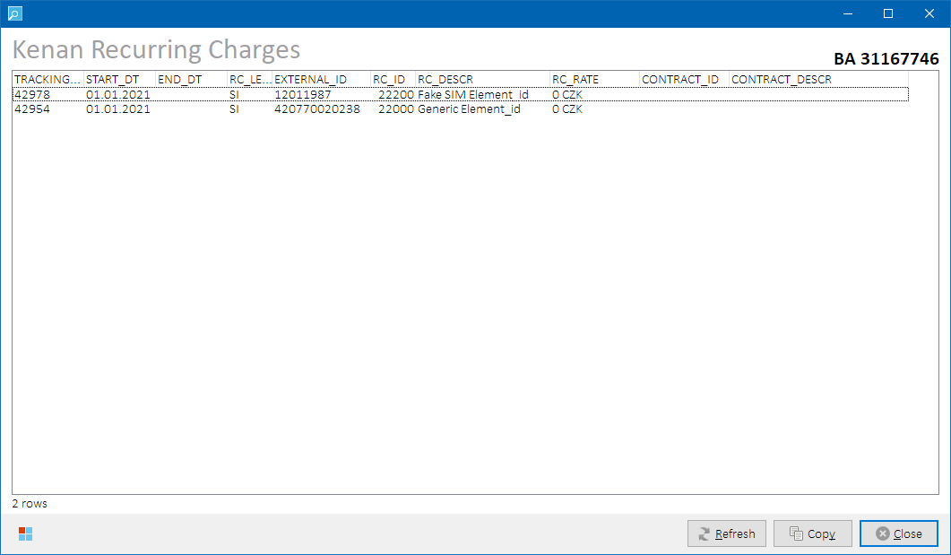

*Kenan Recurring Charges Status form*

**NOTE:** To check if BA is known for given main grid row, hover mouse cursor over MSISDN, SIM or ICCID column value to display a cell hint with additional row information. See Main Grid for more details.

##### Output Data

Following data are returned:

|  |  |
| --- | --- |
| **Column** | **Description** |
| TRACKING_ID | Product tracking id |
| START_DT | Product start date |
| END_DT | Product end date (empty if ongoing) |
| RC_LEVEL | Product level:   * **BA** – account-level recurring charge * **SI** – subscriber-level recurring charge |
| EXTERNAL_ID | External ID of the entity to which the product is bound:   * **for BA-level** **contract** – billing account external id * **for SI-level contract** – subscriber external id |
| RC_ID | Product element ID |
| RC_DESCR | Product element description |
| RC_RATE | Product rate. Empty if not applicable. |
| CONTRACT_ID | Contract tracking id. Empty for standalone (not contracted) product. |
| CONTRACT_DESCR | Contract start date. Empty for standalone (not contracted) product. |

Please refer to Kenan system documentation for more details on the output column meanings and values.

##### Process Overview

Following Kenan tables are queried for contract details for given BA and its subscribers:

CONTRACT_TYPES

CUSTOMER_CONTRACT

CUSTOMER_ID_ACCT_MAP

CUSTOMER_ID_EQUIP_MAP

DESCRIPTIONS

DESCRIPTIONS

PRODUCT

PRODUCT_ELEMENTS

PRODUCT_RATE_OVERRIDE

RATE_RC

##### Role Differences

|  |  |  |  |  |  |
| --- | --- | --- | --- | --- | --- |
| **Action / Role** | **ADMIN** | **LEAD** | **TESTING-VF** | **TESTING-IBM** | **TESTING-V2** |
| **Access to Recurring Charges Status** | Y | Y | N | Y | N |

### Kenan Contracts Status

In the main grid, select a row with known BA, then select **Kenan 🡪 Contracts** in the main menu to open Kenan Contracts Status form. Details of Kenan contracts associated with the provided BA or its subscribers will be displayed:

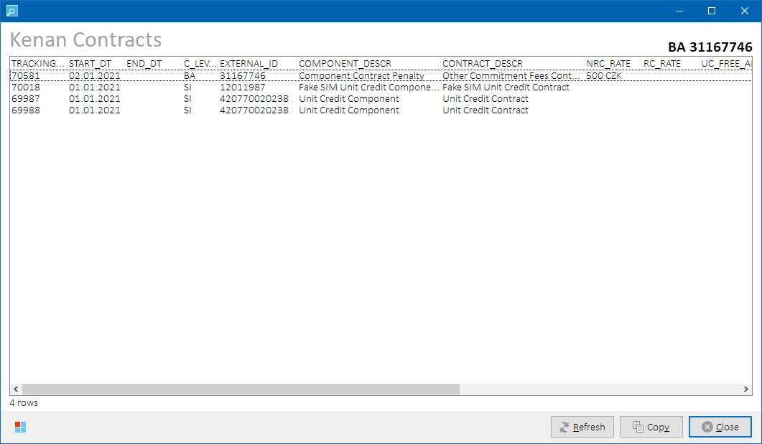

*Kenan Contracts Status form*

**NOTE:** To check if BA is known for given main grid row, hover mouse cursor over MSISDN, SIM or ICCID column value to display a cell hint with additional row information. See Main Grid for more details.

##### Output Data

Following output columns are returned:

|  |  |
| --- | --- |
| **Column** | **Description** |
| TRACKING_ID | Contract tracking id |
| START_DT | Contract start date |
| END_DT | Contract end date (empty if ongoing) |
| C_LEVEL | Contract level:   * **BA** – account-level contract * **SI** – subscriber-level contract * **GRP** – group-level contract (e.g., PRMSLG) * **UNKNOWN** – undetermined contract level |
| EXTERNAL_ID | External ID of the entity to which the contract is bound:   * **for BA-level** **contract** – billing account external id * **for SI-level contract** – subscriber external id * **for GRP-level contract** –group external id |
| COMPONENT_DESCR | Description of component holding the contract |
| CONTRACT_DESCR | Contract description |
| NRC_RATE | Contracted NRC rate. Empty if not applicable. |
| RC_RATE | Contracted RC rate. Empty if not applicable. |
| UC_FREE_AMT | Contracted Unit Credit – free amount. Empty if not applicable. |
| UC_FREE_UNITS | Contracted Unit Credit – free units. Empty if not applicable. |
| DISCOUNT_AMT | Contracted discount – amount. Empty if not applicable. |
| DISCOUNT_PCT | Contracted discount – percentage. Empty if not applicable. |
| HI_BC_BILLED | Number of billed bill periods.  Handset Instalments contracts only. Empty if not applicable. |
| HI_BC_TOTAL | Number of total contracted bill periods.  Handset Instalments contracts only. Empty if not applicable. |
| HI_REMAINS | Remaining commitment in CZK.  Handset Instalments contract only. Empty if not applicable. |

Please refer to Kenan system documentation for more details on the output column meanings and values.

##### Process Overview

Following Kenan tables are queried for contract details for given BA and its subscribers:

COMPONENT_DEFINITION_VALUES

CONTRACT_TYPES

CUSTOMER_CONTRACT

CUSTOMER_CONTRACT_KEY

CUSTOMER_ID_ACCT_MAP

CUSTOMER_ID_EQUIP_MAP

CUSTOMER_ID_GROUP_MAP

DESCRIPTIONS

NRC

PACKAGE_COMPONENT_MEMBERS

PRODUCT

PRODUCT_RATE_OVERRIDE

RATE_DISCOUNT_OVERRIDES

RATE_RC

RATE_UNIT_CR_OVERRIDES

##### Role Differences

|  |  |  |  |  |  |
| --- | --- | --- | --- | --- | --- |
| **Action / Role** | **ADMIN** | **LEAD** | **TESTING-VF** | **TESTING-IBM** | **TESTING-V2** |
| **Access to Contracts Status** | Y | Y | N | Y | N |

### Kenan Account Extended Data Status

In the main grid, select a row with known BA, then select **Kenan 🡪 Account Extended Data** in the main menu to open Kenan Account Extended Data Status form. Details of Kenan extended data associated with the provided BA will be displayed. If attribute value was changed in the past, last change date and previous attribute value is also provided.

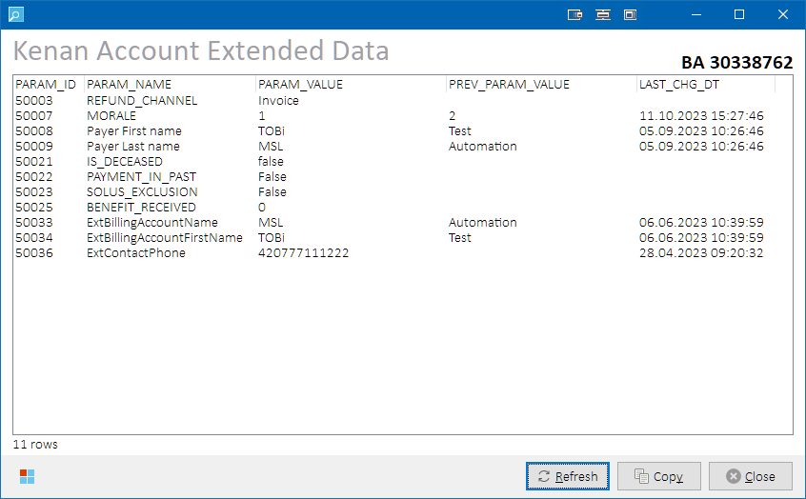

*Kenan Account Extended Data Status form*

**NOTE:** To check if BA is known for given main grid row, hover mouse cursor over MSISDN, SIM or ICCID column value to display a cell hint with additional row information. See Main Grid for more details.

##### Output Data

Following data are returned:

|  |  |
| --- | --- |
| **Column** | **Description** |
| PARAM_ID | Kenan extended parameter identifier. |
| PARAM_NAME | Kenan extended parameter name. |
| PARAM_VALUE | Kenan extended parameter value. |
| PREV_PARAM_VALUE | Parameter value before last change. Empty if no change is tracked. |
| LAST_CHG_DT | Date of last parameter value change. Empty if no change is tracked. |

Please refer to Kenan system documentation for more details on the output column meanings and values.

##### Process Overview

Following Kenan tables are queried for account extended data details for given BA:

CMF_EXT_DATA

VF_CONFIG.VF_CMF_EXT_DATA_AUDIT

DESCRIPTIONS

##### Role Differences

|  |  |  |  |  |  |
| --- | --- | --- | --- | --- | --- |
| **Action / Role** | **ADMIN** | **LEAD** | **TESTING-VF** | **TESTING-IBM** | **TESTING-V2** |
| **Access to Account Extended Data Status** | Y | Y | N | Y | N |

### Kenan Rating (CDR Data) Status

In the main grid, select one or multiple rows with populated MSISDN and known Kenan Account Number, then select **Kenan 🡪 Rating (CDR data)** in the main menu to open Kenan CDR Data Status form. Details of Kenan CDR records of provided MSISDN’s will be displayed.

**NOTE:** To check if Kenan Account Number is known for given main grid row, hover mouse cursor over MSISDN, SIM or ICCID column value to display a cell hint with additional row information. See Main Grid for more details.

##### Output Data

Following data sets are available to display:

|  |  |
| --- | --- |
| **Data Set** | **Description** |
| **Successful** | Successfully processed CDR’s are displayed.  **Row Color Legend:**   |  |  | | --- | --- | | GREEN | Billed CDR’s | | BLACK | Unbilled CDR’s | |
| **Failed** | CDR’s in error are displayed with basic information about the MIU error. |
| **Failed (Extended)** | CDR’s in error are displayed with extended information about the MIU error. |

Output columns vary per selected data set. Please refer to Kenan system documentation for more details on the column meanings and values.

##### Data Set “Successful”

Successfully processed CDR’s are displayed.

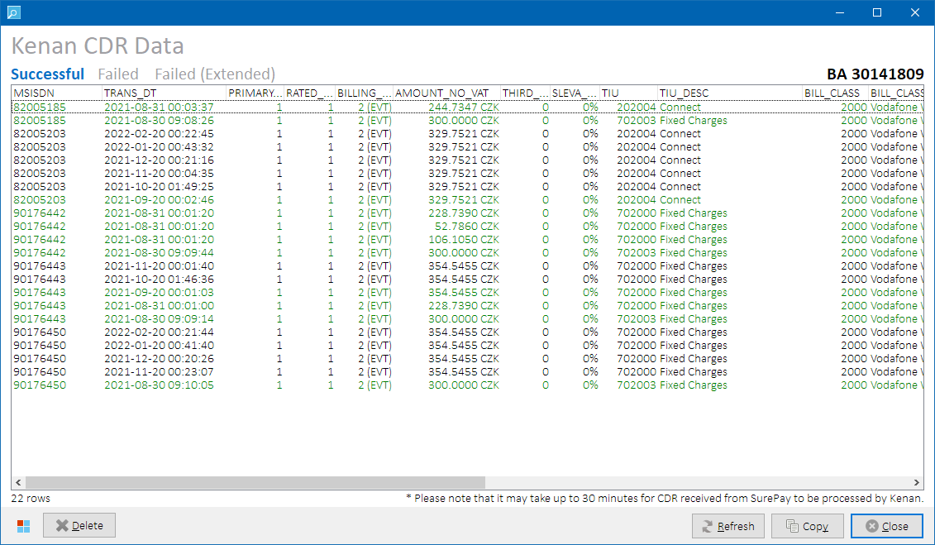

*Kenan CDR Data Status form*

Following output columns are returned:

|  |  |
| --- | --- |
| **Column** | **Description** |
| MSISDN | External id of subscription. |
| TRANS_DT | Date and time the usage event (transaction) took place. |
| PRIMARY_UNITS | Number of raw units to be rated. |
| RATED_UNITS | Number of rated units. |
| BILLING_UNITS_DESCR | Description of billing units used for billing. |
| AMOUNT_NO_VAT | Amount of the transaction. Calculated after rate period discounts and before unit credits. Without VAT. |
| THIRD_UNITS | Number of optional third units. Represents discount amount. |
| SLEVA_PCT | Discount percentage (i.e., third units to amount ratio * 100). |
| TIU | Usage type id. |
| TIU_DESC | Usage type description. |
| BILL_CLASS | Bill class id. |
| BILL_CLASS_DESC | Bill class description. |
| JURISDICTION | Jurisdiction id. |
| JUR_DESC | Jurisdiction description. |
| JURISDICTION_CLASS | Jurisdiction class. |
| JUR_CLASS_DESC | Jurisdiction class description. |
| IS_BILLED | Flag if the CDR record was billed (Y/N). |
| POINT_TARGET | Target point or prefix, defined in USAGE_POINTS. Empty if not applicable. |
| RC_PRORATING | RC proration flag value from CDR annotation:   * **Not prorated** (0 or empty) * **At activation** (1) * **At deactivation** (2) * **Refund at BC change** (3) * **Surcharge at BC change** (4) * **UNKNOWN** – undetermined flag value |

###### Form-specific button controls

|  |  |
| --- | --- |
| **Button Caption** | **Description** |
| **Delete** | Removes selected unbilled CDR records from Kenan database and reloads the grid.  The button is only visible on **Successful** data set.  **NOTE:** Billed CDR’s cannot be deleted.A dialog is presented to the user if such attempt is detected. |

###### Process Overview

Following Kenan tables are queried for details of successful CDR’s:

CDR_DATA

CDR_UNBILLED

DESCRIPTIONS

JURISDICTIONS

USAGE_TYPES

Following Kenan tables are updated upon CDR removal:

CDR_DATA

CDR_UNBILLED

##### Data Set “Failed”

CDR’s in error are displayed with basic information about the MIU error.

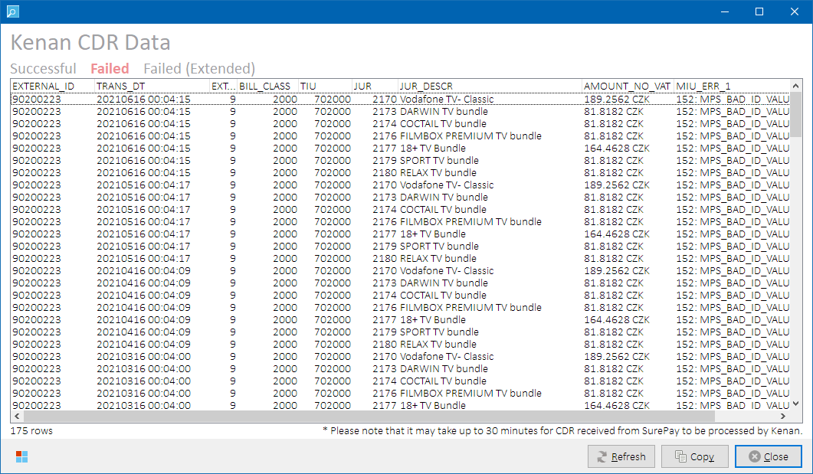

Following output columns are returned:

|  |  |
| --- | --- |
| **Column** | **Description** |
| EXTERNAL_ID | External id of subscription. |
| TRANS_DT | Date and time the usage event (transaction) took place. |
| EXT_ID_TYPE | Type of external_id, defined in EXTERNAL_ID_TYPE_REF. |
| BILL_CLASS | Bill class id, defined in BILL_CLASS_REF. |
| TIU | Usage type id. |
| JUR | Jurisdiction id. |
| JUR_DESCR | Jurisdiction description. |
| AMOUNT_NO_VAT | Amount of the transaction. Calculated after rate period discounts and before unit credits. Without VAT. |
| MIU_ERR_1 | First error causing guiding/rating failure, from SYSTEM_MESSAGES.  Includes both the error code and description. |
| MIU_ERR_2 | Second error causing guiding/rating failure, from SYSTEM_MESSAGES.  Includes both the error code and description. **NOTE:** Column is hidden if empty. |
| MIU_ERR_3 | Third error causing guiding/rating failure, from SYSTEM_MESSAGES.  Includes both the error code and description. **NOTE:** Column is hidden if empty. |

##### Data Set “Failed (Extended)”

CDR’s in error are displayed with extended information about the MIU error.

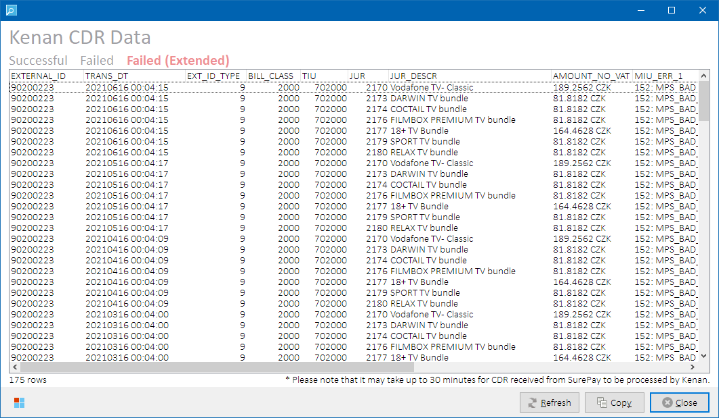

Following **additional** output columns are returned (comparing to the **Failed**data set):

|  |  |
| --- | --- |
| **Column** | **Description** |
| FILE_ID | Unique file id assigned to the file by COM module. |
| FILE_NAME | Input file name incl. ext_contact_id prefix. E.g. 20.mcast2-0_VF2_16062021000500CEST_0005.data |
| FILE_STATUS | File status:   * **1 (retrieved files)** = New file from external contact, ready to be processed.   **(send files)** = New file created by Kenan/BP module, ready to send.   * **2** = A Kenan/BP module is currently processing the file. * **3 (send files only)** = File successfully sent to external contact. * **4 (retrieved files only)** = File successfully processed by Kenan/BP module. * **5** = Error during file transfer. * **6** = Transfer successful, but error during processing. * **7** = File has been identified for type. * **9** = Transfer failed; no further attempts will be made. * **10** = File processed successfully (MCAP/CAP). * **11, 12, 16** = Record written out by CAP to be consolidated separately |
| FILE_BYTE_COUNT | File info to help verify success/failure of file transfer. This is populated when COM or Kenan/BP processing module creates this entry. |
| NUM_GOOD | Total number of good records in the file. |

###### Process overview

Following Kenan tables are queried for details of failed CDR’s:

CDR_DATA_WORK

DESCRIPTIONS

EXTERNAL_ID_ACCT_MAP

EXTERNAL_ID_EQUIP_MAP

FILE_STATUS

JURISDICTIONS

SYSTEM_MESSAGES

##### Role differences

|  |  |  |  |  |  |
| --- | --- | --- | --- | --- | --- |
| **Action / Role** | **ADMIN** | **LEAD** | **TESTING-VF** | **TESTING-IBM** | **TESTING-V2** |
| **Access to CDR Data Status** | Y | Y | N | Y | N |

### Kenan Billing & Collections

Select **Kenan 🡪 Billing & Collections** from the main menu to open Collections form. Collections form gives access to various Kenan operations related to billing and collections.

If a row with known BA is selected in the main grid, the BA is automatically loaded into the Collections form. Otherwise, paste one of the following identifiers to the Billing Account edit box and press **Enter** to load the billing account data:

|  |  |
| --- | --- |
| **Identifier** | **Description** |
| Billing Account External ID (BA) | External ID associated to a Kenan billing account (BA). |
| Customer Account External ID (CA) | External ID associated to a Kenan customer account (CA). |
| Invoice number (BILL_REF_NO) | Kenan invoice identifier |
| Kenan account number (ACCOUNT_NO) | Internal Kenan account number in format **nnnnn|s**, where:   * **nnnnn** = account number * **s** = server number (i.e., 3 or 4) |

**HINT:** If provided identifier represents Customer Account external ID and the customer account contains more billing accounts, additional BA-selector form is displayed so that the user can pick one of them:

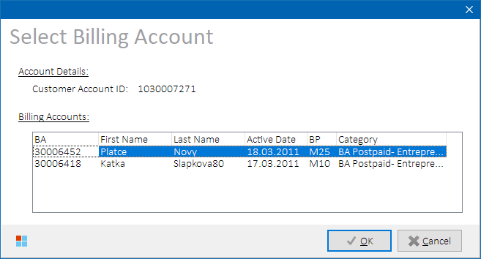

*BA selector form*

**NOTES:**

* **MVNO accounts are not supported.**
* To check if BA is known for given main grid row, hover mouse cursor over MSISDN, SIM or ICCID column value to display a cell hint with additional row information. See Main Grid for more details.

When the BA is known, Collections form is displayed.

##### Controls

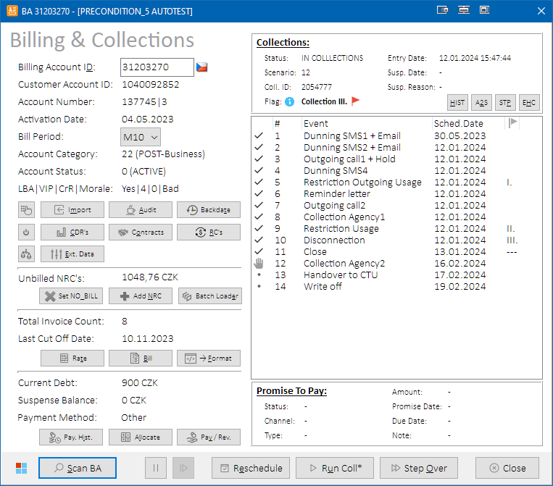

*Collections form*

Below table describes controls that are present on the Collections form:

|  |  |
| --- | --- |
| **Control Caption** | **Description** |
| **Left side** | |
| **(Bill Period)** | Bill Period combo box. Allows to change account’s bill period.  See Changing account bill period for more details. |
| **Apply** | Applies new bill period to the billing account. Only visible if new billing period differs from original billing period. |
| ***Keypad*** | Shows Password Management form. Allows to change passwords in CUR system.  See Setting New Passwords for more details. |
| **🡨 Import** | Imports active subscribers on the selected BA into the main grid and closes the Collections form.  See Inventory Import for more details. |
| **Audit** | Opens Kenan Audit form with events related to current BA.  See Kenan Audit for more details. |
| **Backdate** | Opens Backdating Properties form.  See Kenan Account Backdating for more details. |
| ***DiscReq*** | Updates account status to DISC_REQ. If account’s balances are even, the account will close (set status to DISC_DONE) after next billing. |
| **CDR’s** | Opens Kenan CDR Data Status form with CDR’s filtered to current BA.  See [Kenan Rating (CDR Data) Status](#_Kenan_Rating_(CDR) for more details. |
| **Contracts** | Opens Kenan Contracts Status form with contracts filtered to current BA.  See Kenan Contracts Status for more details. |
| **RC’s** | Opens Kenan Recurring Charges Status form with recurring charges filtered to current BA. See Kenan RC Status for more details. |
| ***Morale*** | Temporarily changes account morale from Bad to Good and vice versa.  Account morale will be restored during next collection run.  See Changing account morale (ACI Before-unsafe) and Changing account morale to Bad (ACI Before-safe) for more details. |
| **Ext. Data** | Opens Kenan Account Extended Data Status form with extended data filtered to current BA. See Kenan Account Extended Data Status for more details. |
| **Set NO_BILL** | Sets all currently unbilled NRC’s on the BA as not-billable.  See Setting NRC as not-billable for more details. |
| **Add NRC** | Adds a new NRC to the BA.  See Inserting NRC for more details. |
| **Batch Loader** | Processes selected input file with NRC Batch Loader.  See Running NRC Batch Loader for more details. |
| **Rate** | Executes rating modules for given Kenan customer server.  See Running Rating modules (COM, MCAP, CAP) for more details. |
| **Bill** | Opens Billing Properties form.  See Running Billing module (BIP) for more details. |
| **🡪 Format** | Opens Invoice Formatting (INEXT) form and closes the Collections form.  See [Kenan Invoicing (INEXT)](#_Kenan_Invoicing_(INEXT)) for more details. |
| **Pay. Hist.** | Opens Kenan Payments Status form for the account (i.e., account payment history).  See Kenan Payments & Refills for more details. |
| **Allocate** | Allocates currently unallocated payments to the account’s balance.  See Payment Allocation for more details. |
| **Pay / Rev.** | Inserts a new payment or payment reversal to the account.  See Payment Insert for more details. |
| **Collections panel** | |
| **HIST** | Opens Collections History & Morale form.  See Kenan Collection History for more details. |
| **A2S** | Opens A2S Actions / Collection Events Status form with events filtered to current BA.  See Kenan A2S Actions / Collection Events Status for more details. |
| **STP** | Opens STP Status form with events filtered to current BA.  See STP Status for more details. |
| **EHC** | Opens EHC Task Events form with prefilled MSISDN, BA, and CA filters with values related to the account currently open in the Collections form.  See [EHC Task Events View](#_EHC_Status_(Task) for more details. |
| **Bottom button bar** | |
| ***Scan BA*** | Reloads the form with account’s data. |
| ***Suspend*** | Suspends (pauses) current collection scenario.  See Suspending/Resuming Collection Scenario for more details. |
| ***Resume*** | Resumes (unpauses) currently suspended collection scenario. Also marks HOLD steps as processed.  See Suspending/Resuming Collection Scenario for more details. |
| **Reschedule** | Reschedules collection event dates in the current collection scenario.  See Rescheduling Collection Events for more details. |
| **Run Coll** | Runs Kenan Collection modules mode once.  See Running Collections and Running Collections in specific mode for more details. |
| **Step Over** | Runs Kenan Collection modules repeatedly until selected collection event is reached.  See Stepping Over Collection Events. |
| **Close** | Closes the Collections form. |
| **Collection Events grid right-click context menu items** | |
| **Skip Preceding Events** | Allows to skip collection events that precede selected collection event.  See Skipping Preceding Collection Events for more details. |
| **Change Event Status To** | Allows to update collection event status to a custom value.  See Changing Collection Events Status for more details. |

##### Output Data

On the left side of the form, there are account and billing details of the account; on the right side, there are components displaying details about Collections and PTP processes.

Following account details are displayed:

|  |  |
| --- | --- |
| **Caption** | **Description** |
| **Left side** | |
| Billing Account ID | External ID of the user-selected billing account.  **HINT:** Hover mouse cursor over the edit box to show billing account nick name (if set). |
| *Spinner* | Displayed while the account data are being loaded. All other form controls are disabled.  **Icon Legend:**   |  |  | | --- | --- | | N/A | Account data are loaded or No account selected. | |  | Account data load in progress. | |
| *Language Flag* *(icon)* | Flag representing language of the billing account.  **Icon Legend:**   |  |  | | --- | --- | |  | Czech language. | |  | English language. | |
| *UPC Flag* | Represents account migrated from UPC. Only visible for migrated accounts.  **Icon Legend:**   |  |  | | --- | --- | | N/A | Account not migrated from UPC. | |  | Account migrated from UPC. |     **HINT:** Hovering mouse cursor over the UPC icon will reveal more details about the migration (based on corresponding CMF_EXT_PARAMS values):   * **UPC Billing Account External ID** * **Migration Date** * **Tenure Date** * **Migration Type** |
| Customer Account ID | External ID of customer account that owns the billing account. |
| Account Number | Internal Kenan account number of the billing account. |
| Activation Date | Activation date of the billing account. |
| Bill Period | Billing period of the billing account. |
| Account Category | Kenan account category of the billing account. |
| Account Status | Kenan account status of the billing account. One of the following values:   * **-2** (DISC_DONE) * **-1** (NEW) * **0** (ACTIVE) * **>0** (DISC_REQ)   **Icon Legend:**   |  |  | | --- | --- | | N/A | Account is billable. Icon is not visible. | |  | Account has NO_BILL flag set. If billed, it will be skipped by BIP. | |
| LBA|VIP|CrR|Morale | Contains pipe-separated values of:   * **LBA** = Kenan Large billing account flag (Yes/No) * **VIP** = Kenan VIP code value * **CrR** = Kenan credit rating value * **Morale** = Kenan good payment morale (GPM) value (Good/Bad) |
| Unbilled NRC’s | Sum of unbilled NRC’s on the billing account in CZK. |
| Total Invoice Count | Total number of invoices issued on the billing account. |
| Last Cut Off Date | Last cut off date of the billing account. |
| Total Due | Total due of the billing account in CZK. |
| Suspense Balance | Suspense account balance of the billing account. |
| Payment Method | Payment method & clearing house of the billing account.  **Icon / Value Legend:**   |  |  |  | | --- | --- | --- | | N/A | Other | Other payment method | |  | DD (RBS) | Direct Debit via RBS clearing house (historical) | |  | DD (CSOB) | Direct Debit via CSB clearing house (ČSOB) | |  | DD (UPC) | Direct Debit via UPC clearing house | |  | DD (SIPO) | Direct Debit via SIPO (Czech Post) | |  | DD (<unknown>) | Warning – Unknown clearing house | |  | <unknown> | Error – Unknown payment method | |
| **Collections panel** | |
| Status | Collection status of the billing account:   * **IN COLLECTIONS** = account has assigned collection scenario * **SUSPENDED** = in collections, but the collection is suspended * **<unknown>** = unknown collection status * **NOT ELIGIBLE** = account is not eligible for collections |
| Scenario | Numeric identifier of collection scenario assigned to the billing account. |
| Coll. ID | Value of internal Kenan collectable ID currently assigned to the account |
| *Restriction Level Flag* | Text value shows the highest collection restriction level the billing account has reached in its collection scenario in Kenan:   * **None** = No restriction is applied * **Collection I.** = Restriction Outgoing Usage collection event (collection status 3) * **Collection II.** = Restriction Usage collection event (collection status 6) * **Collection III.** = Disconnection collection event (collection status 7)   Flag color shows collection restriction sync status between Kenan and Tibco.  After Tibco processes a collection restriction step, it sends AssetComponent:Suspend call to Kenan during which service parameters 50018, 50019 and 50020 are updated in Kenan table SERVICE_EXT_DATA. Values of these parameters must correspond with the actual collection restriction level in Kenan according to processed collection events – collection states 3,6 and 7).  **Icon Legend:**   |  |  | | --- | --- | | N/A | Account is not in collections AND collection restriction status sync check is successful. | |  | Collection restriction status sync result is currently unknown. | |  | Match between collection restriction states in Kenan and Tibco. | |  | Mismatch between collection restriction states in Kenan and Tibco. | |
| *Information* | When clicked, shows message box with additional information about the Restriction Level Flag value meaning. |
| Entry Date | Date and time the account entered collections (collection scenario was assigned) |
| Susp. Date | Date when the collection scenario was suspended. |
| Susp. Reason | Reason why the collection scenario was suspended. |
| **Collection Events grid** | |
| *Status*  *(icon)* | Shows collection event status from ARM_EVENT_QUEUE table.  Icon representation is only supported for the following collection event states:  **Icon / Collection Event Status Legend:**   |  |  |  | | --- | --- | --- | |  | 0 | Pending / Scheduled | |  | 1 | Completed | |  | 2 | Suspended | |  | 3 | Processed, awaiting manual completion | |  | 6 | Failed | |  | 12 | Skipped | |  | 13 | Hold / Awaiting acknowledgement from external entity |     Please refer to Kenan system documentation for more details on the collection event status values. |
| Number | Number of the event. |
| Event | Name of the event. |
| Sched. Date | Date the event is scheduled to be processed. |
| Flag column | Highlights collection restriction events in the collection scenario i.e.,   * **I.** =Restriction Outgoing Usage * **II.** =Restriction Usage * **III. =** Disconnection |
| **PTP panel** | |
| Status | Description of promise status in VF_CONFIG.ACI_PROMISE_HISTORY table:   * **Pending** = 1 * **Kept** = 2 * **Broken** = 3 * **Canceled** = 4 * **Reconfirmed** = 5 |
| Channel | Channel that initiated the promise (e.g., WSC, IVR, CRM etc.) |
| Type | Promise type (e.g., NORMAL, EXPRESS, MASS etc.) |
| Amount | Promise amount in 10.000ths of CZK |
| Promise Date | Create date of the promise. |
| Due Date | Due date of the promise. |
| Note | Promise note. |

##### Role Differences

|  |  |  |  |  |  |
| --- | --- | --- | --- | --- | --- |
| **Action / Role** | **ADMIN** | **LEAD** | **TESTING-VF** | **TESTING-IBM** | **TESTING-V2** |
| **Access to Collections form** | Y | Y | N | Y | N |

##### Setting NRC as not-billable

Press  **Set NO_BILL** button to flag all currently unbilled NRC’s on the account as unbillable. If no unbilled NRC is found, a message box is displayed to the user.

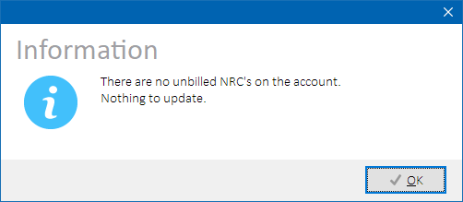

*NO_BILL dialog – no NRC’s to update.*

###### Process Overview

Kenan tables NRC and NRC_KEY are queried for unbilled (mapped to BILL_REF_NO=0) NRC’s related to selected account. If such records are found, they are updated in table NRC with NO_BILL=1 to avoid their billing.

Please refer to Kenan system documentation for more details on the NO_BILL flag.

###### Role Differences

|  |  |  |  |  |  |
| --- | --- | --- | --- | --- | --- |
| **Action / Role** | **ADMIN** | **LEAD** | **TESTING-VF** | **TESTING-IBM** | **TESTING-V2** |
| **Access to set NRC as NO_BILL** | Y | Y | N | Y | N |

##### Inserting NRC

Press  **Add NRC** button to open NRC Properties form in order to provide further details about a non-recurring charge (NRC) to be inserted to the account or one of its services (subscribers).

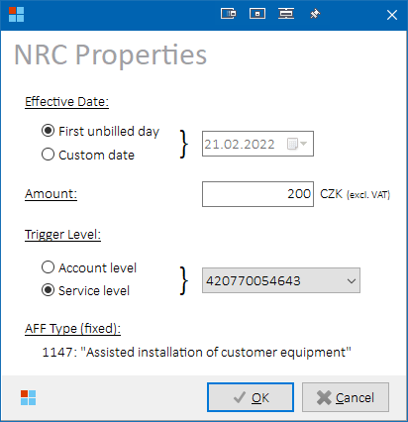

*NRC Properties form*

Select following NRC attributes:

|  |  |
| --- | --- |
| **Option** | **Description** |
| **Effective Date** | Date the non-recurring charge should be billed:   * **First unbilled day:** One day after last cut off date will be used (LAST_CUTOFF_DATE+1). If the account was not yet billed, one day after account activation will be used (ACTIVATION_DATE+1). * **Custom date:** Select custom date in the date picker on the right side of the option. |
| **Amount** | NRC amount in CZK excluding VAT.  **NOTE:** If an excessive NRC amount is entered (more than 214748 CZK), it will be trimmed in Kenan Adapter due to integer datatype limitation. User is informed about the fact with a warning memo below the Amount edit box:    *Warning memo about excessive NRC amount* |
| **Trigger Level** | Kenan entity to be charged:   * **Account level:** NRC will be charged to Billing account (BA-level NRC) * **Service level:** NRC will be charged to selected service (SI-level NRC). Select target service (subscriber) in the combo box on the right side of the option.   **NOTE:** Service level option is unavailable if there are no subscribers on the account. |
| **~~Use negative NRC~~** | ~~Negative NRC will be inserted (such NRC is converted to payment during billing).~~  ~~Only applicable if~~ *~~Account level~~* ~~radio button is selected.  (see WR22_0479 – Mandatory ČTÚ Discount for more details).~~  *\* WR22_0479 was removed from the delivery, changes were reverted* |
| **AFF Type** | NRC type will be set automatically according to Trigger Level to one of the following values:   * **Account level:**   + 1150 – “Other Commitment Fees”   + 178 – “Obligatory subsidized amount” (negative) * **Service level:** 1147 – “Assisted Installation of customer equipment” |

Press **OK** to add the NRC to the account or service.

###### Process Overview

Kenan Adapter SOAP operation **AssetComponent:Add** will be triggered to insert the NRC with user-defined attributes.

###### Role Differences

|  |  |  |  |  |  |
| --- | --- | --- | --- | --- | --- |
| **Action / Role** | **ADMIN** | **LEAD** | **TESTING-VF** | **TESTING-IBM** | **TESTING-V2** |
| **Access to NRC Insert** | Y | Y | N | Y | N |

##### Running NRC Batch Loader

Press  **Batch Loader** button, then select input .CSV file to process (NRC_*.CSV | NWD_*.CSV | V4MP_*.CSV). Selected file will be uploaded to Kenan server and processed by NRC Batch Loader. If there were errors detected during processing, error message is displayed.

If no input file is needed to process (i.e., for cases when the file is already present in NRC Batch Loader input folder), press **Cancel** button in the Open File dialog. In next dialog, you will be asked whether to proceed with running NRC Batch Loader without providing input file.

###### Process Overview

1. Lock process NRC_BTCH_LDR
2. *(optional)* Upload selected file to Kenan via SFTP
3. Execute Kenan script NRCBatchLoader.sh
4. Unlock process NRC_BTCH_LDR

###### Role Differences

|  |  |  |  |  |  |
| --- | --- | --- | --- | --- | --- |
| **Action / Role** | **ADMIN** | **LEAD** | **TESTING-VF** | **TESTING-IBM** | **TESTING-V2** |
| **Access to NRC Batch Loader** | Y | Y | N | Y | N |

##### Change Bill Period

In the upper-left area of the Collection form, select a new bill period value in bill period combo box that displays current bill period of the account. Once new bill period is selected,  **Apply** button is displayed:

**

*Bill period combo box*

Press  **Apply** button to confirm the change.

###### Process Overview

BILL_PERIOD value is updated in Kenan table CMF with user-selected value.

###### Role Differences

|  |  |  |  |  |  |
| --- | --- | --- | --- | --- | --- |
| **Action / Role** | **ADMIN** | **LEAD** | **TESTING-VF** | **TESTING-IBM** | **TESTING-V2** |
| **Access to Bill Period update** | Y | Y | N | Y | N |

##### Insert Payment / Reverse Payment

Press **Payment** button to open Payment Properties form in order to provide further details about a manual payment to be inserted to or reversed from the account:

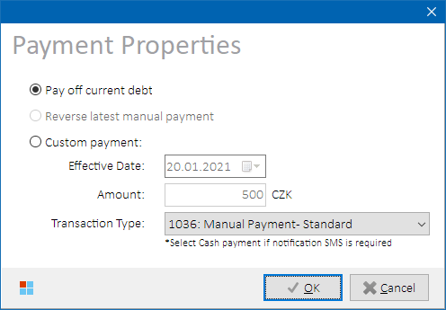

*Payment Properties form*

Select one of the following options:

|  |  |
| --- | --- |
| **Option** | **Description** |
| **Pay off current debt** | Debt currently present on the account will be settled. New balance will be 0 CZK.  **NOTE:** Option is unavailable ifthe account is not in debt. |
| **Reverse latest manual payment** | If Phoenix was previously used to insert a manual payment to the account, use this option to reverse (rollback) the payment.  Payment reversal type will be selected automatically according to the previous payment type as follows:   * **1048:** “Reversal - Manual Payment – Standard” for previous payment type **1036**. * **1065:** “Reversal - Cash Payment” for previous payment type **1063**. * **1045:** “Reversal – Cash Payment (Czech Post)” for previous payment type **1031**. * **1090:** “Reversal - Lump sum compensation - service porting” for previous payment type **1089**. * **1094:** “Marketplace - Refund Reversal” for previous payment type **1093**. * **11:** “Payment Reversal” for previous payment type **213**.   **NOTE:** Option is unavailable if there’s no payment on the account or the latest payment is of an unsupported payment type. |
| **Custom payment** | A manual payment will be inserted to Kenan with user-defined attributes  (see below). |

Optionally, select following attributes of the manual payment to be inserted:

|  |  |
| --- | --- |
| **Option** | **Description** |
| **Effective Date** | Transaction date of the payment. |
| **Amount** | Payment amount in CZK |
| **Transaction Type** | Select one of the following payment types:   * **1036:** “Manual Payment – Standard” * **1063:** “Cash Payment” * **1031:** “Cash Payment (Czech Post)” * **1089:** “Lump sum compensation - service porting” * **1093:** “Marketplace - Refund” * **213:** “Positive Adjustment”   **NOTES:**   * Select Cash payment if notification SMS is required. * Do not select payment reversal types from the combo box – these are assigned automatically when **”Reverse latest manual payment”** option is selected. |

###### Process Overview

Kenan stored procedure ARBOR.BMF_SCRN_INSERT is triggered to insert payment into Kenan DB with user-selected value. Kenan Adapter is bypassed. Phoenix payments or payment reversals are identifiable by BMF.ANNOTATION=‘PHOENIX:SID_'+phoenix_session_id.

###### Role Differences

|  |  |  |  |  |  |
| --- | --- | --- | --- | --- | --- |
| **Action / Role** | **ADMIN** | **LEAD** | **TESTING-VF** | **TESTING-IBM** | **TESTING-V2** |
| **Access to Payment Insert** | Y | Y | N | Y | N |

##### Payment Allocation

Press  **Allocate** button to distribute suspense account balance to open (unpaid) invoices. Fully funded invoices will be closed by this operation.

The option is only available to accounts that have open invoices and suspense account overpayment at the same time. If the account does not meet the above criteria, following message is displayed to user:

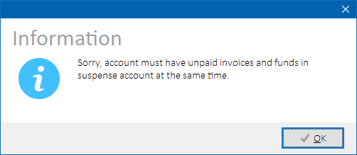

*Information about account not meeting criteria for suspense balance allocation*

Please refer to Kenan system documentation for more details on the suspense balance allocation.

###### Process Overview

Kenan stored procedure ARBOR.ALLOCATE_SUSPENSE is triggered to allocate suspense account balance to open invoices. Fully funded invoices will be closed. Remaining balance is kept on the suspense account.

###### Role Differences

|  |  |  |  |  |  |
| --- | --- | --- | --- | --- | --- |
| **Action / Role** | **ADMIN** | **LEAD** | **TESTING-VF** | **TESTING-IBM** | **TESTING-V2** |
| **Access to Payment Allocation** | Y | Y | N | Y | N |

##### Running Rating modules (COM, MCAP, CAP)

Press  **Rate** button to execute Kenan rating modules on the account’s customer server in order to process newly arrived CDR’s. If rating modules are currently running, user is asked to try again later.

###### Process Overview

1. Lock process RATING
2. Check if UMFFilesPreProcessor.sh is currently running
3. Check if COM module is currently running
4. Check if MCAP module is currently running
5. Check if CAP module is currently running
6. If any of the above is true, stop processing and display the reason
7. Execute Kenan script UMFFilesPreProcessor.sh
8. Execute Kenan script RatingLauncher.ksh for given customer server and COM+MCAP+CAP combination
9. Unlock process RATING

###### Role Differences

|  |  |  |  |  |  |
| --- | --- | --- | --- | --- | --- |
| **Action / Role** | **ADMIN** | **LEAD** | **TESTING-VF** | **TESTING-IBM** | **TESTING-V2** |
| **Access to Rating Modules** | Y | Y | N | Y | N |

##### Running Billing module (BIP)

On either Collections or Invoice Formatting form, press  **Bill** button to open Billing Properties (*a.k.a. BIPProperties*) form in order to provide further details about upcoming billing execution:

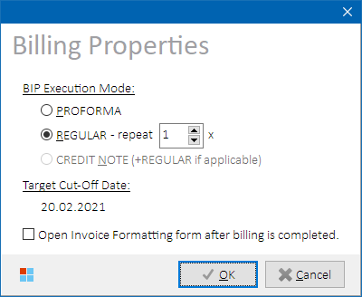

*Billing Properties form*

Select one of the following billing modes:

|  |  |
| --- | --- |
| **Billing Mode** | **Description** |
| **PROFORMA** | Billing will once run in PROFORMA mode for selected account.  **NOTE:**   * Option is unavailable if there are pending credit notes on the account. |
| **REGULAR** | Billing will run once or repeatedly in REGULAR mode for selected account.  Select billing repetition count (default 1) in spin edit box on the right side of the option.  **NOTES:**   * Repetition count is limited in order to avoid cutoff date in future. If target cutoff date exceeds current date, a message is displayed and billing execution is not allowed. * Option is unavailable if first repetition’s cutoff would be in future. * Option is unavailable if there are pending credit notes on the account. |
| **CREDIT NOTE** | Interim billing will run once for account’s customer server. Pending credit notes will be billed first, then regular billing will run as well.  **NOTES:**   * Option is automatically selected if there are pending credit notes on the account as they must be billed first. A message about the same is displayed in the form. * Option is unavailable if there are no pending credit notes on the account. * **Interim billing cannot be run for a single account. All pending credit notes on given customer server will be processed.** |

Please refer to Kenan system documentation for more details on the billing module.

Optionally, select also one of the following options:

|  |  |
| --- | --- |
| **Option** | **Description** |
| **Open Invoice Formatting form after billing is completed** | Collections form will close, and Invoice Formatting (INEXT) form will open after billing is completed. Check box is unchecked when the form is open. |

Following auxiliary tasks that usually are necessary after billing will also be executed:

* SIPO Report Launcher (if the account is postpaid and has configured SIPO payment method)
* Account’s suspense balance allocation
* Invoice Split routines
* Disconnect Done Notification Process (if the account was closed during last billing).

###### Process Overview

1. Lock process BIP
2. Execute Kenan script
   1. BipLauncher.sh in case of PROFORMA or REGULAR mode  
      **- or -**
   2. InterimBIP.ksh in case of INTERIM mode
3. Check billing logs, stop processing in case of error
4. Execute Kenan script SIPOReportLauncher.ksh (if configured to run after BIP, and if the account is eligible – see conditions above)
5. Get current debt
6. Allocate suspense balance if applicable (see Payment Allocation for more details).
7. Execute Kenan script invoice_split.ksh
8. Get current account status
9. Execute Kenan script DiscDoneNotificationProcess.ksh (if current account status is -2 (DISC_DONE) and previous account status was different from -2)
10. Reload account data
11. Unlock process BIP

If BIP did not produce new invoice, warning message is displayed and the user is offered to re-run the billing once again, or stop processing. If there were errors detected during billing, error message is displayed.

**NOTE:** If user tries to execute billing on an account that is already closed or has NO_BILL flag set, a confirmation dialog will be presented informing that the action will not be successful. User can choose to either cancel or continue the operation.

###### Role Differences

|  |  |  |  |  |  |
| --- | --- | --- | --- | --- | --- |
| **Action / Role** | **ADMIN** | **LEAD** | **TESTING-VF** | **TESTING-IBM** | **TESTING-V2** |
| **Access to Billing Module (BIP)** | Y | Y | Y*) | Y | N |

*) Users with TESTING-VF role can run billing from Invoice Formatting form.

##### Collection Management

On the Collection form, user can perform tasks related to Kenan collections processing. See next subchapters for more details.

###### Running Collections

Press **Run Coll** button to run Kenan collections process on given customer server in default TA5 mode that consists of following collection tasks:

* **TREAT:** If the account is eligible for entering collections, a collection scenario will be assigned to it, and collection events grid will be populated with the scenario events.
* **QUEUE:** Once the account is in collections, first unprocessed collection event will be processed if scheduled for today.
* **CURE:** If the account is eligible for exiting collections, collection scenario will be removed from the account. Collection events grid will be emptied.
* **PROMISEQ:** If the account is eligible for PTP, collection scenario will be suspended on the account.

Available collection modes are described in next chapter.

**NOTE:** As QUEUE task is run after TREAT task, an account that newly enters collections will also automatically have its first collection event processed.

Process Overview

* Reschedule collection scenario if needed
* Execute Kenan script CollectionLauncher.ksh in TA2 mode.

Role Differences

|  |  |  |  |  |  |
| --- | --- | --- | --- | --- | --- |
| **Action / Role** | **ADMIN** | **LEAD** | **TESTING-VF** | **TESTING-IBM** | **TESTING-V2** |
| **Access to Collection Management** | Y | Y | N | Y | N |

###### Running Collections in specific mode

Collections can be run in different modes that include different sets of collection tasks that will be executed. Press **Run Coll** button **with** **right mouse button** and select a specific collection mode to run in the opened context menu:

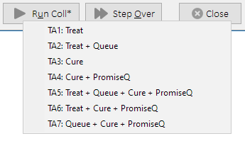

*Collection mode selection*

|  |  |
| --- | --- |
| **Collection Mode** | **Collection Tasks** |
| **TA1** | TREAT |
| **TA2** | TREAT + QUEUE |
| **TA3** | CURE |
| **TA4** | CURE + PROMISEQ |
| **TA5** | TREAT + QUEUE + CURE + PROMISEQ |
| **TA6** | TREAT + CURE + PROMISEQ |
| **TA7** | QUEUE + CURE + PROMISEQ |

Please refer to Kenan system documentation for more details on the collection task meaning.

**NOTE:** If QUEUE task is present in selected collection mode and first unprocessed collection event is not scheduled for today, the user will be notified about the need of collection scenario rescheduling:

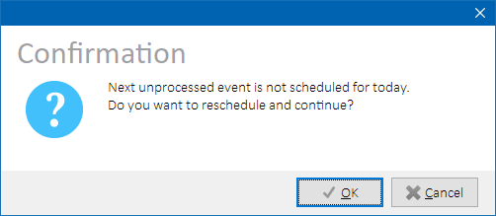

*Reschedule scenario before running QUEUE collection task*

Process Overview

* Reschedule collection scenario if needed
* Execute Kenan script CollectionLauncher.ksh in selected mode.

###### Rescheduling Collection Events

Press  **Reschedule** button to automatically reschedule all scheduled collection events. Scheduled dates of the events will be shifted so that the first one is scheduled for today. This will ensure that the first scheduled event is always picked up when collection processing is run.

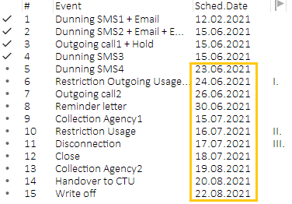 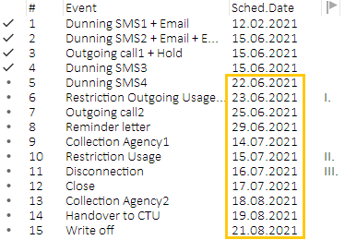

*Rescheduling scheduled collection events by 1 day*

Process Overview

* SCHEDULED_DATE values are updated in Kenan table ARM_EVENT_QUEUE for all events in the account’s collection scenario that currently have PROCESSED_DATE = NULL.

###### Suspending Collection Scenario

Press **Suspend** (*pause*) button to suspend all scheduled collection events. Collection processing will not continue on the account until the events are resumed again. If the scenario is already suspended, the button is not available.

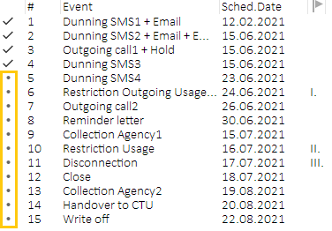 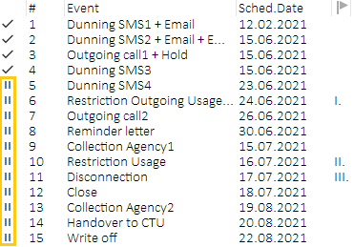

*Suspending collection events*

Process Overview

Pending events are suspended: QUEUE_STATUS value is updated to 2 in Kenan table ARM_EVENT_QUEUE for all events in the account’s collection scenario that currently have QUEUE_STATUS = 0.

###### Resuming Collection Scenario

Press **Resume** (*unpause*) button to resume all previously suspended collection events. Collection processing will continue on the account as scheduled. If the scenario is already resumed, the button is not available.

 

*Resuming collection events*

Process Overview

1. HOLD events are marked as processed: QUEUE_STATUS value is updated to 1 in Kenan table ARM_EVENT_QUEUE for all events in the account’s collection scenario that currently have QUEUE_STATUS = 13.

2. Suspended events are marked as pending: QUEUE_STATUS value is updated to 0 in Kenan table ARM_EVENT_QUEUE for all events in the account’s collection scenario that currently have QUEUE_STATUS = 2.

###### Skipping Preceding Collection Events

Select a scheduled collection event in the collection events grid. Press right mouse button to open context menu and select **Skip preceding events** item. All scheduled collection events that precede the selected event will be marked as Skipped and not processed during collection execution.

**NOTE:** The option is only available for collection events in status **Scheduled / Pending**.

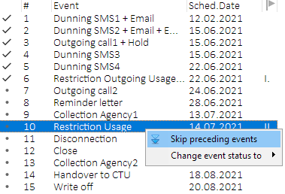 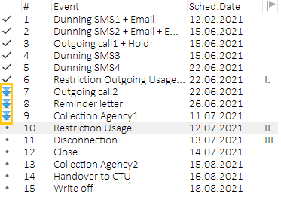

*Skipping preceding scheduled collection events*

**WARNING**: It is generally not recommended to skip restriction collection events i.e., Collection I. / II. / III. If restriction collection events are not processed sequentially, there will most likely be errors during CURE process (AssetComponent:Resume will fail).If user selects to skip a restriction collection event, a warning message is displayed requesting additional confirmation.

**Therefore, if you need to skip a restriction collection event, ensure that ALL restriction collection events in the scenario are skipped.**

###### Changing Collection Events Status

Select a collection event in the collection events grid. Press right mouse button to open context menu, select **Change event status to** item, then select target collection event status. Collection event status will be updated to selected value.

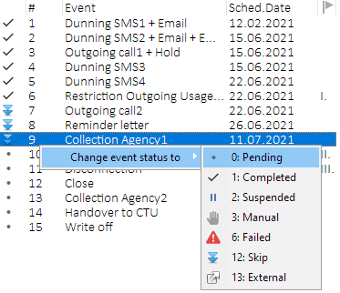 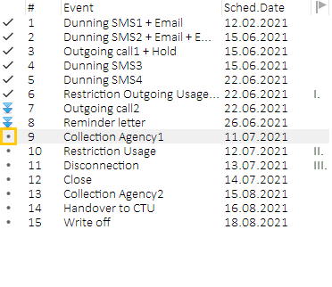

*Updating collection event status*

**WARNING**: Use common sense when updating collection event states to avoid unforeseen consequences during subsequent collection execution.

###### Stepping Over Collection Events

Step Over allows to automatically process multiple collection events. Select a scheduled collection event in the collection events grid. Press  **Step Over** button to automatically process all unprocessed collection events up to and including the selected event.

If HOLD steps are present among the collection events to be processed, user is asked if Phoenix should automatically resume the collection scenario. If confirmed, all HOLD steps will automatically be resumed.

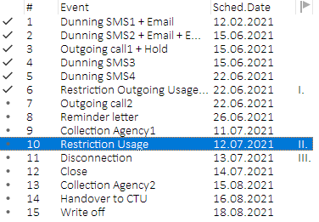 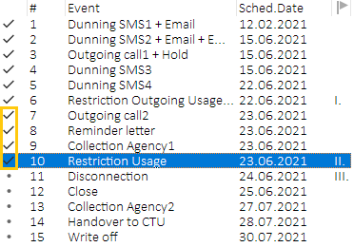

*Collection Step Over*

Confirm the target event in the upcoming dialog:

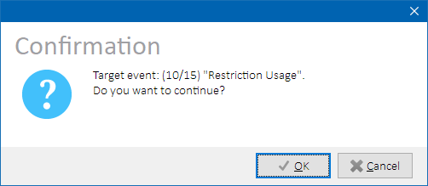

*Collection Step Over - target event confirmation*

While the collection process is running, Working form will display current processing status:

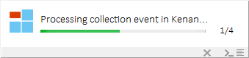

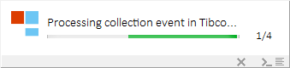

*Collection Step Over – progress bar examples*

**HINT:** Click  **ABORT** button in the Working form to abort processing after current collection event. The button is not visible if last collection event is already being processed.

**NOTES:**

* **Account will not be cured during Step Over** as TA2 mode is used (TREAT+QUEUE)
* Depending on number of collection events to be processed, Step Over process can be quite time-consuming – processing of the whole collection scenario can take 30+ minutes.

Process Overview

For each unprocessed collection event between the first one and the target one:

1. Reschedule collection scenario
2. Execute Kenan script CollectionLauncher.ksh in TA2 mode.
3. Repeatedly check Kenan table (VF_CONFIG.A2S_ACTION_STATUS and wait for Tibco to process A2S actions associated to the collection event (waiting time is configurable, default timeout is after 300 seconds).

If A2S action processing timeouts or fails in Tibco (VF_CONFIG.A2S_ACTION_STATUS table is not updated, or the action receives ERROR status), user is informed and asked to Retry or Cancel the Step Over operation.

###### Curing an Account

Curing an account means its removing from collections. To remove account from collections, perform following steps:

1. Press **Payment** button, then select *Pay off current debt* option.
2. Press **Run Coll** button and wait for CURE task to remove the account from collections.

**HINT:** Run Collections in TA3 mode (only CURE task will be executed) to speed up the processing.

### Changing account morale (ACI Before-unsafe)

Morale value is evaluated by ACI Before process that is run before each collection processing. Account morale is only set to Good if the account meets configured morale conditions, otherwise it’s set to Bad.

Press  ***Morale*** button to bypass ACI Before process and temporarily change account morale from Good to Bad or vice versa. Corresponding A2S event will also be inserted into Tibco interface table so that the change is propagated to other systems.

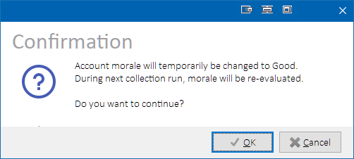

*Account morale change confirmation dialog.*

**NOTES:**

* Morale cannot be changed on prepaid, BR or MVNO accounts.
* Morale cannot be changed if current morale status is *Unknown*.
* **Morale will automatically be re-evaluated by ACI Before process during next collection run (and updated to correct value corresponding with account’s setup).**

##### Process Overview

1. Check if account is eligible for morale change.
2. Check if account morale parameter exists in table CMF_EXT_DATA.
3. Insert or update morale value in CMF_EXT_DATA.
4. Get A2S instance id from sequence VF_CONFIG.ACI_DISP_SEQ.
5. Insert A2S action type 53 into VF_CONFIG.A2S_ACTION_DISPATCH.
6. Insert A2S action parameters 115 and 203 into VF_CONFIG.A2S_PARAMETERS.
7. Reload account data in Collections form.

##### Role Differences

|  |  |  |  |  |  |
| --- | --- | --- | --- | --- | --- |
| **Action / Role** | **ADMIN** | **LEAD** | **TESTING-VF** | **TESTING-IBM** | **TESTING-V2** |
| **Access to changing account morale (ACI Before-unsafe)** | Y | Y | N | Y | N |

### Kenan Collection History

Kenan stores historical information about when the account entered and exited collections. These data are used to calculate account morale (a.k.a. GPM – “Good Payment Morale”).

Press **HIST** button to show Collection History and Morale form:

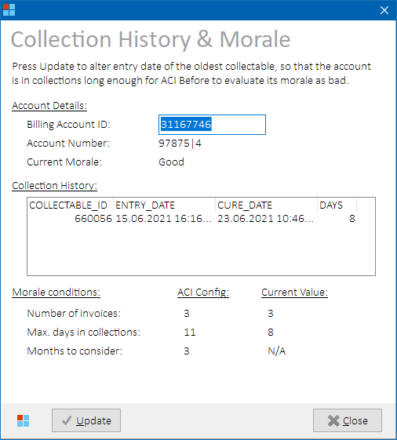

*Collection History & Morale form – before update*

##### Role Differences

|  |  |  |  |  |  |
| --- | --- | --- | --- | --- | --- |
| **Action / Role** | **ADMIN** | **LEAD** | **TESTING-VF** | **TESTING-IBM** | **TESTING-V2** |
| **Access to Collections History form** | Y | Y | N | Y | N |

##### Changing account morale to Bad (ACI Before-safe)

Morale value is evaluated by ACI Before process that is run before each collection processing. Account morale is only set to Good if the account meets configured morale conditions, otherwise it’s set to Bad.

Press  **Update** button to alter collection entry date so that the account seems to be in collections long enough not to meet Good morale conditions anymore. If the account was in collections for several times, the oldest collectable’s entry date is altered.

Account’s morale will be updated to Bad by ACI Before process when collections are run for the next time.



*Notification that collections need to be re-run.*

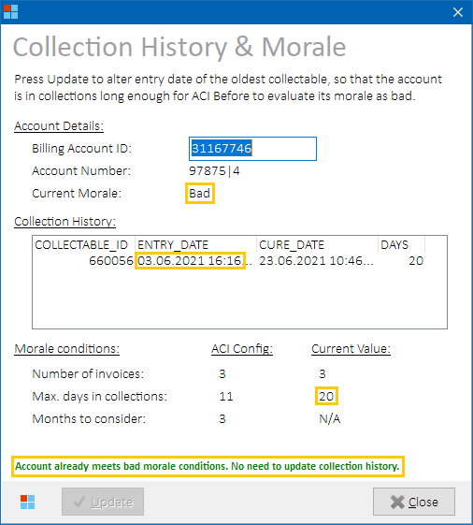

*Collection History & Morale form – after update*

**NOTES:**

* **Update** button is not available if the account already meets bad morale conditions, or if the account has no collection history.
* If shifted collection entry date would precede account activation date, the account must be backdated first.
* **Bad morale will be kept during ACI Before process as long as all conditions are met.**

###### Process Overview

1. Fetch account active date from Kenan table CMF.
2. Fetch current value of ACI parameter “Morale Evalutation - Collection Days” from Kenan table VF_CONFIG.ACI_PARAMETERS.
3. Check Kenan table ARM_HISTORY. Stop processing if the account has no collection history or is not old enough to shift the entry date.
4. Update Kenan table ARM_HISTORY, shift entry date of the oldest collectable by <value from step 1>+1 days.

### Kenan Account Backdating

Backdating of an account means shifting its activation date in Kenan so that enough bill cycles are available for regular billing.

Account must meet following conditions to be eligible to backdating:

|  |  |  |
| --- | --- | --- |
| **Attribute** | **Value** | **Description** |
| **Account Status** | -1 | Only newly created accounts can be backdated. |
| **Inactive Date** | NULL | Account must not have inactive date set |
| **Invoice Count** | 0 | Account must not have been billed. |
| **Inactive Subscribers Count** | 0 | Account must not nave inactive subscribers. |
| **Account Category (Short)** | POST PRE PRE_RES | Only listed account categories are supported. |

**IMPORTANT**: There must not be any modification or termination Siebel order performed on the account before backdating! Accounts with modified or terminated products cannot be backdated.

Press  **Backdate** button to open Backdate Properties form.

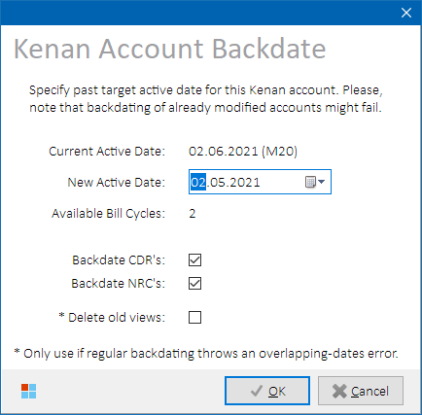

*Backdating Properties form*

Select following NRC attributes:

|  |  |
| --- | --- |
| **Option** | **Description** |
| **New Active Date** | Active date the account should be backdated to.  Number of available bill cycles is recalculated when the date is changed. |
| **Backdate CDR’s** | If checked, existing CDR records related to the account will also be backdated by the same number of days as the account itself.  **Default value: Checked** |
| **Backdate NRC’s** | If checked, existing NRC records related to the account will also be backdated by the same number of days as the account itself.  **Default value: Checked** |
| **Delete old views** | Previous associations of affected external ID’s will be deleted from Kenan tables to avoid date overlapping dates errors.  **NOTE:** Option is only available to users with ADMIN and LEAD roles. |

Press **OK** to backdate the account.

##### Common Issues

If the backdating fails on error “ORA-20001: 316102, TRIG: INSERT/UPDATE Failed: Overlapping active/inactive dates”, it usually means that new active date of an affected external id spans across previously deactivated assignment of the same external id. In such cases, try to backdate the account once again with “**Delete old views**” option checked.

##### Example & Explanation

1. Have a subscriber in account #1 as follows:

|  |  |  |  |
| --- | --- | --- | --- |
| **External ID** | **Active Date** | **Inactive Date** | **Account # / Subscriber #** |
| 420123456789 | 01.06.2021 | 30.06.2021 | ACCT #1 / SUB #1 |

1. Then, the external id was cleansed (thus disconnected from subscriber #1) and re-used on account #2:

|  |  |  |  |
| --- | --- | --- | --- |
| **External ID** | **Active Date** | **Inactive Date** | **Account # / Subscriber #** |
| 420123456789 | 01.06.2021 | 30.06.2021 | ACCT #1 / SUB #1 |
| 420123456789 | 01.09.2021 | NULL | ACCT #2 / SUB #2 |

1. Then, an attempt is made to backdate account #2 from 01.09.2021 to 01.01.2021. This will fail because new interval would overlap with previous interval of the external id association from 01.06.2021 to 30.06.2021:

|  |  |  |  |
| --- | --- | --- | --- |
| **External ID** | **Active Date** | **Inactive Date** | **Account # / Subscriber #** |
| 420123456789 | 01.06.2021 | 30.06.2021 | ACCT #1 / SUB #1 |
| 420123456789 | 01.01.2021 | NULL | ACCT #2 / SUB #2 |

1. Previous association (view) must be deleted first. Then, the account #2 can be backdated to desired active date 01.01.2021.

|  |  |  |  |
| --- | --- | --- | --- |
| **External ID** | **Active Date** | **Inactive Date** | **Account # / Subscriber #** |
| ~~420123456789~~ | ~~01.06.2021~~ | ~~30.06.2021~~ | ~~ACCT #1 / SUB #1~~ |
| 420123456789 | 01.01.2021 | NULL | ACCT #2 / SUB #2 |

**NOTE:**This issue is deliberately not resolved during cleansing, as cleansing process only checks for active external id associations (without populated inactive date) and sets their inactive date to active date to terminate them. Associations with already populated inactive date in the past are not modified as the external id is already considered reusable, although not necessarily “backdate-able”.

##### Process Overview

1. Fetch account inactive date from Kenan table CMF. Stop processing if populated.
2. Fetch count of inactive subscribers on the account from Kenan table EXTERNAL_ID_EQUIP_MAP. Stop processing if greater than zero.
3. Calculate difference in days as TRUNC(original_active_date – new_active_date) + 1.
4. Update data in following Kenan tables:

|  |  |  |
| --- | --- | --- |
| **Server** | **Schema Name** | **Table Name** |
| ADMIN | ARBOR | EXTERNAL_ID_ACCT_MAP |
| ADMIN | ARBOR | EXTERNAL_ID_EQUIP_MAP |
| ADMIN | ARBOR | EXTERNAL_ID_EQUIP_MAP_KEY |
| ADMIN | ARBOR | EXTERNAL_ID_EQUIP_MAP_VIEW |
| ADMIN | ARBOR | ORD_ITEM_MAP |
| ADMIN | ARBOR | SERVER_LOOKUP |
| ADMIN | VF_CONFIG | VF_PROD_INST |
| CUSTOMER | ARBOR | CDR_DATA |
| CUSTOMER | ARBOR | CDR_UNBILLED |
| CUSTOMER | ARBOR | CMF |
| CUSTOMER | ARBOR | CMF_COMPONENT_ELEMENT |
| CUSTOMER | ARBOR | CMF_EXEMPT |
| CUSTOMER | ARBOR | CMF_PACKAGE |
| CUSTOMER | ARBOR | CMF_PACKAGE_COMPONENT |
| CUSTOMER | ARBOR | CUSTOMER_CONTRACT |
| CUSTOMER | ARBOR | CUSTOMER_CONTRACT_VIEW |
| CUSTOMER | ARBOR | CUSTOMER_ID_ACCT_MAP |
| CUSTOMER | ARBOR | CUSTOMER_ID_EQUIP_MAP |
| CUSTOMER | ARBOR | CUSTOMER_ID_EQUIP_MAP_KEY |
| CUSTOMER | ARBOR | CUSTOMER_ID_EQUIP_MAP_VIEW |
| CUSTOMER | ARBOR | DEPOSIT |
| CUSTOMER | ARBOR | GROUP_MEMBER |
| CUSTOMER | ARBOR | GROUPS |
| CUSTOMER | ARBOR | NRC |
| CUSTOMER | ARBOR | ORD_ORDER |
| CUSTOMER | ARBOR | ORD_SERVICE_ORDER |
| CUSTOMER | ARBOR | PRODUCT |
| CUSTOMER | ARBOR | PRODUCT_RATE_OVERRIDE |
| CUSTOMER | ARBOR | PRODUCT_VIEW |
| CUSTOMER | ARBOR | SERVICE |
| CUSTOMER | ARBOR | SERVICE_BILLING |
| CUSTOMER | ARBOR | SERVICE_STATUS |
| CUSTOMER | ARBOR | SERVICE_VIEW |
| CUSTOMER | VF_CONFIG | VF_DEPOSIT |
| CUSTOMER | VF_CONFIG | VF_GROUP_EXT_DATA |

##### Role Differences

|  |  |  |  |  |  |
| --- | --- | --- | --- | --- | --- |
| **Action / Role** | **ADMIN** | **LEAD** | **TESTING-VF** | **TESTING-IBM** | **TESTING-V2** |
| **Access to Backdating** | Y | Y | Y | Y | N |

### Kenan Invoicing (INEXT)

Select **Kenan 🡪 Invoicing (INEXT)** from the main menu to open Invoice Formatting form. Invoice Formatting form gives access to various Kenan operations related to invoice processing after billing.

If a row with known BA is selected in the main grid, the BA is automatically loaded into the Invoice Formatting form. Otherwise, paste one of the following identifiers to the Billing Account edit box and press **Enter** to load the billing account data:

|  |  |
| --- | --- |
| **Identifier** | **Description** |
| Billing Account External ID (BA) | External ID associated to a Kenan billing account (BA). |
| Customer Account External ID (CA) | External ID associated to a Kenan customer account (CA). |
| Invoice number (BILL_REF_NO) | Kenan invoice identifier |
| Kenan account number (ACCOUNT_NO) | Internal Kenan account number in format **nnnnn|s**, where:   * **nnnnn** = account number * **s** = server number (i.e., 3 or 4) |

**HINT:** If pasted identifier represents is Customer Account external ID, and the customer account contains more billing accounts, additional BA-selector form is displayed so that the user can pick one of them:



*BA selector form*

**NOTES:**

* **MVNO accounts are not supported.**
* To check if BA is known for given main grid row, hover mouse cursor over MSISDN, SIM or ICCID column value to display a cell hint with additional row information. See Main Grid for more details.

When the BA is known, Invoice Formatting form is displayed (screenshots are provided in below sub-chapters).

##### Controls

###### Layout

On the left side of the form, there are account and billing details of the account. Below them, custom INEXT run parameters can be set. On the right side of the form, the user can choose between Invoices & Credit Notes grid displaying details about issued invoices, credit notes and their attributes, or Dunning Letters grid displaying details about issued dunning letters.

**HINT:** All icon columns in the Invoices & Credit Notes grid and Dunning Letters grid support hints with icon description and optionally additional information. Hover mouse cursor over the icon to show the hint value.

###### Form-specific controls

Below table describes controls that are present on the Invoice Formatting form:

|  |  |
| --- | --- |
| **Control Caption** | **Description** |
| **Left side – Account Details** | |
| **Backdate** | Opens Backdating Properties form.  See Kenan Account Backdating for more details.  **NOTE:** Button is only visible to users with TESTING-VF role. Other user roles can access backdating from Collections form. |
| **Bill** | Opens Billing Properties form.  See Running Billing module (BIP) for more details. |
| **🡪 Collections** | Opens Billing & Collections form and closes the Invoice Formatting form.  See Kenan Billing & Collections for more details.  **NOTE:** Button is only visible to users with role different from TESTING-VF. |
| **Left side – INEXT Run Parameters** | |
| Server ID | Kenan Server ID. Populated automatically upon row selection in the Invoice grid. Following values are available:   * **2** = Admin server * **3** = Customer server #3 * **4 =** Customer server #4 * **5** = MVNO customer server   Please refer to INEXT documentation for more details on INEXT parameters. |
| Document Type | INEXT document type. Populated automatically upon row selection in the Invoice grid. Following values are available:   * **INV** = invoice * **EBILL** = e-billing (no longer officially supported since WR16_0861) * **ALL =** invoice + e-billing(no longer officially supported since WR16_0861) * **CN** = credit note * **DL** = dunning letter * **STD** = simplified tax document * **PTD** = prepaid tax document   Please refer to INEXT documentation for more details on INEXT parameters. |
| Run Mode | INEXT run mode. Populated automatically upon row selection in the Invoice grid. Following values are available:   * **Regular** * **Proforma**   Please refer to INEXT documentation for more details on the run modes. |
| File Tag | INEXT file tag. Populated automatically upon row selection in the Invoice grid. Following values are available:   * **PRN** * **PRD** (for Regular invoices) * **TTT** * **PFM** (for Proforma invoices) * **SAMPLING**   Please refer to INEXT documentation for more details on INEXT parameters. |
| Launch ID | Unique user identifier. Populated automatically with constant PX + <phoenix_user_id>.  Please refer to INEXT documentation for more details on INEXT parameters.  **NOTE:** Option is not available for the following document types:   * **CN** * **DL** * **STD** |
| **Bottom button bar** | |
| **Scan BA** | Reloads the form with account’s data. |
| **Run INEXT** | Suspends current collection scenario.  See Suspending/Resuming Collection Scenario for more details. |
| **Send to Xerox** | Sends all XML documents produced by Kenan to Xerox.  See Sending XML to Xerox for more details. |
| **Upload STD** | Uploads STD request from Siebel to Kenan.  See Uploading STD to Kenan.  **NOTE:** Button is only visible to users with role different from TESTING-VF. |
| ***SMS Notif.*** | Executes SMS Launcher module for given Kenan customer server.  See Running SMS Launcher module for more details. |
| **Back Out** | Backs out (reverts) a Kenan invoice.  See Backing Out an Invoice for more details.  **NOTE:** Button is only visible to users with role different from TESTING-VF. |
| **Show QR** | Displays QR Code picture for selected invoice.  See Displaying Invoice QR Code for more details.  **NOTE:** Button is only visible to users with role different from TESTING-VF. |
| **Close** | Closes the Invoice Formatting form. |

##### Output Data

###### All Tabs

|  |  |
| --- | --- |
| **Caption** | **Description** |
| **Left side – Account Details** | |
| **Billing Account ID** | External ID of the user-selected billing account.  **HINT:** Hover mouse cursor over the edit box to show billing account nick name (if set). |
| ***Spinner*** | Displayed while the account data are being loaded. All other form controls are disabled.  **Icon Legend:**   |  |  | | --- | --- | | N/A | Account data are loaded or No account selected. | |  | Account data load in progress. | |
| ***Language Flag* *(icon)*** | Flag representing language of the billing account.  **Icon Legend:**   |  |  | | --- | --- | |  | Czech language. | |  | English language. | |
| ***UPC Flag*** | Represents account migrated from UPC. Only visible for migrated accounts.  **Icon Legend:**   |  |  | | --- | --- | | N/A | Account not migrated from UPC. | |  | Account migrated from UPC. |     **HINT:** Hovering mouse cursor over the UPC icon will reveal more details about the migration (based on corresponding CMF_EXT_PARAMS values):   * **UPC Billing Account External ID** * **Migration Date** * **Tenure Date** * **Migration Type** |
| **Account Number** | Internal Kenan account number of the billing account. |
| **Activation Date** | Activation date of the billing account. |
| **Bill Period** | Billing period of the billing account. |
| **Account Category** | Account category of the billing account. |
| **Payment Method** | Payment method & clearing house of the billing account.  **Icon / Value Legend:**   |  |  |  | | --- | --- | --- | | N/A | Other | Other payment method | |  | DD (RBS) | Direct Debit via RBS clearing house (historical) | |  | DD (CSOB) | Direct Debit via CSB clearing house (ČSOB) | |  | DD (UPC) | Direct Debit via UPC clearing house | |  | DD (SIPO) | Direct Debit via SIPO (Czech Post) | |  | DD (<unknown>) | Warning – Unknown clearing house | |  | <unknown> | Error – Unknown payment method | |
| **Last Cut Off Date** | Last cut off date of the billing account. |
| **Bill Fmt | Disp Meth** | Bill format option description from BILL_FMT_OPT_VALUES table.  N/A for prepaids.  Bill dispatch method (Printed / Electronic) from CMF.BILL_DISP_METH. |
| **SMS Notif. RMS Check** | Shows SMS notification RMS pre-check configuration in table VF_CONFIG.VF_PRE_NOTIFICATION_RMS_CHK. RMS checks might be performed during dispatching of following SMS notifications:   * Issued Invoice SMS (action type 50) * Payment Confirmation SMS (action type 51).   **Value Legend:**   |  |  | | --- | --- | | Issued Invoice SMS | RMS check will be performed for action_type 50 | | Payment Confirm SMS | RMS check will be performed for action_type 51 | | Invoice & Payment SMS | RMS check will be performed for action_type 50 and 51 | | Disabled | BA has RMS checks disabled | | Not Set | BA does not have the RMS checks configured | |
| **Registered Prepaid** | Checked if prepaid account is registered to invoicing. |
| ***Information*** | When clicked, shows message box with additional information about the Registered check box meaning. |
| **Left side – INEXT Run Parameters** | |
| **Server ID** | Kenan Server ID for which INEXT should run.  By default, populated with customer server ID that the account resides on. |
| **Document Type** | INEXT document type. |
| **Run Mode** | INEXT run type. |
| **File Tag** | File tag of the output INEXT file. |
| **Launch ID** | Unique user identifier.  By default, populated with a constant that differs for each Phoenix user. |

###### Invoices, Credit Notes Tab

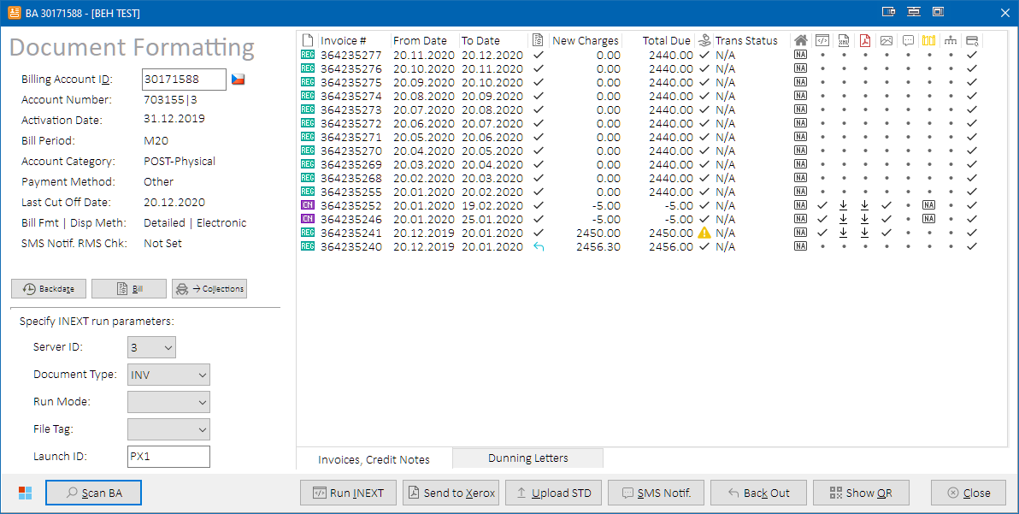

*Document Formatting (INEXT) form – Invoices & Credit Notes Tab*

|  |  |
| --- | --- |
| **Caption** | **Description** |
| **Right side – Invoices & Credit Notes Grid** | |
| ***Document Type*** | Kenan document type.  **Icon Legend:**   |  |  | | --- | --- | |  | Unknown | |  | Regular Invoice | |  | Proforma Invoice | |  | Credit Note | |
| **Invoice #** | Kenan invoice number from BILL_INVOICE table |
| **From Date** | First date included on bill, same as prev_cutoff_date for cyclical invoices |
| **To Date** | First date not included on bill, from BILL_CYCLE.cutoff_date for this cycle (for cyclical invoices). |
| ***Billed*** | Billing status:  **Icon Legend:**   |  |  | | --- | --- | |  | Unknown | |  | Unbilled | |  | Billed | |  | Backed Out | |  | Failed (a billing error occurred e.g., when trying to bill an empty proforma invoice) | |
| **New Charges** | Total new charges for invoice. Includes prebilled adjustments. |
| **Total Due** | Total amount due on the account at the time the row was created. |
| ***Paid*** | Payment status:  **Icon Legend:**   |  |  | | --- | --- | |  | Unknown | |  | Open (unpaid or partially paid) | |  | Open (unpaid or partially paid) **& overdue** | |  | Paid & closed | |  | Not Applicable (e.g., when billing has failed so payment status is not relevant) | |  | Unable to fetch |     **HINT:** Hover mouse cursor over the value to show due date of the invoice. |
| **Trans Status** | Direct Debit transaction status, based on BILL_INVOICE.PAY_METHOD:   * **Other** = N/A * **Direct Debit** = translated PAYMENT_TRANS.TRANS_STATUS value:   + 0 = Not Run   + 2 = Requested   + 4 = Rejected   + 6 = Canceled   + 8 = Confirmed   + else = Unknown |
| ***Clearing House*** | Direct Debit Clearing House:  **Icon / Value Legend:**   |  |  | | --- | --- | | N/A | Not applicable (e.g., for Other payment method or backed out invoice) | |  | Direct Debit via RBS clearing house (historical) | |  | Direct Debit via CSB clearing house (ČSOB) | |  | Direct Debit via UPC clearing house | |  | Direct Debit via SIPO (Czech Post) | |  | Warning – Unknown clearing house | |
| ***Format Status*** | Invoice formatting status (result of INEXT process):  **Icon Legend:**   |  |  | | --- | --- | |  | Unknown | |  | Not Formatted (INEXT not run) | |  | Formatted (INEXT succeeded) | |  | Not Applicable (e.g., when billing has failed so the invoice cannot be formatted) | |  | Error during formatting (INEXT failed) | |
| ***XML Document*** | XML file status:  **Icon Legend:**   |  |  | | --- | --- | |  | Unknown | |  | XML file is not stored locally | |  | XML file is stored locally | |  | Not Applicable (e.g., when billing has failed so the invoice cannot be formatted) | |
| ***PDF Document*** | PDF file status:  **Icon Legend:**   |  |  | | --- | --- | |  | Unknown | |  | PDF file is not available in eArchive | |  | PDF file available for download from eArchive | |  | PDF file is stored locally | |  | Not Applicable (e.g., when billing has failed so the invoice cannot be formatted) | |
| ***IMAGE_DONE*** | IMAGE_DONE flag status. Normally set by Kenan script SMS_launcher.ksh when dispatching Issued Invoice SMS action. If not set, collection SMS would not be sent when running CollectionSMSLauncher.ksh.  **Icon Legend:**   |  |  | | --- | --- | |  | Unknown | |  | IMAGE_DONE = 0 (i.e., not set) | |  | IMAGE_DONE > 0 (i.e., set to 1 or 3) | |  | Not Applicable (e.g., when billing has failed so the invoice cannot be formatted) | |
| ***SMS Notification*** | SMS notification status from tables VF_CONFIG.VF_BILL_INVOICE_NOTIFICATION and VF_CONFIG.VF_BILL_INVOICE_NOTIFICATION_ARCH. Set by Kenan script SMS_launcher.ksh when dispatching Issued Invoice SMS action.  **Icon Legend:**   |  |  | | --- | --- | |  | Unknown | |  | Notification record is not present, but not yet processed. | |  | Notification was processed and SMS was dispatched. **HINT:** Hover mouse over the icon to see exact SMS sending date: | |  | SMS notification is not applicable – displayed for documents with bill format EBILL (customers receive their invoices in e-mail, so SMS notifications are not sent). | |  | Notification is pending (notification record is present, but not yet processed. Run SMS launcher to process.). | |  | Notification was processed but sending of SMS failed by design – displayed for proforma invoices (SMS are not sent for proformas). | |  | Notification was processed but SMS was not sent. Process possibly ended up in error. | |
| ***Golden Gate / OLC*** | Status of invoice in OLC (based on table L0_BILL_INVOICE):  **Icon Legend:**   |  |  | | --- | --- | |  | Unknown | |  | Invoice is not present in OLC | |  | Invoice is present in OLC | |  | Not Applicable (invoice is not supposed to be synced to OLC) | |  | Error fetching invoice status from OLC | |
| ***Invoice Breakdown*** | Status of invoice breakdown data in OLC (based on tables BE_IBD#1 and BE_IBD#2):  **Icon Legend:**   |  |  | | --- | --- | |  | Unknown | |  | Invoice breakdown data is present in OLC | |  | Invoice breakdown data is not present in OLC | |  | Not Applicable (invoice is not supposed to be synced to OLC) | |  | Error fetching invoice breakdown status from OLC | |
| ***OPMP Status*** | Status of invoice in OPMP (based on table BE_INVOICE):  **Icon Legend:**   |  |  | | --- | --- | |  | Unknown | |  | Invoice is not present in OPMP | |  | Invoice is present in OPMP | |  | Not Applicable (invoice is not supposed to be synced to OPMP) | |  | Error fetching invoice status from OPMP | |

###### Dunning Letters Tab

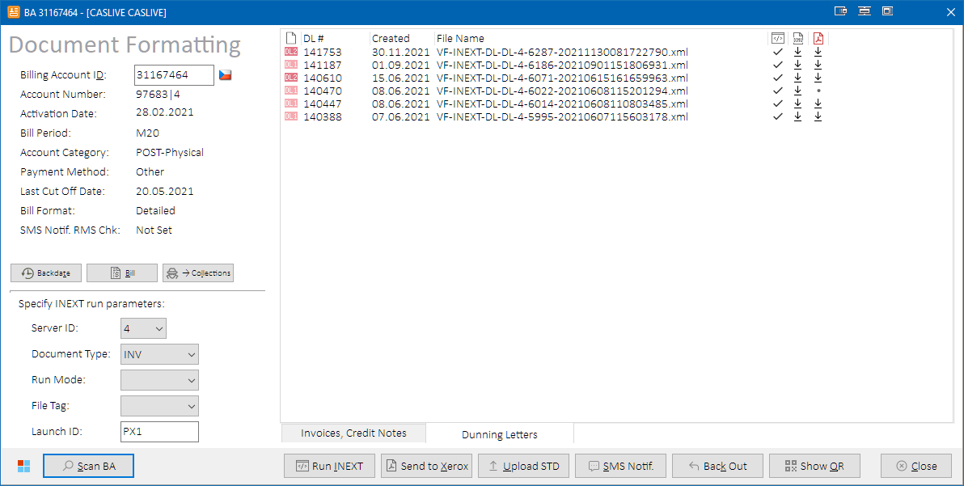

*Document Formatting (INEXT) form – Dunning Letters Tab*

|  |  |
| --- | --- |
| **Caption** | **Description** |
| **Right side – Dunning Letters grid** | |
| ***Document Type*** | Kenan document type.  **Icon Legend:**   |  |  | | --- | --- | |  | Dunning Letter type 1 (a.k.a. Initial Reminder Letter) | |  | Dunning Letter type 2 (a.k.a. Reminder Letter) | |
| **DL #** | Kenan document reference number from table VF_CONFIG.INEXT_XML_DATA. |
| **File Name** | Document file name from Kenan table VF_CONFIG.INEXT_FILES. |
| ***Format Status*** | Document formatting status (result of INEXT process):  **Icon Legend:**   |  |  | | --- | --- | |  | Unknown | |  | Not Formatted (INEXT not run) | |  | Formatted (INEXT succeeded) | |  | Error during formatting (INEXT failed) | |  | Canceled (document is marked as canceled) |     **HINT:** Hovering mouse cursor over the Format Status icon will reveal more details about the formatting error, if such has occurred. |
| ***XML Document*** | XML file status:  **Icon Legend:**   |  |  | | --- | --- | |  | Unknown | |  | XML file is not stored locally | |  | XML file is stored locally | |  | Not Applicable (e.g., when formatting has failed so the document cannot be formatted) | |
| ***PDF Document*** | PDF file status:  **Icon Legend:**   |  |  | | --- | --- | |  | Unknown | |  | PDF file is not available in eArchive | |  | PDF file available for download from eArchive | |  | PDF file is stored locally | |  | Not Applicable (e.g., when formatting has failed so the document cannot be formatted) | |

##### Role Differences

|  |  |  |  |  |  |
| --- | --- | --- | --- | --- | --- |
| **Action / Role** | **ADMIN** | **LEAD** | **TESTING-VF** | **TESTING-IBM** | **TESTING-V2** |
| **Access to Invoice Formatting (INEXT) form** | Y | Y | Y | Y | N |

##### Registering Prepaid for Invoicing

Check the **Registered** check box to register the prepaid account for invoicing in Kenan. Otherwise, invoice would not be generated for the account. Please ensure that the account meets additional off-Kenan conditions necessary for prepaid invoicing (the prepaid is not anonymous, its address is set, etc.).

Clicking on the **Information icon** next to the check box will reveal a message box with additional information for the user:

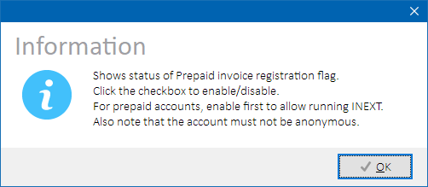

*Prepaid Registration to Invoicing – hint*

###### Process Overview

1. Query Kenan table PARAM_DEF to check if prepaid registration flag is configured on the environment. Stop processing if not configured.
2. Insert or update new value of parameter 50045 into Kenan table CMF_EXT_DATA.

##### Specifying INEXT run parameters

When an invoice is selected in the Invoice grid, Phoenix determines values of parameters that are used when launching INEXT process as follows:

|  |  |
| --- | --- |
| **Invoice Grid Item** | **INEXT parameters** |
| **Regular Invoice** | * **Run Mode = Regular** * **Document Type** = INV (postpaid) or PTD (prepaid) |
| **Proforma Invoice** | * **Run Mode = Proforma** * **Document Type** = INV (postpaid) or PTD (prepaid) |
| **Credit Note** | * **Document Type** = CN |

Should these values not suit user’s needs, they can modify them in the corresponding combo boxes in the lower-left side of the Invoice Formatting form.

Following document types are always processed per server, not per account:

* CN
* DL
* STD

User is informed about the fact with a memo below the Invoice grid:



*Memo about server-based document type processing*

Please refer to INEXT documentation for more details on INEXT parameters.

##### Running document formatting module (INEXT)

Press  **Run INEXT** button to launch INEXT process with selected run parameters.

Following pre-run checks are performed for server-based run (document types CN, DL and STD):

|  |  |
| --- | --- |
| **Check** | **Resolution** |
| **Server-based run Parameters Combination** | Server-based INEXT run will only be allowed for following run parameter value combinations:   * Document Type = CN **and** Account Category = POST **and** Server ID <> 2 and Run Mode is specified **– or –** * Document Type = DL **and** Account Category = POST **and** Server ID <> 2 **– or –** * Document Type = STD **and** Account Category IN (PRE, PRE_RES) **and** Server ID = 2   **NOTE:** It is usually not needed to manually run INEXT for DL document type (Dunning Letters), as it’s launched automatically during processing of the respective Collections events by ACI AFTER process. |

Following pre-run checks are performed for account-based run:

|  |  |
| --- | --- |
| **Check** | **Resolution** |
| **No Invoice Selected** | Select rows in the Invoice grid that you want to process. |
| **Unregistered Prepaid** | A warning message is displayed that INEXT will likely fail. User can select to cancel or continue. |
| **Prepaid E-billing** | E-BILL document type is not supported for prepaid accounts.  Select different document type. |
| **Unbilled Invoice** | Unbilled or erroneously billed invoices cannot be formatted. Refine your selection in the Invoice grid. |
| **Empty Invoice** | If billed invoice is empty (contains no rows in BILL_INVOICE_DETAIL table), it cannot be formatted – INEXT would fail. Refine your selection in the Invoice grid not to contain empty invoices. |
| **Already Formatted Invoice** | Already formatted invoices cannot be selected for another formatting.  Refine your selection in the Invoice grid not to contain already formatted invoices, or reset the invoice formatting first.  See Reset Document Formatting for more details. |
| **CN / Invoice Mixed** | Credit notes cannot be formatted in account-based mode. Refine your selection in the Invoice grid so that Credit Notes are not selected together with Invoices. |
| **Regular / Proforma Invoice Mixed** | Regular and Proforma invoices must be formatted separately.  Refine your selection in the Invoice grid so that Regular Invoices are not selected together with Proforma Invoices. |

Upon further confirmation, INEXT process is launched:

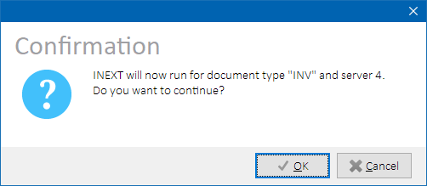

*INEXT launch confirmation dialog*

**NOTE:** XMLSENDER process is also locked during INEXT processing so that other Phoenix users cannot send created XML files from Kenan server to Xerox in the meantime. Otherwise, the files could not be downloaded.

While INEXT is running, Working form will display current processing status:

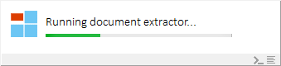

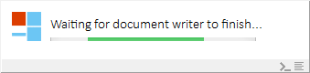

*INEXT execution – progress bar examples*

When INEXT extractor and writer modules finish, user is asked to download created invoice XML files:

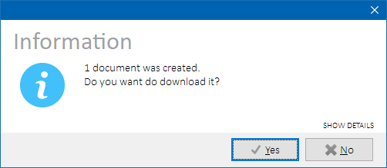

*XML Document download confirmation dialog*

**NOTES:**

* Documents downloading is only available for invoice XML’s. If other document types were processed, the option will not be available.
* Click **SHOW DETAILS** labelin the dialog to show a list of filenames that INEXT has produced.

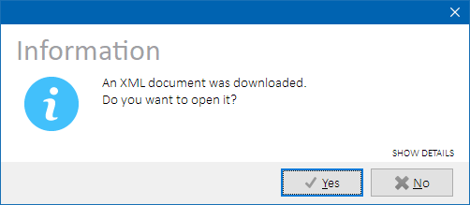

*XML Document opening confirmation dialog*

**NOTES:**

* Document opening is only available if a single invoice XML was downloaded. If multiple files were downloaded, the option will not be available.
* Click **SHOW DETAILS** labelin the dialog to show a list of filenames that INEXT has produced.

Several additional tasks that usually are necessary after invoice formatting will also be executed, such as running SIPO Report Launcher (if the account is postpaid and uses SIPO payment method).

###### Process Overview

1. Lock processes INEXT, XMLSENDER
2. Check INEXT-related DB objects validity in Kenan VF_CONFIG schema. Stop processing if invalid objects are found.
3. Fetch latest extractor run ID from table VF_CONFIG.INEXT_RUNS for given Launch ID and store it for later comparison
4. If running in account-mode:
   1. Delete old content with selected Launch ID from table VF_CONFIG.INEXT_INV_LIST
   2. If document type IN (INV, CN), insert selected invoice and credit note numbers into table VF_CONFIG.INEXT_INV_LIST
   3. If document type IN (EBILL, ALL), purge previously extracted e-bill documents from Kenan folder $ARBORDATA/inext/ready folder.
5. Execute Kenan script inext.ksh with selected run parameter values
6. Check SSH output. Stop processing if errors are detected.
7. Fetch new extractor run ID from table VF_CONFIG.INEXT_RUNS for given Launch ID that is larger than the one stored in step 3. Stop processing if none is found.
8. Periodically check table VF_CONFIG.INEXT_RUNS until RUN_STATUS > 10 (INEXT extractor is finished).
9. If RUN_STATUS <> 50 (Finished), check one of the below guiding tables corresponding to selected document type:
   1. VF_CONFIG.INEXT_CN_GUIDE
   2. VF_CONFIG.INEXT_DL_GUIDE
   3. VF_CONFIG.INEXT_INV_GUIDE

If RUN_STATUS = 90 (Error), retrieve detailed error message.  
Unlock processes INEXT, XMLSENDER, stop processing and report INEXT extractor error.

1. Check number of extracted documents. If DOCS_IMPORTED = 0, unlock processes INEXT, XMLSENDER, stop processing and report that there were no documents to extract.
2. Fetch latest writer run ID from table VF_CONFIG.INEXT_WRITE_RUNS for given Launch ID and store it for later comparison.
3. Periodically check table VF_CONFIG.INEXT_WRITE_RUNS until STATUS > 1 (INEXT writer is finished).
4. If STATUS <> 5 (Finished), retrieve detailed error message, unlock processes INEXT, XMLSENDER, stop processing and report INEXT writer error.
5. Check statistics in table VF_CONFIG.INEXT_FILES. If count of files in Ready state (STATE = 6) = 0, unlock processes INEXT, XMLSENDER, stop processing and report that there were no files created.
6. Fetch file names from table VF_CONFIG.INEXT_FILES.
7. Execute Kenan script SIPOReportLauncher.ksh (if configured to run after INEXT, and if the account is eligible – see conditions above).
8. Unlock process INEXT.
9. If document type IN (DL, STD), unlock process XMLSENDER and stop processing. Downloading of XML files for DL documents is not automatically offered to the user, but they can be manually downloaded from the Dunning Letters grid. Downloading of XML files for STD documents is not yet supported.
10. Ask the user to download created invoice or credit note XML files. If download is not requested, unlock processes INEXT, XMLSENDER and stop processing.
11. Download created invoice or credit note XML files from Kenan folder $ARBORDATA/inext/ready to user-selected local folder.
12. Update **Format Status** and **XML Document** column values in the Invoice grid.
13. Store local locations of downloaded XML files to Windows registry key HKCU\Software\Phoenix\Docs\<environment>\, so that they can be worked with even after Phoenix is restarted.
14. Ask the user to open downloaded XML file, if only one file was downloaded
15. Open the file in an application that is associated with opening of files with .XML extension.
16. Unlock process XMLSENDER.

###### Role differences

|  |  |  |  |  |  |
| --- | --- | --- | --- | --- | --- |
| **Action / Role** | **ADMIN** | **LEAD** | **TESTING-VF** | **TESTING-IBM** | **TESTING-V2** |
| **Access to Running INEXT** | Y | Y | Y | Y | N |

##### Sending XML to Xerox

Press  **Send to Xerox** button to send all XML’s present in Kenan output folder to Xerox via SFTP.

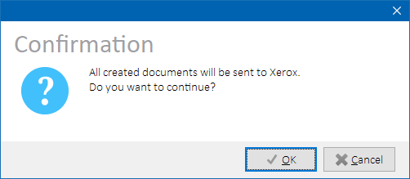

*XMLSender - user confirmation*

###### Process Overview

1. Lock process XMLSENDER
2. Execute Kenan script XMLSender.ksh in ALL mode.
3. Check SSH output and report no documents to process or processing errors.
4. If account billing mode is e-billing or selected document type is IN (EBILL, ALL):
   1. execute Kenan script XMLSender.ksh in EBILL mode.
   2. Check SSH output and report no documents to process or processing errors.
5. Unlock process XMLSENDER

**NOTE:** By default, Kenan output folder containing the XML’s is $ARBORDATA/inext/ready.

Please refer to Kenan system documentation for more details on the XMLSender process.

###### Role differences

|  |  |  |  |  |  |
| --- | --- | --- | --- | --- | --- |
| **Action / Role** | **ADMIN** | **LEAD** | **TESTING-VF** | **TESTING-IBM** | **TESTING-V2** |
| **Access to XMLSender** | Y | Y | Y | Y | N |

##### Uploading STD Requests to Kenan

Press  **Upload STD** button to upload all STD request files created by Siebel and transferred to Kenan input folder to Kenan database. Once uploaded, INEXT can process them further.

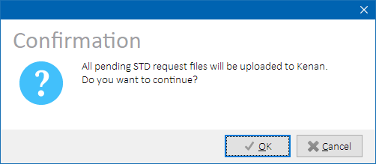

*STDUpload – user confirmation*

###### Process Overview

1. Lock process STDUPLOAD
2. Execute Kenan script IET_STDUpload.ksh.
3. Stop processing on errors.
4. Unlock process STDUPLOAD

**NOTES:**

* Kenan input folder for STD request files from Siebel is $ARBORDATA/iet/std/ready.
* Kenan table holding uploaded STD requests is VF_CONFIG.SIMPLE_TAX_REQ

Please refer to Kenan system documentation for more details on the STDUpload process.

Role Differences

|  |  |  |  |  |  |
| --- | --- | --- | --- | --- | --- |
| **Action / Role** | **ADMIN** | **LEAD** | **TESTING-VF** | **TESTING-IBM** | **TESTING-V2** |
| **Access to STD Upload** | Y | Y | N | Y | N |

##### Backing Out an Invoice

Press  **Back Out** button to back out (revert) the newest Regular invoice on the account. Suitable row is selected automatically in the Invoices grid. Operation cannot be performed if there’s no Regular invoice to back out.

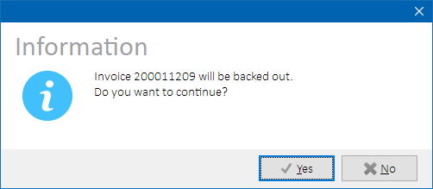

Upon confirmation, Kenan billing module will be run in BACKOUT mode, the invoice will be flagged as backed out and account balances will be recalculated as if the invoice was never issued.

###### Process Overview

1. Lock process BIP
2. Execute Kenan script BipLauncher.sh in BACKOUT mode  
   Check billing logs, stop processing in case of error
3. Get current debt
4. Allocate suspense balance if applicable (see Payment Allocation for more details).
5. Execute Kenan script invoice_split.ksh
6. Reload account data
7. Unlock process BIP

###### Role Differences

|  |  |  |  |  |  |
| --- | --- | --- | --- | --- | --- |
| **Action / Role** | **ADMIN** | **LEAD** | **TESTING-VF** | **TESTING-IBM** | **TESTING-V2** |
| **Access to Back Out** | Y | Y | N | Y | N |

##### Running SMS Launcher module

Press  ***SMS Notif.*** button to execute SMS Launcher module that processes SMS notifications for newly issued invoices. The invoices must already have been processed by eArchive (i.e. have PDF document ready to download).

If the process finishes successfully, information dialog is displayed. If errors occurred during processing, parsed details about each invoice processing result are also available:

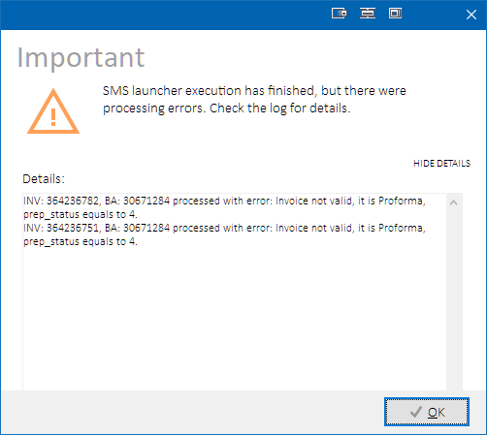

*SMS Launcher – successful execution*

If no notifications were processed, the user is informed as follows:

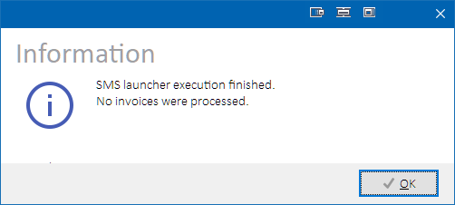

If errors are detected in the module output, corresponding error dialog is displayed as well.

###### Process Overview

1. Lock process SMS_LAUNCHER
2. Check if SMS_launcher.ksh is currently running
3. If the process is already running, stop processing and display the reason
4. Execute Kenan script SMS_launcher.ksh
5. Unlock process SMS_LAUNCHER

###### Role Differences

|  |  |  |  |  |  |
| --- | --- | --- | --- | --- | --- |
| **Action / Role** | **ADMIN** | **LEAD** | **TESTING-VF** | **TESTING-IBM** | **TESTING-V2** |
| **Access to SMS Launcher Module** | Y | Y | N | Y | N |

##### Displaying Invoice QR Code

Press  **Show QR** button to display Payment QR Code form for selected invoice:

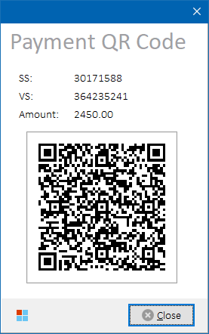

*Payment QR Code form*

Values of specific symbol, variable symbol and amount due are presented along with the QR code picture. The form is not modal so it is possible for the user to iterate among invoices (rows) on Document Formatting (INEXT) form and their QR code will automatically be refreshed.

###### Process Overview

1. Load message template text QR_CODE_TEMPLATE from table RMSTOOL_CONFIG.
2. Replace variable placeholders with actual values for selected invoice:
   * %SS% = specific symbol
   * %VS% = variable symbol
   * %AM% = amount
3. Generate QR code picture.
4. Display payment QR Code form if not already showing.

###### Role Differences

|  |  |  |  |  |  |
| --- | --- | --- | --- | --- | --- |
| **Action / Role** | **ADMIN** | **LEAD** | **TESTING-VF** | **TESTING-IBM** | **TESTING-V2** |
| **Access to Payment QR Code form** | Y | Y | Y | Y | N |

##### Setting / Clearing image done flag

Select formatted invoice(s) in the invoice grid. Press right mouse button to open context menu and select  **Modify image done flag 🡪 Set / Clear** item. Image done flag will be set for the selected documents.

###### Process Overview

1. Check if there are rows selected in the invoice grid.
2. Check if selected invoices are formatted.
3. Check if selected invoices have billing or formatting errors. Stop if so.
4. Update IMAGE_DONE value in Kenan table BILL_INVOICE to:
   1. 0 if clearing
   2. 1 if setting for invoices formatted in XML mode
   3. 3 if setting for invoices formatted in XML+EBILL mode
5. If clearing, also update Kenan table VF_CONFIG.VF_BILL_INVOICE_NOTIFICATION as follows, so that the notification can be re-triggered:
   1. SMS_SENDING_DATE = NULL
   2. EMAIL_SENDING_DATE = NULL
   3. SMS_PROCESSED_DATE = NULL
   4. EBILL_PROCESSED_DATE = NULL
   5. SENT_FOR_REPROCESS = 0

###### Role Differences

|  |  |  |  |  |  |
| --- | --- | --- | --- | --- | --- |
| **Action / Role** | **ADMIN** | **LEAD** | **TESTING-VF** | **TESTING-IBM** | **TESTING-V2** |
| **Access to Modify image done flag** | Y | Y | N | Y | N |

##### Changing of Due Date

Select an invoice in the invoice grid. Press right mouse button to open context menu and select  **Change due date** item to open Preferred Payment Due Date (PPDD) Properties form:

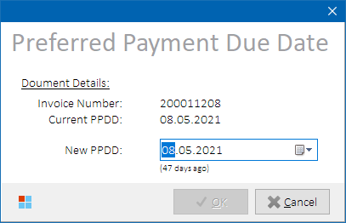

*Preferred Payment Due Date Properties form*

Select new preferred due date and press **OK** button to continue. Invoice due date will be updated in Kenan database.

###### Process Overview

1. Check if there is exactly one row selected in the invoice grid.
2. Check if selected row represents invoice document.
3. Check if selected invoice has billing errors. Stop if so.
4. Show PPDD Properties form.
5. Update PAYMENT_DUE_DATE value in Kenan table BILL_INVOICE.
6. Update PPDD_DATE and ORIG_PPDD_DATE values in Kenan table CMF_BALANCE.
7. Update PAYMENT_DUE_DATE value in Kenan table PAYMENT_TRANS.
8. Update PAYMENT_DUE_DATE value in Kenan table VF_CONFIG.VF_SIPO_PAYMENT_TRANS.

###### Role Differences

|  |  |  |  |  |  |
| --- | --- | --- | --- | --- | --- |
| **Action / Role** | **ADMIN** | **LEAD** | **TESTING-VF** | **TESTING-IBM** | **TESTING-V2** |
| **Access to PPDD form** | Y | Y | N | Y | N |

##### Reset Document Formatting

Select formatted invoices or credit notes in the invoice grid. Press right mouse button to open context menu and select  **Reset formatting** item. Document status will be reverted as if they were not formatted. After the reset, INEXT can be run for the documents again.

**NOTE:** Aside from invoices and credit notes, account’s DL and STD documents formatting is always reset regardless of whether there are rows selected in the invoice grid or not. User is informed about the fact with additional dialog box.

###### Process Overview

1. Check if there are rows selected in the invoice grid.
2. Check if selected documents have billing errors. Stop if so.
3. For selected invoices or credit notes:
   1. Update Kenan table BILL_INVOICE with FORMAT_STATUS=0, IMAGE_DONE=0.
   2. Delete the invoice from table VF_CONFIG.INEXT_INV_GUIDE.
   3. Delete the CN from table VF_CONFIG.INEXT_CN_GUIDE.
4. For account’s DL documents:
   1. Delete the DL from table VF_CONFIG.INEXT_DL_GUIDE.
   2. If the account is in collections, update Kenan table VF_CONFIG.A2S_ACTION_DISPATCH with PROCESS_STATUS=0 where ACTION_TYPE=15 (Dunning Letter) for account’s current collectable ID.
5. For account’s STD documents:
   1. Delete the STD from table VF_CONFIG.INEXT_STD_GUIDE.
   2. Update Kenan table VF_CONFIG.SIMPL_TAX_REQ with PROCESSING_STATUS=0 for all MSISDNs on the account.
6. Update PAYMENT_DUE_DATE value in Kenan table VF_CONFIG.VF_SIPO_PAYMENT_TRANS.
7. Remove previously stored local document filenames for affected invoices.
8. Reload account data

###### Role Differences

|  |  |  |  |  |  |
| --- | --- | --- | --- | --- | --- |
| **Action / Role** | **ADMIN** | **LEAD** | **TESTING-VF** | **TESTING-IBM** | **TESTING-V2** |
| **Access to Reset Formatting** | Y | Y | N | Y | N |

##### Reset Issued Invoice Notification

****Select formatted invoices or credit notes in the invoice grid. Press right mouse button to open context menu and select **Reset notification** item. Notification status will be reverted as if it was not processed. After the reset, SMS Launcher can be run for the documents again.

###### Process Overview

1. Check if there are rows selected in the invoice grid.
2. For selected invoices or credit notes:
   1. Update Kenan table VF_CONFIG.VF_BILL_INVOICE_NOTIFICATION with:
      1. SMS_SENDING_DATE = NULL
      2. EMAIL_SENDING_DATE = NULL
      3. SMS_PROCESSED_DATE = NULL
      4. EBILL_PROCESSED_DATE = NULL
      5. SENT_FOR_REPROCESS = 0
3. Reload account data

###### Role Differences

|  |  |  |  |  |  |
| --- | --- | --- | --- | --- | --- |
| **Action / Role** | **ADMIN** | **LEAD** | **TESTING-VF** | **TESTING-IBM** | **TESTING-V2** |
| **Access to Reset Notification** | Y | Y | N | Y | N |

##### XML / PDF File Operations

****Select a formatted document in the respective document grid. Press right mouse button to open context menu and select **XML 🡪 <file operation>**, or **PDF 🡪 <file operation>**, respectively.

Following operations are available:

|  |  |
| --- | --- |
| **File Operation** | **Description** |
| **Download from Kenan** | XML file for selected document will be downloaded from Kenan and stored locally to user-defined folder. Once the file is downloaded, the icon changes to a check mark. If single file was downloaded, the user is asked whether they want to open it right away (see **Open** task below).  **NOTE:** XML document data must be available for download in Kenan. |
| **Download from eArchive** | PDF file for selected document will be downloaded from Kenan and stored locally to user-defined folder. Once the file is downloaded, the icon changes to a check mark. If single file was downloaded, the user is asked whether they want to open it right away (see **Open** task below).  **NOTE:** PDF document data must be available for download in eArchive. |
| **Open** | Locally stored XML or PDF file for selected document will open in an application that is associated with opening of files with the particular file extension (.XML or .PDF). If local file is not accessible, a dialog will be displayed. |
| **Show in folder** | Locally stored XML or PDF file for selected document will be located and focused in newly opened Windows Explorer window. If local file is not accessible, a dialog will be displayed. |
| **Copy** | Locally stored XML or PDF file for selected document will be copied to clipboard (as file object). If local file is not accessible, a dialog will be displayed.  **NOTE:** Once copied, the file can be pasted in Outlook as an attachment, etc. |
| **Copy file path** | File name of locally stored XML or PDF file for selected document will be copied to clipboard including full path. If local file is not accessible, a dialog will be displayed. |
| **Check eArchive downloader lock status** | Will check if eArchive downloader is locked for billing invoice and dunning letter document types.  If the particular document type downloader is locked, it means that   * either it’s currently in use (PDF files are currently being downloaded from Xerox SFTP to eArchive database), * or it got stuck and PDF files are not being periodically downloaded   Re-check lock status after a few minutes. If the downloader is locked longer than expected (usually only a few minutes), it usually means it’s stuck and must be unlocked by eArchive application support.  User is informed about the fact with a warning memo by the bottom edge of the the Invoice or Dunning Letters grid:  *Warning memo about locked eArchive downloader*    **NOTE:** This operation is only available from the **PDF** submenu. |

###### Process Overview

eArchive Document Download

1. Login to UCM database as <UCM_DB_USER>/<UCM_DB_PASW>@<UCM_DB>
2. Select available primary documents from tables DOCMETA, FILESTORAGE and DOCUMENTS for given input BA and BILL_REF_NO.
3. For each found document:
   1. Download PDF binary data from table FILESTORAGE to memory stream.
   2. Save document binary data from memory stream to local file.

eArchive Process Lock Status Check

1. Establish SSH connection to UCM server as < UCM_UNIX_USER>@< UCM_UNIX_HOST>:< UCM_UNIX_PORT> using < UCM_UNIX_PASW> password.
2. Chdir to <UCM_UNIX_LOCK_PATH>
3. Count number of lock files configured in <UCM_UNIX_LOCK_FILENAMES>
4. Count number of lock files configured in <UCM_UNIX_LOCK_FILENAMES_DL>
5. Log Warning message and show Warning Memo if number of found lock files is larger than 0.

###### Role Differences

|  |  |  |  |  |  |
| --- | --- | --- | --- | --- | --- |
| **Action / Role** | **ADMIN** | **LEAD** | **TESTING-VF** | **TESTING-IBM** | **TESTING-V2** |
| **Access to file operations** | Y | Y | N | Y | N |

##### Create SIPO Confirmation File for an Invoice

Select a formatted invoice in the invoice grid. Press right mouse button to open context menu and select  **SIPO 🡪 Create SIPO confirmation file (ZA*.*)**. Select destination folder and press **OK**. SIPO confirmation file will be generated and saved to selected folder.

Output text file content is formatted according to project CHG-027023 - CTMR SIPO CR10:

|  |  |  |  |
| --- | --- | --- | --- |
| **#** | **Field** | **Length** | **Description + Value** |
| **01** | Recipient Number | 6 | Payment recipient number - assigned to VF / UPC by contract with Czech Post.  **Value:** based on account’s UPC Migration Flag value from CMF_EXT_PARAMS (PARAM_ID 50051):   * 0 - Not migrated (VF) account: 907229 * 1 - Migrated (UPC) account: 907168 |
| **02** | Connection Number | 10 | SIPO Payer ID  **Value:** SIPO Connection Number value from CMF_EXT_PARAMS (PARAM_ID 50053) |
| **03** | Period | 6 | Month, when payment was requested in MMYYYY format.  **Value:** BILL_INVOICE.TO_DATE |
| **04** | Payment Code | 3 | Defined by Czech Post, according to contract.  **Value:** 145 |
| **05** | Paid Amount | 9 | Payment amount in CZK in format KKKKKK.HH (only integer allowed).  **Value:** BILL_INVOICE.TOTAL_DUE |
| **06** | Date of Payment | 10 | Date the payment was posted in format DD.MM.YYYY.  **Value:** BILL_INVOICE.TO_DATE + 1 day |
| **07** | Text for Recipient | 18 | Free text.  **Value:** BILL_INVOICE.BILL_REF_NO |

Filename pattern: *"ZAppppp_yyyyMMddHHMISS.DDD"*

* **pppppp** = Recipient Number (see above, field #01)
* **yyyyMMddHHMISS** *=* timestamp of file generation
* **DDD** = day of the year

Created file can be used as an input for processing of incoming SIPO payments from Czech Post simulating that the invoice was successfully paid using SIPO.

**NOTE:** This option is only available for invoices with SIPO clearing house.

###### Role Differences

|  |  |  |  |  |  |
| --- | --- | --- | --- | --- | --- |
| **Action / Role** | **ADMIN** | **LEAD** | **TESTING-VF** | **TESTING-IBM** | **TESTING-V2** |
| **Access to creating SIPO Confirmation File** | Y | Y | N | Y | N |

## Tibco Operations

### EHC Task Events (EHC Status)

Select **Tibco 🡪 EHC Task Events** from the main menu to search in Tibco EHC tables. Tibco EHC contains data about Tibco task events that go through Tibco and their processing status. If a row with known MSIDN / BA / CA is selected in the main grid while EHC Task Events form is invoked, the values will be prefilled in their correspondingfilter fields.

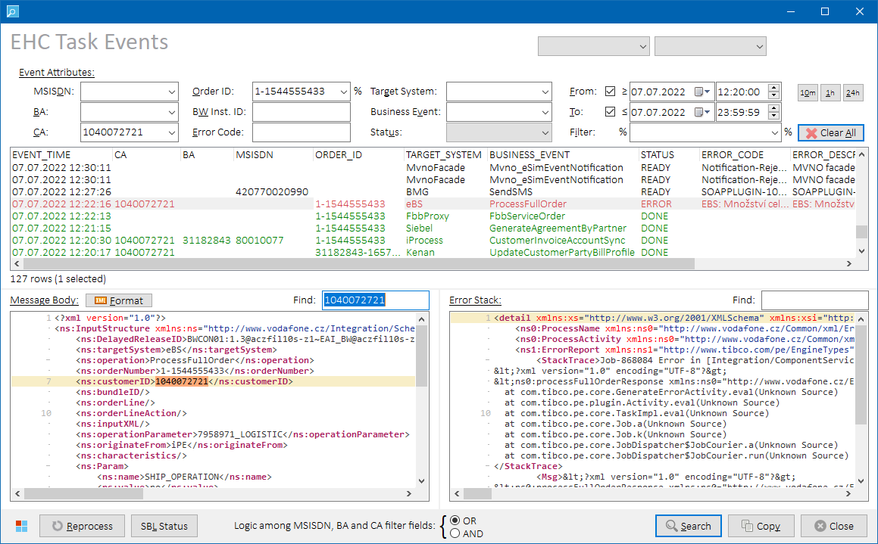

*EHC Task Events form*

**Row Color Legend:**

|  |  |
| --- | --- |
| GREEN | Events with status DONE |
| RED | Events with status ERROR |
| BLACK | Events with status different from DONE and ERROR |

##### Controls

###### Search Filter Fields

User can apply additional search conditions using following filter edit boxes on top of the form:



|  |  |
| --- | --- |
| **Filter Edit Box** | **Description** |
| **MSISDN** | Show only events with matching MSISDN (MSISDN) or set of MSISDN’s.  **NOTES:**   * If *EHC Task Events* form is opened from main menu, the combo box is pre-filled with MSISDN value from selected row in the main grid. * If *EHC Task Events* form is opened from Collections form, or from STP Status form opened from within the Collections form, the combo box is pre-filled with subscribers belonging to the BA that is currently open on the Collections form. If there are more subscribers, additional item “**(any of the below)**” is inserted before all the MSISDN’s. Select this item to limit the search to any of the subscribers listed in the combo box (using logical OR). |
| **BA** | Show only events with matching Billing Account (ACCOUNTCODE).  **NOTES:**   * If *EHC Task Events* form is opened from main menu, the combo box is pre-filled with BA value from selected row in the main grid. * If *EHC Task Events* form is opened from Collections form, the combo box is pre-filled with BA number that is currently open on the Collections form. |
| **CA** | Show only events with matching Customer Account (CUSTOMERCODE).  **NOTES:**   * If *EHC Task Events* form is opened from main menu, the combo box is pre-filled with CA value from selected row in the main grid. * If *EHC Task Events* form is opened from Collections form, the combo box is pre-filled with CA number related to the BA that is currently open on the Collections form. |
| **Order ID** | Show only events with matching Order ID (ORDERID).  **NOTES:**   * If *EHC Task Events* form is opened from *STP Status* form, the combo box might be pre-filled with *BO_ID* identifier from the selected STP transaction. See STP Status for more details. |
| **BW Inst. ID** | Show only events with matching BW Instance ID (BWINSTANCEID). |
| **Error Code** | Show only events with matching error code (ERRORCODE). |
| **Target System** | Show only events with matching Target System (TARGETSYSTEM).  List of available values is retrieved from EHC_TARGET_SYSTEMS table when the form is displayed for the first time. |
| **Business Event** | Show only events with matching Business Event (BUSINESSEVENT).  List of available values is retrieved from EHC_BUSINESS_EVENTS table when the form is displayed for the first time. |
| **Status** | Show only event with given status (STATUS).  List of available values is retrieved from EHC_EVENT_STATUSES table when the form is displayed for the first time. |
| **From Time** | Show only events that came to Tibco between specified dates and times (EVENTTIME). See also *Form-specific button controls* section below.  **NOTES:**   * Default From Time value is sysdate – 10 minutes. * Default To Time value is end of today (23:59:59). * If *EHC Task Events* form is opened from within *STP Status* form:   + From Time is populated with *START_DT* value from the selected STP transaction.   + End Time is set to From Time + 20 minutes. |
| **To Time** |
| **Filter** | Show only events with message body containing given substring.   * If *EHC Task Events* form is opened from *STP Status* form, the combo box might be pre-filled with *ST_ID* identifier from the selected STP transaction. See STP Status for more details. |

All search values are case-sensitive.

If no search filter is applied, the search will be limited to last 24 hours by default.

Search-filter-fields-related controls:

|  |  |
| --- | --- |
| **Caption** | **Description** |
| **Clear All** | Clears all search filter fields. |
| **From/To** | If checked, respective from/to datetime condition is included in the search. |
| **10m** | Sets date/time picker values as follows:   * **From Time:** Sysdate – 10 minutes * **To Time:** End of today (23:59:59) |
| **1h** | Sets date/time picker values as follows:   * **From Time:** Sysdate – 1 hour * **To Time:** End of today (23:59:59) |
| **24h** | Sets date/time picker values as follows:   * **From Time:** Sysdate – 24 hours * **To Time:** End of today (23:59:59) |

###### Additional Controls

|  |  |
| --- | --- |
| **Caption** | **Description** |
| **Find** | Finds input text within *Message Body* or *Error Stack* memo content. |

###### Additional Buttons

|  |  |
| --- | --- |
| **Caption** | **Description** |
| **Format** | Re-formats XML content of *Message Body* memo. If the original content is Base64-encoded, it’s decoded first. |
| **Reprocess** | Reprocesses selected events.  See Tibco Event Reprocessing for more details. |
| **SBL Status** | Opens selected order in the Siebel status form.  See Siebel Status for more details. |
| **Search** | Retrieves list of events matching with provided search conditions and populate them to the *Event List* grid on the upper side of the form. Events are sorted by their EVENTTIME in descending order. |
| **Copy** | Copies the *Event List* grid content to clipboard as a structured text table with **TAB**-separated values into clipboard. If no rows are selected, then the whole grid is copied. If some rows are selected, then only selected rows are copied.   **HINT:** Hold **ALT** while clicking on the **Copy** button (or press **ALT+CTRL+C**) to include also additional event data from *Message Body* and *Error Stack* memos. While the **ALT** key is pressed down, **Copy** button caption changes to **“Copy+”** to indicate that extended set of data is going to be copied to clipboard. |
| **Logic among MSISDN, BA and CA filter fields** | Select which logical operator to apply when filtering the search by MSISDN, BA, or CA value. Filter condition will be updated accordingly.   * **OR:** … AND (MSISDN = <msisdn> OR BA = <ba> OR CA = <ca>) AND … * **AND:** … AND (MSISDN = <msisdn> AND BA = <ba> AND CA = <ca>) AND …   Using OR operator is useful when the user is unsure which of the three values is actually logged in the EHC event table.  **NOTE:** Other fields are always filtered using AND operator. |

###### Additional Keyboard Shortcuts

|  |  |
| --- | --- |
| **Key** | **Description** |
| **Numpad +** | If single row is selected in the *Event List* grid, value of selected cell will be copied to search filter field assigned to selected column. |
| **Numpad -** | If single row is selected in the *Event List* grid, and there’s a search filter field assigned to selected column, respective search filter field will be cleared. |
| **Numpad \*** | If single row is selected in the *Event List* grid, all search filter fields will be cleared and value of selected cell will be copied to search filter field assigned to selected column. |
| **Numpad /** | All search filter fields will be cleared. |

##### Output Data

Following output columns are present in the *Event List* grid:

|  |
| --- |
| **Column Name** |
| CA |
| BA |
| MSISDN |
| ORDER_ID |
| TARGET_SYSTEM |
| BUSINESS_EVENT |
| EVENT_TIME |
| STATUS |
| ERROR_CODE |
| ERROR_DESCR |
| BW_INSTANCE_ID |

Click on an event in the *Event List* grid to load its body in the *Message Body* memo in the lower-left part of the form.

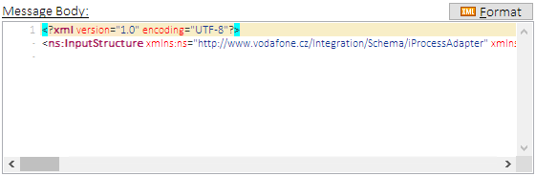

*Message Body memo example – original formatting*

If XML content in the *Message Body* memo is not well-formatted, press  **Format** button to re-format it:

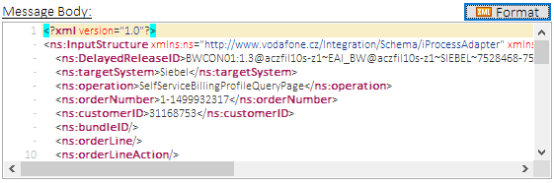

*Message Body memo example – formatted*

**NOTE:** *Message Body* is re-formatted automatically upon loading if the original content only has 1 or 2 lines, or if Base64 encoding is detected.

If an event with **ERROR** status is selected in the *Event List* grid, error details are displayed in the *Error Stack* memo in the lower-right part of the form:

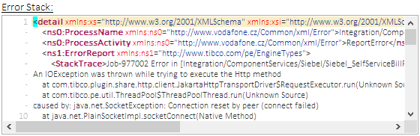

*Error Stack memo example*

##### Process Overview

1. Configuration tables **TIBCOINT.**EHC_TARGET_SYSTEMS, **TIBCOINT.**EHC_BUSINESS_EVENTS and **TIBCOINT.**EHC_EVENT_STATUSES are queried for available values to filter the events by.
2. Tibco event tables **TIBCOINT.EVENTS** and **TIBCOINT.EVENTS_ERRORS** are queried for Tibco events matching user-defined filter criteria.

##### Role Differences

|  |  |  |  |  |  |
| --- | --- | --- | --- | --- | --- |
| **Action / Role** | **ADMIN** | **LEAD** | **TESTING-VF** | **TESTING-IBM** | **TESTING-V2** |
| **Access to EHC Task Events Form** | Y | Y | N | Y | N |

##### Tibco Event Reprocessing

Select Tibco event in ERROR status in the Event List grid. Press  **Reprocess** button to have the event reprocessed. If no row is selected then all eligible events will be reprocessed.

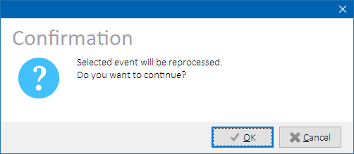

*Tibco Event Reprocessing – confirmation dialog*

Event’s status will be updated to READY and the event will then be picked and processed by Tibco once again.

###### Role Differences

|  |  |  |  |  |  |
| --- | --- | --- | --- | --- | --- |
| **Action / Role** | **ADMIN** | **LEAD** | **TESTING-VF** | **TESTING-IBM** | **TESTING-V2** |
| **Access to Event Reprocessing** | Y | Y | N | Y | N |

### Tibco SMS History

Select **Tibco 🡪 Tibco SMS History** in the main menu to open Tibco SMS History form. Enter a MSISDN in 420nnnnnnnnn format to display SMS messages sent to BMG for selected MSISDN in last 30 days. If a row with populated MSISDN is selected in the main grid upon form opening, MSISDN from that row will be used.

Following data sets are available to display:

|  |  |
| --- | --- |
| **Data Set** | **Description** |
| **Basic** | Basic details about dispatched SMS messages are displayed.  See [Data Set “Basic”](All#_Data_Set_) for more details. |
| **Extended** | Extended details about dispatched SMS are displayed, incl. BMG processing status.  See [Data Set “Extended”](Pending#_Data_Set_) for more details. |

Output columns vary per selected data set. Please refer to Tibco and BMG system documentations for more details on the column meanings and values.

Messages are sorted by DATETIME in descending order.

If a single row is selected in the messages grid, full SMS text is also displayed in below memo.

##### Data Set “Basic”

Basic view of SMS messages dispatched from Tibco to BMG. Rows are colored according to BMG processing result.

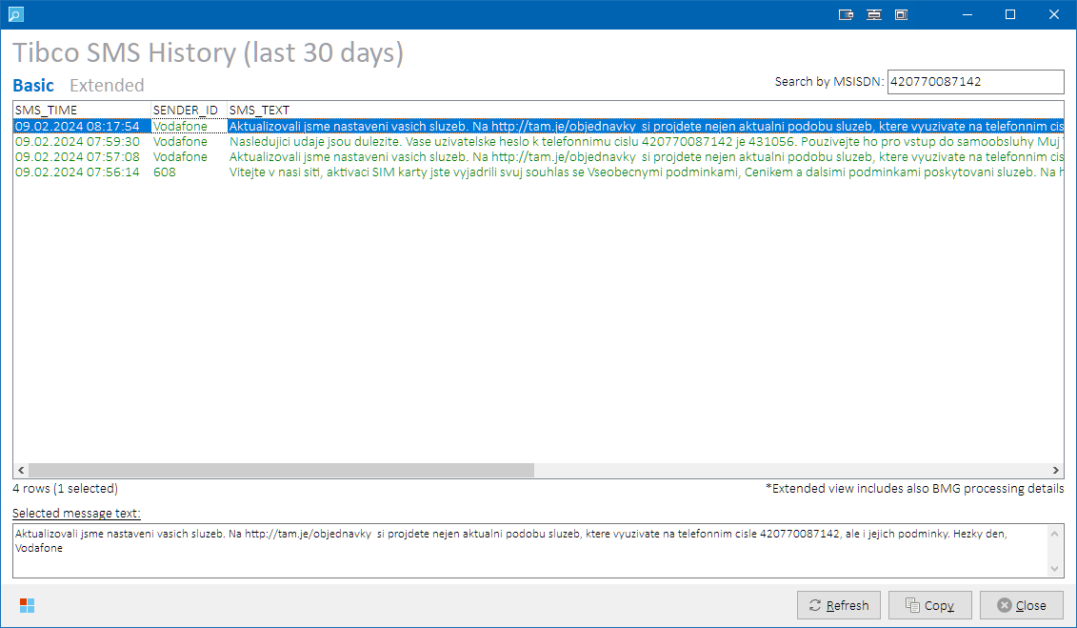

*Tibco SMS History form – data set “****Basic****”*

**Row Color Legend:**

|  |  |
| --- | --- |
| GREEN | Messages with BMG status Success |
| RED | Messages with BMG status Server error |
| BLACK | Messages with empty BMG status (BMG response not received) |
| PURPLE | Messages with BMG status value different from all above. |

**NOTE:** BMG status value is not visible in **Basic** data set.

Following output columns are returned:

|  |  |
| --- | --- |
| **Column** | **Description** |
| SMS_TIME | Datetime the SMS was sent from Tibco to BMG. (TIMESTAMP) |
| SENDER_ID | Sender identification.  Extracted from request message XMLBODY elements:  /SenderIdentification/SenderAddress/ShortCode **– or –**  /SenderIdentification/SenderAddress/AlphaNumeric (whichever is not empty) |
| SMS_TEXT | Message text sent from Tibco to BMG.  Extracted from request message XMLBODY element:  /MessageExtraData/element[3]/value |

##### Data Set “Extended”

This view includes additional identifiers as Tibco BW Instance ID, BMG message ID, and message processing status received from BMG.

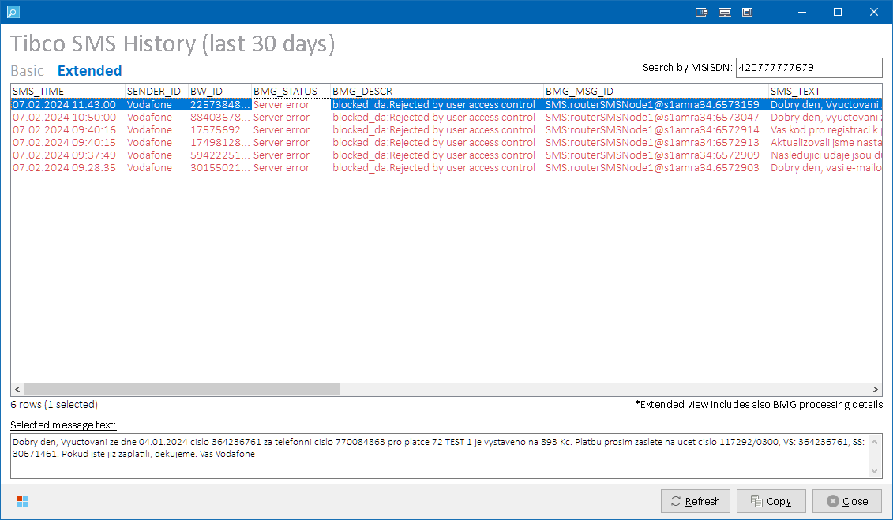

*Tibco SMS History form – data set “****Extended****”*

**Row Color Legend:**

|  |  |
| --- | --- |
| GREEN | Messages with BMG status Success |
| RED | Messages with BMG status Server error |
| BLACK | Messages with empty BMG status (BMG response not received) |
| PURPLE | Messages with BMG status value different from all above. |

Following output columns are returned:

|  |  |
| --- | --- |
| **Column** | **Description** |
| SMS_TIME | Datetime the SMS was sent from Tibco to BMG. (TIMESTAMP) |
| SENDER_ID | Sender identification.  Extracted from request message XMLBODY elements:  /SenderIdentification/SenderAddress/ShortCode **– or –**  /SenderIdentification/SenderAddress/AlphaNumeric (whichever is not empty) |
| BW_ID | Tibco BW instance ID. |
| BMG_STATUS | Message processing status received from BMG.  Extracted from response message XMLBODY element:  /Status/StatusText |
| BMG_DESCR | Message processing status description received from BMG.  Extracted from response message XMLBODY element:  /Status/Details/Description |
| BMG_MSG_ID | Internal message ID assigned to the SMS message by BMG.  Extracted from response message XMLBODY elements:  /MessageID  E.g.: SMS:routerSMSNode1@s1amra34:6572914 |
| SMS_TEXT | Message text sent from Tibco to BMG.  Extracted from request message XMLBODY element:  /MessageExtraData/element[3]/value |

##### Process Overview

Tibco log table TIBCO_LOG_OWN.TIBCO_LOG_BW is queried for log records having:

* + - * + EVENT = “SCA_SendSMS”
        + TARGET = “BMG”
        + ACTIVITY IN (“LogInput”, “Log Response”)

Requests and responses are linked together using BWINSTANCEID and TIMESTAMP values. Additional message attributes are extracted from their XML bodies – see column descriptions above.

##### Role Differences

|  |  |  |  |  |  |
| --- | --- | --- | --- | --- | --- |
| **Action / Role** | **ADMIN** | **LEAD** | **TESTING-VF** | **TESTING-IBM** | **TESTING-V2** |
| **Access to Tibco SMS History** | Y | Y | N | Y | N |

### STP Status

Select a row with known BA in the main grid. Select **Tibco 🡪 STP Status** in the main menu to open STP Status form. Tibco sales transactions related to the selected billing account and its subscribers will be displayed.

**NOTES:**

* To check if BA is known for given main grid row, hover mouse cursor over MSISDN, SIM or ICCID column value to display a cell hint with additional row information. See Main Grid for more details.
* STP Status form is also accessible from Collections form with **STP** button.

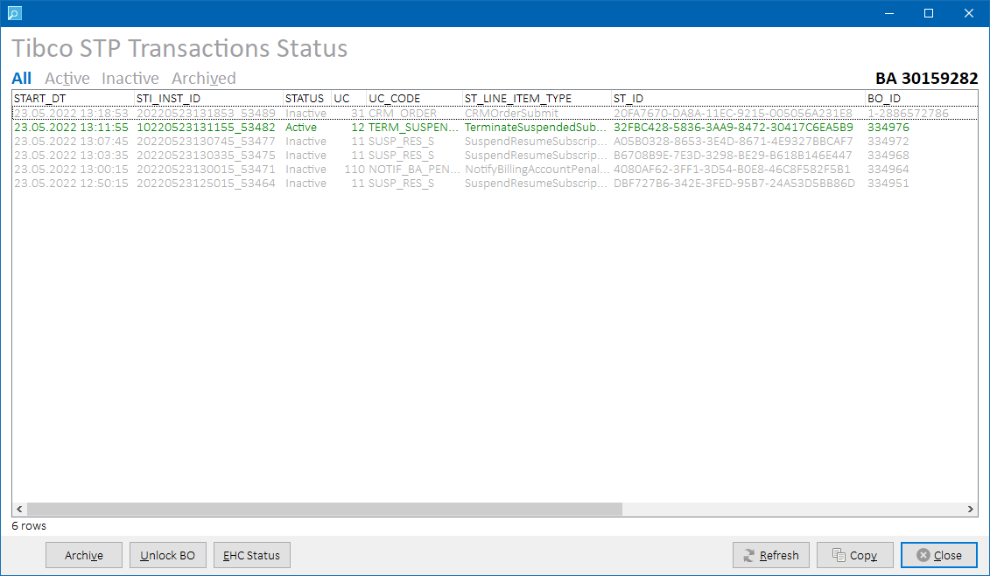

*STP Status form*

##### Controls

|  |  |
| --- | --- |
| **Button Caption** | **Description** |
| **Archive** | Sales transactions will be archived in STP database.  See Archiving Sales Transactions for more details.  **HINT:** Select row(s) in the status grid to archive only selected sales transactions. |
| **Unlock BO** | Unlocks CRM business order in STP database.  See Unlocking Business Orders for more details. |
| **EHC Status** | Displays [EHC Task Events](#_EHC_Status_(Task) form with pre-populated filter fields with values from the selected STP transaction as follows:   * **From:** STP transaction start date * **To:** From + 20 minutes * **MSISDN:** (depends on UC_CODE value; see table below) * **Order ID:** (depends on UC_CODE value; see table below) * **Contains:** (depends on UC_CODE value; see table below)  |  |  |  |  | | --- | --- | --- | --- | | **STP Status UC_CODE** | **EHC Status MSISDN filter** | **EHC Status Order ID filter** | **EHC Status Contains filter** | | CRM_ORDER | (not pre-filled) | BO_ID | (not pre-filled) | | SUSP_RES_S | list of MSISDN’s | (not pre-filled) | (not pre-filled) | | TERM_SUSPENDED_S | (not pre-filled) | (not pre-filled) | ST_ID | | (others) | (not pre-filled) | BO_ID | ST_ID |   **NOTE:** Select a single transaction to proceed. |

##### Output Data

Following data sets are available to display:

|  |  |
| --- | --- |
| **Data Set** | **Description** |
| **All** | All transactions are displayed in time-descending order.  **Row Color Legend:**   |  |  | | --- | --- | | GREEN | Active and unarchived transactions | | BLACK | Inactive transactions | | GRAY | Archived transactions | |
| **Active** | Only actions with STATUS = **Active** are displayed |
| **Inactive** | Only actions with STATUS <> **Active** are displayed |
| **Archived** | Only actions with IS_ARCHIVED = 1 are displayed |

Please refer to Tibco system documentation for more details on the STP attributes meanings and values.

Following output columns are returned in each data set:

|  |
| --- |
| **Column** |
| START_DT |
| ST_INST_ID_X |
| STATUS |
| UC |
| UC_CODE |
| ST_LINE_ITEM_TYPE |
| ST_ID |
| BO_ID |
| KEY_LIST |
| END_DT |
| ARCHIVED |
| CANCELED |

##### Process Overview

Tibco STP tables are queried for status of the transactions related to the selected billing account or its subscribers.

##### Role Differences

|  |  |  |  |  |  |
| --- | --- | --- | --- | --- | --- |
| **Action / Role** | **ADMIN** | **LEAD** | **TESTING-VF** | **TESTING-IBM** | **TESTING-V2** |
| **Access to STP Status** | Y | Y | N | Y | N |

##### Archiving Sales Transactions

There are two possible approaches for sales transaction archiving:

1. Using list of key pairs referring to BA and its subscriber(s) – used when no rows were selected in the status grid, or
2. Using list of specific sales transaction ID’s – used when specific row(s) were selected in the status grid

Eligible sales transactions will be archived in STP database.

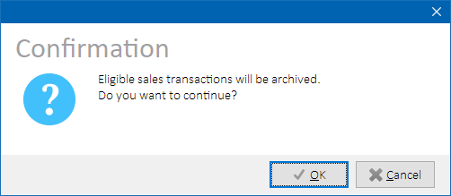

###### Process Overview

1. *(Applicable to key pairs approach only)*   
   Query STP_OWN tables ST_SEARCH_IX, ST_INST, and ST_LINE_INST for impacted sales transactions ID’s as follows:
   1. KEY_NAME = “BillingAccountNumber” AND KEY_VALUE = <Billing Account ID>, **or**
   2. KEY_NAME = “BillingAccountNumber” AND KEY_VALUE = <Kenan Account Number>, **or**
   3. KEY_NAME = “ServiceNumber” AND KEY_VALUE = <subscriber External ID’s> (for all subscribers under the BA)  
      **– and –**
   4. IS_ARCHIVED = 0

Store the list of found unique transaction identifiers (ST_INST_ID).

1. For each ST_INST_ID in the list, run stored procedure STP_OWN.T_PROCESSING_API.ARCHIVE_SALES_TRANSACTION
2. Report errors if occurred.
3. Reload account data.

###### Role Differences

|  |  |  |  |  |  |
| --- | --- | --- | --- | --- | --- |
| **Action / Role** | **ADMIN** | **LEAD** | **TESTING-VF** | **TESTING-IBM** | **TESTING-V2** |
| **Access to STP Archiving** | Y | Y | N | Y | N |

##### Unlocking Business Orders

To unlock a sales transaction representing a CRM Order, select the transaction in the transaction grid and press **Unlock BO** button. If no row is selected, all suitable transactions are detected automatically.

Eligible sales transactions must meet following criteria:

|  |  |
| --- | --- |
| **Attribute** | **Value** |
| **STATUS** | Active |
| **IS_ARCHIVED** | 0 |
| **UC_TYPE_ID** | 31 (CRM_ORDER) |

If no eligible sales transaction is found, a message box is displayed:

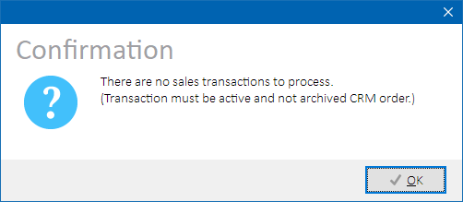

*BO Unlocking - No suitable transaction found.*

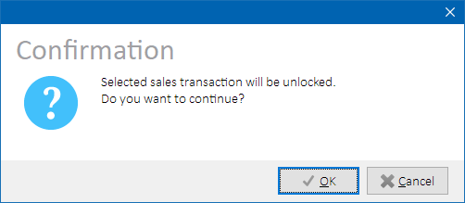

*Unlocking BO – Confirmation dialog*

Upon user confirmation, Phoenix will dispatch JMS messages to Tibco SOP for each Business Order ID, and Tibco will unlock the sales transactions.

###### Process Overview

1. *(If no row is selected in the transactions grid)* Select transactions meeting the above criteria and store their BO_ID into list.
2. Load connection properties for Tibco EMS FOM server (configurable) and STP SOP Response queue name (configurable)
3. For each BO_ID in the list:
   1. Construct processServiceOrderResponse JMS message based on values in the form
   2. Dispatch the message to the Tibco SOP queue
4. Report errors if occurred.
5. Wait 5 seconds for Tibco to process the message
6. Reload transaction grid data – transactions should now be archived

Please refer to Tibco system documentation for more details on processServiceOrder message processing on the Tibco side.

Dispatched JMS example:

TextMessage={ Header={ MessageID={ID:EMS4-FOM.4A0060D09701108B5B:1} Destination={Queue[cz.vodafone.stp_sop.response]} ReplyTo={} DeliveryMode={Persistent} Redelivered={False} CorrelationID={} MsgType={http://www.vodafone.cz/SalesTransactionProcessor/Engine/Processing/xsd:createSalesTransactionExecutionPlan} Timestamp={25.06.2021 10:39} Expiration={0} Priority={4} } Properties={ TRACE_IDENTIFIER_IDENTITY_ID={String:PHOENIX} TRACE_IDENTIFIER_APPLICATION_ID={String:V4} TRACE_IDENTIFIER_SAGA_ID={String:0} TRACE_IDENTIFIER_SERVICE_INTERFACE_VERSION={String:1.0} TRACE_IDENTIFIER_TIMESTAMP={String:2021-06-25T12:39:36.319+02:00} TRACE_IDENTIFIER_COMMAND_ID={String:0} TRACE_IDENTIFIER_SERVICE_ID={String:ProcessServiceOrderResponse} } Text={<processServiceOrderResponse xmlns="http://www.vodafone.cz/ServiceOrderProcessor/Interface/xsd/v1_0">

<ns0:returnStatus xmlns:ns0="http://www.vodafone.cz/Common/xml/Common">SUCCESS</ns0:returnStatus>

<businessOrderId>1-1499286258_S1</businessOrderId>

</processServiceOrderResponse>

} }

###### Role Differences

|  |  |  |  |  |  |
| --- | --- | --- | --- | --- | --- |
| **Action / Role** | **ADMIN** | **LEAD** | **TESTING-VF** | **TESTING-IBM** | **TESTING-V2** |
| **Access to BO Unlocking** | Y | Y | N | Y | N |

### Cross Reference Status

Select a row with known MSISDN or IMSI in the main grid. Select **Tibco 🡪 Cross Reference Status** in the main menu to open Cross Reference Status form.

If no rows are selected in the main grid, then empty form is displayed. In such case, user needs to enter custom entity identifier into edit box in the upper-right corner of the form and press **Enter** to load the data set:

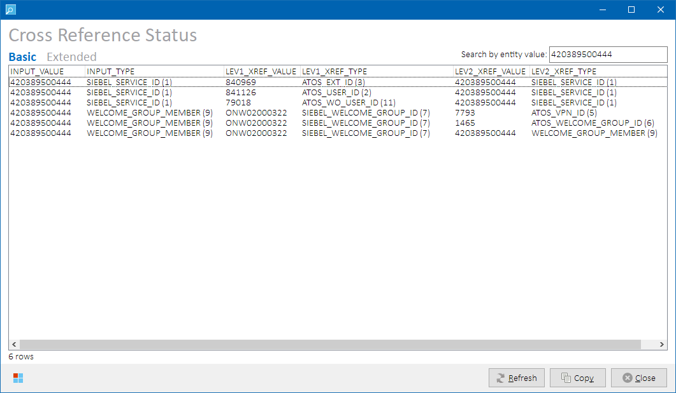

*Cross Reference Status form – Basic data set*

Identifiers of entities that are linked to the selected entity identifier are displayed along with their types.

##### Output Data

Following data sets are available to display:

|  |  |
| --- | --- |
| **Data Set** | **Description** |
| **Basic** | Displays one-way references i.e., selected entity (S) is on the left side of the link.   * 1st degree: entities that are linked to selected entity (E1) * 2nd degree: entities that are linked to 1st degree entities (E2)   *(S) 🡪 (E1) 🡪 (E2)* |
| **Extended** | Includes two-way references in the 1st degree i.e., selected entity can be on both sides of the link.  *(S) or (E1) 🡨🡪 (S) or (E1) 🡪 (E2)* |

Following output columns are returned:

|  |  |
| --- | --- |
| **Column** | **Description** |
| INPUT_VALUE | Input entity identifier. |
| INPUT_TYPE | Input entity type. |
| LEV1_XREF_VALUE | 1st degree linked entity identifier. |
| LEV1_XREF_TYPE | 1st degree linked entity type and type ID. |
| LEV2_XREF_VALUE | 2nd degree linked entity identifier. |
| LEV2_XREF_TYPE | 2nd degree linked entity type and type ID. |

Please refer to Tibco system documentation for more details on the column meanings and values.

##### Process Overview

Cross reference tables CROSSREF_OWN.CROSS_REFERENCE and CROSSREF_OWN.ENTITY_TYPE are queried for cross-referenced entities related to the input entity identifier provided by user.

##### Role Differences

|  |  |  |  |  |  |
| --- | --- | --- | --- | --- | --- |
| **Action / Role** | **ADMIN** | **LEAD** | **TESTING-VF** | **TESTING-IBM** | **TESTING-V2** |
| **Access to Cross Reference Status** | Y | Y | N | Y | Y |

### IMEI Change Event (JMS)

Select **Tibco 🡪 IMEI Change Event (JMS)** to open*IMEI Change*formin *Tibco mode*.

If a row was selected in the main grid, IMSI value from the row is pre-filled.

See IMEI Change for more details.

##### IMEI Change

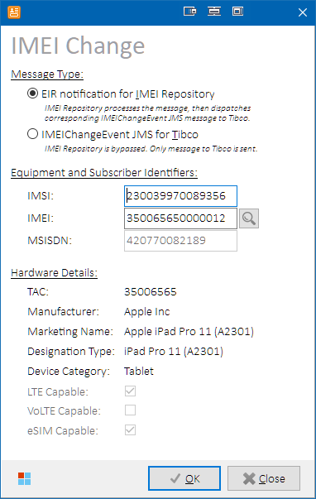

*IMEI Change form*

EIR mode:

Enter IMSI and IMEI values to be used in the message. Paired MSISDN and hardware details are retrieved automatically and cannot be modified.

Press  button to lookup a valid TAC code matching your needs.

Tibco mode:

Enter IMSI and IMEI values to be used in the message. Paired MSISDN and hardware details are retrieved automatically. MSISDN and device flags can be modified.

Press  button to lookup a valid TAC code matching your needs.

###### Controls

|  |  |
| --- | --- |
| **Label** | **Description** |
| **Message Type** | |
| **EIR Notification***(EIR Mode)* | EIR notification message will be dispatched to IMEI Repository. IMEI Repository processes the message, then dispatches corresponding IMEIChangeEvent JMS message to Tibco.  Preconfigured hardware details will be used.  **NOTE:** In *EIR mode, –* since there is only one instance of IMEI Repository – Phoenix checks that IMEI Repository is indeed connected to selected testing environment. A warning message is displayed if environment discrepancy is detected to prevent users from sending notifications to wrong Tibco instance. |
| **IMEIChangeEvent** *(Tibco mode)* | IMEIChangeEvent JMS message will be sent to Tibco. IMEI Repository is bypassed.  Hardware details are customizable.  **NOTE:** In *Tibco mode*, IMSI-IMEI pair will not be stored in IMEI repository. Avoid using queryByIMSI call, as it would return *Unknown IMSI*. |
| **Equipment and Subscriber Identifiers** | |
| ***IMSI*** | IMSI to be used in the message.  Upon IMSI value change:   * + - Paired MSISDN is retrieved from RMS.     - Paired IMEI is retrieved from IMEI Repository (*only in EIR mode*).   If the IMSI represents a OneNumber inventory in RMS, corresponding icon is displayed next to the edit box:  **Icon Legend:**   |  |  | | --- | --- | |  | IMSI is not OneNumber-related. | |  | IMSI has primary OneNumber relationship in RMS. | |  | IMSI has secondary OneNumber relationship in RMS. |   **HINT:** Hover mouse cursor over the icon to reveal location details in text form. |
| ***IMEI*** | IMEI to be used in the message.  Ensure the IMEI value is formed using a correct TAC number. |
| ***(TAC lookup)*** | Press the button to open *IMEI Repository TAC Catalog* form to lookup a valid TAC code. See IMEI Repository – TAC Catalog for more details. |
| ***MSISDN*** | MSISDN to be used in the message. Read-only in *EIR mode*.  Mode differences:   * + - **EIR mode:** MSISDN paired with provided IMSI is automatically retrieved from RMS.  If the IMSI is not paired, sending of the message will however still be possible, because during MVNO activation, the MSISDN is initially only paired in PG, but not yet in RMS. IMEI Repository first queries PG, then RMS. The link in RMS will be created during de-hotline of such customer.     - **Tibco mode**: Custom MSISDN value can be used.   If the MSISDN represents a OneNumber inventory in RMS, corresponding icon is displayed next to the edit box:  **Icon Legend:**   |  |  | | --- | --- | |  | MSISDN is not OneNumber-related. | |  | MSISDN has primary OneNumber relationship in RMS. | |  | MSISDN has secondary OneNumber relationship in RMS. |   **HINT:** Hover mouse cursor over the icon to reveal location details in text form. |
| **Hardware Details** | |
| In *EIR* mode, hardware details are automatically loaded from TAC database and cannot be modified. | |
| **TAC** | TAC code of the device.  **Value:** First eight numbers from IMEI.  **NOTES:**   * + - If a WTTx modem is detected, a “**– WTTx**” note is displayed next to the IMEI value. (TAC = 86402503)     - If FMS device is detected, a “**– FMS**” note is displayed next to the IMEI value. (MANUFACTURER like “%huawei%” and DESIGNATION_TYPE like “%b310%”) |
| **Manufacturer** | Device manufacturer.  **Value:** TAC.MANUFACTURER |
| **Marketing Name** | Device marketing name.  **Value:** TAC.MARKETING_NAME |
| **Designation Type** | Device designation type.  **Value:** TAC.DESIGNATION_TYPE |
| **Device Category** | Device category.  **Value:** TAC.DEVICE_CATEGORY  **NOTE:** If project *eSIM Drop 2B* is not installed on the environment, N/A will be displayed. |
| **LTE Capable** | Flag if the device is LTE-capable. Read-only in *EIR mode*.  **Value:** true if TAC.BANDS contains “LTE” |
| **VoLTE Capable** | Flag if the device is VoLTE-capable.  **Value:**   * + - * + *EIR mode:* <retrieved from IMEI Repository DB (MySQL) – table VOLTE_TAC. Read-only.         + *Tibco mode:* <user-defined>   **IMPORTANT:** Tibco will ignore attempts to disable VoLTE on OneNumber inventory. Warning message will be displayed in the form when applicable. |
| **eSIM Capable** | Flag if the device is eSIM-capable. Read-only in *EIR mode*.  **Value:** true if TAC.REMOVABLE_EUICC > 0 OR TAC.NON_REMOVABLE_EUICC > 0  **NOTE:** If project *eSIM Drop 1* is not installed on the environment, the check box will be unchecked by default. |

Update LTE-Capable, VoLTE-Capable and eSIM-Capable flags as needed.

Press **OK** button to send the JMS message directly to Tibco. IMEI Repository is bypassed.

###### Process Overview

Pre-checks:

1. SSH to IMEI Repository application server at <IMEIREPO_UNIX_HOST>:<IMEIREPO_UNIX_PORT>.
2. Download configuration file from <IMEIREPO_CONFIG_FILE_PATH>/configuration.xml
3. Determine current IMEI Repository environment based on value found in <provider-url> element.

EIR mode:

1. *(EIR mode)* Display warning message if IMEI Repository is connected to different testing environment.
2. Query IMEI_LOAD_OWN.TAC table for handset details based on the TAC value
3. *(EIR mode)* Query VOLTE_TAC table (MySQL) for VoLTE flag based on the TAC value
4. Load connection properties for IMEI Repository EIR queue from <HTTP_IMEIREPOSVC_ENDPOINT> (configurable)
5. Construct EIR message based on values in the form
6. Dispatch the message to IMEI Repository

Dispatched message example:

http://s5java35:8580/EQUEV?VRSN=1&IMEI=330107820000001&IMSI=230039990000477&ESTS=W&RNTP=149

1. Call IMEI Repository service queryByIMSI to check that requested IMSI-IMEI pair was indeed stored in IMEI Repository database.

Tibco mode:

1. Query IMEI_LOAD_OWN.TAC table for handset details based on the TAC value
2. Load connection properties for Tibco EMS AFF server (configurable) and IMEI detection queue name (configurable)
3. Construct identification JMS message based on values in the form
4. Dispatch the message to the Tibco queue

Dispatched message example:

TextMessage={ Header={ MessageID={ID:EMS-SEREAI_INT.17B560D08FC610FEFF:1} Destination={Queue[cz.vodafone.adapters.imei.detection.event]} ReplyTo={} DeliveryMode={Persistent} Redelivered={False} CorrelationID={} MsgType={} Timestamp={25.06.2021 7:43} Expiration={0} Priority={4} } Properties={ } Text={<?xml version="1.0"?>

<identification xmlns="http://www.vodafone.cz/handset/xml/Identification" xmlns:xsi="http://www.w3.org/2001/XMLSchema-instance">

<msisdn>420770020238</msisdn>

<imsi>230039970020340</imsi>

<imei>351756051523999</imei>

<lteCapable>false</lteCapable>

<volteCapable>false</volteCapable>

<marketingName>Samsung GT-E2232</marketingName>

<designationType>Samsung GT-E2232</designationType>

<manufacturer>Samsung Korea</manufacturer>

<deviceCategory>Mobile Phone/Feature phone</deviceCategory>

<timestamp>2021-06-25T09:42:47.096+02:00</timestamp>

</identification>

} }

###### Role Differences

|  |  |  |  |  |  |
| --- | --- | --- | --- | --- | --- |
| **Action / Role** | **ADMIN** | **LEAD** | **TESTING-VF** | **TESTING-IBM** | **TESTING-V2** |
| **Access to IMEI Change Event form** | Y | Y | N | Y | N |

### Restriction Instance Change Event (JMS)

Select **Tibco 🡪 Restriction Instance Change (JMS)** in the main menu to open Restriction Instance Change Event form. If a row was selected in the main grid, MSISDN, BA and CA values from the row are used:

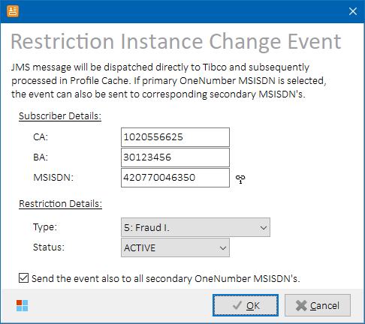

*Restriction Instance Change Event form*

###### Controls

|  |  |
| --- | --- |
| **Control** | **Description** |
| ***MSISDN***  ***(icon)*** | Icon representing OneNumber relation.  **Icon Legend:**   |  |  | | --- | --- | |  | MSISDN is not OneNumber-related. | |  | MSISDN is primary OneNumber MSISDN. | |  | MSISDN is secondary OneNumber MSISDN. |   **HINT:** Hover mouse cursor over the icon to reveal location details in text form. |
| **Restriction Type** | Type of the restriction:   * + - **1:** 1st Invoice Returned     - **2:** Collection I.     - **3:** Collection II.     - **4:** Collection III.     - **5:** Fraud I.     - **6:** Fraud II.     - **7:** MNP Delayed pick-up     - **8:** On Customer Request     - **9:** Stolen/Lost     - **10:** Barring – Security Deposit |
| **Restriction Status** | Status of the restriction:   * + - **ACTIVE**     - **INACTIVE**   Choose whether to enforce or to remove the restriction. |
| **Send the event also to all secondary OneNumber MSISDN’s** | Check to send the same restriction change event to all corresponding secondary OneNumber MSISDN’s.  **NOTE:** Only available if primary OneNumber MSISDN is selected. |

Press **OK** button to send the JMS message(s) directly to Tibco.

After the event is processed in Tibco, the restriction status can be checked in Profile Cache.

Please see Profile Cache Status for more details.

**NOTE:** ***In order for Phoenix to be able to communicate with Tibco API using JMS messages, a 3rd party component is needed. Currently, this component is used in trial mode that only works 5 minutes from the application start.*** *Sorry for the inconvenience; please consider buying full version of the component (€ 299,-) to be able to send JMS messages at any time.*

###### Process Overview

1. Load connection properties for Tibco EMS AFF server (configurable) and Business Event topic name (configurable)
2. Construct restrictionInstanceChangeEvent JMS message based on values in the form
3. Dispatch the message to the Tibco topic

Dispatched message example:

TextMessage={ Header={ MessageID={ID:EMS-SEREAI_INT.17B560D08FC610FF4B:1} Destination={Topic[cz.vodafone.business.event]} ReplyTo={} DeliveryMode={Persistent} Redelivered={False} CorrelationID={} MsgType={http://www.vodafone.cz/CustomerSubscriber/xml/Events:restrictionInstanceChangeEvent} Timestamp={25.06.2021 7:59} Expiration={0} Priority={4} } Properties={ OSS_APPLICATION_DN={String:V4TIBCO} VCZ_SUBOPERATOR={String:V4} OSS_EVENT_TYPE={String:restrictionInstanceChange} } Text={<?xml version="1.0" encoding="UTF-8"?>

<ns0:restrictionInstanceChangeEvent xmlns:ns0="http://www.vodafone.cz/CustomerSubscriber/xml/Events">

<ns1:header xmlns:ns1="http://www.vodafone.cz/Common/xml/Common">

<ns1:correlationId>0</ns1:correlationId>

<ns1:eventTimeStamp>2021-06-25T09:58:40.901+02:00</ns1:eventTimeStamp>

<ns1:applicationCode>PHOENIX</ns1:applicationCode>

<ns1:effectiveDate>2021-06-25T09:58:40.901+02:00</ns1:effectiveDate>

</ns1:header>

<ns1:customerAccountNumber xmlns:ns1="http://www.vodafone.cz/Common/xml/Customer">1040057626</ns1:customerAccountNumber>

<ns1:billingAccountNumber xmlns:ns1="http://www.vodafone.cz/Common/xml/Customer">31167746</ns1:billingAccountNumber>

<ns1:msisdn xmlns:ns1="http://www.vodafone.cz/Common/xml/Customer">420770020238</ns1:msisdn>

<ns0:restrictionCode>5</ns0:restrictionCode>

<ns0:restrictionStatus>ACTIVE</ns0:restrictionStatus>

</ns0:restrictionInstanceChangeEvent>

} }

###### Role Differences

|  |  |  |  |  |  |
| --- | --- | --- | --- | --- | --- |
| **Action / Role** | **ADMIN** | **LEAD** | **TESTING-VF** | **TESTING-IBM** | **TESTING-V2** |
| **Access to Restriction Instance Change Event form** | Y | Y | N | Y | N |

## Siebel Operations

### Siebel Status

Select **Siebel 🡪 Siebel Status (products, orders)** in the main menu to open Siebel Status form. Current Siebel status of inventory items on selected rows in the main grid will be displayed.

If no rows are selected in the main grid, or MSISDN is not populated in the selected row, then empty form is displayed. In such case, user needs to enter custom entity identifier into the Filter edit box in the upper-right corner of the form and press **Enter** to load the data set. Following identifiers are supported:

|  |  |
| --- | --- |
| **Identifier** | **Description** |
| Order Number | Siebel order number in format 1-XX… |
| Billing Account External ID (BA) | Billing account (BA) external ID. |
| Customer Account External ID (CA) | Customer account (CA) external ID. |
| MSISDN | MSISDN of the subscriber |

##### Controls

|  |  |
| --- | --- |
| **Button Caption** | **Description** |
| **Accelerate** | Accelerates selected scheduled request items in Siebel.Only visible in **Products** data set.  See Accelerate Scheduled Request Items for more details. |
| **Show EHC** | Opens EHC Task Events form for selected order. Only visible in **Orders** data set.  See [EHC Task Events View](#_EHC_Status_(Task) for more details. |
| **Cancel All** | Cancels all orders related to a MSISDN. Only visible in **Orders** data set.  See Cancel All Orders for more details. |

##### Output Data

Following data sets are available to display:

|  |  |
| --- | --- |
| **Data Set** | **Description** |
| **Products** | Displays information about assets related to provided identifier.  See Data Set “Products” for more details.  **Row Color Legend:**   |  |  | | --- | --- | | PURPLE | Item type is Solution or Subscriber Bundle. | | BLACK | Other item types. |   **Request Item columns Color Legend:**   |  |  | | --- | --- | | RED | Request item status is Scheduled. | | GREEN | Request item status is Completed. | | BLACK | Other Request item states | |
| **Orders** | Displays information about orders and their order items related to provided identifier.  See Data set “Orders” for more details.  **Row Color Legend:**   |  |  | | --- | --- | | GREEN | Order status is Complete. | | GRAY | Order status is Cancelled. | | RED | Order status is Failed. | | BLACK | Other order states. | |

Output columns vary per selected data set.

##### Data Set “Products”

Displays information about assets related to provided identifier.

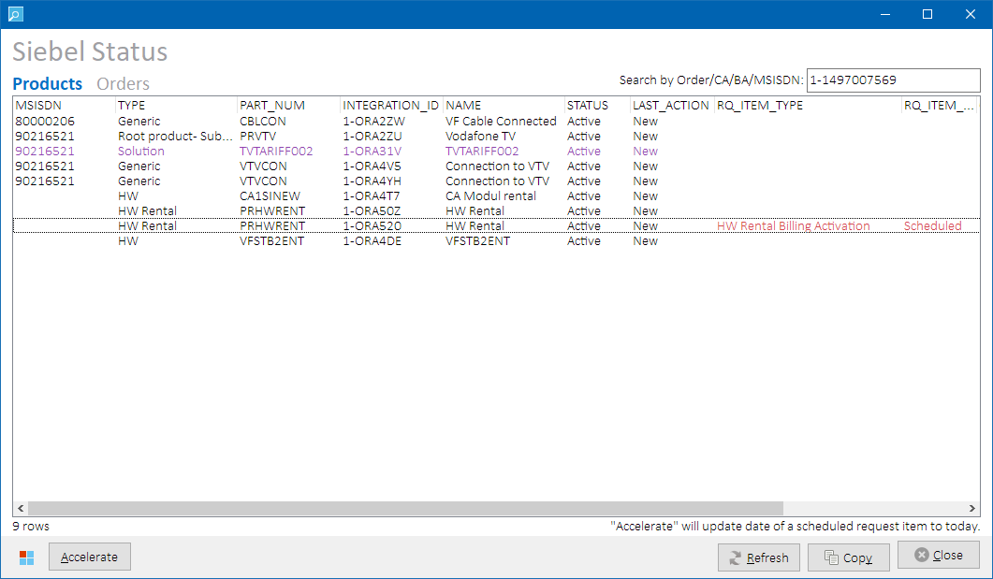

*Siebel Status form – data set “****Products****”*

Data set is sorted by MSISDN, ORDER_DATE DESC.

Following output columns are returned:

|  |
| --- |
| **Column** |
| MSISDN |
| TYPE |
| PART_NUM |
| INTEGRATION_ID |
| NAME |
| STATUS |
| LAST_ACTION |
| RQ_ITEM_TYPE |
| RQ_ITEM_STATUS |
| ORDER_NUMBER |
| ORDER_DATE |

Please refer to Siebel system documentation for more details on the column values.

###### Process Overview

Following Siebel tables are queried for status of the inventory present in the main grid:

SIEBEL.CX_REQUEST_ITEM

SIEBEL.S_ASSET

SIEBEL.S_INV_PROF

SIEBEL.S_ORDER

SIEBEL.S_ORDER_ITEM

SIEBEL.S_ORG_EXT

SIEBEL.S_PROD_INT

##### Data set “Orders”

Displays information about orders and their order items related to provided identifier.

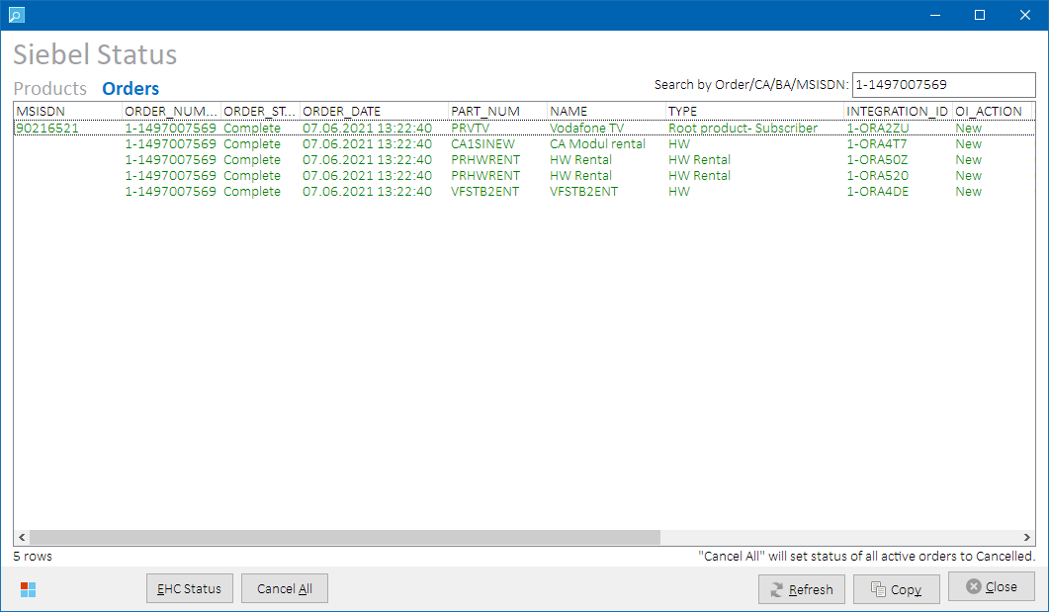

*Siebel Status form – data set “****Orders****”*

Data set is sorted by ORDER_DATE DESC.

Following output columns are returned:

|  |
| --- |
| **Column** |
| MSISDN |
| ORDER_NUMBER |
| ORDER_STATUS |
| ORDER_DATE |
| PART_NUM |
| NAME |
| TYPE |
| INTEGRATION_ID |
| OI_ACTION |
| OI_STATUS |
| ORDER_ITEM_CREATED |
| ORDER_ITEM_LAST_UPD |
| SOURCE_CHANNEL |
| X_ORD_REASON |

Please refer to Siebel system documentation for more details on the column values.

###### Process Overview

Following Siebel tables are queried for status of the inventory present in the main grid:

SIEBEL.CX_REQUEST_ITEM

SIEBEL.S_ASSET

SIEBEL.S_INV_PROF

SIEBEL.S_ORDER

SIEBEL.S_ORDER_ITEM

SIEBEL.S_ORG_EXT

SIEBEL.S_PROD_INT

##### Accelerate Scheduled Request Items

In Siebel status grid displaying **Products** data set, select row(s) that contains scheduled request item in status Scheduled:



*Siebel Status form – data set “****Products****” – scheduled request item*

Press **Accelerate** button to update selected request item(s) so that Siebel picks them up and process them right away:

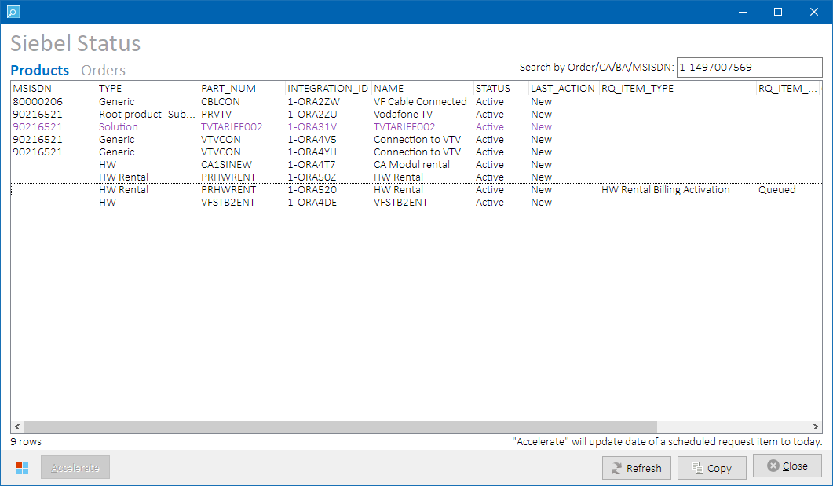

*Siebel Status form – data set “****Products****” – accelerated request item*

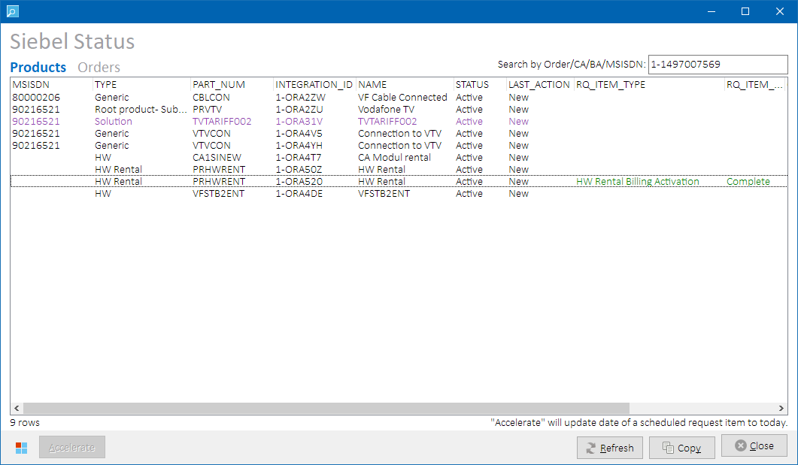

*Siebel Status form – data set “****Products****” – accelerated request item – processing completed*

###### Process Overview

1. Create list of impacted INTEGRATION_ID’s on selected rows in the status grid.
2. Update each request item as described in in Accelerate Scheduled Request Items.
3. Reload data set.

##### EHC Task Events Status

In Siebel status grid displaying **Orders** data set, select a row with populated order number. Press **Show EHC** button to check order status in Tibco EHC. EHC Task Events form will open with pre-filled order number value. If order number is not populated on the selected row, it will not be propagated to the EHC Task Events form. See [EHC Task Events View](#_EHC_Status_(Task) for more details.

##### Cancel All Orders

In Siebel status grid displaying **Orders** data set, press **Cancel All** button to cancel all orders related to all MSISDN’s present in the status grid.

***Process overview:***

1. Store all MSISDN’s (service numbers) from status grid to a list.
2. “Find all orders and order items related to items in the list and in status:  
   (“Open”, “Submitted for Cancellation”, “Submitted”, “Preactivated”, “Pending”, “On Hold”, “Submitted for Pre-Activation”, “Revised”, “Failed”)
3. Set status of found orders and order items to Cancelled in Siebel tables SIEBEL.S_ORDER and SIEBEL.S_ORDER_ITEM.
4. Reload data set.

##### Role Differences

|  |  |  |  |  |  |
| --- | --- | --- | --- | --- | --- |
| **Action / Role** | **ADMIN** | **LEAD** | **TESTING-VF** | **TESTING-IBM** | **TESTING-V2** |
| **Access to Siebel Status** | Y | Y | N | Y | N |

### Siebel Product Catalog

Select **Siebel 🡪 Product Catalog** in the main menu to open Siebel Product Catalog form to show details of Siebel products.

Enter custom filtering condition into the Filter edit box in the upper-right corner of the form and press **Enter** to filter the data set. If any of the below item attributes matches the filtering condition, the item is displayed:

|  |  |
| --- | --- |
| **Identifier** | **Description** |
| Part Number | Only products with matching part number are displayed. (S_PROD_INT.PART_NUM) |
| Product Name | Only products with matching name are displayed. (S_PROD_INT.NAME) |
| Product Description | Only products with matching description are displayed. (S_PROD_INT_LANG.DESC_TEXT) |

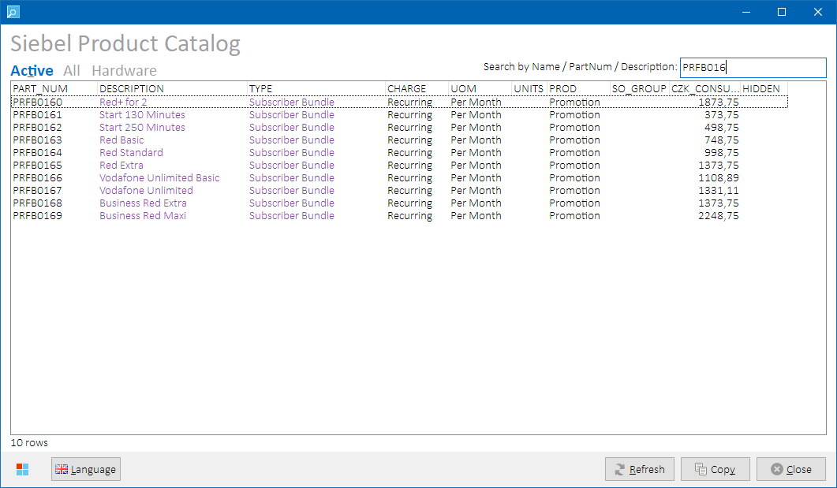

*Siebel Product Catalog form – data set “****Active****”, filtered*

##### Controls

###### Additional Buttons

|  |  |
| --- | --- |
| **Button Caption** | **Description** |
| **Language** | Change language of descriptions in the data grid.  Displayed flag represents currently selected language.  **Icon Legend:**   |  |  | | --- | --- | |  | Czech language. | |  | English language. | |

##### Output Data

Following data sets are available to display:

|  |  |
| --- | --- |
| **Data Set** | **Description** |
| **Active** | Displays active non-HW products (TYPE <> “HW” AND X_HIDDEN_FLG <> “Y”).  **Row Color Legend:**   |  |  | | --- | --- | | PURPLE | Item type is Solution or Subscriber Bundle. | | BLACK | Other item types. | |
| **All** | Displays all non-hardware products, incl. hidden ones. (TYPE <> “HW”).  **Row Color Legend:**   |  |  | | --- | --- | | PURPLE | Item type is Solution or Subscriber Bundle. | | ORANGE | Item is hidden. | | BLACK | Other item types. | |
| **Hardware** | Displays all hardware products, incl. hidden ones. (TYPE = “HW”).  **Row Color Legend:**   |  |  | | --- | --- | | PURPLE | Item type is Solution or Subscriber Bundle. | | ORANGE | Item is hidden. | | BLACK | Other item types. | |

Data sets are sorted by PART_NUM.

Following output columns are returned:

|  |  |
| --- | --- |
| **Column** | **Description** |
| PART_NUM | Part number. |
| DESCRIPTION | Product description according to selected language. |
| TYPE | Product type. |
| CHARGE | Charge type. Value from PRICE_TYPE_CD. |
| UOM | Unit of measurement. Value from UOM_CD. |
| SIZE | Item size. |
| UNITS | Custom item size units. Value from X_ITEM_SIZE_UNITS. |
| PROD | Product type code. Value from PROD_CD. |
| SO_GROUP | Custom smart overview group. Value from X_SMART_OVERVIEW_GROUP. |
| CZK_CONSUMER | Charge amount. Value from STD_PRI_UNITS in price list “Consumer Siebel”. |
| HIDDEN | Hidden flag (Y = hidden). |

Please refer to Siebel system documentation for more details on the column values.

##### Process Overview

Following Siebel tables are queried to retrieve details of the product items:

SIEBEL.S_PROD_INT

SIEBEL.S_PROD_INT_LANG

SIEBEL.S_PRI_LST_ITEM

##### Role Differences

|  |  |  |  |  |  |
| --- | --- | --- | --- | --- | --- |
| **Action / Role** | **ADMIN** | **LEAD** | **TESTING-VF** | **TESTING-IBM** | **TESTING-V2** |
| **Access to Siebel Product Catalog** | Y | Y | N | Y | N |

### Change MSISDN in WTTx Order

Select **Siebel 🡪 Change MSISDN in WTTx Order** in the main menu to open Change WTTx MSISDN form. Enter Siebel order number and hit **Enter** or press  **Scan** button to load current WTTx MSISDN(‘s) on the order:

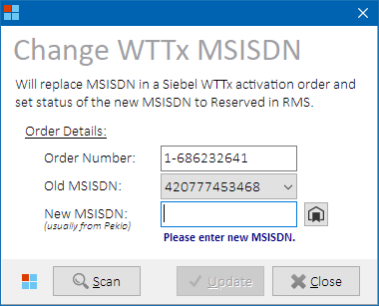

*Change WTTX MSISDN form*

Select **old** **MSISDN** from the combo box in case there are more of them available in the order and the one that was automatically selected is not the one you want to work with.

Enter **new** **MSISDN** to the appropriate edit box, or press  Reserve button to retrieve a suitable MSISDN from Peklo (V4, CONSUMER).

Finally, press **Update** button to store the change into Siebel and RMS databases:

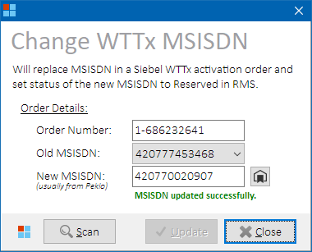

*Change WTTX MSISDN form – value updated*

**NOTES:**

* New MSISDN must have status Available or Reserved in RMS, otherwise the change will not be allowed.
* If the new MSISDN is in status Reserved, additional user confirmation is requested (as it could have been reserved by someone else).

**HINT:** Formatted text with details about processed MSISDN change (both successful or failed) is also stored to clipboard so that it can easily be sent in email to whomever has requested it:

ORDER ID: 1-686232641

OLD MSISDN: 420777453468

NEW MSISDN: 420770020907

STATUS: OK

##### Controls

|  |  |
| --- | --- |
| **Button Caption** | **Description** |
| **Scan** | Find current WTTx MSISDN for provided order number. |
| **Update** | Update the order with a new WTTx MSISDN value in Siebel, and updates the MSISDN status in RMS. |
| **Reserve** | Retrieves an available MSISDN from Peklo. |

##### Process Overview

1. Find current WTTx MSISDN’s (having NAME = “MSISDN” in SIEBEL.S_PROD_INT table) for provided order number
2. (optional) Retrieve a new MSISDN from Peklo
3. Check RMS status of the old MSISDN. Stop processing if MSISDN not found.
4. Check RMS status of the new MSISDN. Stop processing if MSISDN not found or its status is not in (1, 8).
5. Check Siebel order. Stop processing if order number not found.
6. Fetch Siebel order details and store found asset integration id.   
   Stop processing if any of the following conditions is not met:
   1. Exactly one row is returned for given Order / Old MSISDN combination.
   2. Order status = Pending
   3. Old MSISDN type = “MSISDND”
   4. Asset Integration ID is not empty
7. Request user permission to continue if new MSISDN status = Reserved
8. If RMS status of the new MSISDN is Available, invoke Kenan Adapter SOAP operation InventoryModifyElementStatus to update the status to Reserved. Stop processing if the update fails.
9. Update MSISDN value (SERVICE_NUM) in Siebel order row having asset integration id found in previous steps in table SIEBEL.S_ORDER.

##### Role differences

|  |  |  |  |  |  |
| --- | --- | --- | --- | --- | --- |
| **Action / Role** | **ADMIN** | **LEAD** | **TESTING-VF** | **TESTING-IBM** | **TESTING-V2** |
| **Access to WTTx MSISDN update** | Y | Y | Y | Y | N |

### Change MSISDN in OneNumber Order

By default, secondary OneNumber MSISDN’s are not present in the Siebel order and are reserved by Tibco in RMS after the order is submitted. This leads to issues when the MSISDN picked by Tibco from Kenan is outside of preconfigured official test ranges, so it’s – for example – missing in IL whitelists. Provisioning of such MSISDN would hence go against dummy network elements. To insert a custom secondary OneNumber MSISDN into unsubmitted Siebel order, proceed as follows:

Select **Siebel 🡪 Change MSISDN in OneNumber Order** in the main menu to open Change Secondary OneNumber MSISDN form. Enter Siebel order number and hit **Enter** or press  **Scan** button to load current secondary OneNumber MSISDN(‘s) on the order:

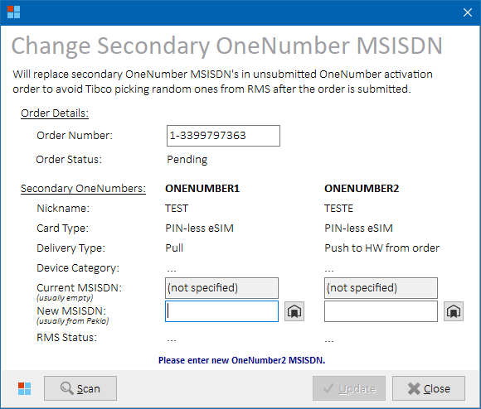

*Change Secondary OneNumber MSISDN form*

Enter **new** **MSISDN(s)** to the appropriate edit box(es), or press appropriate  Reserve button to retrieve a suitable MSISDN from Peklo (V4, CONSUMER).

Finally, press **Update** button to store the change into Siebel and RMS databases:

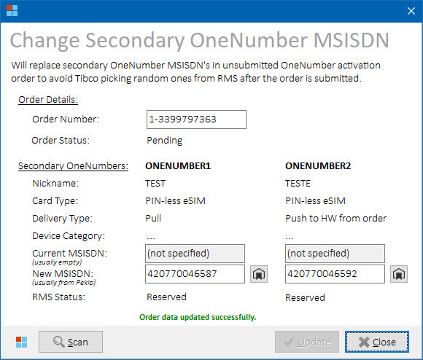

*Change Secondary OneNumber MSISDN form – value updated*

**NOTES:**

* New MSISDN must have status Available or Reserved in RMS, otherwise the change will not be allowed.

**HINT:** Formatted text with details about processed MSISDN change (both successful or failed) is also stored to clipboard so that it can easily be sent in email to whomever has requested it:

ORDER ID: 1-3399983860

OLD ONENUMBER1 MSISDN: (not specified)

NEW ONENUMBER1 MSISDN: 420770046587

OLD ONENUMBER2 MSISDN: (not specified)

NEW ONENUMBER2 MSISDN: 420770046592

STATUS: OK

##### Controls

|  |  |
| --- | --- |
| **Button Caption** | **Description** |
| **Scan** | Scan Siebel order, get current OneNumber MSISDN’s. |
| **Update** | Update the order with a new MSISDN value(s) in Siebel, and updates the MSISDN status in RMS. |
| **Reserve** | Retrieves an available MSISDN from Peklo. |

##### Process Overview

1. Find current OneNumber MSISDN’s (having PART_NUM IN (“ONENUMBER1”, “ONENUMBER2”) AND ATTR_NAME = “MSISDN” in SIEBEL.S_ORDER_ITEM_XA table) for provided order number
2. (optional) Retrieve a new MSISDN from Peklo
3. Check RMS status of the old MSISDN. Stop processing if MSISDN not found.
4. Check RMS status of the new MSISDN. Stop processing if MSISDN not found or its status is not in (1, 8).
5. Check Siebel order status. Stop processing if Order not found or status <> Pending
6. If RMS status of the new MSISDN is Available, invoke Kenan Adapter SOAP operation InventoryModifyElementStatus to update the status to Reserved. Stop processing if the update fails.
7. Update MSISDN value (MSISDN) in Siebel row found in step 1 previous steps in table SIEBEL. SIEBEL.S_ORDER_ITEM_XA table.

##### Role differences

|  |  |  |  |  |  |
| --- | --- | --- | --- | --- | --- |
| **Action / Role** | **ADMIN** | **LEAD** | **TESTING-VF** | **TESTING-IBM** | **TESTING-V2** |
| **Access to Secondary OneNumber MSISDN update** | Y | Y | Y | Y | N |

### Accelerate Scheduled Request Items

Select **Siebel 🡪 Accelerate Scheduled Request Items** in the main menu to open Accelerate Request Items form. Enter Siebel order number and hit **Enter** or press  **Scan** button to load order request items:

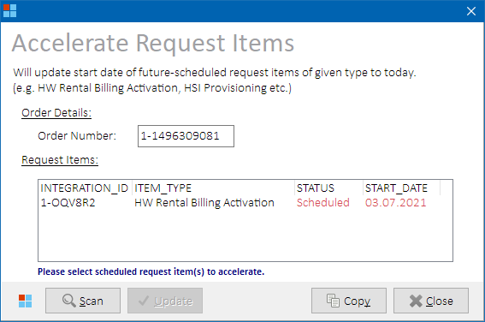

*Accelerate Request Items form*

In the Request Items grid, select row(s) with request items in Scheduled status and press **Update** button to accelerate their processing in Siebel:

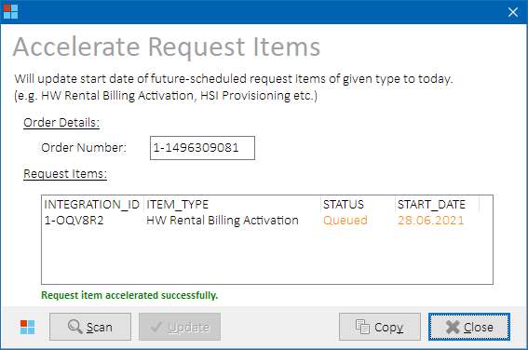

*Accelerate Request Items form – accelerated request item*

After about a minute, press  **Scan** button again to check if the request item was processed in Siebel:

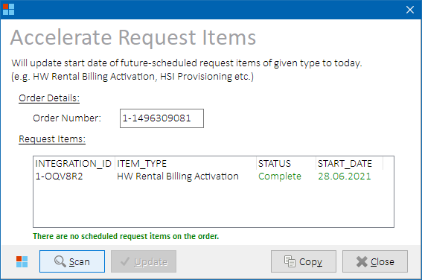

*Accelerate Request Items form – accelerated request item – processing completed*

**NOTES:**

* + - * If request item status falls back to Scheduled, consult with Siebel staff to find out more details on what prevented its completion.
      * If Siebel job “IBM Enqueue Scheduled Request Item” is not running, the application will issue a warning. Consult environment administrators to start the job.

##### Controls

|  |  |
| --- | --- |
| **Button Caption** | **Description** |
| **Scan** | Find request items for provided order number. |
| **Update** | Update scheduled request items in Siebel. |

##### Process Overview

1. Check if an order exists in Siebel table SIEBEL.S_ORDER with provided order number.
2. Find request items and their status related to the order.
3. Create list of impacted INTEGRATION_ID’s from selected rows
4. Check if ID’s from the list still have pending requests in table SIEBEL.CX_REQUEST_ITEM. Stop processing if request items are not found.
5. Update request items in table SIEBEL.CX_REQUEST_ITEM as follows:
   1. START_DATE = TRUNC(SYSDATE)
   2. STATUS = “Queued”
6. Reload data set.

##### Role Differences

|  |  |  |  |  |  |
| --- | --- | --- | --- | --- | --- |
| **Action / Role** | **ADMIN** | **LEAD** | **TESTING-VF** | **TESTING-IBM** | **TESTING-V2** |
| **Access to Request Items acceleration** | Y | Y | N | Y | N |

### Update Average Revenue

Select **Siebel 🡪 Update Average Revenue** in the main menu to open Average Revenue form. If a row was selected in the main grid, it’s MSISDN value will be preloaded. Press  **Scan** button to load current average revenue value. If average revenue value is not set in Siebel, corresponding edit box will be empty:

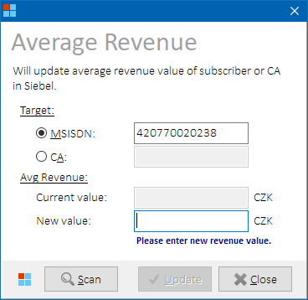

*Average Revenue form*

Enter a new value and press  **Update** button to store it into Siebel database:

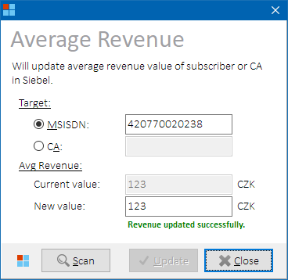

*Average Revenue form – value updated*

##### Controls

|  |  |
| --- | --- |
| **Button Caption** | **Description** |
| **Scan** | Find current average revenue value for provided identifier. |
| **Update** | Update average revenue value for provided identifier in Siebel database. |

##### Process Overview

1. Fetch current average revenue value for provided identifier:
   1. **MSISDN**: X_AVERAGE_REVENUE from table SIEBEL.S_ASSET (root products only).
   2. **CA**: X_AVEREGE_REVENUE_VAT from table SIEBEL.S_ORG_EXT.
2. Stop processing if MSISDN or CA are not found.
3. Update average revenue with user-defined value in the same tables.

##### Role Differences

|  |  |  |  |  |  |
| --- | --- | --- | --- | --- | --- |
| **Action / Role** | **ADMIN** | **LEAD** | **TESTING-VF** | **TESTING-IBM** | **TESTING-V2** |
| **Access to Average Revenue update** | Y | Y | N | Y | N |

### Update UPC Migration Attributes

Select **Siebel 🡪 Update UPC Migration Attributes** in the main menu to open UPC Migration Attributes form. If a row was selected in the main grid, it’s BA value will be preloaded. Press  **Scan** button to load current values:

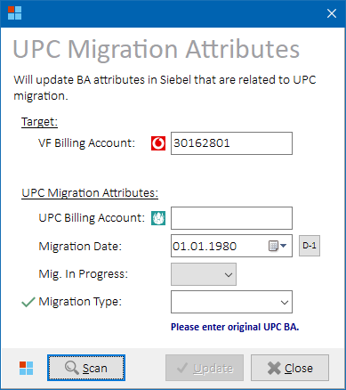

*UPC Migration Attributes form*

Enter new values and press  **Update** button to store them into Siebel database.

Please refer to Siebel system documentation for more details on the applicable values.

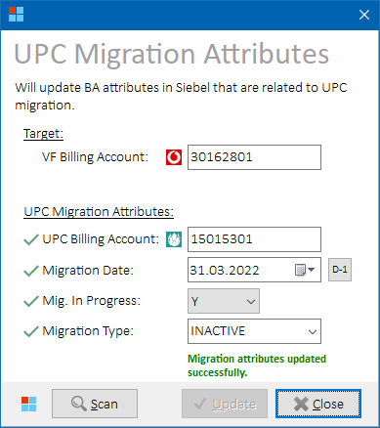

*UPC Migration Attributes form – value updated*

##### Controls:

|  |  |
| --- | --- |
| **Button Caption** | **Description** |
| **Scan** | Find current UPC migration attribute values for provided billing account. |
| **Update** | Update UPC migration attribute values for provided billing account in Siebel database. |
| **D-1** | Selects SYSDATE-1 as migration date value. |

##### Process Overview

1. Find current UPC migration attribute values for provided billing account from table SIEBEL.S_INV_PROF:
   * X_ORIG_UPC_BA_ID
   * X_UPC_MIGR_RUN
   * X_UPC_MIGR_DATE
   * X_UPC_MIGR_TYPE
2. Stop processing if BA was not found.
3. Update the table with new user-defined values.

##### Role Differences

|  |  |  |  |  |  |
| --- | --- | --- | --- | --- | --- |
| **Action / Role** | **ADMIN** | **LEAD** | **TESTING-VF** | **TESTING-IBM** | **TESTING-V2** |
| **Access to UPC Migration Attributes update** | Y | Y | N | Y | N |

### Update Date of Birth Validation Flag

Select **Siebel 🡪 Update Date of Birth Validation Flag** in the main menu to open DOB Validation form. If a row with known BA was selected in the main grid, it’s BA value will be preloaded. Press  **Scan** button to load current flag value. If the flag is not set in Siebel, corresponding combo box will be empty.

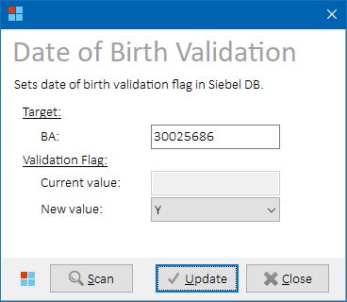

*DOB Validation form*

Select one of the available values (empty / Y / N) from the combo box and press  **Update** button to store it into Siebel database.

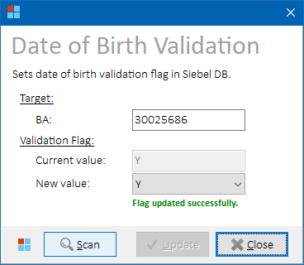

*DOB Validation form – value updated*

##### Controls

|  |  |
| --- | --- |
| **Button Caption** | **Description** |
| **Scan** | Find current flag value for provided BA. |
| **Update** | Update flag value for provided BA in Siebel database. |

##### Process Overview

1. Fetch current DOB validation flag value (ACN_RC_CHECKED) for provided BA from table SIEBEL.S_ORG_EXT_X.
2. Stop processing if BA was not found.
3. Update flag value with user-defined value in the same table.   
   If empty value was selected in the combo box, the value will be updated to NULL.

##### Role Differences

|  |  |  |  |  |  |
| --- | --- | --- | --- | --- | --- |
| **Action / Role** | **ADMIN** | **LEAD** | **TESTING-VF** | **TESTING-IBM** | **TESTING-V2** |
| **Access to DOB Validation Flag update** | Y | Y | N | Y | N |

## CUR Operations

### Password Management

##### Getting Current Passwords

Select one or more rows with known BA/CA in the main grid. Select **CUR 🡪 Password** from the main menu to retrieve current passwords from CUR system, and open Password Management form where new passwords can optionally be set:

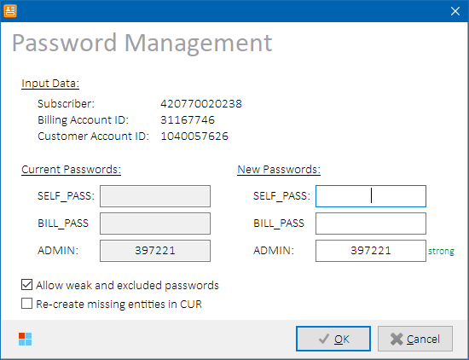

*Password Management form – single row selected in the main grid*

**NOTE:** To check if BA/CA is known for given main grid row, hover mouse cursor over MSISDN, SIM or ICCID column value to display a cell hint with additional row information. See Main Grid for more details.

Current passwords are displayed in read-only edit boxes on the left side of the form. Empty value means that there was no password of given level set.

**NOTE:** If multiple rows were selected in the main grid, current passwords will not be retrieved. In such case, new passwords will be set for all selected items in the main grid:

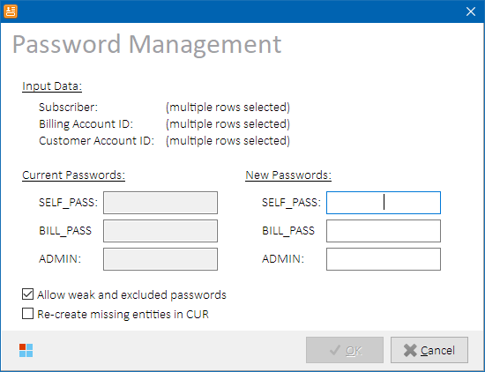

*Password Management form – multiple rows selected in the main grid*

###### Process Overview

1. Invoke SOAP operation getPassword for MSISDN, BA, and CA value if single row is selected in the main grid to retrieve current passwords from CUR.

##### Setting New Passwords

New passwords can be entered in edit boxes on the right side of Password Management form; current values are pre-filled.

After new passwords are entered, their strength is verified in Tibco and displayed next to them:

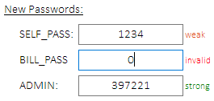

*Password Management – password strength examples*

Select following options, if needed:

|  |  |
| --- | --- |
| **Option** | **Description** |
| **Allow weak and excluded passwords** | Weak and excluded passwords will be allowed to be stored to CUR. Password strength validation will be bypassed in Tibco. |
| **Re-create missing entities in CUR** | SubscriberActivation request is sent to CUR for each entity before setting new passwords to ensure the entity exists in CUR. |

Press **OK** to store the new passwords to CUR and close Password Management form.

###### Process Overview:

1. Invoke SOAP operation checkPasswordWeakness after new password value is entered.
2. *(optional)* Invoke SOAP operation SubscriberActivation to re-create missing entities in CUR.
3. Invoke SOAP operation setPassword to set new passwords in CUR.

##### Role Differences

|  |  |  |  |  |  |
| --- | --- | --- | --- | --- | --- |
| **Action / Role** | **ADMIN** | **LEAD** | **TESTING-VF** | **TESTING-IBM** | **TESTING-V2** |
| **Access to Password Management** | Y | Y | Y | Y | N |

## Java Operations

Describes operations related to systems delivered or maintained by IBM Java (formerly T16) team.

### Location Dispatcher Status

Select **Java 🡪 Location Dispatcher Status** from the main menu. Location Dispatcher status of MSISDN inventory items on selected rows in the main grid will be displayed. If no rows are selected in the main grid, then all rows are processed.

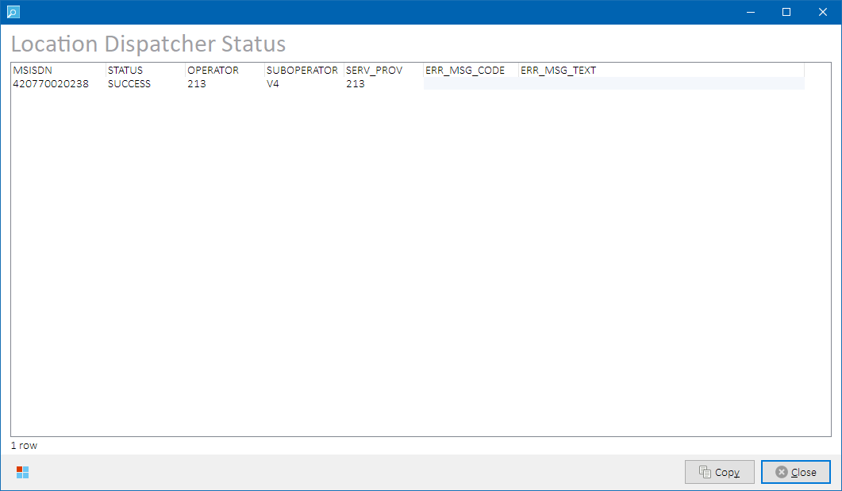

*Location Dispatcher Status form*

**NOTE:** SIM inventory items are not applicable to this status view.

|  |  |
| --- | --- |
| **Column** | **Description** |
| MSISDN | External id of the subscription |
| STATUS | SOAP call status (SUCCESS / ERROR) |
| OPERATOR | Operator value from LD |
| SUBOPERATOR | Suboperator value from LD |
| SERV_PROV | Service provider value from LD |
| ERR_MSG_CODE | Error code from LD (empty if status = SUCCESS) |
| ERR_MSG_TEXT | Error message text from LD (empty if status = SUCCESS) |

Please refer to Kenan and Location Dispatcher system documentation for more details on the column values.

##### Process Overview

Location Dispatcher’s SOAP operation GetOperatorMembership will be invoked for each MSISDN and response values will be displayed in the status grid.

##### Role Differences

|  |  |  |  |  |  |
| --- | --- | --- | --- | --- | --- |
| **Action / Role** | **ADMIN** | **LEAD** | **TESTING-VF** | **TESTING-IBM** | **TESTING-V2** |
| **Access to Location Dispatcher Status** | Y | Y | N | Y | N |

### Profile Cache Status

Select **Java 🡪 Profile Cache Status** from the main menu. Profile Cache status of MSISDN inventory items on selected rows in the main grid will be displayed. If no rows are selected in the main grid, then all rows are processed.

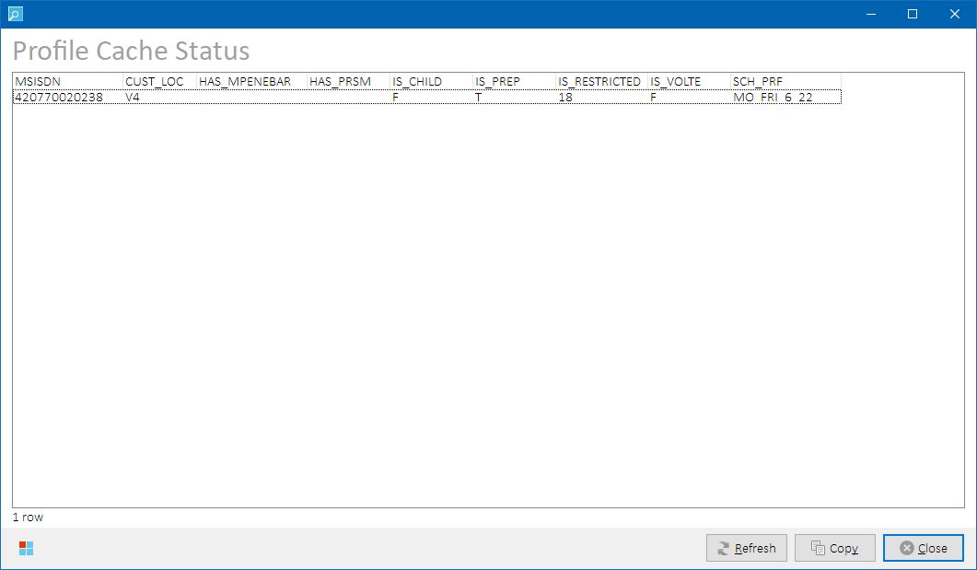

*Profile Cache Status form*

**NOTE:** SIM inventory items are not applicable to this status view.

Following output columns are returned:

|  |  |
| --- | --- |
| **Column** | **Description** |
| MSISDN | External id of the subscription. |
| CUST_LOC | Customer location (V4, V2, etc.). |
| HAS_MPENEBAR | Has enabled barring flag. |
| HAS_PRSM | Has PRSM flag. |
| IS_CHILD | Child flag (T=TRUE, F=FALSE). |
| IS_PREP | Prep flag (T=TRUE, F=FALSE). |
| IS_RESTRICTED | Restriction value (numeric representation). |
| IS_VOLTE | VoLTE flag (T=TRUE, F=FALSE). |
| SCH_PRF | Profile schedule. |

Please refer to Profile Cache system documentation for more details on the output column values.

##### Process Overview

Profile Cache tables **PROFILE_OWN.MSISDN_LIST** and **PROFILE_OWN.ATTRIBUTE_LIST** are queried for current status of the MSISDN inventory present in the main grid.

##### Role Differences

|  |  |  |  |  |  |
| --- | --- | --- | --- | --- | --- |
| **Action / Role** | **ADMIN** | **LEAD** | **TESTING-VF** | **TESTING-IBM** | **TESTING-V2** |
| **Access to Profile Cache Status** | Y | Y | N | Y | N |

### BMG SMS History

Select **Java 🡪 BMG SMS History** from the main menu. SMS messages processed by BMG for the MSISDN inventory items on selected rows in the main grid in last 30 days will be displayed. If no rows are selected in the main grid, then all rows are processed.

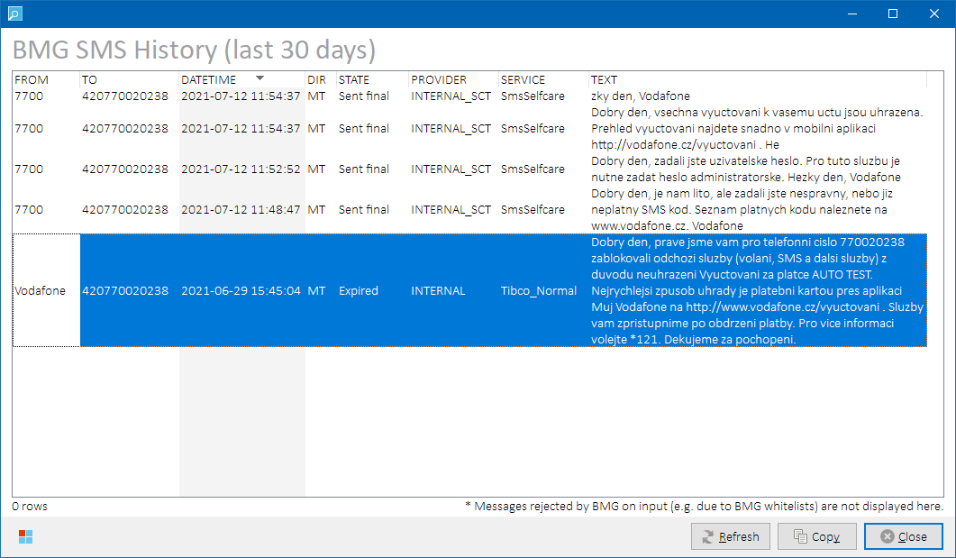

*BMG SMS History form*

Messages are sorted by DATETIME in descending order.

**NOTES:**

* SIM inventory items are not applicable to this status view.
* SMS History can be fetched for maximum of 10 MSISDN’s at a time.
* **Messages rejected by BMG on input (e.g., due to BMG whitelists) are not displayed.**

##### Output Data

Following output columns are returned:

|  |  |
| --- | --- |
| **Column** | **Description** |
| FROM | Message source address (alphanumeric originator). |
| TO | Message destination address (target MSISDN, short code, etc.). |
| DATETIME | Date and time the message was sent / received. |
| DIR | Message direction (MT = mobile terminating, MO = mobile originating). |
| STATE | Message status in BMG. |
| PROVIDER | BMG provider that processed the message. |
| SERVICE | BMG service that processed the message. |
| TEXT | Message text. |

Please refer to BMG system documentation for more details on the output column values.

**NOTE:** There’s an error in BMG API impacting messages in error state. For these, message length in format (c=<message_length>) is returned instead of actual message text. To overcome this, use Tibco SMS History functionality to fetch details about dispatched SMS messages from Tibco log.

##### Process Overview

SOAP operation messageQuery (provided by amr/trackingIF endpoint) will be invoked for each MSISDN and response values will be displayed in the status grid. Duplicate messages having the same ID are filtered out (another known bug in BMG API).

##### Role Differences

|  |  |  |  |  |  |
| --- | --- | --- | --- | --- | --- |
| **Action / Role** | **ADMIN** | **LEAD** | **TESTING-VF** | **TESTING-IBM** | **TESTING-V2** |
| **Access to BMG SMS History** | Y | Y | N | Y | N |

### IMEI Repository – EIR Notification

Select **Tibco 🡪 IMEI Repository – EIR Notification** to open*IMEI Change*formin *EIR mode*.

If a row was selected in the main grid, IMSI value from the row is pre-filled.

See IMEI Change for more details.

### IMEI Repository – TAC Catalog

Select **Java 🡪 IMEI Repository - TAC Catalog** from the main menu to open IMEI Repository TAC Catalog form. Provide search criteria and press  **Search** to retrieve matching TAC codes.

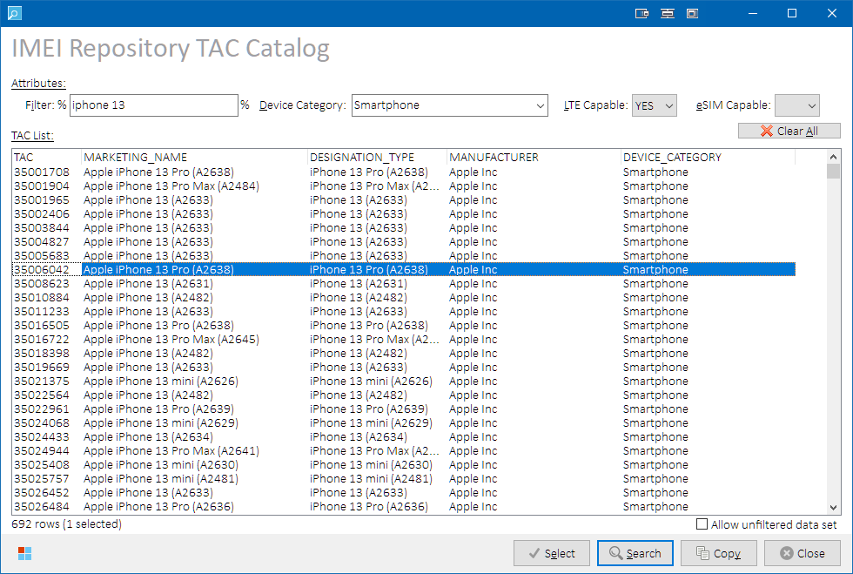

*IMEI Repository TAC Catalog form*

By default, records are sorted by TAC in ascending order.

##### Controls

###### Search Filter Fields



User can apply additional search conditions using following filter edit boxes on top of the form:

|  |  |
| --- | --- |
| **Filter Edit Box** | **Description** |
| **Filter** | Show only records containing given string.  String is matched against following values in the source TAC table:   * TAC * MANUFACTURER * MARKETING_NAME * DESIGNATION_TYPE   **NOTE:** Filter is case-insensitive. |
| **Device Category** | Show only records with given device category. |
| **LTE Capable** | Show only records with given status:   * **(empty)** – do not filter by LTE capability * **YES** – show only records having LTE band configured * **NO** – show only records that do not have LTE band configured   **NOTE:** LTE capability is assumed if BAND value contains “LTE” substring in the source TAC table. |
| **eSIM Capable** | Show only records with given status:   * **(empty)** – do not filter by eSIM capability * **YES** – show only records having eSIM capability configured * **NO** – show only records that do not have esim capability configured   **NOTE:** eSIM capability is assumed if either REMOVABLE_EUICC > 0 or NON_REMOVABLE_EUICC > 0 in the source TAC table. |

Search-filter-fields-related controls:

|  |  |
| --- | --- |
| **Caption** | **Description** |
| **Clear All** | Clears all search filter fields. |
| **Allow unfiltered data set** | By default, using at least one search condition is mandatory.  The rule can be overridden by checking this check box. |

###### Additional Buttons

|  |  |
| --- | --- |
| **Caption** | **Description** |
| **Select** | Copies selected TAC value to the originating *IMEI Change Event* form.  **NOTES:**   * The button is only visible if *TAC Catalog* form was invoked from *IMEI Change Event* form. * The button is only enabled if a single record is selected in the *TAC List* grid. |
| **Search** | Retrieves a list of records matching with provided search conditions and populate them to the *TAC List* grid. Records are sorted by their TAC in descending order |
| **Copy** | Copies the *TAC List* grid content to clipboard as a structured text table with **TAB**-separated values into clipboard. If no rows are selected, then the whole grid is copied. If some rows are selected, then only selected rows are copied.   **HINT:** Hold **ALT** while clicking on the **Copy** button (or press **ALT+CTRL+C**) to include also record’s BAND values. While the **ALT** key is pressed down, **Copy** button caption changes to **“Copy+”** to indicate that extended set of data is going to be copied to clipboard. |

##### Output Data

Following output columns are returned:

|  |  |
| --- | --- |
| **Column** | **Description** |
| TAC | Device TAC code. |
| MARKETING_NAME | Device marketing name. |
| DESIGNATION_TYPE | Device designation type. |
| MANUFACTURER | Device manufacturer. |
| DEVICE_CATEGORY | Device category. |
| BAND | List of bands supported by the device. Not visible in the *TAC List* grid, but can be copied out as extra data, if needed. |

Please refer to IMEI Repository system documentation for more details on the output column values.

##### Process Overview

BMG_LOAD_OWN.TAC table is queried for records matching provided search criteria.

##### Role Differences

|  |  |  |  |  |  |
| --- | --- | --- | --- | --- | --- |
| **Action / Role** | **ADMIN** | **LEAD** | **TESTING-VF** | **TESTING-IBM** | **TESTING-V2** |
| **Access to IMEI Repository TAC Catalog** | Y | Y | N | Y | N |

### Send MO to SMS Self Care

Select **Java 🡪 Send MO SMS to SMS SelfCare** from the main menu to open Send SMS to SMS Self Care (SMS SC) form. If a MSISDN was selected in the main grid, it will be pre-filled:

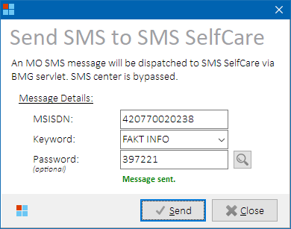

*Send SMS to SMS Self Care form*

Select keyword from the drop-down list and provide password, if needed. Please refer to SMS SC system documentation for more details on the keywords.

Press  **Send** button to send the message to SMS Self Care.

**HINT:** Outgoing SMS from SMS SC can be seen in BMG SMS History form (consider approx. 5 minutes delay before the message is displayed after being processed by SMS SC and BMG).

##### Controls

|  |  |
| --- | --- |
| **Button Caption** | **Description** |
|  | Fetches current end-user password value from CUR (SELF_PASS level). |

##### Process Overview

A msgbatch XML will be constructed and sent directly to SMS Self Care system via “BMG Servlet” interface (provided by HTTP endpoint servlet/bmg). SMS center is bypassed. Message sending result (success / failure) will be displayed in the form.

##### Role Differences

|  |  |  |  |  |  |
| --- | --- | --- | --- | --- | --- |
| **Action / Role** | **ADMIN** | **LEAD** | **TESTING-VF** | **TESTING-IBM** | **TESTING-V2** |
| **Access to Sending SMS to SMSSC** | Y | Y | N | Y | N |

### Reload eSIM Ranges

Select **Java 🡪 eSIM Env Router - Reload eSIM ranges** from the main menu to force reload of eSIM ranges on all eSIM Environment Router nodes. The router is placed between NGINX reverse proxy and Tibco and is responsible for routing of incoming eSIM notifications from SMDP+ via NGINX to Tibco on correct testing environment.

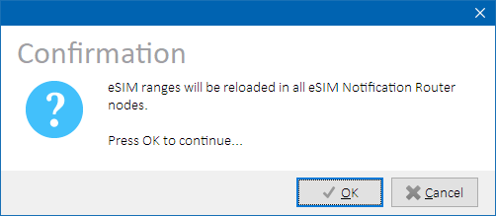

*eSIM range reload confirmation dialog*

**IMPORTANT:** Execute this task after eSIM inventory range records were modified in Phoenix configuration table RMSTOOL_RANGE_REF (inv_type = 'ESIM'). Otherwise, the eSIM notifications might be routed to incorrect Tibco instance (on different testing environment).

##### Process Overview

1. Load Reload API endpoint list from parameter ESIM_ENV_ROUTER_RELOAD_URLS.
2. Send HTTP POST request without payload to each endpoint fetched in previous step.
3. Report errors if occurred.

##### Role Differences

|  |  |  |  |  |  |
| --- | --- | --- | --- | --- | --- |
| **Action / Role** | **ADMIN** | **LEAD** | **TESTING-VF** | **TESTING-IBM** | **TESTING-V2** |
| **Access to Reload eSIM Ranges** | Y | Y | N | Y | N |

## Network Operations

### UMF Status (SurePay)

Select **Network 🡪 UMF Status (SurePay)** from the main menu to open UMF Status form for a MSISDN selected in the main grid. If multiple rows were selected, data related to first selected MSISDN will be displayed by default.

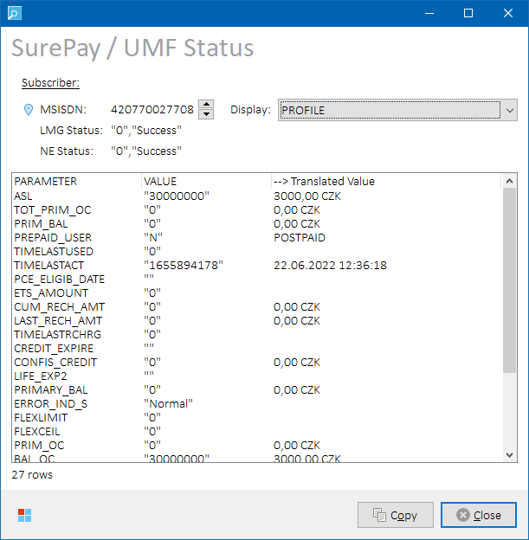

*UMF Status form*

##### Controls

|  |  |
| --- | --- |
| **Control Caption** | **Description** |
|  | MSISDN selector. Use to iterate among MSISDN’s selected in the main grid if multiple MSISDN’s were selected. |
| **Display** | Data to retrieve from SurePay:   1. **PROFILE** = UMF subscriber profile details 2. **<BUCKET_ID+NAME>** = UMF subscriber bucket details   Following buckets are available:   1. **287:PremiumLimit** 2. **454:PREFREECREDIT** = Prepaid Extra Credit bucket 3. **465:TOPGETCREDIT1** =TopUp&Get INDVOICEP03 bucket 4. **466:TOPGETCREDIT2** = TopUp&Get PRFB0126 bucket 5. **Additional buckets (varying)** = based on active Siebel products on the MSISDN   **NOTE:** Extra credit buckets 454, 465 and 466 are only visible for PREPAID subscribers. |

In the drop-down menu, select an item to display (profile or bucket). By default, PROFILE data is displayed.

##### Process Overview

1. Retrieve list of active product part numbers from Siebel tables SIEBEL.S_ASSET and SIEBEL.S_PROD_INT for selected MSISDN.
2. Convert product part numbers found in Siebel to SurePay bucket ID’s based on relations retrieved from CIMUSER.RELATIONSHIPCATALOGUE table (pre-loaded into SPBucketsLkp and SPBundlesLkp lookup tables during environment initialization).
3. Insert additional available buckets found in the previous step to the drop-down menu.
4. Invoke SOAP operation Provisioning_submit to retrieve profile or bucket information.
5. Parse and re-format retrieved values and display them in the status grid.

##### Role Differences

|  |  |  |  |  |  |
| --- | --- | --- | --- | --- | --- |
| **Action / Role** | **ADMIN** | **LEAD** | **TESTING-VF** | **TESTING-IBM** | **TESTING-V2** |
| **Access to UMF Status (SurePay)** | Y | Y | N | Y | N |

### OMM & DMA Status

Select **Network 🡪 OMM & DMA Status** from the main menu to open OMM & DMA Status form for a MSISDN selected in the main grid:

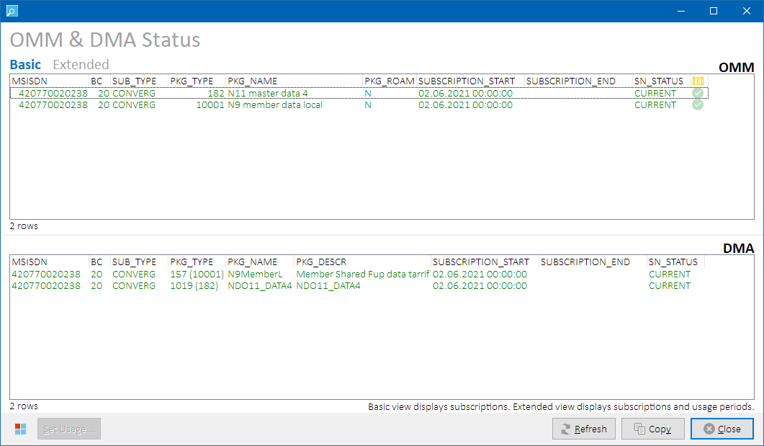

*OMM & DMA Status form*

Upper part of the form displays OMM status grid, lower part displays DMA status grid.

##### Controls

|  |  |
| --- | --- |
| **Button Caption** | **Description** |
| **Set Usage…** | Sets data usage in the selected usage period in OMM database.  See Setting Data Usage for more details. |

##### Output Data

**Basic** or **Extended** data sets are available to display. Output columns vary per selected data set as described in the below table. **Extended** data set returns also historical subscriptions and usage periods.

|  |  |  |  |
| --- | --- | --- | --- |
| **Column / Data Set** | **Basic** | **Extended** | **Description** |
| MSISDN | Y | Y | Input MSISDN. |
| BC | Y | Y | Bill cycle. |
| SUB_TYPE | Y | Y | Subscriber type (e.g., CONVERG). |
| PKG_TYPE | Y | Y | Package type. |
| PKG_NAME | Y | Y | Package name. |
| PKG_ROAM | Y | Y | Roaming package. |
| SUBSCRIPTION_START | Y | Y | Beginning of subscription. |
| SUBSCRIPTION_END | Y | Y | End of subscription. |
| SN_STATUS | Y | Y | Subscription status. One of the following values:   * CURRENT * HISTORY   **Color Legend:**   |  |  | | --- | --- | | GREEN | Current (ongoing) subscription. | | GRAY | Historical (terminated) subscription. | |
| USAGE_PERIOD_START | **N** | Y | Beginning of the usage period. |
| USAGE_PERIOD_END | **N** | Y | End of the usage period. |
| UP_STATUS | **N** | Y | Usage period status. One of the following values:   * CURRENT * HISTORY   **Color Legend:**   |  |  | | --- | --- | | GREEN | Current (ongoing) usage period. | | GRAY | Historical (terminated) usage period. | |
| FUP_LIMIT | **N** | Y | FUP limit value. |
| FUP_USAGE | **N** | Y | FUP usage value. |
| TOTAL_USAGE | **N** | Y | Total usage value (i.e., FUP + overcharge). |
| AR | **N** | Y | Autorebuy. |
| MASTER_MSISDN | **N** | Y | Master MSISDN value. |
| * OLC_SYNC *(icon)* | **N** | Y | OLC sync status (based on tables L0_SUBSCRIBER, L0_SUBSCRIBERTYPE, L0_SUBSCRIPTION, L0_PACKAGETYPE, and L0_USAGE):  **Icon Legend:**   |  |  | | --- | --- | |  | OMM data is not present in OLC | |  | OMM data is present in OLC |     **NOTE:** OMM row is considered synced when a row is found in OLC database with exactly the same values of all fields. |

Please refer to OMM and DMA system documentation for more details on the column values.

##### Process Overview

Following tables are queried for OMM / DMA / OLC sync details:

|  |  |  |
| --- | --- | --- |
| **OMM** | **DMA** | **OLC** |
| PACKAGETYPE | PACKAGE_TYPE | L0_PACKAGETYPE |
| SUBSCRIBER | SUBSCRIBER | L0_SUBSCRIBER |
| SUBSCRIBER | SUBSCRIBER_TYPE | L0_SUBSCRIBER |
| SUBSCRIBERTYPE | SUBSCRIPTION | L0_SUBSCRIBERTYPE |
| SUBSCRIPTION | SUBSCRIPTION_PERIOD | L0_SUBSCRIPTION |
| USAGE |  | L0_USAGE |

##### Role Differences

|  |  |  |  |  |  |
| --- | --- | --- | --- | --- | --- |
| **Action / Role** | **ADMIN** | **LEAD** | **TESTING-VF** | **TESTING-IBM** | **TESTING-V2** |
| **Access to OMM & DMA Status** | Y | Y | N | Y | N |

##### Setting Data Usage

In**Extended** data set, select a row in OMM Status grid that contains a usage period. Press **Set Usage** button and select one of the below options to set the data usage in the usage period:

|  |  |
| --- | --- |
| **Option** | **Description** |
| Almost 75% of FUP | Sets data usage to TRUNC(FUP_LIMIT/100*75)-1 bytes. |
| Almost 90% of FUP | Sets data usage to TRUNC(FUP_LIMIT/100*90)-1 bytes. |
| Almost 100% of FUP | Sets data usage to FUP_LIMIT-1 bytes. |
| Exactly 100% of FUP | Sets data usage to FUP_LIMIT bytes. |

**NOTE:** If usage period is unknown for selected row, the button will not be accessible.

###### Process Overview

1. USAGE and TOTAL_USAGE values are updated in OMM table USAGE for selected *(usage)* ID.
2. Reload data in status grids

### MNP Status

Select **Network 🡪 MNP Status** from the main menu to open MNP Status form for MSISDN(s) selected in the main grid.

**NOTE:** SIM inventory items are not applicable to this status view.

##### Output Data

Following data sets are available to display:

|  |  |
| --- | --- |
| **Data Set** | **Description** |
| **ČAU** | CAU codes status. |
| **Orders** | MNP porting orders status. |

Output columns vary per selected data set. Please refer to MNP system documentation for more details on the column values.

##### Data Set “ČAU”

Details on subscriber’s ČAU codes associated to selected MSISDN’s are displayed:

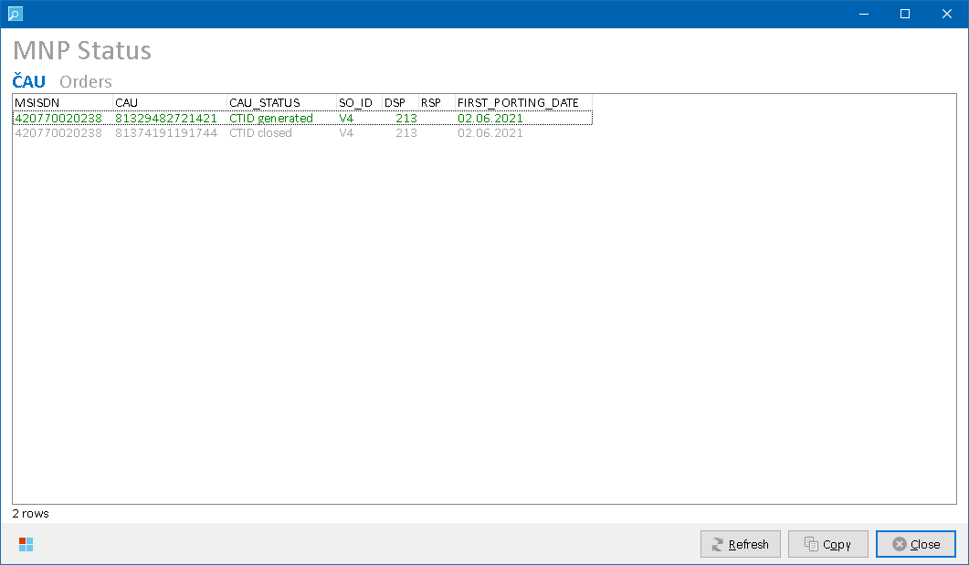

*MNP Status form – data set “ČAU”*

Following output columns are returned:

|  |  |
| --- | --- |
| **Column** | **Description** |
| MSISDN | Input MSISDN. |
| CAU | ČAU code (a.k.a. CPU / OKU / CTID). |
| CAU_STATUS | ČAU code status.  **Row Color Legend:**   |  |  | | --- | --- | | GREEN | CAU_STATUS = 10 (CTID Generated) / active. | | GRAY | CAU_STATUS = 60 (CTID Closed) / inactive. | | BLACK | Other CAU_STATUS values. | |
| SO_ID | Suboperator ID (e.g., V4, V2, etc.) |
| DSP | Donor (source) operator ID. |
| RSP | Recipient (destination) operator ID. |
| FIRST_PORTING_DATE | First scheduled porting date. |

###### Process Overview

Following MNP tables are queried for status details:

|  |
| --- |
| **Table** |
| PR_CAT_CTID_MSISDN_STATES |
| PR_CAT_CTID_STATES |
| PR_CTID |
| PR_CTID_MSISDN |

##### Data Set “Orders”

Details on MNP porting orders associated to selected MSISDN’s are displayed:

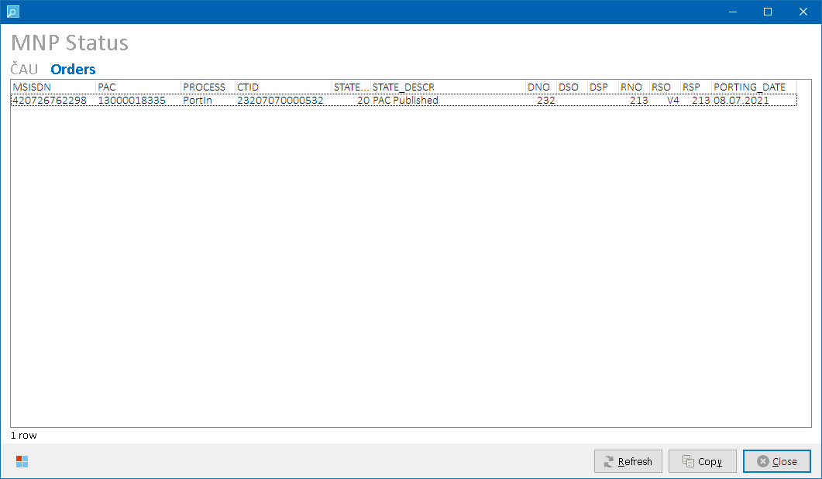

*MNP Status form – data set “Orders”*

Following output columns are returned:

|  |  |
| --- | --- |
| **Column** | **Description** |
| MSISDN | Input MSISDN. |
| PAC | PAC code (porting order ID). |
| PROCESS | Porting process. One of the following values:   * **Port Out:** Port Out process * **Port In:** Port In process * **Rep. Out:** Repatriation Out process * **Rep. In:** Repatriation In process * **Port X:** Port Cross process * **Rep. X:** Repatriation Cross process |
| CTID | CTID code value (contract termination ID). |
| STATE_ID | PAC state ID.  **Row Color Legend:**   |  |  | | --- | --- | | GREEN | STATE_ID value is final for given PROCESS:   * **Port Out:** 185 (PAC Ported) * **Port In:** 85 (PAC Ported) * **Rep. Out:** 385 (Repatriated) * **Rep. In:** 285 (Repatriated) * **Port X:** 480 (FNR Updated) * **Rep. X:** 580 (FNR Updated)   See PR_CAT_PAC_STATE table for more details. | | BLACK | Other STATE_ID values. | |
| STATE_DESCR | PAC state description. |
| DNO | Donor (source) operator ID. |
| DSO | Donor (source) suboperator ID. |
| DSP | Donor (source) service provider ID. |
| RNO | Recipient (destination) operator ID. |
| RSO | Recipient (destination) suboperator ID. |
| RSP | Recipient (destination) service provider ID. |
| PORTING_DATE | Scheduled porting date. |

###### Process Overview

Following MNP tables are queried for status details:

|  |
| --- |
| **Table** |
| PR_CAT_PAC_STATE |
| PR_ORDER |
| PR_ORDER_MSISDN |

##### Role Differences

|  |  |  |  |  |  |
| --- | --- | --- | --- | --- | --- |
| **Action / Role** | **ADMIN** | **LEAD** | **TESTING-VF** | **TESTING-IBM** | **TESTING-V2** |
| **Access to MNP Status form** | Y | Y | N | Y | N |

### Instant Link

##### Routing Status

Select **Network 🡪 InstantLink - Routing Status** from the main menu to open InstantLink Routing Status form displaying routing profiles and routing status for inventory items selected in the main grid.

###### Output Data

Following data sets are available to display:

|  |  |
| --- | --- |
| **Data Set** | **Description** |
| **Basic** | Generic routing profiles and states are displayed |
| **Extended** | Every routed subscriber_id is displayed for each inventory item. |

Output columns vary per selected data set. Please refer to InstantLink system documentation for more details on the column values.

###### Data Set “Basic”

Displays InstantLink routing profile associated to the inventory item and routing status validity from Phoenix perspective (see below).

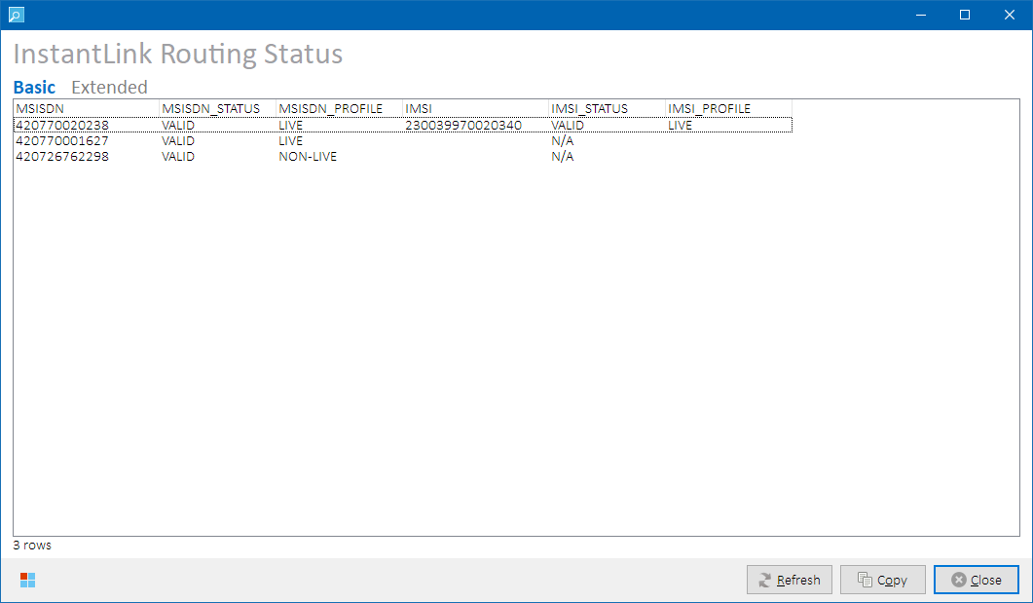

*InstantLink Routing Status form – data set “Basic”*

Data are returned in rows as they were selected in the main grid i.e., MSISDN and IMSI that are on the same row in the main grid are also returned on the same row in the Status grid:

Following output columns are returned:

|  |  |
| --- | --- |
| **Column** | **Description** |
| MSISDN | Input MSISDN. |
| MSISDN_STATUS | Routing status of the MSISDN. One of the following values:   * **VALID:** Routing configuration is correct. * **INVALID:** Routing configuration is incorrect. * **NOT FOUND:** Routing profile was not found. * **N/A:** MSISDN was not present on the selected row in the main grid. |
| MSISDN_PROFILE | Routing profile associated to the MSISDN. |
| IMSI | Input IMSI. |
| IMSI_STATUS | Routing status of the IMSI.   * **VALID:** Routing configuration is correct. * **INVALID:** Routing configuration is incorrect. * **NOT FOUND:** Routing profile was not found. * **N/A:** IMSI was not present on the selected row in the main grid. |
| IMSI_PROFILE | Routing profile associated to the IMSI. |

Routing configuration is considered VALID for LIVE routing profile if following conditions are met:

|  |  |
| --- | --- |
| **Inventory Type** | **Routing Conditions** |
| LIVE MSISDN/ISDN | All of the following formats of the inventory item are routed:   * 420nnnnnnnnn * nnnnnnnnn (without 420 prefix) * +420nnnnnnnnn@<IMS_SUFFIX_V4> * 420nnnnnnnnn@<IMS_SUFFIX_V4>   **NOTE:** <IMS_SUFFIX_V4> value is configurable. |
| LIVE IMSI | Basic format of the inventory item is routed:   * 23003nnnnnnnnnn |
| LIVE  EXTERNAL | Basic format of the inventory item is routed:   * nnnnnnnnn   **NOTE:** This applies e.g., to external ID’s not maintained in RMS but present in Kenan with a known external ID type, such as:   * 5 = FakeSIM * 6 = ADSL/FBB * 7 = ICT * 12 = VTV * 13 = Marketplace   or to external ID’s not present in Kenan at all, such as:   * MAC addresses * PBX numbers |

Process Overview

1. A set of expected SUBSCRIBER_ID variants is constructed for the selected inventory items.
2. InstantLink table ILABATCH_OWN.ROUTING_TEST_NUMBERS is queried for associated routing profiles.
3. Routing status value is evaluated based on retrieved routing configuration.

###### Data Set “Extended”

Displays all routed formats and their routing profiles for the selected inventory items.

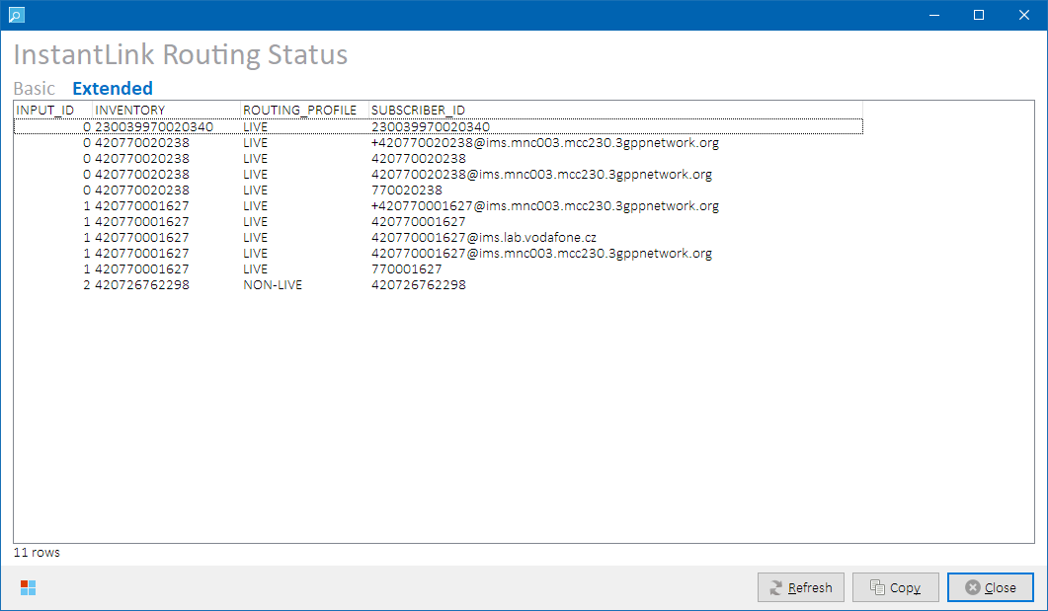

*InstantLink Routing Status form – data set “Extended”*

Following output columns are returned:

|  |  |
| --- | --- |
| **Column** | **Description** |
| INPUT_ID | A relative ID of corresponding selected row in the main grid. First selected row has ID=0, etc. |
| INVENTORY | Input inventory from the main grid. |
| ROUTING_PROFILE | Routing profile associated to the particular subscriber_id that corresponds with the input inventory. |
| SUBSCRIBER_ID | Actual routed subscriber_id value (routed format of the inventory item). |

Process Overview

InstantLink table ILABATCH_OWN.ROUTING_TEST_NUMBERS is queried for routing profiles of all SUBSCRIBER_ID that contain input inventory item as substring.

###### Role Differences

|  |  |  |  |  |  |
| --- | --- | --- | --- | --- | --- |
| **Action / Role** | **ADMIN** | **LEAD** | **TESTING-VF** | **TESTING-IBM** | **TESTING-V2** |
| **Access to InstantLink Routing Status** | Y | Y | N | Y | N |

##### Special Resources Status

Select **Network 🡪 InstantLink – Special Resources Status** from the main menu to open InstantLink Special Resources Status form. The form informs about amounts of available resources in Instant Link white lists for sequence-based resources (i.e., inventory not originating in RMS) and allows the user to extend the numbers of resources in Instant Link white lists:

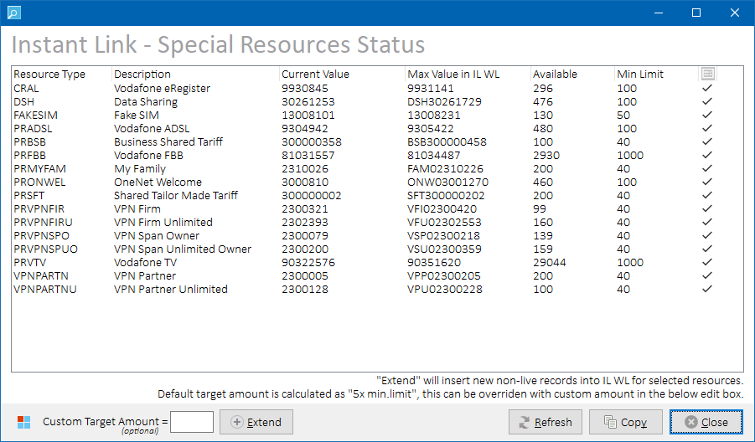

*Instant Link – Special Resources Status form*

If resources are not configured in the Instant Link white lists, their network provisioning requests would be routed to DUMMY network elements. Press **Extend** button to insert new records into Instant Link white lists with NON-LIVE routing profile.

###### Controls

Form-specific controls:

|  |  |
| --- | --- |
| **Control Caption** | **Description** |
| **Custom Target Amount** | Enter custom target amount that is supposed to be available in Instant Link white list. The value overrides the default value of each resource type. |
| **Extend** | Press to extend Instant Link white lists. See Extending Instant Link White Lists for more details. |

###### Output Data

Following output columns are returned:

|  |  |
| --- | --- |
| **Column** | **Description** |
| Resource Type | Resource type part number in Siebel |
| Description | Resource type description |
| Current Value | Current Siebel/Tibco sequence value |
| Max Value in IL WL | Maximum value currently configured in Instant Link white lists |
| Available | Number of available resources in Instant Link white lists |
| Min Limit | Minimum threshold of given resource resource. Configurable.  **NOTE:** If available amount of given resource is lower than configured minimum threshold, Peklo will begin to send hourly warning emails until the white lists are replenished. |
| Status *(icon)* | Graphical representation of resource availability in Instant Link white lists.  **Icon Legend:**   |  |  | | --- | --- | |  | OK Available amount > 5x min. limit | |  | WARNING (INSUFFICIENT) Available amount < 5x min. limit | |  | ERROR (DEPLETED) Available amount = 0. Resource type is depleted in Instant Link white lists. | |

Please refer to Instant Link system documentation for more details on the white lists functionality.

###### Process Overview

Special resources status is fetched from Peklo view IBMTEST.PEKLO_SPECIAL_RESOURCES_<env>.  
  
The view queries current values of special resource sequences in Tibco (FAKE_SIM_ID_SEQ) and Siebel (VF_xxx_SEQ_ID), and compares them to actual content of Instant Link white lists table ILABATCH_OWN.ROUTING_TEST_NUMBERS using special resources configuration table IBMTEST.PEKLO_SPECIAL_RESOURCES_DEF.

###### Role Differences

|  |  |  |  |  |  |
| --- | --- | --- | --- | --- | --- |
| **Action / Role** | **ADMIN** | **LEAD** | **TESTING-VF** | **TESTING-IBM** | **TESTING-V2** |
| **Access to Instant Link – Special Resources Status form** | Y | Y | N | Y | N |

###### Extending Instant Link White Lists

Select rows in the status grid that you want to process i.e., rows that relate to resource types with insufficient or depleted amount.



*Instant Link – Special Resources Status Form – before extending*

By default, the resources are extended so that *“5 times minimum limit”* of each resource type is available. This can be overridden by inserting a custom amount in the appropriate edit box below the status grid.

Press  **Extend** button to insert new records into Instant Link white lists with NON-LIVE routing profile for selected resource types using either default or custom target amount. If the particular resource has lower available number than its configured minimum threshold, new records are inserted for it into Instant Link white lists table. If there is sufficient amount of the resource type already available, no action is taken. Status grid is then reloaded to reflect the changes.



*Instant Link – Special Resources Status Form – after extending*

**NOTE:** Default minimum threshold value differs per resource type and is configurable in IBMTEST.PEKLO_SPECIAL_RESOURCES_DEF table.

**WARNING:** If negative numbers are displayed in the Available column, the most likely root cause is that the sequences have been changed/shifted/tampered in their source system (Tibco or Siebel) without prior notice, leaving Peklo configuration and Instant Link white lists content unaligned. Please contact development team of the particular system in order to re-align the sequences among Tibco/Siebel, Peklo, and Instant Link.

##### Alarms

Select **Network 🡪 Instant Link - Alarms** from the main menu to check if there were any uncleared alarms in Instant Link logged during today. A dialog box will open indicating the number of found today’s uncleared alarms:

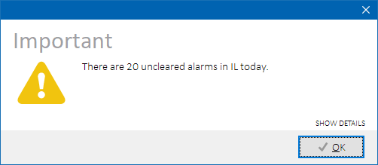

*Uncleared Instant Link alarms warning*

Click **SHOW DETAILS** label to get more information about the alarms:

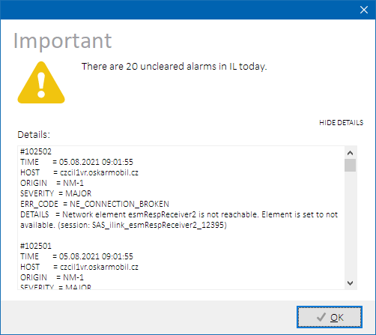

*Uncleared Instant Link alarms warning - extended*

Uncleared alarms should be handled by test environment admin team. Please consult them in order to get more details on the root cause of why the alarm was raised and what is its possible impact.

**NOTE:** Instant Link alarms are also checked before cleansing process commences as they could indicate a possible issue that might interfere with network cleansing task.

###### Process Overview

Instant Link table ILINK_OWN.ALARMS is queried for uncleared alarms with today’s date.

###### Role Differences

|  |  |  |  |  |  |
| --- | --- | --- | --- | --- | --- |
| **Action / Role** | **ADMIN** | **LEAD** | **TESTING-VF** | **TESTING-IBM** | **TESTING-V2** |
| **Access to Instant Link – Alarms** | Y | Y | N | Y | N |

##### Routing Profiles

Select **Network 🡪 Instant Link Config – Routing Profiles** from the main menu to open Instant Link Routing Profiles form. Network element mappings for selected routing profile will be displayed for selected routing profile:

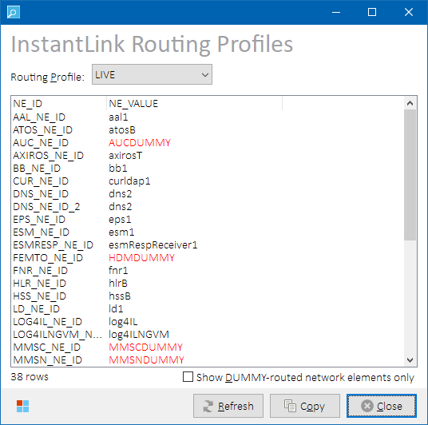

*Instant Link Routing Profiles form*

###### Output Data

Following output columns are returned:

|  |  |
| --- | --- |
| **Column** | **Description** |
| NE_ID | Network element ID. |
| NE_VALUE | Network element instance value.  **Color Legend:**   |  |  | | --- | --- | | RED | DUMMY network element instance | | BLACK | Regular network element instance. | |

Please refer to Instant Link system documentation for more details on the column values.

Select a routing profile from the above combo box to load its network element mappings.

Optionally, check **Show DUMMY-routed network elements only** check box to only display mappings to dummy network elements.

###### Process Overview

Instant Link configuration tables **ILINK_OWN.BST_LOOKUP_TABLE** and **ILINK_OWN.BST_LOOKUP_TABLE_ROW** are queried for LOOKUP_ROUTING_PROFILES configuration. Found data is parsed and represented in a grid view.

###### Role Differences

|  |  |  |  |  |  |
| --- | --- | --- | --- | --- | --- |
| **Action / Role** | **ADMIN** | **LEAD** | **TESTING-VF** | **TESTING-IBM** | **TESTING-V2** |
| **Access to Instant Link Routing Profiles form** | Y | Y | N | Y | N |

### Recharge Prepaid

Select one or more rows with prepaid MSISDN’s in the main grid, then select **Network 🡪 Recharge Prepaid** from the main menu to open Prepaid Recharge form. If single row was selected, SurePay is queried for the prepaid subscriber status, air time, current balances (both primary and extra), and their expiration dates. If multiple rows were selected, current values are not displayed.

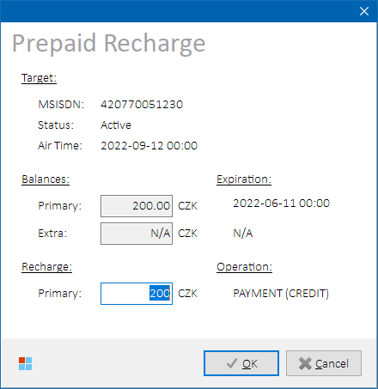

*Prepaid Recharge form*

Enter amount to recharge or adjust the primary balance with. Positive number is processed as a *recharge*, negative number is processed as an *adjustment*. Press **OK** button to apply the changes. Entered number will be added or subtracted from the primary balance.

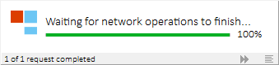

*Waiting form during prepaid recharging*

User is notified about successful processing or about occurred error.

**NOTES:**

* Extra balance amount cannot be changed in Phoenix.

##### Process Overview

1. (If single row was selected):
   1. Invoke SOAP operation PrepaidBalanceInquiry (provided by AssetServices endpoint on Tibco) to get current balances.
   2. Check primary balance expiry date in the response. If the date equals to 1.1.1980 00:00, the subscriber is considered POSTPAID and processing stops.
2. Show the Recharge Prepaid form
3. Spawn TNetworkThread thread that inserts SET request for ocsRecharge service into Instant Link batch processing queue table ILABATCH_OWN.BATCH_PROVISIONING with following structure:

|  |  |  |  |
| --- | --- | --- | --- |
| **Name** | **Value** | | |
| PRIMARY_ID | <user-provided> | | |
| PRIMARY_ID_TYPE | voiceMsisdn | | |
| SERVICE | ocsRecharge | | |
| OPERATION | SET | | |
| PARAMETERS | **Parameter Name** | **Parameter Value** | |
| **Scenario** | **recharge** | **adjustment** |
| operation | PAYMENT | ADJUST |
| amount | <user-provided> | |
| transactionType | CREDIT | DEBIT |
| adjustmentReason | 2 | 6 |
| balanceType | PRIMARY | |
| taxCodeId | 3 | |
| taxPercentage | 21 | |
| STATUS | P (pending) | | |
| BATCH_ID | “P” + <yyyymmddhh24mi> (Phoenix-generated) | | |
| PRIORITY | 9 (lowest) | | |

1. Wait until Instant Link processes the request.
2. If an error occurs during processing, display its details to the user, else display “success” dialog.

##### Role Differences

|  |  |  |  |  |  |
| --- | --- | --- | --- | --- | --- |
| **Action / Role** | **ADMIN** | **LEAD** | **TESTING-VF** | **TESTING-IBM** | **TESTING-V2** |
| **Access to Prepaid Recharge** | Y | Y | Y | Y | Y |

### Network Cleansing Batch Status

If a user with ADMIN or LEAD role has previously selected to skip waiting for a Network Cleansing batch (see Skip Waiting for Instant Link for more details), they can check its status by selecting **Network 🡪 Network Cleansing Batch Status** from the main menu. This will open Network Batch form with prefilled batch id assigned during the latest Network Cleansing task:

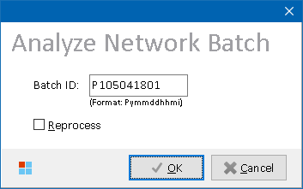

*Network Batch form*

Click on **OK** to check the network batch status.

* If the batch is still running, the same Working form with its progress is displayed as during regular cleansing. It can be closed by clicking on the **SKIP** button again. Network cleansing will continue running in the background.

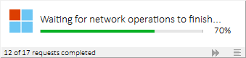

*Network Cleansing task in progress…*

* If the batch has already finished, a dialog will be displayed with batch results:

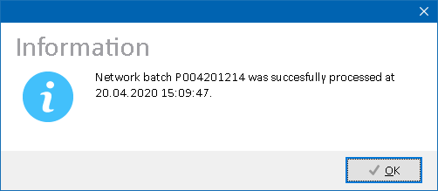

*Network batch successfully processed dialog*

Optionally, check **Reprocess** check box to have the whole network batch re-processed by Instant Link once again, should there be a reason for it.

##### Process Overview

1. Periodically check Instant Link batch provisioning table ILABATCH_OWN.BATCH_PROVISIONING for status of service requests present in given network batch and fetch current numbers of pending and processed requests.
2. Show Waiting form until there are no more pending requests.
3. Show “success” or “error” dialog depending on the processing result.

##### Role Differences

|  |  |  |  |  |  |
| --- | --- | --- | --- | --- | --- |
| **Action / Role** | **ADMIN** | **LEAD** | **TESTING-VF** | **TESTING-IBM** | **TESTING-V2** |
| **Access to Network Batch form** | Y | Y | N | N | N |

## EBS Operations

### EBS Status

Select **EBS 🡪 EBS Status** from the main menu to open EBS Status status form displaying details about SIM cards on selected rows in the main grid. If no rows are selected, all rows are processed.

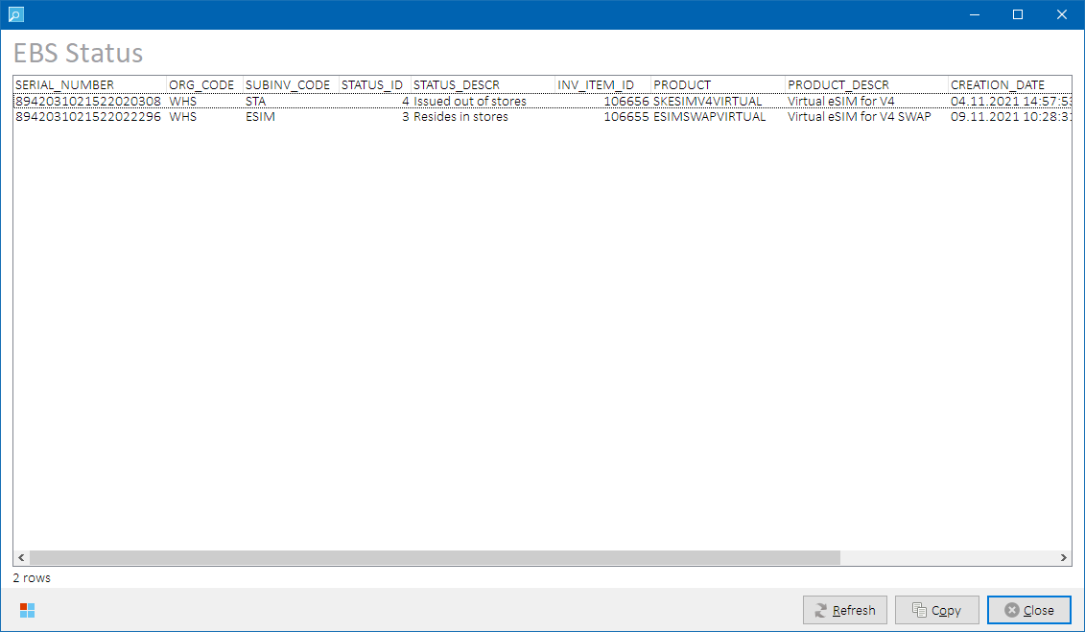

*EBS Status form*

##### Output Data

Following output columns are returned:

|  |  |
| --- | --- |
| **Column** | **Description** |
| SERIAL_NUMBER | Serial number of the inventory item (ICCID). |
| ORG_CODE | Organization code (warehouse, e.g., WHS). |
| SUBINV_CODE | Subinventory code (e.g., ESIM). |
| STATUS_ID | Inventory status identifier |
| STATUS_DESCR | Inventory status description |
| INV_ITEM_ID | Inventory item identifier |
| PRODUCT | Product name |
| PRODUCT_DESCR | Product description |
| CREATION_DATE | Date the item was created |
| SHIP_DATE | Date the item was shipped. NULL if not shipped. |
| LAST_UPDATE_DATE | Date the item was last updated. |

##### Process Overview

Following EBS tables are queried for status of the inventory present in the main grid:

* INV.MTL_SERIAL_NUMBERS
* APPS.MTL_PARAMETERS
* APPS.MTL_SYSTEM_ITEMS_B
* APPS.OE_ORDER_LINES
* APPS.OE_ORDER_HEADERS_ALL
* APPS.MFG_LOOKUPS

##### Role Differences

|  |  |  |  |  |  |
| --- | --- | --- | --- | --- | --- |
| **Action / Role** | **ADMIN** | **LEAD** | **TESTING-VF** | **TESTING-IBM** | **TESTING-V2** |
| **Access to EBS Status form** | Y | Y | N | Y | N |

### EBS Status – Available Virtual eSIM’s

Select **EBS 🡪 EBS Status - Available Virtual eSIM’s** from the main menu to open EBS Status – Available Virtual eSIM’s status form displaying details about virtual eSIM products available in EBS warehouse WHS/ESIM.

##### Output Data

Following data sets are available to display:

|  |  |
| --- | --- |
| **Data Set** | **Description** |
| **Basic** | Displays summarized amounts of available virtual eSIM products.  See Data Set “Basic” for more details. |
| **Extended** | Displays available virtual eSIM inventory items.  See Data Set “Extended” for more details. |

Output columns vary per selected data set. Please refer to Kenan system documentation for more details on the column meanings and values.

**NOTE:** The data sets should not return voucher eSIM products. If any voucher eSIM is returned, it means they were stocked up in incorrect warehouse WHS/ESIM and should be re-stocked to where they actually belong (WHS/PROD).

##### Data Set “Basic”

Summarized amounts of virtual eSIM products available for use in WHS/ESIM warehouse are returned.

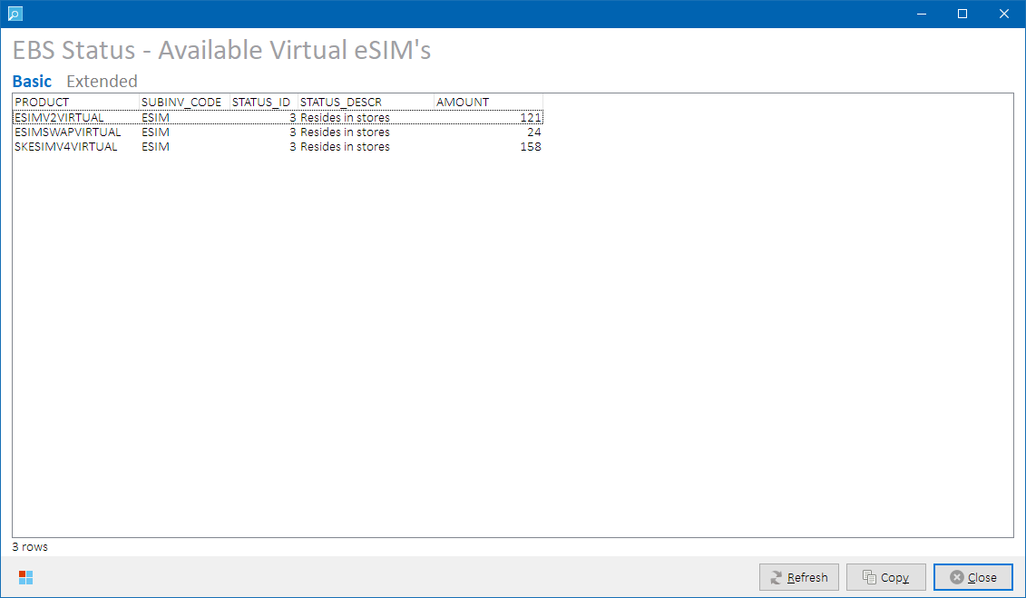

*EBS Status – Available Virtual eSIM’s status form – data set* ***“Basic”***

Following output columns are returned:

|  |  |
| --- | --- |
| **Column** | **Description** |
| PRODUCT | Product name |
| SUBINV_CODE | Subinventory code – should always be “ESIM” |
| STATUS_ID | Inventory status identifier – should always be “3” |
| STATUS_DESCR | Inventory status description – should always be “Resides in stores” |
| AMOUNT | Number of available products |

##### Data Set “Extended”

List of virtual eSIM products available for use in WHS/ESIM warehouse is returned.

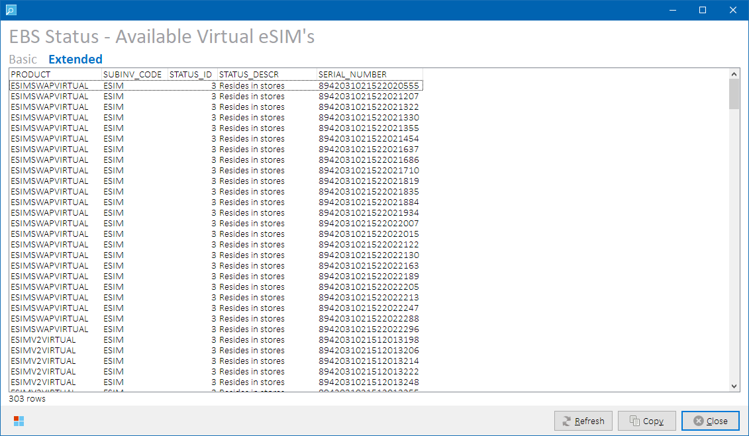 *EBS Status – Available Virtual eSIM’s status form – data set* ***“Extended”***

Following output columns are returned:

|  |  |
| --- | --- |
| **Column** | **Description** |
| PRODUCT | Product name |
| SUBINV_CODE | Subinventory code – should always be “ESIM” |
| STATUS_ID | Inventory status identifier – should always be “3” |
| STATUS_DESCR | Inventory status description – should always be “Resides in stores” |
| SERIAL_NUMBER | Serial number of the inventory item (ICCID). |

##### Process Overview

1. Check existence of eSIM view APPS.XXVF_ESIM_SERIAL_NUMBERS_V, report error if inexistent.
2. Query following EBS tables/views for eSIM items status:

* APPS.XXVF_ESIM_SERIAL_NUMBERS_V
* APPS.MFG_LOOKUPS

##### Role Differences

|  |  |  |  |  |  |
| --- | --- | --- | --- | --- | --- |
| **Action / Role** | **ADMIN** | **LEAD** | **TESTING-VF** | **TESTING-IBM** | **TESTING-V2** |
| **Access to EBS Status – Available Virtual eSIM’s status form** | Y | Y | N | Y | N |

### User Cash Register Status

Select **EBS 🡪 User Cash Register Status** from the main menu to open EBS User Cash Register status form displaying details about preconfigured user cash registers on **S02** warehouse:

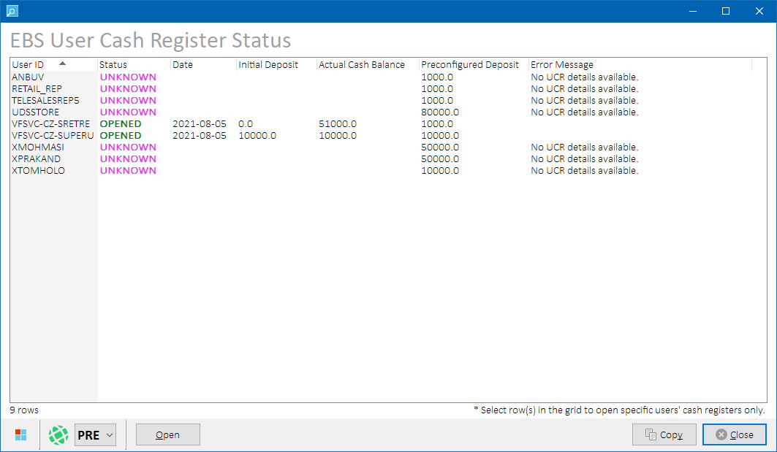

*EBS User Cash Register Status form*

Use environment combo box to change test environment and reload cash register status, if needed.

##### Controls

Form-specific button controls:

|  |  |
| --- | --- |
| **Button Caption** | **Description** |
| **Open** | Press to opens unopened cash registers. See Opening Cash Registers for more details. |

##### Output Data

Following output columns are returned:

|  |  |
| --- | --- |
| **Column** | **Description** |
| User ID | Cash register user ID. |
| Status | Cash register status.  **Row Color Legend:**   |  |  | | --- | --- | | OPENED | Cash register is opened | | CLOSED | Cash register is closed | | UNKNOWN | Cash register status is unknown.  See error message for details. | | ERROR | Error getting cash register status. See error message for details. | | OPENING | Cash register is being opened. | |
| Date | Date when the register was opened. |
| Initial Deposit | Initial deposit amount of the cash register in CZK. |
| Actual Cash Balance | Current cash balance in the cash register in CZK. |
| Preconfigured Deposit | Preconfigured deposit amount in CZK to open the cash register with. Configurable. |
| Error Message | Error message related to UNKNOWN and ERROR states. |

##### Process Overview

1. Load preconfigured user ID’s and initial deposits from RMSTOOL_OWN.RMSTOOL_CASH_REG table.
2. For each loaded user ID, invoke SOAP operation getUcr (provided by CashRegisterServices endpoint on Tibco EBS adapter) to get current cash register status.
3. Show EBS User Cash Register Status form

##### Role Differences

|  |  |  |  |  |  |
| --- | --- | --- | --- | --- | --- |
| **Action / Role** | **ADMIN** | **LEAD** | **TESTING-VF** | **TESTING-IBM** | **TESTING-V2** |
| **Access to EBS User Cash Registers Status form** | Y | Y | N | Y | N |

##### Opening Cash Registers

Press **Open** button to open currently unopened cash registers. If no rows are selected in the status grid, all unopened cash registers are processed, otherwise only selected cash registers are processed.

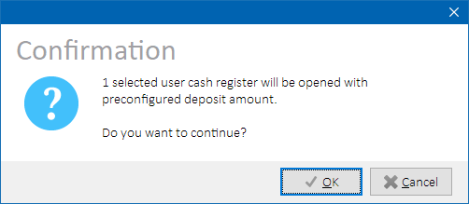

*Opening selected user cash register – confirmation dialog*

The registers will be opened with preconfigured deposit amount (visible in the status grid).

**

*User cash register – status before opening*



*User cash register – status after opening*

###### Process Overview

1. For each selected unopened cash register, invoke SOAP operation openUcr (provided by CashRegisterServices endpoint on Tibco EBS adapter) to open the cash register.
2. Show “success” or “error” dialog depending on the processing result.

###### Role differences

|  |  |  |  |  |  |
| --- | --- | --- | --- | --- | --- |
| **Action / Role** | **ADMIN** | **LEAD** | **TESTING-VF** | **TESTING-IBM** | **TESTING-V2** |
| **Access to Opening EBS User Cash Registers** | Y | Y | N | Y | N |

## OLC Operations

### Subscriber Status

Select **OLC 🡪 Subscriber Status** from the main menu to open OLC Subscriber Status form displaying details about selected subscriber(s) in OLC database. In this way, user can check if Kenan-OLC synchronization is working and that subscriber created in Kenan is transferred to OLC:

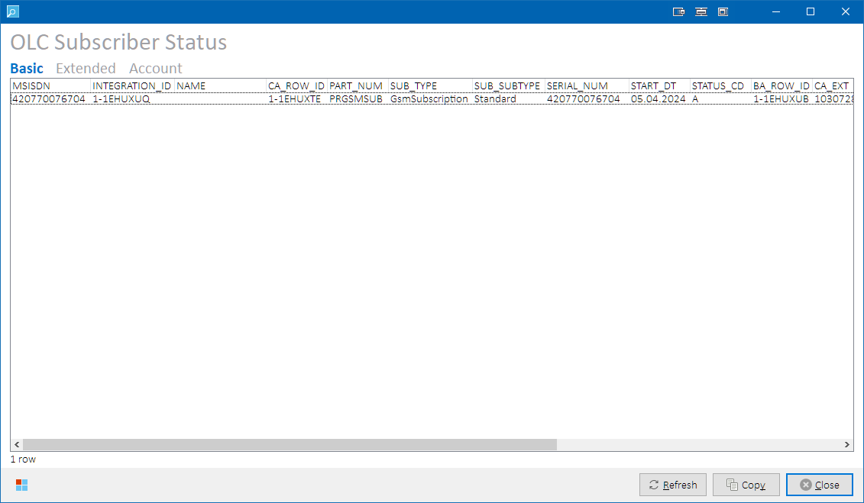

*OLC Subscriber Status form*

##### Output Data

**Basic**, **Extended** and **Account** data sets are available to display.

Output columns vary per selected data set as described in the below table.

|  |  |  |  |
| --- | --- | --- | --- |
| **Column / Data Set** | **Basic** | **Extended** | **Source Table** |
| MSISDN | Y | Y | main grid |
| INTEGRATION_ID | Y | Y | BE_ASSET |
| NAME | Y | Y | BE_ASSET |
| CA_ROW_ID | Y | Y | CA_BA_MAP |
| PART_NUM | Y | Y | BE_PRODUCT |
| EXTERNAL_CODE SUB_TYPE | Y | Y | SERVICE_TYPE_REF |
| EXTERNAL_CODE SUB_SUBTYPE | Y | Y | SERVICE_SUB_TYPE_REF |
| SERIAL_NUM | Y | Y | BE_ASSET |
| START_DT | Y | Y | BE_ASSET |
| STATUS_CD | Y | Y | BE_ASSET |
| BA_ROW_ID | Y | Y | CA_BA_MAP |
| CA_EXT | Y | Y | CA_BA_MAP |
| BA_EXT | Y | Y | CA_BA_MAP |
| PAYMENT_TYPE_CD | Y | Y | BE_BA |
| X_SUBSCRIBER_ID | Y | Y | BE_ASSET |
| REGISTERED_DT | Y | Y | BE_ASSET |
| END_DT | Y | Y | BE_ASSET |
| MSL_CONTRACT_FLG | **N** | Y | BE_SERVICE calculated: (if msl_contract_flg = 'Y' or x_sub_vb_grp_commit_id is not null then 'Y' else 'N') |
| OPTIN_VF_LOCALDATA | **N** | Y | BE_SERVICE_ATTR |
| OPTIN_VF_OPERDATA | **N** | Y | BE_SERVICE_ATTR |
| OPTIN_TNPS | **N** | Y | BE_SERVICE_ATTR |
| OPTIN_VF_COMCOM | **N** | Y | BE_SERVICE_ATTR |
| OPTIN_VF_3RDPARTYCOM | **N** | Y | BE_SERVICE_ATTR |
| CALL_FORWARD_SERVICE_IDENTIF | **N** | Y | BE_SERVICE |
| X_ISIC_CODE | **N** | Y | BE_ASSET |
| X_CONNECTED_WITH_COMPANY | **N** | Y | BE_ASSET |
| ONE_NET_WELCOME_GROUP_ID | **N** | Y | BE_SERVICE |
| KID_FLAG | **N** | Y | BE_SERVICE_ATTR |
| X_SUB_VB_ASSET_INT_ID | **N** | Y | BE_SERVICE |

|  |  |  |
| --- | --- | --- |
| **Column / Data Set** | **Account** | **Source Table** |
| MSISDN | Y | main grid  joined on  L0_EXTERNAL_ID_EQUIP_MAP |
| BA_EXT_ID | Y | L0_EXTERNAL_ID_ACCT_MAP |
| BA_FNAME | Y | L0_CMF |
| BA_LNAME | Y | L0_CMF |
| BA_DATE_ACTIVE | Y | L0_CMF |
| BA_KENAN_ACCOUNT_NO | Y | L0_CMF |
| CA_EXT_ID | Y | L0_EXTERNAL_ID_ACCT_MAP |
| CA_FNAME | Y | L0_CMF |
| CA_LNAME | Y | L0_CMF |
| CA_DATE_ACTIVE | Y | L0_CMF |
| CA_KENAN_ACCOUNT_NO | Y | L0_CMF |

Please refer to OLC system documentation for more details on the column meanings.

##### Process Overview

Following OLC tables are queried for status of the inventory present in the main grid, depending on selected data set:

* BE_ASSET
* BE_BA
* BE_CA
* BE_PRODUCT
* BE_SERVICE
* BE_SERVICE_ATTR
* CA_BA_MAP
* SERVICE_SUB_TYPE_REF
* SERVICE_TYPE_REF
* L0_EXTERNAL_ID_EQUIP_MAP
* L0_EXTERNAL_ID_ACCT_MAP
* L0_CMF

##### Role Differences

|  |  |  |  |  |  |
| --- | --- | --- | --- | --- | --- |
| **Action / Role** | **ADMIN** | **LEAD** | **TESTING-VF** | **TESTING-IBM** | **TESTING-V2** |
| **Access to OLC Subscriber Status form** | Y | Y | N | Y | N |

### MSISDN Synchronization

For OLC to return accurate data to WSC, it must be synchronized with RMS. As inventory cleansing contains RMS operations that are not catched by standard RMS-OLC sync mechanism via Golden Gate, cleansed MSISDN’s must be manually synchronized by calling a dedicated stored procedure in OLC database. This process is run automatically during cleansing finalization phase, but on-demand synchronization is also possible.

Select one or more rows with known MISDN in the main grid. Select **OLC 🡪 Synchronize MSISDN** from the main menu to synchronize their status in OLC according to RMS.

##### Process Overview

For each selected MSISDN, call stored procedure OLC_OWN.RMS_OLC_SYNC

##### Role Differences

|  |  |  |  |  |  |
| --- | --- | --- | --- | --- | --- |
| **Action / Role** | **ADMIN** | **LEAD** | **TESTING-VF** | **TESTING-IBM** | **TESTING-V2** |
| **Access to OLC Subscriber Status form** | Y | Y | N | Y | N |

## Other Operations

### Peklo Status

Select **Other 🡪 Peklo Status (blacklists, reservations)** from the main menu to open Peklo Status form displaying details about whether the inventory is blacklisted in Peklo and also when and by whom was it reserved for the last time:

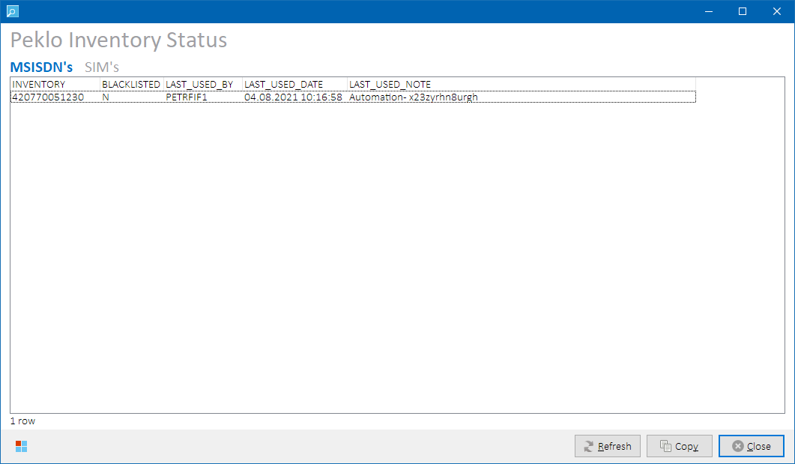

*Peklo Status form –* ***MSISDN’s*** *data set*

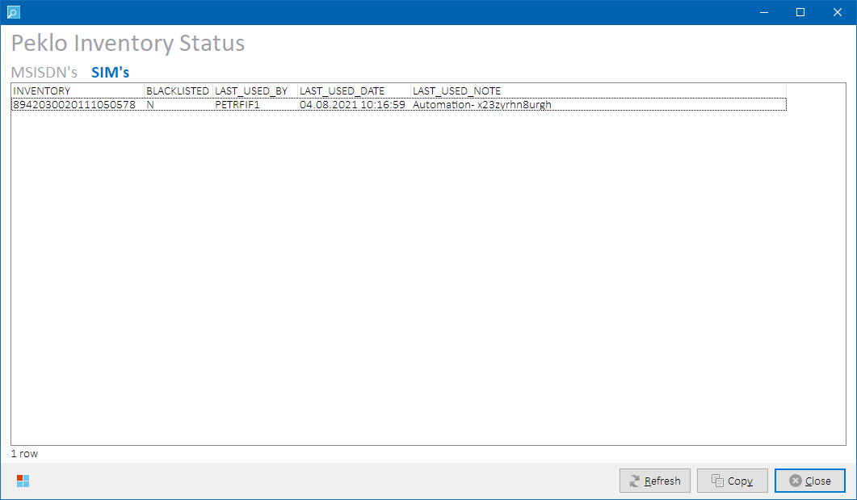

*Peklo Status form –* ***SIM’s*** *data set*

##### Output Data

Following data sets are available to display:

|  |  |
| --- | --- |
| **Data Set** | **Description** |
| **MSISDN’s** | Peklo status for MSISDN’s / ISDN’s |
| **SIM’s** | Peklo status for SIM cards |

Following output columns are returned:

|  |  |
| --- | --- |
| **Column** | **Description** |
| INVENTORY | Input inventory ID (MSISDN or IMSI, depends on selected data set) |
| BLACKLISTED | Y|N – is the inventory present in Peklo black list? |
| LAST_USED_BY | ID of user who reserved the inventory in Peklo. |
| LAST_USED_DATE | Date when the inventory was reserved in Peklo. |
| LAST_USED_NOTE | Note the user entered to Peklo when obtaining the inventory (reservation reason). |

Please refer to Peklo system documentation for more details on the column values.

##### Process Overview

Following Peklo tables queried for status of the inventory present in the main grid:

* For MSISDN’s data set: IBMTEST.PEKLO_<env>_USED_BY, IBMTEST.PEKLO_MSISDN_BL
* For SIM’s data set: IBMTEST.PEKLO_<env>_SIM_USED_BY, IBMTEST.PEKLO_SIM_BL

##### Role Differences

|  |  |  |  |  |  |
| --- | --- | --- | --- | --- | --- |
| **Action / Role** | **ADMIN** | **LEAD** | **TESTING-VF** | **TESTING-IBM** | **TESTING-V2** |
| **Access to Peklo Status** | Y | Y | Y | Y | Y |

### Phoenix Cleansing Blacklist Status

Select **Other 🡪 Phoenix Cleansing Blacklist Status** from the main menu to open Phoenix Cleansing Blacklist Status form displaying whether the inventory is blacklisted for cleansing in Phoenix:

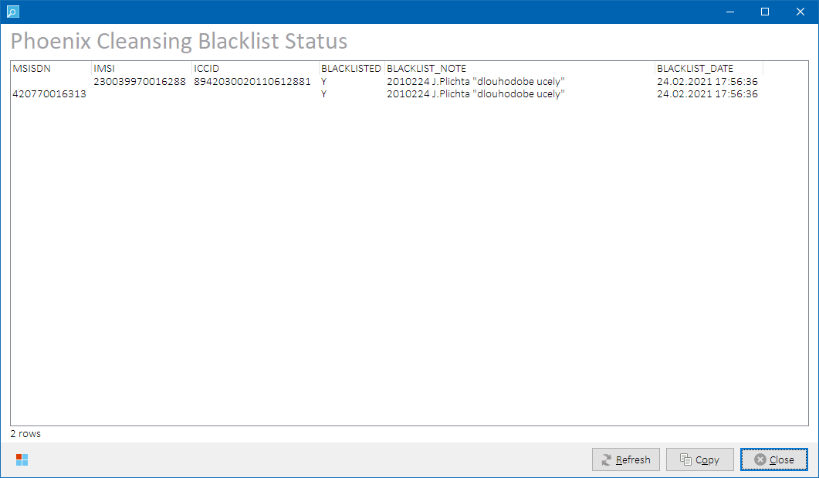

*Phoenix Cleansing Blacklist Status form*

##### Output Data

Following output columns are returned:

|  |  |
| --- | --- |
| **Column** | **Description** |
| MSISDN | Input MSISDN (if row containing a MSISDN/ISDN was selected in the main grid) |
| IMSI | Input IMSI (if row containing a SIM card was selected in the main grid) |
| ICCID | Input ICCID (if row containing a SIM card was selected in the main grid) |
| BLACKLISTED | Y|N – is the inventory present in Phoenix black list? |
| BLACKLIST_NOTE | Note the user entered to Phoenix when blacklisting the inventory. |
| BLACKLIST_DATE | Date when the inventory was blacklisted in Phoenix. |

##### Process Overview

Phoenix table RMSTOOL_OWN.RMSTOOL_INV_GROUP is queried for inventory group assignment of the inventory present in the main grid. If the inventory is present in inventory group 0, it is considered black listed. See Phoenix Inventory Groups for more details on inventory group assignment.

**NOTE:** Cleansing of blacklisted inventory is not allowed. If such attempt is detected, the inventory is flagged as UNAUTHORIZED in the main grid (/ or similar purple icon for corresponding inventory type) and error message is displayed. See Inventory Authorization for more details.

##### Role Differences

|  |  |  |  |  |  |
| --- | --- | --- | --- | --- | --- |
| **Action / Role** | **ADMIN** | **LEAD** | **TESTING-VF** | **TESTING-IBM** | **TESTING-V2** |
| **Access to Phoenix Cleansing Blacklist Form** | Y | Y | Y | Y | Y |

### OKU Code Generator

Select **Other 🡪 Generate OKU code** from the main menu open Generate OKU Code form:

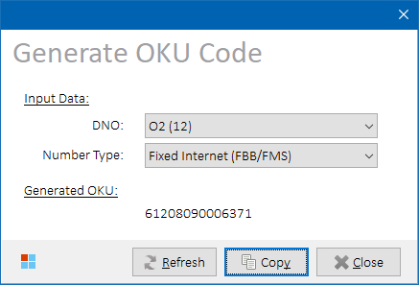

*Generate OKU Code form*

After input parameters are selected, OKU code is generated and displayed.

##### Process Overview

Peklo DB function IBMTEST.PEKLO_API_PKG.GENERATE_CPU is called to obtain the OKU code.

##### Role Differences

|  |  |  |  |  |  |
| --- | --- | --- | --- | --- | --- |
| **Action / Role** | **ADMIN** | **LEAD** | **TESTING-VF** | **TESTING-IBM** | **TESTING-V2** |
| **Access to Peklo Non-Live MAC Address Generator** | Y | Y | Y | Y | Y |

### MAC Address Generator

Select **Other 🡪 Generate non-live MAC address** from the main menu to generate a non-live MAC address from Peklo.

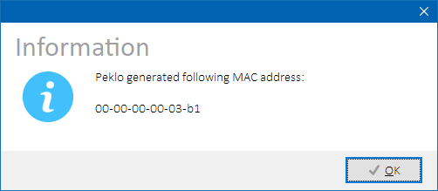

*Generated non-live MAC address dialog*

##### Process Overview

Peklo DB function IBMTEST.PEKLO_API_PKG.GENERATE_MAC is called to obtain the MAC address.

##### Role Differences

|  |  |  |  |  |  |
| --- | --- | --- | --- | --- | --- |
| **Action / Role** | **ADMIN** | **LEAD** | **TESTING-VF** | **TESTING-IBM** | **TESTING-V2** |
| **Access to Peklo Non-Live MAC Address Generator** | Y | Y | Y | Y | Y |

### Outage Notifier Integration

Select **Other 🡪  Launch Outage Notifier** from the main menu to launch Outage Notifier. Outage Notifier is a standalone application that resides in the tray area and informs about test environment outages. If the application is already running, the user is notified about it.

See Outage Notifier for more details on the application.

## Admin Operations

Operations described in this chapter are only accessible by users with ADMIN role.

### Inventory Range Operations / Bulk Upload

Inventory Range Operations serve to populate main grid with selected inventory range or to find gaps in inventory ranges in RMS.

Select **Admin 🡪 Inventory Range Operations** from the main menu to open RMS Inventory Range Generator form:

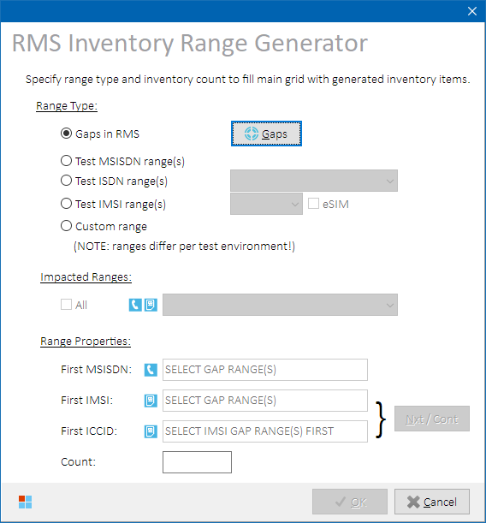

*RMS Inventory Range Generator form*

Select a range type to work with:

|  |  |
| --- | --- |
| **Range Type** | **Description** |
| **Gaps in RMS** | Inventory range consisting of found RMS gaps will be populated. Detects gaps in RMS inventory range.  See Detecting Gaps in RMS Inventory Ranges for more details. |
| **Test MSISDN range(s)** | Preconfigured official range(s) of test MSISDN’s will be populated. See Preconfigured Ranges for more details. |
| **Test ISDN ranges(s)** | Select one of the available ISDN regions from the adjacent combo box. Preconfigured official range(s) of test ISDN’s belonging to selected region will be populated.  Check **eSIM** checkbox to only work with preconfigured eSIM IMSI ranges.  See Preconfigured Ranges for more details.  **NOTE:** Source value is optional for eSIM ranges. |
| **Test IMSI range(s)** | Select one of the available sources from the adjacent combo box.  Preconfigured official range(s) of test IMSI’s belonging to selected source will be populated.  See Preconfigured Ranges for more details. |
| **Custom Range** | Specify custom range details in **Range Properties** section.  Inventory range consisting of items matching the criteria will be populated.  See Custom Range for more details. |

##### Controls

|  |  |
| --- | --- |
| **Button Caption** | **Description** |
| **Gaps** | Press to open RMS Inventory Range Gaps Finder form.  See Detecting Gaps in RMS Inventory Ranges for more details. |
| **Nxt/Cont** | If main grid is empty and First ICCID value is empty, finds next available ICCID based on the maximum value found in RMS starting with: “89420300YYMM”.  If there are already items present in the main grid, use this button to continue with the ICCID and IMSI sequences that are already present in the main grid. |

##### Preconfigured Ranges

If test MSISDN’s, ISDN’s or IMSI’s ranges are selected, the target preconfigured range(s) details are displayed in the **Impacted Ranges** section of the form.

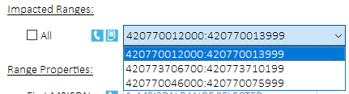

*Impacted Ranges combo box (SYS2 environment, Test MSISDN ranges)*

Check **All** check box to work with all the applicable ranges, or uncheck it and select a single target range to work with from the combo box. Number of impacted ranges and their total item count is visible in the **Range Properties** section below:

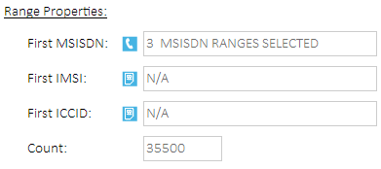

*Range properties for preconfigured ranges*

**NOTE:** Edit boxes in Range Properties section are read-only when working with preconfigured ranges.

**IMPORTANT:** Preconfigured test ranges differ per test environment!

###### Process Overview

Preconfigured ranges are stored in RMSTOOL_OWN.RMSTOOL_RANGE_REF table.

##### Custom Range

If custom range is selected, it’s properties must be entered manually in the appropriate edit boxes in the **Range Properties** section. Example below:

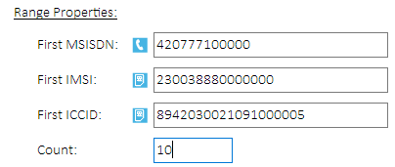

*Range properties for custom range*

**HINT:** Use asterisk at the final position to automatically fill in First Inventory and Count values. E.g., Entering “420777123*” as First MSISDN value will be translated to:  
- First MSIDN value: “420777123000”  
- Count value: “1000”

**NOTE:** Only enter First ICCID value whenit’s desirable to also populate ICCID range – e.g., when generating new SIM cards. The ICCID’s will be generated and validated starting with selected value. If selected value does not have valid checksum, a first next larger value will be used.

##### Detecting Gaps in RMS Inventory Ranges

During testing, inventory items can be accidentally or deliberately deleted by testers from RMS creating gaps in configured inventory items. Gap detection (unconfigured/missing inventory items) ensures that all inventory items in given ranges are present in RMS as expected.

Press  **Gaps** button to open RMS Inventory Range Gap Finder form:

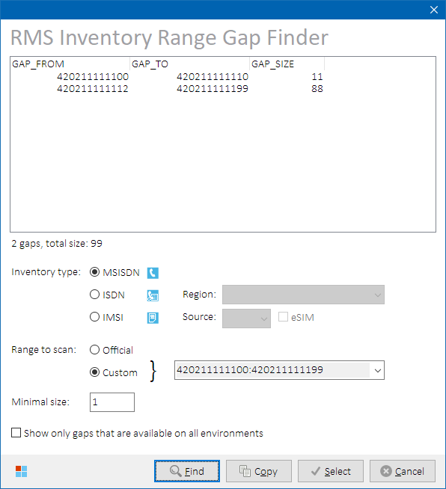

*RMS Inventory Range Gap Finder form*

Select inventory type and a range to scan. When selecting ISDN, choose one of the available regions. When selecting IMSI, choose one from the available sources, or check **eSIM** checkbox to only work with preconfigured eSIM IMSI ranges.

Select a range to scan. Either choose one of the preconfigured ranges, or manually enter a custom range in the adjacent edit box in format <first_value>:<last_value>.

**NOTE:** Only one range can be scanned at a time.

Choose minimal gap size to report. Gaps smaller than defined size will not be returned.

Optionally, check **Show only gaps that are available on all environments** check box to further filter the results. The search will be performed on all testing environments and the results will then be intersected.

Press  **Find** button to start the search. Found gaps are populated in the gap grid.

**Example:** Let MSISDN 420211111111 be the only inventory item configured in range 420211111100:420211111199. Following gaps will be returned:

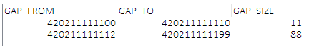

*Example of found gaps in given range.*

If there are no items configured in the selected range, the user is notified about the fact that the whole range is free:

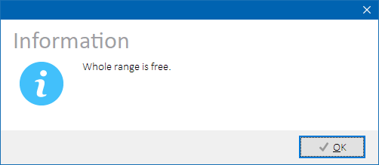

*Free range notification dialog.*

Select one or more gap ranges from the gap grid and press **Select** button to return to the RMS Inventory Range Generator form.

###### Controls

|  |  |
| --- | --- |
| **Button Caption** | **Description** |
| **Find** | Starts the gap search according to given criteria. |
| **Select** | RMS Inventory Range Gap Finder form is closed and selected gap ranges are used in the RMS Inventory Range Generator form. |

###### Process Overview

RMS table INVD_MAIN is queried for inventory items from defined range. Unconfigured items are returned.

##### Range Import

Aftertarget range (*gap* or *preconfigured* or *custom*) is selected, press **OK** button to open Import Options form. Choose additional options on how to import the range to the main grid. Press **OK** button again to have the inventory imported:

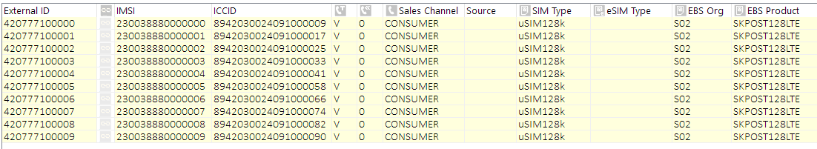

*Bulk-imported inventory items from specified range.*

Unless generating new SIM cards, there’s usually no need to generate ICCID range so it’s better approach to keep the field empty and retrieve ICCID’s from the database based on provided IMSI range.

###### Role Differences

|  |  |  |  |  |  |
| --- | --- | --- | --- | --- | --- |
| **Action / Role** | **ADMIN** | **LEAD** | **TESTING-VF** | **TESTING-IBM** | **TESTING-V2** |
| **Access to Inventory Range Operations** | Y | N | N | N | N |

### Inventory Recycling

##### Overview

Inventory recycling is a process that scans configured official test inventory ranges for used inventory items. Following inventory types are supported:

* MSISDN
* ISDN
* SIM
* Virtual eSIM

The items are then cleaned in all systems, so that they can be re-used.

Inventory recycling process consists of three main phases that are described in next chapters:

1. Obtaining Recyclable Inventory from Peklo or RMS
2. Cleansing
3. Refreshing Peklo

##### Obtaining Recyclable Inventory

* **MSISDN**, **ISDN** and **SIM** inventory items are identified using data in Peklo.
* **Virtual eSIM** inventory items are identified using data in EBS and RMS.

MSISDN, ISDN and SIM are further differentiated to “**agile**” and “**standard**” inventory items. Agile inventory means inventory retrieved from Peklo by automation tools used in agile VF testing teams and is identified by a configurable specific substring presence in Note field in Peklo that was entered by the automation tool while reserving the inventory via Peklo API. This differentiation does not apply to Virtual eSIM’s.

To avoid recycling of recently used inventory items and interfering with ongoing testing, inventory age condition is also incorporated (“minimal threshold date”) ensuring that inventory items retrieved from source system (Peklo or EBS/RMS) after this date are not provided as recycling candidates. Minimal threshold date differs for agile and standard inventory – this is to allow cleansing of the agile inventory items sooner than the standard inventory items.

Default configuration is as follows:

|  |  |  |
| --- | --- | --- |
| **Inventory Kind** | **Peklo Note value** | **Minimal Threshold Date** |
| **agile** | contains “x23zyrhn8urgh” | sysdate minus 3 days |
| **standard** | does not contain “x23zyrhn8urgh” | sysdate minus 15 days |
| **Virtual eSIM** | N/A (Peklo is not used) | sysdate minus 3 days |

Select **Admin 🡪  Inventory Recycling** from the main menu to open Inventory Recycling form where further recycling options can be set.

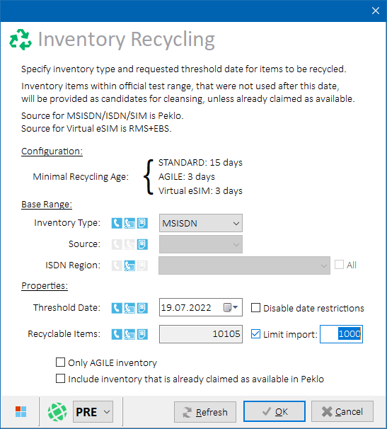

*Inventory Recycling form*

Choose an inventory type to recycle, and fill in its mandatory parameters as depicted by icons next to each combo box:

|  |  |
| --- | --- |
| **Inventory Type** | **Mandatory Parameters** |
| **MSISDN** | No additional mandatory parameters are required. |
| **ISDN** | ISDN Region value must be selected.  Optionally, check **All** check box to include all ISDN regions. |
| **SIM** | Source value must be selected. |
| **Virtual eSIM** | Source value must be selected. |

Set a custom threshold date if only even older inventory items should be returned and the default value does not suit the needs.

Select following options, if needed:

|  |  |
| --- | --- |
| **Option** | **Description** |
| **Disable date restrictions** | Restrictions on minimal threshold date will not be applied.  Any date up to sysdate can be selected in the date picker.  **NOTE:** Use with caution, as this can result in deleting of testing inventory that testers are still working on. |
| **Limit import** | Only specified number of inventory items will be imported into main grid for further processing.  **NOTE:** Use when large number of recycling candidates is returned. In general, it is not advised to process more than 5.000 items to avoid performance issues. |
| **Only AGILE inventory** | Only agile inventory items will be returned.  Not applicable to Virtual eSIM (eSIM candidates are selected from EBS). |
| **Include inventory that is already claimed as available in Peklo** | Inventory items that are already claimed as available **in Peklo** will also be returned. Not applicable to Virtual eSIM (eSIM candidates are selected from EBS).  **NOTE:** This option is to re-assure data consistency between data in RMS and data in Peklo, should there be any concerns regarding it. It’s not needed during normal operation. |

Once all parameters are set, a number of available recycling candidates is returned in **Recyclable Items** edit box.

Press **OK** to populate main form with found recyclable inventory items (recycling candidates).

Once the grid is populated, update inventory attributes and continue with cleansing tasks as needed.

###### Controls

Additional Buttons

|  |  |
| --- | --- |
| **Button Caption** | **Description** |
| **Refresh** | Recalculates the number of available recycling candidates. |

###### Process Overview

For MSISDN / ISDN / SIM:

1. Construct a combined array of all inventory items belonging to ranges configured for the selected inventory type and test environment in table RMSTOOL_OWN.RMSTOOL_RANGE_REF.
2. Query following Peklo tables
   * PEKLO_<env>_MAIN
   * PEKLO_<env>_MAIN_SIM
   * PEKLO_<env>_USED_BY
   * PEKLO_<env>_SIM_USED_BY
   * PEKLO_MSISDN_BL
   * PEKLO_SIM_BL

for inventory items as follows:

* 1. Include all items from the combined array constructed in previous step
  2. Remove agile inventory items not meeting agile threshold date
  3. Remove standard inventory items not meeting standard threshold date
  4. Remove blacklisted inventory items
  5. Optionally, remove inventory items already claimed as Available (AVAILABLE = 1) (if the user selected this option)
  6. Remove inventory items that were allocated in Peklo but haven’t been used yet (STATUS = 1)
  7. Optionally, intersect with set of agile inventory items in Peklo (NOTE LIKE ‘%<agile_note>%’ (if user selected option to recycle agile inventory only)

1. Populate main grid with found inventory items meeting the above recycling conditions.

For Virtual eSIM:

1. Construct a combined array of all inventory items belonging to ranges configured for the selected inventory type in table RMSTOOL_OWN.RMSTOOL_RANGE_REF.
2. Query following RMS tables
   * INVD_MAIN
   * INVD_MAIN_EXT_DATA

to retrieve PARAM_ID 30004 value (ICCID) for all IMSI returned in previous step

1. Query EBS table INV.MTL_SERIAL_NUMBERS for items having:
   1. SERIAL_NUMBER (ICCID) from previous RMS query
   * SHIP_DATE before selected date (i.e., used long ago enough to be considered as cleansing candidate)
   * CURRENT_STATUS <> 3 (In Stock)
2. Populate main grid with found inventory items meeting the above recycling conditions.

Also see Inventory Recycling Model for more details.

###### Role Differences

|  |  |  |  |  |  |
| --- | --- | --- | --- | --- | --- |
| **Action / Role** | **ADMIN** | **LEAD** | **TESTING-VF** | **TESTING-IBM** | **TESTING-V2** |
| **Access to Inventory Recycling form** | Y | N | N | N | N |

##### Cleansing

Once the main grid is populated with recycling candidates, fix any errors that the inventory items may have (see status row icons) and proceed with their cleansing. See Inventory Cleansing for more details on the cleansing process.

**IMPORTANT:** Please take into consideration that cleansing of a large number of inventory items (hundreds or thousands) will take a serious amount of time – possibly hours. Plan your work accordingly.

##### Refreshing Peklo

Optionally, after cleansing process is finished, run Peklo Refresher application so that Peklo inventory tables are refreshed and recycled inventory items are offered to testers. If Peklo Refresher is not run, the items will be offered by Peklo after midnight when automatic refresh job is run in Peklo. See Peklo Refresher for more details on the Peklo Refresher.

### SSH Console

SSH Console form shows SSH terminal window for currently active SSH connection:

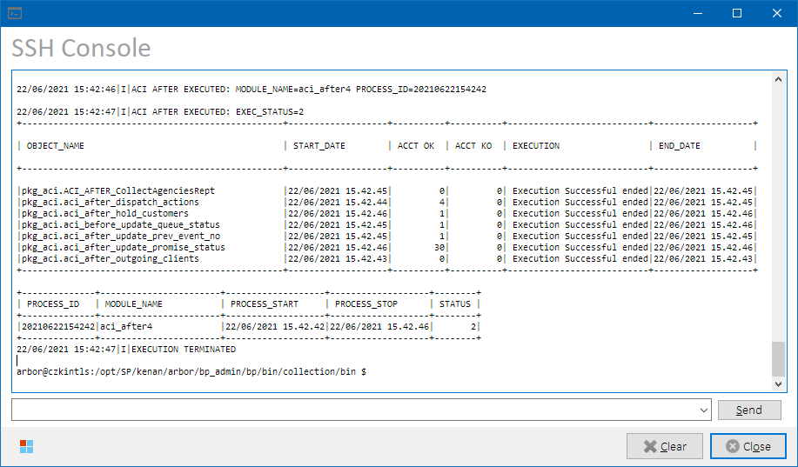

*SSH Console form*

SSH Console form can be invoked from the following places:

1. **Main form:**
   1. Select **Admin 🡪  Show SSH Console Window** from the main menu.
   2. Click on SSH activity icon  displayed over the mini-log memo while SSH connection is sending or receiving data (this can be a little tricky as the icon blinks irregularly).
2. **Working form**: Press  **SSH** button in the lower-right corner of the Working form:

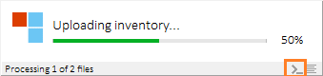

*Working form – SSH button*

Use edit box at the bottom of the SSH Console form to enter a custom command if needed. The edit box is not accessible if the connection is not active.

##### Controls

###### Additional Buttons

|  |  |
| --- | --- |
| **Button Caption** | **Description** |
| **Send** | Sends entered command to SSH terminal. |
| **Clear** | Clears SSH console memo. |

##### Role Differences

|  |  |  |  |  |  |
| --- | --- | --- | --- | --- | --- |
| **Action / Role** | **ADMIN** | **LEAD** | **TESTING-VF** | **TESTING-IBM** | **TESTING-V2** |
| **Access to SSH Console Form** | Y | N | N | N | N |

### DB Connections Status

Select **Admin 🡪 Show DB connections status** from the main menu to open a dialog with summary of currently open database connections:

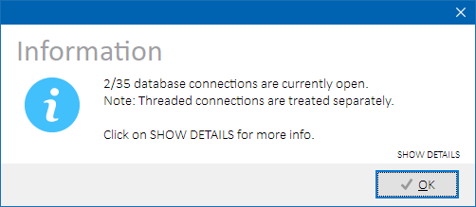

*Open database connections dialog – summary*

Click **SHOW DETAILS** label to show which particular database connections are open:

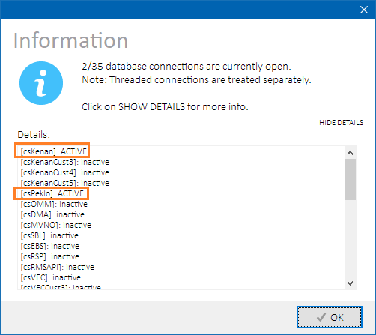

*Open database connections dialog – details*

##### Role Differences

|  |  |  |  |  |  |
| --- | --- | --- | --- | --- | --- |
| **Action / Role** | **ADMIN** | **LEAD** | **TESTING-VF** | **TESTING-IBM** | **TESTING-V2** |
| **Access to Database Connections Status** | Y | N | N | N | N |

### Test Connections

Select **Admin 🡪 Test connections to all systems** from the main menu to test database connections to all configured systems. A dialog is open showing the results:

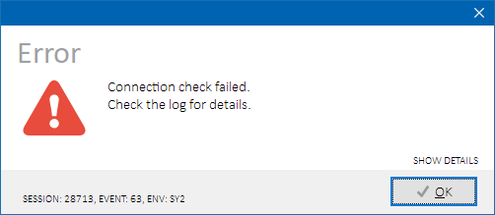

*Test all database connections dialog – summary*

Click **SHOW DETAILS** label to show which particular database connections have failed:

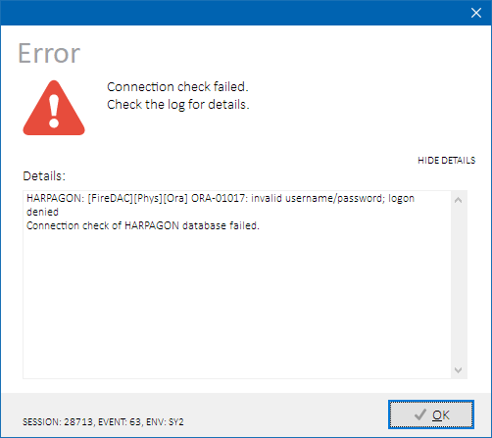

*Test all database connections dialog – details*

**NOTE:** Connections to all configured systems are tested in this routine, even those related to systems that are currently disabled for inventory cleansing or uploading.

##### Role Differences

|  |  |  |  |  |  |
| --- | --- | --- | --- | --- | --- |
| **Action / Role** | **ADMIN** | **LEAD** | **TESTING-VF** | **TESTING-IBM** | **TESTING-V2** |
| **Access to Connections Check** | Y | N | N | N | N |

### Show Oracle client version

Select **Admin 🡪 Show Oracle client version** from the main menu to show Oracle client version as stored in the V$SESSION_CONNECT_INFO table for the Phoenix session. A dialog is open showing the result:

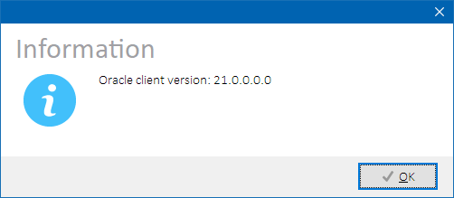

*Show Oracle client version dialog*

##### Role Differences

|  |  |  |  |  |  |
| --- | --- | --- | --- | --- | --- |
| **Action / Role** | **ADMIN** | **LEAD** | **TESTING-VF** | **TESTING-IBM** | **TESTING-V2** |
| **Access to Oracle client version check** | Y | N | N | N | N |

### Environment Restrictions

See further chapters describing on how to configure an environment warning message, lock down complete environment, or disable particular cleansing tasks.

When locking down an environment or disabling cleansing tasks, it is also highly recommended to set appropriate environment warning message describing reason for the restriction in place.

##### Configuring Environment Warning Message

Warning messages are stored in configuration table RMSTOOL_CONFIG.

Environment warning message is related to a specific environment. Alter the environment message text manually as needed. The message will be displayed to the users in the Main form Warning Dock. See Warning Dock for more details.

Updater warning message is related to Phoenix Updater. It will be displayed to user during outdated Phoenix client initialization instead of launching Phoenix Updater. Set the message if you want to prevent the users from launching Phoenix Updater.

|  |  |  |  |
| --- | --- | --- | --- |
| ***Table RMSTOOL_CONFIG  (entries used for environment warning message)*** | | | |
| **SECTION** | **PARAM_NAME** | **PARAM_VALUE** | **Description** |
| **<ENV>** | **WARNING_MESSAGE** | **<message_text>** | Environment warning message. |
| **GENERAL** | **UPDATER_WARNING_MESSAGE** | **<message_text>** | Updater warning message. |

**NOTES:**

* Environment warning message can also be displayed without full environment lockdown or cleansing tasks restrictions. The functions are independent.
* Warning messages are not time-based, so remember to remove the warning message manually again after the reason for it has passed.

**HINT:** Use hash symbol (#) as the first character of the message text to comment out the warning message. Such record will be treated by Phoenix clients as if there was no warning message configured.

##### Environment Lockdown

In the Main form, check **Environment lockdown** check box below the main grid to lock out users from the selected test environment. For new sessions, locked environment will fail to initialize. For existing sessions, the environment remains initialized, but no operations will be allowed.

Information about locked environment is displayed in the Lock Dock:

**

*Lock Dock – locked environment*

###### Process Overview

1. Process lock is inserted into RMSTOOL_OWN.RMSTOOL_PROCESS_LOCK table with PROCESS_NAME = “ENVIRONMENT”
2. Trigger RMSTOOL_OWN.RMSTOOL_PROCESS_LOCK invokes DBMS Alert with message “PROC_LOCK_CHG_<env>” that is picked up by running Phoenix clients that will disable the particular testing environment in their GUI.

###### Role Differences

|  |  |  |  |  |  |
| --- | --- | --- | --- | --- | --- |
| **Action / Role** | **ADMIN** | **LEAD** | **TESTING-VF** | **TESTING-IBM** | **TESTING-V2** |
| **Access to Environment Lockdown GUI** | Y | N | N | N | N |

##### Disabling Cleansing Tasks

Cleansing tasks can be individually enabled or disabled by application administrator. See Cleansing Restrictions for more details.

Disabled cleansing tasks are displayed in the Cleansing Processing Options form with a warning symbol  adjacent to their particular check box – see Disabled Cleansing Tasks for more details on the visualization.

##### Configuring Ignorable InstantLink Alarms

Environment admins do not clear InstantLink alarms periodically which might lead to increased number of uncleared InstantLink alarms that are reported to Phoenix users before cleansing. To exclude specific uncleared InstantLink alarms from being reported, configure their attributes in configuration table RMSTOOL_IGNORED_IL_ALARMS_REF.

See Table RMSTOOL_IGNORED_IL_ALARMS_REF for table specification.

Only non-NULL values are considered.

### Advanced Context Menu

In Main form, press right mouse button on the main grid to open context menu with additional options for manipulation with data present in the main grid:

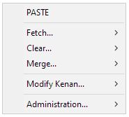

*Advanced context menu*

Select **PASTE** menu item to open Import Properties form to import inventory items currently present in clipboard. See Advanced Import for more details. See next chapters on details of the other items’ functionality.

##### Role Differences

|  |  |  |  |  |  |
| --- | --- | --- | --- | --- | --- |
| **Action / Role** | **ADMIN** | **LEAD** | **TESTING-VF** | **TESTING-IBM** | **TESTING-V2** |
| **Access to Advanced Context Menu (and all submenus)** | Y | N | N | N | N |

##### Fetch submenu

Select **Modify Kenan 🡪 Fetch… 🡪 <option>** to fix missing or invalid data in the main grid. These operations are not needed during normal operation as all values are retrieved automatically during inventory import. However, they come in handy during manual inserts or value updates in the main grid (ADMIN role only) where missing values need to be retrieved or aligned. If specific rows are not selected, then all rows are processed.

Following options are available:

|  |  |
| --- | --- |
| **Menu Item** | **Description** |
| **Paired Inventory** | Populates missing MSISDN / IMSI / ICCID values and pair status. |
| **All attributes from DB** | Populates all missing inventory attributes with current values retrieved from the respective databases (RMS / EBS). |
| **IMSI by MSISDN** | Populates missing IMSI values and pair status according to MSISDN values. |
| **MSISDN by IMSI** | Populates missing MSISDN values and pair status according to IMSI values. |
| **IMSI by ICCID** | Populates missing IMSI values and pair status on selected rows from the main grid by according to ICCID values. |
| **ICCID by IMSI** | Populates missing ICCID values and pair status according to IMSI values. |
| **Generate Missing ICCID’s** | Generates dummy ICCID values that can be used when inserting new IMSI range into RMS. See Generate Missing ICCID’s for more details. |
| **Fix invalid ICCID’s** | ICCID values with incorrect checksum are replaced with new ones. See Fix invalid ICCID’s for more details. |

###### Generate Missing ICCID’s

Generates dummy ICCID values that can be used when inserting new IMSI range into RMS.

Process Overview

1. Get max value of parameter 30004 (ICCID) from Kenan table INVD_MAIN_EXT_DATA table that begins with “89420300YYMM”.
2. If max value is obtained then generate new dummy ICCID value larger than previously found max value.
3. If max value does not exist, generate new dummy ICCID value starting with “89420300YYMM1000000”.

**NOTE:** Generated ICCID values have their final digit populated according to Luhn algorithm so that their checksum is correct.

###### Fix invalid ICCID’s

ICCID values with incorrect checksum are replaced with new ones.

Process Overview

1. Check current ICCID value with Luhn algorithm. Continue if the check has failed.
2. Get max value of parameter 30004 (ICCID) from Kenan table INVD_MAIN_EXT_DATA table that begins with “89420300YYMM”.
3. If max value is obtained then generate new dummy ICCID value larger than previously found max value.
4. If max value does not exist, generate new dummy ICCID value starting with “89420300YYMM1000000”.

**NOTE:** Generated ICCID values have their final digit populated according to Luhn algorithm so that their checksum is correct.

##### Clear submenu

Select **Modify Kenan 🡪 Clear… 🡪 <option>** to partially clear main grid content. If specific rows are not selected, then all rows are processed.

Following options are available:

|  |  |
| --- | --- |
| **Menu Item** | **Description** |
| **Clear MSISDN values** | Erases values in MSISDN-related columns:   * + - External ID     - Service Type     - Is Donated     - Sales Channel     - Source (if SIM is not present on the same row) |
| **Clear SIM values** | Erases values in SIM-related columns:   * + - IMSI     - ICCID     - Source (if MSISDN is not present on the same row)     - SIM Type     - EBS Org     - EBS Product |
| **Clear eSIM values** | Erases values in eSIM-related columns:   * + - eSIM Type |
| **Remove rows with inventory available in RMS** | Removes rows from the main grid that have all of the following values in green color (i.e., representing Available (1) status in RMS):   * + - External ID     - IMSI     - ICCID     - eSIM Type |
| **Remove rows with inventory available in EBS** | Removes rows from the main grid that have following value in green color (i.e., representing In Stock (3) status in EBS):   * + - EBS Product |
| **Remove rows with inventory available in RMS+EBS** | Removes rows from the main grid that have all of the following values in green color (i.e., representing Available (1) status in RMS and In Stock (3) status in EBS):   * + - External ID     - IMSI     - ICCID     - eSIM Type     - EBS Product |
| **Remove rows with inventory unavailable in RMS** | Removes rows from the main grid that have one or more of the following values in black color (i.e., representing status different from Available (1) in RMS):   * + - External ID     - IMSI     - ICCID     - eSIM Type |
| **Remove rows with inventory unavailable in EBS** | Removes rows from the main grid that have following value in black color (i.e., representing status different from In Stock (3) in EBS):  EBS Product |
| **Remove rows with inventory unavailable in RMS+EBS** | Removes rows from the main grid that have one or more of the following values in black color (i.e., representing states different from Available (1) in RMS and In Stock (3) in EBS):   * + - External ID     - IMSI     - ICCID     - eSIM Type     - EBS Product |
| **Clear empty rows** | Removes rows from the main grid that contain no data. |

##### Merge submenu

Select **Modify Kenan 🡪 Merge… 🡪 <option>** to merge rows containing only MSISDN with rows containing only SIM (i.e., IMSI and ICCID) along with their attribute values.

Following options are available:

|  |  |
| --- | --- |
| **Menu Item** | **Description** |
| **Merge selected two rows** | Merges selected MSISDN row with selected SIM row.  **NOTE:** Exactly one MSISDN row and one SIM row must be selected for this operation. |
| **Merge all (MSISDN rows with SIM rows)** | Merges MSISDN rows with SIM rows in the grid on a FIFO basis i.e., first MSISDN row is merged with first SIM row, second MSISDN row is merged with second SIM row etc.  **NOTE:** Number ofMSISDN rows and SIM rows in the main grid must be the same for this operation. |

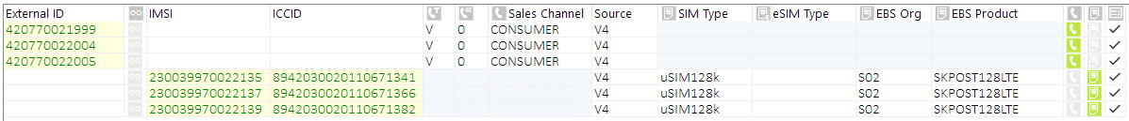

*Main grid rows before merging (separate MSISDN and SIM rows)*

**

*Main grid rows after merging*

**NOTE:** SOURCE attribute is shared among MSISDN and SIM in the main grid. In cases when SOURCE value differs on the source MSISDN and SIM rows, then value from the MSISDN row is used in the merged row.

##### Modify Kenan submenu

Options in the Modify Kenan submenu directly updates data in the respective Kenan databases.

###### Direct Kenan DB Updates

Select **Modify Kenan 🡪** **via Direct DB Update… 🡪 <attribute_name>** to update the inventory attribute value directly in Kenan database for selected rows in the main grid.

Following options are available:

|  |  |  |
| --- | --- | --- |
| **Menu Item** | **Description** | **Target database item** |
| **MSISDN / ISDN** | | |
| **Update Status** | Update MSISDN or ISDN status value.  **NOTE:** Only active view (having STATE=0) is updated. | INVD_VIEWS.STATUS_ID |
| **Update Service Type** | Update MSISDN service type value. | INVD_MAIN_EXT_DATA.PARAM_VALUE  (PARAM_ID=10002) |
| **Update Sales Channel** | Update sales channel value.  **NOTE:** If new sales channel is PORT-IN, then IS_DONATED flag is also updated to 1. | INVD_MAIN.SALES_CHANNEL_ID. |
| **Update Source** | Update MSISDN source value. | INVD_MAIN_EXT_DATA.PARAM_VALUE  (PARAM_ID=10001) |
| **Update Type** | Update MSISDN type value. | INVD_MAIN_EXT_DATA.PARAM_VALUE  (PARAM_ID=10000) |
| **Update IsDonated flag** | Update IS_DONATED value. | INVD_MAIN.IS_DONATED |
| **ISDN only** | | |
| **Update ISDN flag** | Update ISDN flag value. | INVD_MAIN_EXT_DATA.PARAM_VALUE  (PARAM_ID=30007) |
| **SIM only** | | |
| **Update SIM Status** | Update SIM status value.  **NOTE:** Only active view (having STATE=0) is updated. | INVD_VIEWS.STATUS_ID |
| **Update SIM Source** | Update SIM source value. | INVD_MAIN_EXT_DATA.PARAM_VALUE (PARAM_ID=30006) |
| **Update SIM Type** | Update SIM service type value. | INVD_MAIN_EXT_DATA.PARAM_VALUE  (PARAM_ID=30005) |
| **eSIM only** | | |
| **Update eSIM Status** | Update eSIM status value.  **NOTE:** Only active view (having STATE=0) is updated. | INVD_VIEWS.STATUS_ID |
| **Update eSIM Source** | Update eSIM source value. | INVD_MAIN_EXT_DATA.PARAM_VALUE (PARAM_ID=30006) |
| **Update eSIM Type** | Update eSIM service type value. | INVD_MAIN_EXT_DATA.PARAM_VALUE  (PARAM_ID=30005) |
| **Update eSIM Confirmation Code** | Update eSIM confirmation code value. | INVD_MAIN_EXT_DATA.PARAM_VALUE (PARAM_ID=3008) |
| **Update eSIM SMDS Address** | Update eSIM SMDS address value. | INVD_MAIN_EXT_DATA.PARAM_VALUE  (PARAM_ID=30009) |
| **Update eSIM Matching ID** | Update eSIM Matching ID value. | INVD_MAIN_EXT_DATA.PARAM_VALUE (PARAM_ID=300010) |
| **Update eSIM EID** | Update eSIM EID value. | INVD_MAIN_EXT_DATA.PARAM_VALUE  (PARAM_ID=300011) |
| **Update eSIM SMDPFQDN** | Update eSIM SMDPFQDN value. | INVD_MAIN_EXT_DATA.PARAM_VALUE  (PARAM_ID=300012) |

Select new value in **Value** combo box in the Attribute Dialog form:

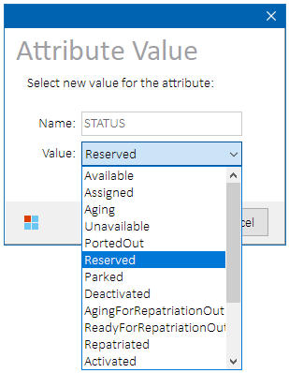

*Attribute Dialog form – available MSISDN status values*

**NOTE:** Available values are fetched from Kenan database during environment initialization. Custom values are not allowed.

###### Kenan Constraints

Select **Modify Kenan 🡪** **Constraints 🡪 Enable | Disable** menu item to manually enable or disable set of database constrains that normally is taken care of automatically during cleansing process. See System Cleansing chapter for the full list of impacted constraints.

##### Administration submenu

###### Phoenix Inventory Groups Administration

Select **Administration… 🡪** **Phoenix… 🡪 <operation> 🡪 <inventory_group>** menu item to add or remove inventory items to/from a preconfigured Phoenix inventory group:

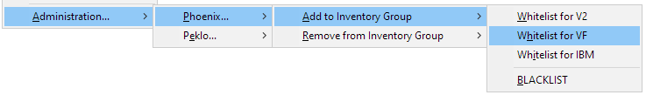

*Phoenix inventory groups administration submenu structure*

Enter a custom note describing the reason of the inventory group assignment (not required for inventory removal):

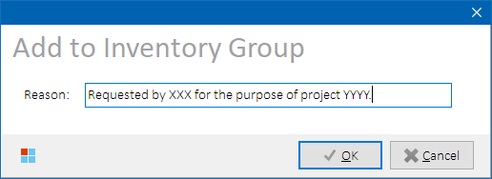

*Inventory Group Reason form*

Inventory items on the selected rows in the main grid will be added or removed from the selected Phoenix inventory group (a.k.a. whitelist/blacklist). For user roles that require whitelist, only whitelisted inventory will be allowed to clean. Blacklisted inventory will not be allowed to clean even if whitelisted.

Inventory groups for logged-in users are reloaded at following occasions:

* + During environment initialization
  + During inventory import
  + During main grid data refresh
  + After inventory cleansing
  + After inventory group update

See Inventory Groups Configuration for more details.

**NOTES:**

* Inventory item can be present in multiple inventory groups at the same time.
* Different inventory groups can be assigned to users with the same role.

Process Overview

Records are added or removed to Phoenix table RMSTOOL_OWN.RMSTOOL_INV_GROUP with selected inventory group.

###### Peklo Blacklists Administration

Select **Administration… 🡪** **Peklo… 🡪 <blacklist_operation>** menu item to add or remove inventory items to/from Peklo black list:

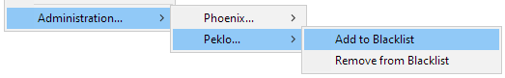

*Peklo black list administration submenu structure*

Inventory items on the selected rows in the main grid will be added or removed from Peklo black list. Blacklisted items will not be offered by Peklo.

Process Overview

1. Records are added or removed to/from Peklo tables IBMTEST.PEKLO_MSISDN_BL and IBMTEST.PEKLO_SIM_BL.

**NOTE:** Inventory items are added to Peklo blacklist with EXPIRY_DATE = 31.12.9999 and NOTE = “PHOENIX:<session_id>”

## Working Form

Working form is displayed whenever it’s needed to inform the user about current operation progress. It contains looping or delimited (with minimum and maximum thresholds) progress bar and additional details (process description, amount, percentage, or elapsed time) of the ongoing operation. While Working form is showing, controls on the other forms are disabled and do not receive user’s input.

Working form examples:

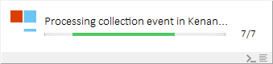

*Working form – looping progress bar with counter*

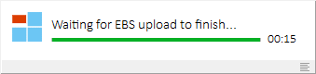

*Working form – looping progress bar with elapsed time*

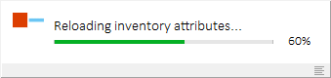

*Working form – delimited progress bar with percentage*

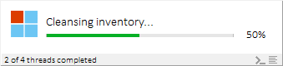



*Working form – delimited progress bars with percentage and additional info*

### Controls

Depending on the operation, one or more of the shortcut labels are accessible in the upper-right corner of the Working form:

|  |  |  |
| --- | --- | --- |
| **Button  Glyph** | **Keyboard**  **Shortcut** | **Description** |
| *(abort)* | **ALT+A** | Alerts current operation about user-requested abort. Looped process will stop after current iteration and error dialog will be displayed. |
| *(skip)* | **ALT+S** | Skips waiting for current operation to finish while the operation continues in the background. See e.g., Skip Waiting for Instant Link. |
| *(console)* | **ALT+H** | Opens SSH Console form. |
| *(log)* | **ALT+L** | Opens Event log form. |

### Forced Application Termination

**HINT:** If Phoenix gets stuck for a reason and the Working form won’t go away, try pressing **CTRL+END**. This will trigger forced abort of current operation (all looped operations will stop) and the application will close. It is highly recommended to check data consistency after performing a forced abort.

## System Menu

### About Form

Click on the application icon in the upper-left corner of the Main form and select **About** menu item**:**

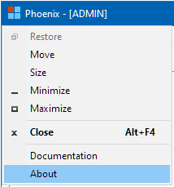

*About menu item*

Form with additional application information such as client version, Oracle client version, license information, etc. will be displayed:

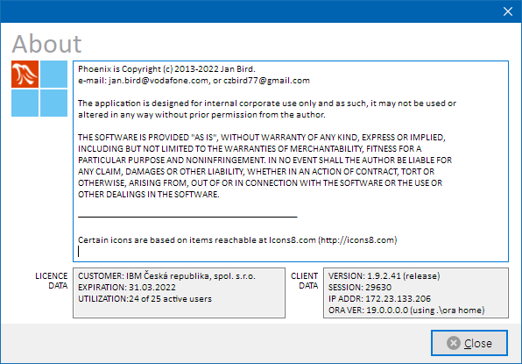

*About form*

### System Documentation

Click on the application icon in the upper-left corner of the Main form and select **Documentation** menu item**:**

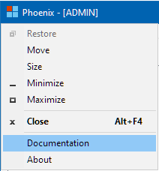

*System Documentation menu item*

URL pointing to system documentation will be open in default browser.

## Bundled Applications

Phoenix is distributed along with several bundled side-applications. Although it is possible to maintain each of these separately, it’s generally not recommended as their updates are handled mutually by Phoenix Updater.

### Phoenix Updater

Please see Phoenix Updater for more details.

**NOTE:** Phoenix Updater executable is part of Phoenix delivery, but it is not initially present in installation on client workstations. It will be downloaded by Phoenix when needed.

### Peklo Refresher

Peklo Refresher application is a standalone executable (PHOENIX_REFRESHER.EXE) that sits in Windows application tray and refreshes materialized views used by Peklo application. This is to achieve that Phoenix can be closed while Peklo refresh is still in progress.

The application is primarily designed to be spawned from Phoenix refresh menu, but it can also be started from command line if correct input parameters are provided:

|  |  |
| --- | --- |
| Input Parameter | Description |
| Environment | Test environment to refresh:   * SY2 * INT * PRE |
| Refresh Mode | Refresh mode to use:   * 0 = FULL refresh * 1 = MSISDN only (a.k.a. QUICK1) * 2 = MSISDN + SIM only (a.k.a. QUICK2) * 3 = HW only (a.k.a. QUICK3) |
| Session ID | Phoenix session identifier that has triggered the refresh. |

##### Main form

Application main window is displayed above application tray area:

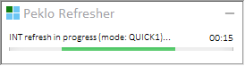

*Peklo Refresher – main form*

Once started, the application checks Peklo Refresh lock status, acquires PEKLO process lock in Phoenix database, starts stored procedure in Peklo database and if successful, broadcasts named Windows message that is intercepted by Phoenix to inform it that the refresh has begun.

Press  **Minimize** button to hide the form in the application tray area.

When the refresh is finished, another message is broadcasted indicating refresh result – success or failure. The result is then displayed in Phoenix, if running.

##### Configuration

See Peklo Refresher Configuration for more details.

### Outage Notifier

Outage Notifier application is a standalone executable (PHOENIX_OUTGTRAY.EXE) that sits in Windows application tray area and periodically notifies the user about current status of test environment outages.

##### Main Form

Click on the application icon in the tray area to reveal or hide application main form:

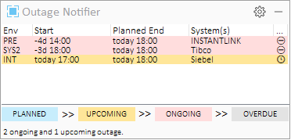

*Outage Notifier – main form*

A list of known outages is displayed for selected test environments with background color based on the outage kind:

|  |  |  |
| --- | --- | --- |
| Outage Kind | Description | Status Glyph |
| PLANNED | Outage is scheduled to start later than today | ⛶ |
| UPCOMING | Outage is scheduled to start today | 🕓 |
| ONGOING | Outage is ongoing with planned end in the future | ⛔ |
| OVERDUE | Outage is ongoing with planned end is in the past | ⚠ |

Hover mouse cursor on a grid row to reveal outage details:

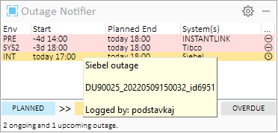

Press  **Minimize** button in the upper-right corner of the Main form to hide the form back to the application tray area.

Press  **Options** button to reveal context menu with additional options.

Keyboard shortcuts:

|  |  |
| --- | --- |
| **Keyboard**  **Shortcut** | **Description** |
| **CTRL+O** | Opens **Options** context menu.  See Options for more details. |
| **CTRL+E** | Opens test environment selection panel. See Selecting Environments for more details. |
| **CTRL+M** | Minimizes the application to system tray. |
| **CTRL+Q** | Quits the application. |

##### Options

Press  **Options** button to reveal context menu with additional options:

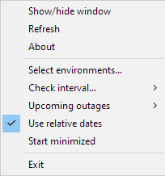

*Options context menu*

|  |  |
| --- | --- |
| Option | Description |
|
| Show/hide window | Main form will be shown if currently hidden, or hidden if currently showing |
| Refresh | Outage data will be re-fetched |
| About | Shows version and support contact information |
| Select environments… | Allows to select environments on which outages will be watched |
| Check interval | Select interval in which the outage status will be checked:   * 10 seconds * 30 seconds (default) * 1 minute * 5 minutes * 10 minutes |
| Upcoming outages | Choose how upcoming outages are displayed:   * Hide * Show today only (default) * Show all |
| Use relative dates | If checked, outage start and end dates will display yesterday, today and tomorrow texts where applicable instead of exact dates.  Time part remains unchanged. |
| Start minimized | If checked, the application will minimize into the tray area when launched. |
| Exit | Closes the application. |

Selected options are stored to Windows registry key HKCU \Software\Phoenix\OutageNotifier\, and applied during every application launch.

##### Selecting Environments

Choose ***Select environments…*** from the  Options menu to select environments for which the outages should be reported:

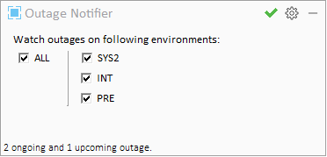

*Outage Notifier – environment selection*

Press  **OK** button in the upper-right corner once the environments were selected.

##### Notifications

Outage notifications are provided in following ways:

|  |  |
| --- | --- |
| Notification Type | Examples |
|
| Tray Area | When outage status is changed, a corresponding Windows notification is displayed above the tray area: |
| Tray Icon Color | Application icon changes its colors according to retrieved outage details:  **Icon Color Legend:**   |  |  | | --- | --- | |  | No outage | |  | Upcoming outage | |  | Ongoing/overdue outage | |  | Both ongoing/overdue and upcoming outage. |     NOTE: Planned outages (i.e., future outages that do not start today) *are not* reflected by the tray icon picture. |
| Tray Icon Hint | Tray icon hint displays summary of notifications per environment:    If there’s no outage on any environment, a joint message is present for all the environments:    NOTE: Planned outages (i.e., future outages that do not start today) *are* mentioned in the tray icon hint. |
| Windows Notification Center | Furthermore, all past notifications are also cumulated in Windows Notification center: |

##### Configuration

**See** Outage Notifier Configuration **for more details.**

# Insights

Describes in more detail technical approach to selected complex tasks.

## Process Locks and Notifications

As multiple users use the application simultaneously, a notification and locking mechanism was introduced so that running instances can communicate among themselves, and to avoid users trying to run specific tasks simultaneously if such use is not supported by the target system.

Following DBMS alert signal messages are used to notify running instances about changes in Phoenix database:

|  |  |  |
| --- | --- | --- |
| **Table** | **Trigger** | **DBMS Alert**  **Signal Message** |
| RMSTOOL_PROCESS_LOCK | RMSTOOL_TR_PROCESS_LOCK_CHG | PROC_LOCK_CHG_<ENV> |
| RMSTOOL_SESSION | RMSTOOL_TR_TERM_CHG | TERM_<SESSION_ID> |
| RMSTOOL_CONFIG  RMSTOOL_CONFIG | RMSTOOL_TR_CONFIG_CHG  RMSTOOL_TR_CONFIG_CHG | WARNING_CHG_<ENV> |
| VERSION_CHG |

### Process Lock Notification

Module lock is enforced by inserting a record into RMSTOOL_PROCESS_LOCK table with information about locked module, environment, and user session ID. Trigger RMSTOOL_TR_LOCK_CHG then fires DBMS alert signal message “**PROC_LOCK_CHG_<ENV>**” that is intercepted by all running instances and their Lock Docks are updated accordingly. A lockable process must first be configured in table RMSTOOL_PROCESS_REF by the application development, and lock acquiring/releasing must be added to the application code.

If user locks a module on a particular environment, all other users that want to use the module on the same environment must wait until it is unlocked first.

##### Lockable Modules

Following modules are subject to locking:

|  |  |
| --- | --- |
| **Module** | **Description** |
| ARM | Kenan collection modules (ARM) are running. |
| BIP | Kenan billing module (BIP) is running |
| CLEANSING | Cleansing is running |
| CONFIG | Configuration is being updated (e.g., black lists / white lists) |
| CONN_CHK | Connection check is running |
| ENVIRONMENT | Environment is locked down completely |
| IBD_CACHE | Invoice Breakdown data are being refreshed in WSC Invoice Cache |
| INEXT | Kenan invoicing module (INEXT) is running |
| INSTANTLINK | Network operations are in progress (e.g., during network cleansing) |
| KENAN_MV | Kenan materialized views are being refreshed |
| MASSPAIR | Kenan mass pairing module is running |
| PEKLO | Peklo application is being refreshed |
| RATING | Kenan rating modules (COM, MCAP, CAP) are running |
| RMS_API_MV | RMS API materialized views are being refreshed |
| SO_CACHE | Smart Overview data cache is being refreshed |
| STDUPLOAD | Kenan STD upload module is running |
| XMLSENDER | Kenan XML sender module is running |

### Instance Termination Notification

Admin user can request a running instance to terminate itself by updating its session record in table RMSTOOL_SESSION and setting its LOCKED value to “TERM” or “KILL”. Trigger RMSTOOL_TR_TERM_CHG then fires DBMS alert signal message **“TERM_<SESSION_ID>”** that is intercepted by all running instances that compare their Session identifier with Session identifier received in the notification. Instance with matching Session identifier should terminate itself as soon as possible.

**NOTE:** To avoid data corruption, target instance will not be terminated during cleansing.

### Environment Warning Message Notification

Admin user can set an environment warning message related to a particular environment by updating configuration parameter WARNING_MESSAGE in table RMSTOOL_CONFIG. Trigger RMSTOOL_TR_CONFIG_CHG then fires DBMS alert signal message **“WARNING_CHG_<ENV>”** that is intercepted by all running instances that compare their selected environment with environment received in the notification. Instances with matching environment will then retrieve updated warning message text from the database and update their Warning Dock accordingly.

### Version Update Notification

After updated application files were deployed in application repository, user with ADMIN role must launch the updated Phoenix executable on their workstation and make the new version available to other users by pressing **Announce Update** button. This will update new minimal required client version value in configuration parameter MIN_CLIENT_VERSION in table RMSTOOL_CONFIG to the value retrieved from the launched executable itself.

Trigger RMSTOOL_TR_CONFIG_CHG then fires DBMS alert signal message **“VERSION_CHG”** that is intercepted by all running instances that will display Info Dock with information about available application update.

Newly started instances compare their version with the configured value during their initialization and automatically launch Phoenix Updater to update themselves, if necessary.

## History Model

Several forms support history tracking of input data inserted by the user. User-entered values are logged in RMSTOOL_LOG table with EVENT_TAG=1, so that they can easily be searched for later.

On supported form, user can then press **CTRL+H** to open Inventory History form where they are presented with 50 previously saved values, ordered by date descending:

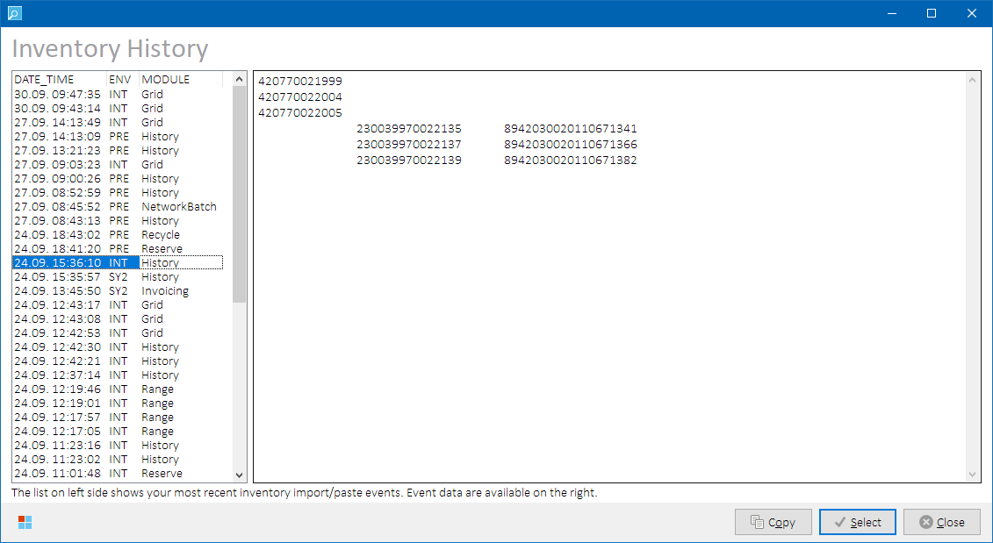

*Inventory History form*

LOV table RMSTOOL_HISTORY_REF is used to translate often long event module name to a shorter user-friendly display value presented in the History form.

Select a history item from the list on the left side of the form and press **Select** button to continue with selected value(s). In case a history item from another environment is selected, Phoenix will change the environment automatically.

### Forms supporting History

Following forms support inventory history:

|  |  |  |
| --- | --- | --- |
| **Form** | **Target Element** | **Module Name**  **displayed in History form** |
| **Main** | Parsed input data pasted to main grid | Grid |
| Parsed input data loaded from file | FileOpen |
| Inventory reserved in Peklo | PekloReserve |
| Parsed input inventory range | Range |
| **Recycling** | Recycling candidates | Recycle |
| **History** | Historical data retrieved from History form | History |
| **Collections** | Billing Account ID edit box | Collections |
| **Invoice Formatting (INEXT)** | Billing Account ID edit box | Invoicing |
| **Tibco BW Instance Lookup** | BW instance ID edit box | KenanAudit |
| **CA Selector** | CA ID edit box | History |
| **Network Batch** | Network Batch ID edit box | NetworkBatch |
| **Average Revenue** | MSISDN / CA edit boxes | AvgRevenue |
| **Change WTTX MSISDN** | Order ID edit box | UpdateWTTX |
| **UPC Migration Attributes** | BA ID edit box | UPCMigration |
| **A2S Status** | BA ID edit box | StatusA2S |
| **EHC Task Events** | MSISDN edit box | EHC |
| **Siebel Status** | Filter edit box | StatusSBL |

**NOTE:** Users cannot see history data stored by sessions belonging to other users.

## Inventory Cleansing Model

Inventory Cleansing is a process where test inventory data is reset in selected systems so that it appears as never used before and as such, it can be re-used by testing teams over and over again without the risk of replenishing assigned test inventory ranges. The process also allows to set routing profiles of the inventory items in Instant Link white lists.

**NOTE:** In the below chapters, a bracketed element (e.g., <EXAMPLE>) denotes a configuration parameter name in Phoenix configuration table RMSTOOL_OWN.RMSTOOL_CONFIG that represents a user-defined value.

### Cleansing Approach

###### There are two types of cleansing that are utilized in Phoenix:

1. Indirect Cleansing – used if target system provides its own cleansing API, Phoenix forwards list of cleansing candidates to the target system that performs the cleansing itself.   
   This cleansing type is currently used e.g. in MNP cleansing and in Network Cleansing (via Instant Link).
2. Direct Cleansing – used if target system does not provide its own cleansing API, Phoenix executes a set of predefined operations (see below) to clean the inventory.

This cleansing type is currently used everywhere else.

A multi-threaded approach is utilized in order to keep the overall cleansing process as fast as possible – all systems are being cleansed at the same time, and cleansing threads’ results are analyzed after all threads have finished.

Each supported system is represented by its own cleansing class. One or more threaded instances of such class is spawned for each system where the cleansing is being performed.

Cleansing operations performed by each thread can either be:

1. A set of SOAP calls (used for CUR and SMDP cleansing)
2. A set of REST calls (currently unused)
3. A set of SQL commands (used everywhere else)

### Cleansing Tasks

Cleansing process consists of several tasks briefly described in Inventory Cleansing chapter.

See below diagram and chapters for technical insight of each task.

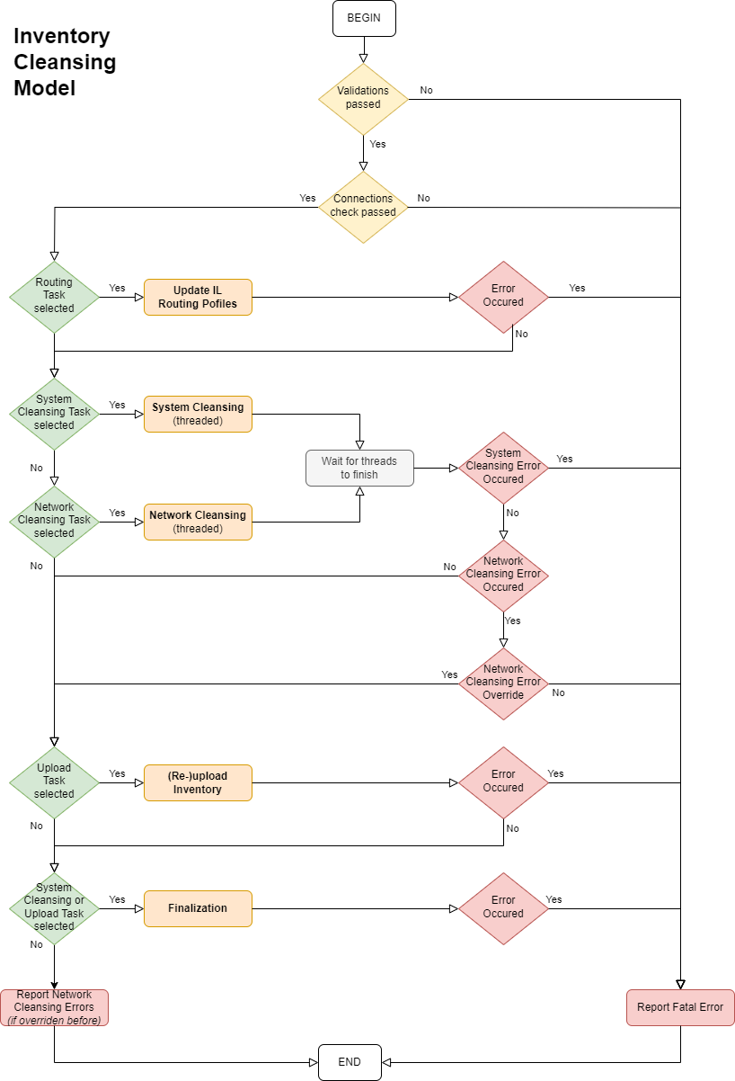

*Inventory Cleansing Model – high level flowchart*

##### Pre-cleansing Validations

Following pre-cleansing validations are performed in order to ensure the cleansing process will not fail:

|  |  |
| --- | --- |
| **Pre-cleansing Validation** | **Description / Remediation** |
| Client Version | Cleansing is only allowed with the latest version installed.  Install the latest version to proceed. |
| Environment Outages | User confirmation is needed if an ongoing outage is announced. |
| Instant Link Alarms | User confirmation is needed if an uncleared Instant Link alarm is detected. |
| Invalid Inventory Items | Invalid inventory items cannot be cleaned. Remove invalid inventory items from the main grid, or check **Allow Invalid Items** checkbox to allow their processing. |
| Unauthorized Inventory Items | Unauthorized inventory items cannot be cleaned at all.   * Remove unauthorized inventory items from the main grid to continue cleansing without them, OR * Remove unauthorized inventory items from the cleansing black list to allow their cleansing, OR * Add unauthorized inventory items to white list used by the particular user role to allow their cleansing.   See Inventory Authorization for more details. |
| Duplicate Inventory Items | Duplicate inventory items cannot be cleaned. Remove duplicate inventory items from the main grid. |
| Missing Source | Inventory items with undefined Source value cannot be uploaded. |

If any of the pre-cleansing validations fail, cleansing process is aborted.

##### Connection Check

Connection Check is an initialization task. It does not perform any data manipulation.

Method Threaded_ConnectionCheck performs following operations:

1. **Create threaded SQL connection to each impacted system** selected by the user. Execute a simple select command in each target database to ensure the connection is working. Evaluate status returned by the database threads and report errors
2. If CUR is involved:
   * **Evaluate accessibility of CUR adapter web service** URL <SOAP_CURSVC_ENDPOINT>?wsil using WinInet.InternetOpenUrl method
3. If EBS is involved:
   * **Check EBS concurrent processes status** via EBS database query to tables APPLSYS.FND_CONCURRENT_PROGRAMS and APPLSYS.FND_CONCURRENT_REQUESTS. An error is reported if returned LAST_RUN_SECONDS_AGO value is larger than <UPLOAD_TIMEOUT_SEC> value.
4. If Network Cleansing task is selected:
   * **Check Instant Link adapter status** by establishing SSH connection to InstantLink host <IL_UNIX_HOST>, and checking if Instant Link adapter process with name <IL_UNIX_ILADAPTER_PROCESS_NAME> is returned among running processes on the server.
   * **Check Instant Link batch processing status** by checking presence of line “BATCH.ISUSED=ON” in file <IL_UNIX_ILADAPTER_PATH>\ILAdapter.properties on the InstantLink host.

**NOTE:** Phoenix public key must be installed on the Instant Link application server under **testing** user.

**The task can optionally be skipped.**

##### InstantLink Routing (White Lists)

Method RoutingWrapper performs following operations:

1. Create routing thread instance
2. Populate thread instance input data and start it
3. Wait until the thread is finished
4. Log and analyze thread result
5. If the thread reported error, stop processing

**Type:** DB

**Access Configuration:** <ILB_DB_USER>/<ILB_DB_PASW>@<ILB_DB>

|  |  |
| --- | --- |
| **Input Identifier** | **Routing Profile Update Steps** |
| MSISDN  IMSI  Routing Profile | 1. Create list of keys to delete from and/or to insert into the Instant Link white lists table on inventory type in the main grid and selected routing profile value:   **Inventory type to subscriber_id formats mapping:**   |  |  |  |  |  | | --- | --- | --- | --- | --- | | **IL WL**  **Action** | **Inventory Type** | **Routing**  **Profile** | **Source** | **SUBSCRIBER_ID Formats** | | DELETE | MSISDN  ISDN | N/A | ANY | * 420nnnnnnnnn * nnnnnnnnn (without 420 prefix) * +420nnnnnnnnn@<IMS_SUFFIX_V4> * 420nnnnnnnnn@<IMS_SUFFIX_V4> * ~~420nnnnnnnnn@<IMS_SUFFIX_V2>~~ | | DELETE | EXTERNAL | N/A | N/A | Input external ID | | DELETE | IMSI | N/A | N/A | 23003nnnnnnnnnn | | DELETE | MAC | N/A | N/A | 0123456789ABCDEF (no separators) | | DELETE | PBX | N/A | N/A | * nnnnnn_nnnnn@<IMS_SUFFIX_V4> * ~~nnnnnn_nnnnn@<IMS_SUFFIX_V2>~~ | | UPSERT | MSISDN  ISDN | NON-LIVE | ANY | 420nnnnnnnnn | | UPSERT | MSISDN  ISDN | LIVE | V4 | * 420nnnnnnnnn * nnnnnnnnn (without 420 prefix) * +420nnnnnnnnn@<IMS_SUFFIX_V4> * 420nnnnnnnnn@<IMS_SUFFIX_V4> | | UPSERT | MSISDN  ISDN | LIVE | V2 | * 420nnnnnnnnn * nnnnnnnnn (without 420 prefix) * ~~420nnnnnnnnn@<IMS_SUFFIX_V2>~~ | | UPSERT | EXTERNAL | N/A | N/A | Input external ID | | UPSERT | IMSI | N/A | N/A | 23003nnnnnnnnnn | | UPSERT | MAC | N/A | N/A | 0123456789ABCDEF (no separators) | | UPSERT | PBX | N/A | N/A | * nnnnnn_nnnnn@<IMS_SUFFIX_V4> * ~~nnnnnn_nnnnn@<IMS_SUFFIX_V2>~~ |  1. Delete selected keys from table ILABATCH_OWN.ROUTING_TEST_NUMBERS 2. Insert selected keys from table ILABATCH_OWN.ROUTING_TEST_NUMBERS |

##### System Cleansing

Method CleanWrapper performs following operations:

1. Log list of impacted systems
2. If eSIM records are being cleaned:
   1. Create one or more instances of SMDP cleansing thread
   2. Populate thread instance input data and start it
   3. Wait until all threads are finished
   4. Analyze SMDP cleansing results reported by each thread
   5. Populate exclusion list of ICCID’s that failed to be cleansed in SMDP. **Impacted inventory items will be excluded from all subsequent cleansing tasks (System Cleansing, Network Cleansing, Upload).**
3. Create one or more instances of cleansing thread for selected systems except SMDP
4. Populate thread instance input data and start it
5. Wait until all threads are finished
6. Log and analyze results reported by each thread
7. If any thread reported error, stop processing

Final count of spawned threads per system depends on thread type and input data count. Multiple threads per system are currently applied only to SOAP-cleansing threads.

|  |  |  |
| --- | --- | --- |
| **Thread Type** | **Total Input Data Count** | **Maximum Input Data Count per Thread** |
| DB | N/A | ALL  (1 DB thread is always spawned per system) |
| SOAP REST | <=100 | 25 |
| <=500 | 50 |
| <=1000 | 100 |
| >1000 | TOTAL_INPUT_DATA_COUNT div 20  (so that maximum of 20 threads is maintained) |
| NETWORK | N/A | ALL  (1 network cleansing DB thread is always spawned) |

###### KENAN+RMS cleansing

**Type:** DB

**Target Schemas:** ARBOR, VF_CONFIG

**Access Configuration:** <KENAN_DB_USER>/<KENAN_DB_PASW>@<KENAN_ADMIN_DB|KENAN_CUST_DB_3|KENAN_CUST_DB_4>

Two types of Kenan cleansing threads are spawned

1. Admin – 1x
2. Customer – 1x per each Kenan customer server

|  |  |  |
| --- | --- | --- |
| **Cleansing Thread Type** | **Input Identifiers** | **Cleansing Steps** |
| Admin | MSISDN | **A. MSISDN Termination:**   1. Truncate table INVD_TMP_TERM_MSISDN_IN 2. Populate table INVD_TMP_TERM_MSISDN_IN with input list of MSISDN’s 3. Run procedure INVD_TMP_TERM_MSISDN_PRC This will terminate the MSISDN’s in:    * CUSTOMER_ID_EQUIP_MAP_VIEW on all customer DB’s (via synonyms PHOENIX_CIEMV3 and PHOENIX_CIEMV4)    * EXTERNAL_ID_EQUIP_MAP_VIEW    * VF_CONFIG.VF_PROD_INST 4. Check errors in INVD_TMP_TERM_MSISDN_LOG |
| INVENTORY_ID +  INVENTORY_ID_RES | **B. RMS Inventory Removal:**   1. Delete records from following tables:    * INVD_MAIN_EXT_DATA_HISTORY    * INVD_MAIN_HISTORY    * INVD_NUMBER_BLOCKS    * INVD_RELATIONSHIP_INV    * INVD_RELATIONSHIP_CONT    * INVD_CONTAINERS    * INVD_CONTAINERS_EXT_DATA    * INVD_MAIN_EXT_DATA    * INVD_VIEWS    * INVD_MAIN    * EXTERNAL_ID_GROUP_MAP   6. Update INVD_MAIN table (remove TOP_LEVEL_CONTAINER_ID)  **NOTE:** eSIM cards that failed to be cleansed in SMDP are excluded. |
| Customer | MSISDN | **Delete records** from following tables:   * + CUSTOMER_ID_GROUP_MAP   **Update records** in following tables:   * + CMF Following fields will be set to NULL: * CUST_PHONE1 * CUST_PHONE2 * CONTACT1_PHONE * CONTACT2_PHONE |

**IMPORTANT:** Following Kenan constraints will temporarily be disabled while Kenan cleansing thread is running:

|  |  |
| --- | --- |
| **Constraint Type** | **Constraint Name** |
| TRIGGER | INVD_RELATIONSHIP_INV_AIU_TR |
| TRIGGER | INVD_RELATIONSHIP_INV_BIU_TR |
| TRIGGER | INVD_RELATIONSHIP_INV_BIUR_TR |
| TRIGGER | INVD_RELATIONSHIP_CONT_BIU_TR |
| TRIGGER | INVD_RELATIONSHIP_CONT_BIUR_TR |
| TRIGGER | INVD_RELATIONSHIP_CONT_AIU_TR |
| TRIGGER | INVD_CONTAINERS_BIU_TR |
| TRIGGER | INVD_CONTAINERS_BIUR_TR |
| TRIGGER | INVD_CONTAINERS_AIU_TR |
| TRIGGER | INVD_MAIN_EXT_DATA_BIU_TR |
| TRIGGER | INVD_MAIN_EXT_DATA_BIUR_TR |
| TRIGGER | INVD_MAIN_EXT_DATA_AIU_TR |
| TRIGGER | INVD_VIEWS_AIUR_TR |
| TRIGGER | INVD_VIEWS_AIU_TR |
| TRIGGER | INVD_VIEWS_BDR_TR |
| TRIGGER | INVD_VIEW_AD_TR |
| TRIGGER | INVD_MAIN_BIU_TR |
| TRIGGER | INVD_MAIN_BIUR_TR |
| TRIGGER | INVD_VIEWS_BIUD_TR |
| TRIGGER | INVD_MAIN_AIU_TR |
| FOREIGN KEY | INVD_MAIN_VM_TLCTR_FK (table INVD_MAIN) |
| FOREIGN KEY | INVD_RLTNSHP_NV_VRV_VM_FK (table INVD_RELATIONSHIP_INV) |

The constrains will be re-enabled when Kenan cleansing thread finishes or when an error occurs during cleansing.

There must be several mandatory custom objects present in Kenan Admin database in order for Kenan cleansing to work. Lack of their presence will render the cleansing thread to fail:

|  |  |  |
| --- | --- | --- |
| **Object Name**  **(schema ARBOR)** | **Object**  **Type** | **Description** |
| INVD_TMP_TERM_MSISDN_IN | TABLE | Holds input list of MSISDN’s to be terminated. |
| INVD_TMP_TERM_MSISDN_LOG | TABLE | Holds results of MSISDN terminations. |
| INVD_TMP_TERM_MSISDN_PRC | PROCEDURE | Procedure to terminate the MSISDN’s. |
| INVD_TMP_TERM_MSISDN_UPD | PROCEDURE | Updates status in table INVD_TMP_MSISDN_LOG |
| PHOENIX_CIEMV3 | SYNONYM | Synonym to ARBOR.CUSTOMER_ID_EQUIP_MAP@CUST_SERV_3 |
| PHOENIX_CIEMV4 | SYNONYM | Synonym to ARBOR.CUSTOMER_ID_EQUIP_MAP@CUST_SERV_4 |

###### EBS cleansing

**Type:** DB

**Target Schemas:** INV, APPS

**Access Configuration:** <EBS_DB_USER>/<EBS_DB_PASW>@<EBS_DB>

|  |  |
| --- | --- |
| **Input Identifier** | **Cleansing Steps** |
| ICCID | **Delete records** from following tables:   * + INV.MTL_SERIAL_NUMBERS   + APPS.MTL_UNIT_TRANSACTIONS   + APPS.MTL_SERIAL_NUMBERS_INTERFACE   **NOTE:** eSIM cards that failed to be cleansed in SMDP are excluded. |

###### OMM cleansing

**Type:** DB

**Target Schema:** OGW

**Access Configuration:** <OMM_DB_USER>/<OMM_DB_PASW>@<OMM_DB>

|  |  |
| --- | --- |
| **Input Identifier** | **Cleansing Steps** |
| MSISDN | **Delete records** from following tables:   * + USAGE   + SUBSCRIPTION   + SUBSCRIBER   + ASSIGNCOUNTRY |

###### DMA cleansing

**Type:** DB

**Target Schema:** DMA_OWN

**Access Configuration:** <DMA_DB_USER>/<DMA_DB_PASW>@<DMA_DB>

|  |  |
| --- | --- |
| **Input Identifier** | **Cleansing Steps** |
| MSISDN | 1. Create temporary index PHOENIX_SUB_I_01 on SUBSCRIBER (msisdn) 2. **Delete records** from following tables:    * SMS (notification entity types: PE, PR, SB, SU, CC)    * NOTIFICATION (notification entity types: PE, PR, SB, SU, CC)    * SUBSCRIPTION_PERIOD    * PROMOTION    * CC_PERIOD    * SUBSCRIPTION    * CHANGE    * SUBSCRIBER 3. Drop temporary index PHOENIX_SUB_I_01 |

###### BMA cleansing

**Type:** DB

**Target Schema:** BMA_OWN

**Access Configuration:** <BMA_DB_USER>/<BMA_DB_PASW>@<BMA_DB>

|  |  |
| --- | --- |
| **Input Identifier** | **Cleansing Steps** |
| MSISDN | **Delete records** from following tables:   * + USAGE   + SUBSCRIPTION |

###### STP cleansing

**Type:** DB

**Target Schema:** STP_OWN

**Access Configuration:** <STP_DB_USER>/<STP_DB_PASW>@<STP_DB>

|  |  |
| --- | --- |
| **Input Identifiers** | **Cleansing Steps** |
| * ServiceNumber (MSISDN’s) * BillingAccountNumber (BA external ID’s) | * 1. Fetch unarchived sales transaction identifiers (ST_INST_ID) from tables ST_SEARCH_IX, ST_INST, ST_LINE_INST where KEY_NAME and KEY_VALUE correspond to input data.   2. For each found ST_INST_ID, call stored procedure STP_OWN. ST_PROCESSING_API.ARCHIVE_SALES_TRANSACTION to archive the transaction. |

###### MVNO cleansing

**Type:** DB

**Target Schema:** MVNO_OWN

**Access Configuration:** <MVNO_DB_USER>/<MVNO_DB_PASW>@<MVNO_DB>

|  |  |
| --- | --- |
| **Input Identifier** | **Cleansing Steps** |
| MSISDN | **Delete records** from following tables:   * + SRV_PROV_ORDER_PARAM   + SRV_PROV_ORDER |
| IMSI | **Delete records** from following table:   * + RUNNING_PROCESSES |

###### RCRPAY cleansing

**Type:** DB

**Target Schema:** RCRPAY_OWN

**Access Configuration:** <RCRPAY_DB_USER>/<RCRPAY_DB_PASW>@<RCRPAY_DB>

|  |  |
| --- | --- |
| **Input Identifier** | **Cleansing Steps** |
| MSISDN | **Delete records** from following tables:   * + EVENT_ACTION   + SUBSCRIPTION |

###### RSPROXY cleansing

**Type:** DB

**Target Schema:** RSPROXY_OWN

**Access Configuration:** <RSPROXY_DB_USER>/<RSPROXY_DB_PASW>@<RSPROXY_DB>

|  |  |
| --- | --- |
| **Input Identifier** | **Cleansing Steps** |
| MSISDN | **Delete records** from following tables:   * + TRANSACTION_HISTORY   + ACTION_TRANSACTION   + TRANSACTION   + ACTION   + SUBSCRIPTION   + SUBSCRIBER |

###### CROSSREF (Cross Reference) cleansing

**Type:** DB

**Target Schema:** CROSSREF_OWN

**Access Configuration:** <CROSSREF_DB_USER>/<CROSSREF_DB_PASW>@<CROSSREF_DB>

|  |  |
| --- | --- |
| **Input Identifier** | **Cleansing Steps** |
| MSISDN | **Delete records** from following tables:   * + CROSS_REFERENCE (checked both FIRST_ENTITY_ID and SECOND_ENTITY_ID) |

###### PROFCACHE (Profile Cache) cleansing

**Type:** DB

**Target Schema:** PROFILE_OWN

**Access Configuration:** <PRC_DB_USER>/<PRC_DB_PASW>@<PRC_DB>

|  |  |
| --- | --- |
| **Input Identifier** | **Cleansing Steps** |
| MSISDN | **Delete records** from following tables:   * + ATTRIBUTE_LIST   + MSISDN_LIST |

###### CUR cleansing thread

**Type:** SOAP

**Target Endpoint:** SubscriberServices

**Auth:** Basic

**Access Configuration:** <SOAP_CURSVC_USER>/<SOAP_CURSVC_PASW>@ <SOAP_CURSVC_ENDPOINT>

|  |  |
| --- | --- |
| **Input Identifiers** | **Cleansing Steps** |
| MSISDN | For each MSISDN, call SOAP operation SubscriberDeactivation. |

###### VFCONFIG cleansing

**Type:** DB

**Target Schema:** VF_CONFIG

**Access Configuration:** <VFCONFIG_DB_USER>/<VFCONFIG_DB_PASW>@<KENAN_ADMIN_DB|KENAN_CUST_DB_3|KENAN_CUST_DB_4>

Two types of VF_CONFIG cleansing threads are spawned

1. Admin – 1x
2. Customer – 1x per each Kenan customer server

|  |  |  |
| --- | --- | --- |
| **Cleansing Thread Type** | **Input Identifiers** | **Cleansing Steps** |
| Admin | * MSISDN * IMSI | **Delete records** from following tables:   * + VF_MASS_PAIRING   + VF_MASS_PAIRING_MVNO |
| Customer | MSISDN | **Delete records** from following tables:   * + VF_USAGE_RATES   + VF_USAGE_RATES_HISTORY |

###### SIEBEL cleansing

**Type:** DB

**Target Schema:** SIEBEL

**Access Configuration:** <SIEBEL_DB_USER>/<SIEBEL_DB_PASW>@<SIEBEL_DB>

|  |  |
| --- | --- |
| **Input Identifier** | **Cleansing Steps** |
| MSISDN | **Update records** in following tables:   * + S_ASSET_XA   + S_ASSET   + S_ORDER   + S_ORDER_ITEM   **Delete records** from following table:   * + CX_SIM_PREACTIVATION |
| ICCID | **Delete records** from following table:   * + CX_SIM_PREACTIVATION |

###### MTE cleansing

**Type:** DB

**Target Schema:** MTE_OWN

**Access Configuration:** <MTE_DB_USER>/<MTE_DB_PASW>@<MTE_DB>

|  |  |
| --- | --- |
| **Input Identifier** | **Cleansing Steps** |
| MSISDN | **Delete records** from following tables:   * + MTEA_PACKAGE_PRODUCT_REL   + MTEA_PACKAGE_PRODUCT   + MTEA_PRODUCT   + MTEA_PACKAGE   + MTEA_SUBSCRIPTION |

###### ACR cleansing

**Type:** DB

**Target Schema:** ACR_OWN

**Access Configuration:** <ACR_DB_USER>/<ACR_DB_PASW>@<ACR_DB>

|  |  |
| --- | --- |
| **Input Identifier** | **Cleansing Steps** |
| MSISDN | **Delete records** from following tables:   * + ACR_TOKENS   + REVOKED_TOKENS |

###### MNP cleansing

**Type:** DB

**Target Schema:** MNP_OWN or MNPPROXY_OWN (depends on MNP DB migration status)

**Access Configuration:** <MNP_MAINT_DB_USER>/<MNP_MAINT_DB_PASW>@<MNP_DB>

|  |  |
| --- | --- |
| **Input Identifiers** | **Cleansing Steps** |
| MSISDN | 1. Get MNP schema name on selected environment from <MNP_DB_USER> variable (expected MNP_OWN or MNPPROXY_OWN). 2. Populate table PR_MSISDN_RECYCLING with list of input MSISDN’s. 3. Call stored procedure PCK_MNT.RECYCLE_MSISDN. 4. Evaluate final MSISDN status in the interface table. 5. Log MSISDN’s where cleansing was unsuccessful. 6. Return success if    * SP returns 0 (all MSISDN’s were successfully cleansed), or    * SP returns 1 and GENERAL.IGNORE_MNP_CLEANSING_ERRORS=1 (cleansing was partially successful, all errors are treated as attempts to clean already cleaned MSISDN’s and ignored). |

###### HARPAGON cleansing

**Target Schema:** HARPAGON_OWN

**Access Configuration:** <HARPAGON_DB_USER>/<HARPAGON_DB_PASW>@<HARPAGON_DB>

|  |  |
| --- | --- |
| **Input Identifier** | **Cleansing Steps** |
| MSISDN | **Delete records** from following tables:   * + CREDIT_INFO |

###### SMDP+ (ESIM) cleansing

**Type:** SOAP

**Target Endpoint:** SmdpServicesEndpoint

**Auth:** Basic

**Access Configuration:** <SOAP_SMDPSVC_USER>/<SOAP_SMDPSVC_PASW>@ <SOAP_SMDPSVC_ENDPOINT>

|  |  |
| --- | --- |
| **Input Identifiers** | **Cleansing Steps** |
| * ICCID * eID * MatchingID | 1. Store list of applicable ICCID’s (must have corresponding eSIM Type = Virtual-eSIM) 2. For each stored ICCID, retrieve EID and MatchingID values from RMS table INVD_MAIN_EXT_DATA (PARAM_ID=30010,30011) 3. Spawn SMDP cleansing thread that calls SOAP operation CancelOrder with input array of known values of ICCID, eID, and MatchingID.  **NOTE:** If SMDP returns *Invalid Association* error (see below table), the call is repeated once again for the respective ICCID without providing eID and MatchingID values. Should this second attempt fail as well, it’s reported in the log with suffix “(retried)”.   **SMDP cleansing result mapping to subsequent cleansing tasks:**   |  |  |  |  |  | | --- | --- | --- | --- | --- | | **SMDP Result** | **SMDP Error Code** | **Align RMS Status** | **Clean**  **RMS Attributes and eSIM**  **Notifications** | **Report Error**  **and**  **Exclude from Cleansing** | | SUCCESS | N/A | YES  (Available) | YES | NO | | ERROR | 8.2.1.1.2  (Already Available) | YES  (Available) | YES | NO | | ERROR | 8.2.1.1.2  (other status) | YES  (Unavailable) | NO | YES | | ERROR | 8.2.1.3.9  (Unknown) | YES  (Unavailable) | NO | YES | | ERROR | 8.2.1.3.3  (Downloaded) | NO | NO | YES | | ERROR | 8.2.1.3.10  (*Invalid Association* – different eID) | NO | NO | YES | | ERROR | 8.2.6.3.10  (*Invalid Association* – different MatchingID) | NO | NO | YES |  1. Report occurred SMDP errors to the user. 2. *(optional)* Align eSIM RMS record status (with INVENTORY_TYPE_ID=6) in RMS table INVD_VIEWS 3. *(optional)* Delete below-listed extended RMS attributes of eSIM record in RMS from table ARBOR.INVD_MAIN_EXT_DATA for those ICCID’s that were updated to status Available in RMS:    * 30008 (Confirmation Code)    * 30009 (SMDS Address)    * 30010 (Matching ID)    * 30011 (eID)    * 30012 (SMDPFQDM)    * 30013 (Last Change Date) 4. *(optional)* Delete old eSIM notification records from table VF_CONFIG.VF_INVENTORY_NOTIFICATION for those ICCID’s that were updated to status Available in RMS   **NOTES:**   * + - eSIM RMS records ofVoucher-eSIM type are not cleansed in SMDP.     - eSIM RMS records ofVirtual-eSIM type that have failed to be cleansed in SMDP will be excluded from all subsequent cleansing tasks (System Cleansing, Network Cleansing, Upload). |

###### SDS cleansing thread

Cleanses ~~OneNumber secondary~~ MSISDN’s in SDS system via Tibco SDS Adapter.

**Type:** SOAP

**Target Endpoint:** OneNumberManagementEndpoint

**Auth:** Basic

**Access Configuration:** <SOAP_SDSSVC_USER>/<SOAP_SDSSVC_PASW>@ <SOAP_SDSSVC_ENDPOINT>

|  |  |
| --- | --- |
| **Input Identifiers** | **Cleansing Steps** |
| MSISDN | For each main grid row containing MSISDN ~~that is OneNumber secondary MSISDN~~, call SOAP operation RemoveNumber. |

SDS cleansing thread will re-try to clean each inventory item up to 10 times if timeout is detected (on APIX side or similar).

###### RCS cleansing thread

~~Cleanses OneNumber secondary pairs in VFG RCS system via Tibco eSIM Connector.~~

**~~Type:~~** ~~SOAP~~

**~~Target Endpoint:~~** ~~MultiDeviceNotificationsEndpoint~~

**~~Auth:~~** ~~Basic~~

**~~Access Configuration:~~** ~~<SOAP_RCSSVC_USER>/<SOAP_RCSSVC_PASW>@ <SOAP_RCSSVC_ENDPOINT>~~

|  |  |
| --- | --- |
| **~~Input Identifiers~~** | **~~Cleansing Steps~~** |
| * ~~MSISDN~~ * ~~IMSI~~ | ~~For each main grid row containing MSISDN and IMSI that form OneNumber secondary pair, call SOAP operation Ceased.~~ |

~~RCS cleansing thread will re-try to clean each inventory item up to 10 times if timeout is detected (on APIX side or similar).~~

Disabled in 04/2023 due to planned replacement of the system on VF Group side.

##### Network Cleansing

Network Cleansing utilizes indirect cleansing approach.

1. Lists of input identifiers are constructed from data in the main grid to be used as PRIMARY_ID in the inserted Instant Link requests:

|  |  |
| --- | --- |
| **Input**  **Identifiers** | **Description** |
| External ID | External ID value from the main grid row in (**External ID** or **IMSI** columns). |
| Inventory Type | Identified inventory type on the main grid row.  Possible values:   * MSISDN * ISDN * IMSI * MAC * PBX   **NOTE:** eSIM cards that failed to be cleansed in SMDP are excluded. |
| Routing Profile | Identified MSISDN and SIM routing profiles on the main grid row.  Possible values:   * LIVE * NON-LIVE * CUSTOM * INVALID * NOT FOUND * UNKNOWN |
| Xref Attributes | Cross-reference identifiers retrieved from cross-reference database for inventory items on the main grid row.  Possible values:   * ATOS_WELCOME_GROUP_ID * ATOS_GROUP_CLI_ID * WELCOME_GROUP_HEADER_NUMBER |
| OneNumber Secondary MSISDN | Identified OneNumber secondary MSISDN on the main grid row. |

1. Database thread is spawned among other System Cleansing threads that performs the following operations:
   1. Cancel old requests in Instant Link table ILABATCH_OWN.BATCH_PROVISIONING (set status from “W” to “C”)
   2. For each External ID in the input identifier lists, insert one or more requests (with PRIMARY_ID in multiple formats) with DELETE operation to Instant Link services mapped according to Inventory Type value as follows:

|  |  |
| --- | --- |
| **Inventory Type** | **Instant Link services** |
| MSISDN | * atosGroupCli * atosCallQueuing * mtasSubscription * dnsSubscription * imsSubscription * curContentFilter * gprsProfile * ocsProfile * ocsUserAccess * pcrfProfile * profile * sms2email * mms * voicemail * atosExt * portedNumber |
| ISDN | * atosGroupCli * atosCallQueuing * dnsSubscription * imsSubscription * ocsProfile * ocsUserAccess * atosExt * umpSipCred |
| IMSI | * epsSubscription * profile |
| MAC | * umpHardware |
| PBX | * imsSubscription |

Unless stated otherwise in the Instant Link service subchapters, following default values are used the particular Instant Link requests:

|  |  |
| --- | --- |
| **Param Name** | **Param Default Value** |
| PRIMARY_ID  *(format)* | 420NNNNNNNNN for MSISDN and ISDN  23003NNNNNNNNNN for IMSI |
| OPERATION | DELETE |
| PARAMETERS | (Not specified) |
| PRIORITY | 9 (lowest) |
| STATUS | P (pending) |
| BATCH_ID | “P” + <yyyymmddhh24mi> (Phoenix-generated) |

1. Wait until all threads are finished (together with other spawned system cleansing threads)
2. While the requests are being processed by Instant Link, a Working form is shown to the user informing about the amount and percentage of completed requests. Phoenix queries the table periodically and reads out numbers of requests from current request batch grouped by their processing status.
3. Log and analyze network cleansing results
4. If an error occurs, stop processing unless the check box **Continue processing despite network cleansing errors** was checked.

###### mtasSubscription service

Instant Link request parameters:

|  |  |  |
| --- | --- | --- |
| **Inventory**  **Type** | **Param Name** | **Param Value** |
| MSISDN | PRIMARY_ID_TYPE | voiceMSISDN |

###### dnsSubscription service

Instant Link request parameters:

|  |  |  |
| --- | --- | --- |
| **Inventory**  **Type** | **Param Name** | **Param Value** |
| MSISDN | PRIMARY_ID_TYPE | e164 |
| PARAMETERS | range=FALSE |
| ISDN | PRIMARY_ID_TYPE | e164 |
| PARAMETERS | range=FALSE |

###### imsSubscription service

Instant Link request parameters:

|  |  |  |
| --- | --- | --- |
| **Inventory**  **Type** | **Param Name** | **Param Value** |
| MSISDN | PRIMARY_ID_TYPE | subscriberId |
| PRIMARY_ID | * <MSISDN><IMS_SUFFIX_V4> * +<MSISDN><IMS_SUFFIX_V4> * ~~<MSISDN><IMS_SUFFIX_V2>~~ |
| ISDN | PRIMARY_ID_TYPE | subscriberId |
| PRIMARY_ID | * <ISDN><IMS_SUFFIX_V4> * +<ISDN><IMS_SUFFIX_V4> * ~~<ISDN><IMS_SUFFIX_V2>~~ |
| PBX | PRIMARY_ID_TYPE | subscriberId |
| PRIMARY_ID | * <PBX><IMS_SUFFIX_V4> * ~~<PBX><IMS_SUFFIX_V2>~~ |

If secondary OneNumber IMSI is being cleansed, additional “SET DELETE” request is passed to Instant Link to remove the secondary IMSI from companion devices under the respective OneNumber primary MSISDN, so that it can be re-used on IMS:

|  |  |  |
| --- | --- | --- |
| **Inventory**  **Type** | **Param Name** | **Param Value** |
| SECONDARY_ ONENUMBER_ IMSI | PRIMARY_ID_TYPE | subscriberId |
| PRIMARY_ID | +<PRIMARY MSISDN><IMS_SUFFIX_V4> |
| OPERATION | SET |
| PARAMETERS | privateUser {  privateUserId=<SECONDARY_IMSI><IMS_SUFFIX_V4>  privateUserIdNil=true  }  publicData [  {  publicIdValue=tel:+<SECONDARY_MSISDN>  publicIdValueNil=true  }  {  publicIdValue=sip:+ <SECONDARY_MSISDN><IMS_SUFFIX_V4>  publicIdValueNil=true  }  {  publicIdValue=sip:<SECONDARY_IMSI><IMS_SUFFIX_V4>  publicIdValueNil=true  }  ]  subSrvProfile {  ServiceProfileId=+<SECONDARY_MSISDN><IMS_SUFFIX_V4>  subSrvProfile.ServiceProfileIdNil=true  } |

###### epsSubscription service

Instant Link request parameters:

|  |  |  |
| --- | --- | --- |
| **Inventory**  **Type** | **Param Name** | **Param Value** |
| IMSI | PRIMARY_ID_TYPE | imsi |

###### curContentFilter service

Instant Link request parameters:

|  |  |  |
| --- | --- | --- |
| **Inventory**  **Type** | **Param Name** | **Param Value** |
| MSISDN | PRIMARY_ID_TYPE | vfSid |

###### gprsProfile service

Instant Link request parameters:

|  |  |  |
| --- | --- | --- |
| **Inventory**  **Type** | **Param Name** | **Param Value** |
| MSISDN | PRIMARY_ID_TYPE | voiceMsisdn |

###### ocsProfile service

Instant Link request parameters:

|  |  |  |
| --- | --- | --- |
| **Inventory**  **Type** | **Param Name** | **Param Value** |
| MSISDN | PRIMARY_ID_TYPE | voiceMSISDN |
| ISDN | PRIMARY_ID_TYPE | voiceMSISDN |

###### ocsUserAccess service

If secondary OneNumber MSISDN is being cleansed, additional DELETE request is passed to Instant Link to remove the secondary MSISDN from companion devices under the respective OneNumber primary MSISDN, so that it can be re-used on OCS.

Instant Link request parameters:

|  |  |  |
| --- | --- | --- |
| **Inventory**  **Type** | **Param Name** | **Param Value** |
| SECONDARY_ ONENUMBER_ MSISDN | PRIMARY_ID_TYPE | subscriberId |
| PRIMARY_ID | <PRIMARY_MSISDN> |
| OPERATION | DELETE |
| PARAMETERS | accessId=<SECONDARY_MSISDN> |

###### pcrfProfile service

Instant Link request parameters:

|  |  |  |
| --- | --- | --- |
| **Inventory**  **Type** | **Param Name** | **Param Value** |
| MSISDN | PRIMARY_ID_TYPE | voiceMsisdn |

###### profile service (HLR)

Instant Link request parameters:

|  |  |  |
| --- | --- | --- |
| **Inventory**  **Type** | **Param Name** | **Param Value** |
| MSISDN | PRIMARY_ID_TYPE | voiceMsisdn |
| IMSI | PRIMARY_ID_TYPE | imsi |

###### portedNumber service (FNR)

Instant Link request parameters:

|  |  |  |
| --- | --- | --- |
| **Inventory**  **Type** | **Param Name** | **Param Value** |
| MSISDN | PRIMARY_ID_TYPE | voiceMsisdn |
| ISDN | PRIMARY_ID_TYPE | voiceMsisdn |

###### sms2email service

Instant Link request parameters:

|  |  |  |
| --- | --- | --- |
| **Inventory**  **Type** | **Param Name** | **Param Value** |
| MSISDN | PRIMARY_ID_TYPE | voiceMsisdn |

###### mms service

Instant Link request parameters:

|  |  |  |
| --- | --- | --- |
| **Inventory**  **Type** | **Param Name** | **Param Value** |
| MSISDN | PRIMARY_ID_TYPE | voiceMsisdn |

###### voiceMail service

Instant Link request parameters:

|  |  |  |
| --- | --- | --- |
| **Inventory**  **Type** | **Param Name** | **Param Value** |
| MSISDN | PRIMARY_ID_TYPE | voiceMsisdn |

###### atosGroupCli service

Instant Link request parameters:

|  |  |  |
| --- | --- | --- |
| **Inventory**  **Type** | **Param Name** | **Param Value** |
| MSISDN | PRIMARY_ID_TYPE | gclId |
| PRIMARY_ID | %ATOS_GROUP_CLI_ID% |
| PARAMETERS | gclId= %PRIMARY_ID%  user=V4 headerNumber=%WELCOME_GROUP_HEADER_NUMBER% |
| PRIORITY | 7 |
| ISDN | PRIMARY_ID_TYPE | gclId |
| PRIMARY_ID | %ATOS_GROUP_CLI_ID% |
| PARAMETERS | gclId= %PRIMARY_ID%  user=V4 headerNumber=%WELCOME_GROUP_HEADER_NUMBER% |
| PRIORITY | 7 |

###### atosCallQueuing service

Instant Link request parameters:

|  |  |  |
| --- | --- | --- |
| **Inventory**  **Type** | **Param Name** | **Param Value** |
| MSISDN | PRIMARY_ID_TYPE | callQueHeaderId |
| PRIMARY_ID | %ATOS_WELCOME_GROUP_ID% |
| PARAMETERS | callQueHeaderId= %PRIMARY_ID%  user=V4 |
| PRIORITY | 8 |
| ISDN | PRIMARY_ID_TYPE | callQueHeaderId |
| PRIMARY_ID | %ATOS_WELCOME_GROUP_ID% |
| PARAMETERS | callQueHeaderId= %PRIMARY_ID%  user=V4 |
| PRIORITY | 8 |

###### atosExt service

Instant Link request parameters:

|  |  |  |
| --- | --- | --- |
| **Inventory**  **Type** | **Param Name** | **Param Value** |
| MSISDN | PRIMARY_ID_TYPE | address |
| PRIMARY_ID | External ID without leading 420 |
| PARAMETERS | user=V4  arrayOfAddress {  address=%PRIMARY_ID%  addressType=1  } |
| PRIORITY | 8 |
| ISDN | PRIMARY_ID_TYPE | Address |
| PRIMARY_ID | External ID without leading 420 |
| PARAMETERS | user=V4  arrayOfAddress {  address=%PRIMARY_ID%  addressType=3  } |
| PRIORITY | 8 |

###### umpSipCred service

Instant Link request parameters:

|  |  |  |
| --- | --- | --- |
| **Inventory**  **Type** | **Param Name** | **Param Value** |
| ISDN | PRIMARY_ID_TYPE | isdn |

###### umpHardware service

Instant Link request parameters:

|  |  |  |
| --- | --- | --- |
| **Inventory**  **Type** | **Param Name** | **Param Value** |
| MAC | PRIMARY_ID_TYPE | macAddress |

###### smscMultidevice service

If a secondary OneNumber MSISDN is being cleansed, additional CREATE request is passed to Instant Link to remove the secondary OneNumber MSISDN from companion devices under the respective OneNumber primary MSISDN while keeping remaining secondary OneNumber MSISDN’s.

If all secondary OneNumber MSISDN’s under the same primary OneNumber MSISDN are being cleansed or if the primary OneNumber MSISDN is being cleansed itself, DELETE operation is sent instead to remove the primary OneNumber MSISDN along with all companion devices under it.

Instant Link request parameters:

|  |  |  |
| --- | --- | --- |
| **Inventory**  **Type** | **Param Name** | **Param Value** |
| MSISDN | PRIMARY_ID_TYPE | voiceMsisdn |
| PRIMARY_ID | <PRIMARY_ONENUMBER_MSISDN> |
| PARAMETERS | **CREATE:**  imsi=<PRIMARY_ONENUMBER_IMSI>  package=OneNumber devices [  {  deviceMsisdn=<SECONDARY_MSISDN_TO_KEEP>  imsi=<SECONDARY_IMSI_TO_KEEP>  ipOnly=1  }  ]  **DELETE:**  (empty) |
| PRIORITY | 9 |

##### Inventory Upload

Method UploadWrapper performs following operations:

1. Log list of impacted systems
2. Sequentially call dedicated upload wrappers for each impacted system
3. Log and analyze results reported by each upload wrapper
4. If any thread reported error, stop processing

Unlike System Cleansing, Inventory Upload task is not parallelized.

###### RMS upload

**Type:** SSH

**Access Configuration:** < KENAN_UNIX_USER>@< KENAN_UNIX_HOST>:< KENAN_UNIX_PORT>/<KENAN_UNIX_ARBORDATA_PATH>

**Key:** Phoenix public key must be installed on the Kenan application server under **arbor** user.

|  |  |
| --- | --- |
| **Input Identifiers** | **Upload Steps** |
| MSISDN/ISDN  IMSI  ICCID  Service Type  Is Donated  Sales Channel  Source  SIM Type  eSIM Type | ResourceLoader script is used to import inventory items to RMS.   1. Prepare input files for Kenan ResourceLoader script from values present in the main grid. Up to 3 files can be prepared, depending on input inventory types – MSISDN/ISDN, SIM and ESIM inventory use separate input files. 2. SSH to Kenan application server and upload prepared files to <KENAN_UNIX_ARBORDATA_PATH> /customscript/inventoryscript/resourceloader/input 3. Chdir to ../bin 4. For each uploaded file, run ResourceLoader.sh <filename> 5. Analyze SSH console output, report errors.   **Notes:**   * Default inventory status is configurable: * <UPLOAD_INVENTORY_STATUS_V2> * <UPLOAD_INVENTORY_STATUS_V4> * <UPLOAD_INVENTORY_STATUS_ESIM_PINLESS> * <UPLOAD_INVENTORY_STATUS_ESIM_VOUCHER> * <UPLOAD_INVENTORY_STATUS_ESIM_VIRTUAL> * Default inventory start datetime configuration:   01/01/2012 (hard-coded)   * Data files naming convention:   UPLOAD_<MSISDN|SIM|ESIM>_VODAFONE_<YYYYMMDDHHNNSS>.DAT   * eSIM cards that failed to be cleansed in SMDP are excluded. |

###### EBS upload

**Type:** DB

**Access Configuration:** <EBS_DB_USER>/<EBS_DB_PASW>@<EBS_DB>

|  |  |
| --- | --- |
| **Input Identifiers** | **Upload Steps** |
| ICCID  EBS Organization  EBS Product  eSIM Type | Transaction Interface is used to import inventory items to EBS.   1. Create groups of SIM cards to be inserted based on values of **EBS Organization** and **EBS Product** values in the main grid.   **Subinventory code mapping:**   |  |  |  |  | | --- | --- | --- | --- | | **Source** | **SIM Type** | **eSIM Type** | **EBS Subinventory** | | (any) | eSIM | Virtual-eSIM | ESIM | | V2/V4 | (any) | (any) | PROD | | BR | (any) | (any) | PROD_BR |  1. Log into EBS database 2. Call APPS.QA_LOGIN to initialize the interface with user name <EBS_QA_USER> 3. For each inventory group  * Get transaction identifier from sequence APPS.MTL_MATERIAL_TRANSACTIONS_S * Insert transaction header (OPEN_QTY_MIGRATION) to APPS.MTL_TRANSACTIONS_INTERFACE * Insert SIM cards data to APPS.MTL_SERIAL_NUMBERS_INTERFACE  1. Call stored procedure APPS.FND_REQUEST.SUBMIT_REQUEST to start concurrent job in EBS to process inserted SIM cards with following parameters:  * APPLICATION = INV * PROGRAM = INCTCM * DESCRIPTION = Zpracovat rozhraní transakcí  1. Repeatedly check submitted transaction states in table APPS.MTL_TRANSACTIONS_INTERFACE until all submitted transactions are processed or timeout <UPLOAD_TIMEOUT_SEC> seconds is reached. 2. Post-upload check: Reload EBS attributes for all uploaded SIM cards to ensure their presence in EBS, report error if a SIM card was not found.   **NOTE:** eSIM cards that failed to be cleansed in SMDP are excluded. |

##### Finalization

Method FinalizationWrapper performs following operations:

1. Log list of impacted systems (read from SYSTEMS_FINALIZE configuration)
2. Sequentially call dedicated finalization wrappers for each impacted system
3. Log and analyze results reported by each finalization wrapper
4. If any thread reported error, stop processing

Automatically executed if System Cleansing or Inventory Upload tasks were selected.

Unlike System Cleansing, Finalization task is not parallelized.

###### OLC sync

*Disabled in R2211 major release (OLC is now capable of processing changes originated by DELETE operations in RMS tables that are synced to OLC)*

**Type:** DB

**Access Configuration:** <OLCU_DB_USER>/<OLCU_DB_PASW>@<OLCU_DB>

|  |  |
| --- | --- |
| **Input Identifier** | **Synchronization Steps** |
| MSISDN | 1. Create list of MSISDN’s to synchronize 2. Log into OLC database 3. For each MSISDN in the list, call stored procedure OLC_OWN.RMS_OLC_SYNC. 4. Log error summary, if errors occurred during processing. |

##### Grid Reload

Grid Reload is a finalization task executed after preceding cleansing, upload, or routing tasks have finished. It does not perform any data manipulation.

Values in internal data arrays and inventory attributes in the main grid are refreshed to reflect the changes.

**Always executed.**

### Recovery Scenarios

Several failure scenarios can happen during cleansing, the below chapters describe the most common ones. Mitigation of such scenarios can usually only be done by a user with ADMIN role as other roles cannot choose which particular tasks to execute.

**IMPORTANT:** If any of the tasks fail, do not reload the main grid so that current inventory attributes are preserved and can be re-used when the failing tasks are re-run.

##### Failure during System Cleansing

Consequences: Inventory items were only partially cleaned and they were not yet re-uploaded to any source systems and thus their usage is impossible.

Remediation: If System Cleansing Task fails, it reports the thread(s) where the cleansing was unsuccessful. After the error root-cause was fixed, run System Cleansing Task and other desired subsequent tasks again and select only the systems where previous cleansing attempt failed.

##### Failure during Network Cleansing

Consequences: Inventory items were not properly cleansed on the network elements, so their next provisioning will most likely fail in InstantLink.

Remediation: If Network Cleansing Task fails, it reports detailed errors returned by InstantLink. Errors during network cleansing will not halt rest of the processing unless the user explicitly specified so. After the error root-cause was fixed, run standalone Network Cleansing Task again.

##### Stuck Network Cleansing

Introduction: If Network Cleansing Task is stuck, it usually means that InstantLink is trying to provision command to a Network Element that is not accessible. Since there are quite long default timeouts in Instant Link, the process may appear stuck.

Consult the situation with environment administrators.

Remediation #1:

If the Network Element outage is assumed to be short, wait until the Network Element is available again.

Remediation #2:

If the Network Element outage is assumed to be long, skip Network Cleansing by pressing *****Skip* shortcut label on the Working form. Wait for the cleansing process to finish.

Consequences: Inventory items were not properly cleansed on the network elements, so their next provisioning will most likely fail in InstantLink. After the error root-cause was fixed, run standalone Network Cleansing Task again.

##### Failure during Inventory Upload

Consequences: Inventory items were fully cleansed, but as for now they are not present in any of the source systems and thus their usage is impossible.

Remediation: If Inventory Upload Task fails, it reports detailed errors from system where the upload has failed. Re-run Inventory Upload Task again, and select all systems except the failing one to upload data at least there.

After the error root-cause was fixed in the failing system, re-run Inventory Upload Task again and select only the system where previous upload attempt has failed.

##### Stuck Tasks – Generic Advices

If any of the tasks gets stuck and does not return any error, there are several possibilities on how to handle such situation.

1. Read detailed Phoenix logs to identify a module having issues
2. Check the system related to the particular module (DB connectivity, API connectivity, all jobs running, etc.)
3. (Last Resort) Mercifully (CTRL+END) or forcibly (via Windows Task Manager) kill the Phoenix app and restart it. Downside of this approach is main grid data loss and possible need of manual repair of the impacted inventory items.

### Adding of a New System to Cleansing

In case a new system is to be added to Phoenix as a cleansing target, following list describes the basic tasks that need to be performed, assuming that current threaded cleansing solution is otherwise sufficient.

* Identify which inventory items are impacted
* Identify exact SQL commands or SOAP actions to perform in the target system to clean the inventory
* Identify success and error scenarios (responses)
* Add connectivity configuration as
  + SQL DB (<NAME>_DB, <NAME>_DB_USER, <NAME>_DB_PASW)
  + or SOAP endpoint (SOAP_<NAME>SVC_ENDPOINT, SOAP_<NAME>SVC_USER, SOAP_<NAME>SVC_PASW)
  + or REST endpoint (REST_<NAME>_HOST, REST_<NAME>_<APINAME>_API_PATH, SOAP_<NAME>SVC_USER, SOAP_<NAME>SVC_PASW)
* Develop new cleansing thread class containing the SQL commands / SOAP actions / REST calls and handling responses from the target system
* Develop new Threaded_Clean<NAME> system cleansing wrapper that creates a dedicated thread instance using relevant inventory data from the main grid and internal arrays, and also remedies situations where the new system is only installed on some of the testing environments.
* Include the new system identification into configuration parameters <SYSTEMS_CLEAN> and <SYSTEMS_CLEAN_DEBUG>, so that the new system is offered for cleansing
* Include call of the new Threaded_Clean<NAME> system cleansing wrapper into main CleanWrapper method and link it with the new systems’ identifier.
* Create new cleansing results analysis method if specific error handling is required for the new system.

### Cleansing Restrictions

Cleansing Tasks can be restricted on a database level by adjusting following configuration parameters:

|  |  |  |  |
| --- | --- | --- | --- |
| ***Table RMSTOOL_CONFIG  (cleansing tasks restriction entries)*** | | | |
| **SECTION** | **PARAM_NAME** | **PARAM_VALUE** | **Description** |
| <ENV> | SYSTEMS_CLEAN_ENABLED | 0/1 | 0: System Cleansing Task is disabled on given environment.  1: System Cleansing Task is enabled on given environment. |
| <ENV> | SYSTEMS_NETWORK_ENABLED | 0/1 | 0: Network Cleansing Task is disabled on given environment.  1: Network Cleansing Task is enabled on given environment. |
| <ENV> | SYSTEMS_UPLOAD_ENABLED | 0/1 | 0: Inventory Upload Task is disabled on given environment.  1: Inventory Upload Task is enabled on given environment. |
| <ENV> | SYSTEMS_FINALIZE_ENABLED | 0/1 | 0: Finalization Task is disabled on given environment.  1: Finalization Task is enabled on given environment. |
| <ENV> | SYSTEMS_CLEAN | (Comma-separated  list) | Remove system from the list to disable it as system cleansing target. Remember to return it back when safe. |
| <ENV> | SYSTEMS_NETWORK | (Comma-separated  list) | Remove InstantLink service from the list to disable it as network cleansing target. Remember to return it back when safe. |
| <ENV> | SYSTEMS_UPLOAD | (Comma-separated  list) | Remove system from the list to disable it as inventory upload target. Remember to return it back when safe. |
| <ENV> | SYSTEMS_FINALIZE | (Comma-separated  list) | Remove system from the list to disable it as finalization target. Remember to return it back when safe. |

## Inventory Recycling Model

Inventory recycling model consists of two applications:

* Peklo
* Phoenix

In **Peklo**, testers reserve inventory items (MSISDN, ISDN, SIM, HW) for their particular test cases. Once the inventory is reserved, it is not offered to any other tester. Reserved inventory items that were not used during the day are returned to available inventory pool during midnight refresh job.

If available inventory count drops below configured threshold, Peklo will start sending e-mail notifications every hour to IBM Test Leads and Peklo and Phoenix administrators in order to warn them about the need of cleansing.

In **Phoenix**, recycling candidates are obtained and cleansed so the number of available inventory items is increased back to desired levels. Freshly used inventory items cannot be cleansed in order not to damage ongoing testing operations. After cleansing is competed, the inventory will be again offered in Peklo after the midnight refresh job. If it’s necessary to offer the inventory items sooner, Peklo can also be refreshed ad-hoc from within Phoenix GUI.

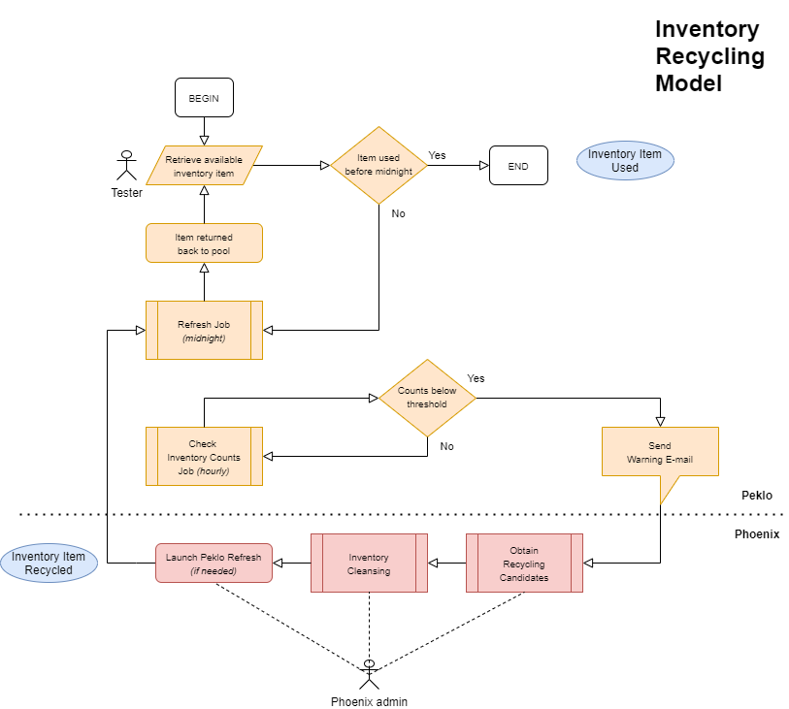

*Inventory Recycling Model – high level flowchart*

## Application Initialization

Tasks listed below are performed during application initialization. If any of the task fails, the application will close.

|  |  |
| --- | --- |
| **Application Initialization**  **Task** | **Description** |
| InitLANCheckConnect | Checks if network is accessible by establishing TCP connection to  l5tstd35.oskarmobil.cz:1522 (IBMTEST database; hard-coded) |
| InitConnect | Connects to configuration database (IBMTEST) |
| InitGetVersionInfo | Retrieves version information from launched .EXE file and configuration database (<MIN_CLIENT_VERSION>) |
| InitCreateSession | Creates new session in table RMSTOOL_OWN.RMSTOOL_SESSION with session type INIT |
| InitCheckUpdates | Compares version information, if needed then updates session type to UPDATER and launches Phoenix Updater |
| InitGetDomainInfo | Retrieves domain controller configuration from network.  If no data is returned (for off-domain workstations, or if use of a custom DC is enforced), load domain controller configuration from RMSTOOL_CONFIG table:  <DOMAIN_SUFFIX>  <DOMAIN_CONTROLLER>  <DOMAIN_NAME>  <DOMAIN_FORCE_USE_CUSTOM_DC> |
| InitAuthUserDomain | 1. Authorizes user-provided login credentials against domain controller. If not authorized after 3 attempts, updates session type to UNAUTHORIZED in table RMSTOOL_SESSION and closes the application. 2. If user selected to remember their login credentials, stores them to local Windows registry key HKEY_CURRENT_USER\Software\Phoenix as string values:  * AppData1 (username) * AppData2 (hashed password)  1. Loads user details from RMSTOOL_USER_REF 2. Reports error and closes the application if the user is suspended (RMSTOOL_USER_REF.SUSPENDED = ”Y”). 3. Assigns configured role to the user. 4. Assigns user to previously created session. 5. Checks and clears orphaned process locks in RMSTOOL_PROCESS_LOCK acquired by previous sessions of the logged-in user 6. Checks and terminates (sets end date) orphaned sessions in RMSTOOL_SESISON created by the logged-in user |
| InitAuthLicence | Loads <LICENCE_INFO> and parses it.  Displays warning if license is about to expire, or error if invalid or expired |
| InitAuthPrivateKey | Check if the private key is stored in local Windows registry key HKEY_CURRENT_USER\Software\Phoenix\ SshHostKeys\Keys as string value:   * testing (hashed key)   If the key is not yet stored, it stores it. |
| InitCreateDynamicGroupMenus | For user with ADMIN role, creates submenus in advanced context menu (**Administration 🡪 Phoenix 🡪 Add/Remove to/from Inventory Group)** for each inventory group configured in RMSTOOL_GROUP_REF. |
| InitUpdateSessionType | Updates session type to REGULAR or DEBUG in table RMSTOOL_SESSION |

## Environment Initialization

Tasks listed below are performed during environment initialization. If any of the task fails, the environment is considered as uninitialized and no operations will be allowed on it.

|  |  |
| --- | --- |
| **Initialization Task** | **Description** |
| EnvChanged | 1. Reconnect to configuration database if disconnected 2. Check if selected environment was used by any user today 3. Show environment initialization dialog 4. Disconnect all open database connections 5. Load database connections configuration of selected environment from table RMSTOOL_CONFIG:  * <NAME>_DB * <NAME>_DB_USER * <NAME>_DB_PASW   and recreates database connections array to configured systems (**full list below**)   1. Calls Threaded_InitLoadLookups to reload internal lookup structures (**full list below**) 2. Reload SOAP timeouts configuration from table RMSTOOL_CONFIG:  * SOAP_CONNECT_TIMEOUT * SOAP_SEND_TIMEOUT * SOAP_RECEIVE_TIMEOUT  1. Store selected environment to RMSTOOL_USER_REF so that it is offered to the user in Login form next time they start the application 2. Update GUI elements |
| ReflectEnvChanged | 1. Call LANCheckConnect to check VF network is accessible 2. Check ongoing environment outages 3. Update GUI elements |

Parameters of following database collections are loaded during EnvChange from configuration table RMSTOOL_CONFIG:

|  |  |
| --- | --- |
| **Connection Alias** | **Configuration Parameters** |
| csKenan | * KENAN_ADMIN_DB * KENAN_DB_USER * KENAN_DB_PASW |
| csKenanCust3 | * KENAN_CUST_DB_3 * KENAN_DB_USER * KENAN_DB_PASW |
| csKenanCust4 | * KENAN_CUST_DB_4 * KENAN_DB_USER * KENAN_DB_PASW |
| csKenanCust5 | * KENAN_CUST_DB_5 * KENAN_DB_USER * KENAN_DB_PASW |
| csPeklo | * PEKLO_DB * PEKLO_DB_USER * PEKLO_DB_PASW |
| csOMM | * OMM_DB * OMM_DB_USER * OMM_DB_PASW |
| csDMA | * DMA_DB * DMA_DB_USER * DMA_DB_PASW |
| csMVNO | * MVNO_DB * MVNO_DB_USER * MVNO_DB_PASW |
| csSBL | * SIEBEL_DB * SIEBEL_DB_USER * SIEBEL_DB_PASW |
| csEBS | * EBS_DB * EBS_DB_USER * EBS_DB_PASW |
| csRSP | * RSP_DB * RSP_DB_USER * RSP_DB_PASW |
| csRMSAPI | * RMSAPI_DB * RMSAPI_DB_USER * RMSAPI_DB_PASW |
| csVFC | * KENAN_ADMIN_DB * VFCONFIG_DB_USER * VFCONFIG_DB_PASW |
| csVFCCust3 | * KENAN_CUST_DB_3 * VFCONFIG_DB_USER * VFCONFIG_DB_PASW |
| csVFCCust4 | * KENAN_CUST_DB_4 * VFCONFIG_DB_USER * VFCONFIG_DB_PASW |
| csBMA | * BMA_DB * BMA_DB_USER * BMA_DB_PASW |
| csRCR | * RCRPAY_DB * RCRPAY_DB_USER * RCRPAY_DB_PASW |
| csMNP | * MNP_DB * MNP_DB_USER * MNP_DB_PASW |
| csMNPMaintenance | * MNP_MAINT_DB * MNP_MAINT_DB_USER * MNP_MAINT_DB_PASW |
| csHarpagon | * HARPAGON_DB * HARPAGON_DB_USER * HARPAGON_DB_PASW |
| csPRC | * PRC_DB * PRC_DB_USER * PRC_DB_PASW |
| csSTP | * STP_DB * STP_DB_USER * STP_DB_PASW |
| csXREF | * CROSSREF_DB * CROSSREF_DB_USER * CROSSREF_DB_PASW |
| csIL | * IL_DB * IL_DB_USER * IL_DB_PASW |
| csILB | * ILB_DB * ILB_DB_USER * ILB_DB_PASW |
| csWDC | * WDC_ADMIN_DB * WDC_ADMIN_DB_USER * WDC_ADMIN_DB_PASW |
| csWDCCust3 | * WDC_CUST_DB_3 * WDC_CUST_DB_3_USER * WDC_CUST_DB_3_PASW |
| csWDCCust4 | * WDC_CUST_DB_4 * WDC_CUST_DB_4_USER * WDC_CUST_DB_4_PASW |
| csOPMP | * OPMP_DB * OPMP_DB_USER * OPMP_DB_PASW |
| csIMEILoad | * IMEI_LOAD_DB * IMEI_LOAD_DB_USER * IMEI_LOAD_DB_PASW |
| csEHC | * EHC_DB * EHC_DB_USER * EHC_DB_PASW |
| csMTE | * MTE_DB * MTE_DB_USER * MTE_DB_PASW |
| csOLC | * OLC_DB * OLC_DB_USER * OLC_DB_PASW |
| csOLCU | * OLCU_DB * OLCU_DB_USER * OLCU_DB_PASW |
| csUCM | * UCM_DB * UCM_DB_USER * UCM_DB_PASW |
| csTibcoLog | * TIBCOLOG_DB * TIBCOLOG_DB_USER * TIBCOLOG_DB_PASW |

Following internal lookup structures are populated during Threaded_InitLoadLookups.

|  |  |  |
| --- | --- | --- |
| **Internal Lookup**  **Structure Name** | **Source**  **Database** | **Description** |
| KenanSourceLkp | Kenan Admin | Kenan sources |
| KenanSimTypeLkp | Kenan Admin | Kenan SIM types |
| KenanEsimTypeLkp | Kenan Admin | Kenan ESIM types |
| KenanStatusDescrLkp | Kenan Admin | Kenan inventory status descriptions |
| KenanSCDescrLkp | Kenan Admin | Kenan sales channel descriptions |
| KenanExtIdTypeDescrLkp | Kenan Admin | Kenan external ID type descriptions |
| KenanBillPeriodLkp | Kenan Admin | Kenan bill periods |
| EBSProdCodesLkp | EBS | EBS product codes |
| EBSOrgCodesLkp | EBS | EBS organizations |
| EBSDispCodesLkp | EBS | EBS dispositions |
| EBSAllowedSrcOrgLkp | Phoenix | Allowed EBS organizations |
| EBSAllowedSrcProdLkp | Phoenix | Allowed EBS products |
| KenanISDNTypeLkp | Phoenix | ISDN types |
| KenanISDNTestRangeLkp | Phoenix | ISDN test ranges |
| InventoryBlacklistLkp | Phoenix | Blacklisted inventory entries |
| InventoryWhitelistLkp | Phoenix | Whitelisted inventory entries |
| SPBundlesLkp  SPBucketsLkp | CIM | SurePay bundles and buckets from CIM |
| KenanBusinessEventsLkp | Kenan Admin (VF_CONFIG) | Kenan audit business events |
| TibcoKenanEventsLkp | EHC | Tibco configuration of Kenan events |
| ILRoutingProfilesLkp | InstantLink | InstantLink routing profiles |
| N/A | InstantLink Batch | *(Dummy thread to check connectivity)* |

**IMPORTANT:** If database connections to aforementioned systems are not available, the environment will not be initialized.

## Logging

Log events are stored in the table RMSTOOL_LOG with appropriate SESSION_ID. For every session, log events are numbered starting with EVENT_ID = 1.

Every time a log event with ERROR type is logged, a corresponding error dialog is also displayed to the user in the application GUI containing corresponding SESSION_ID and EVENT_ID identifiers of the logged error, error description and optionally also error details. All log events are also displayed in Mini-Log memo in the application GUI, unless they are logged as hidden.

Optionally, log events can be accessed via log view RMSTOOL_LOG_VW_FULL that contains also user name.

User RMSTOOL_USR has access to log view RMSTOOL_LOG_VW_MEDIUM that does not contain log data CLOB’s.

# Operational Environment

This chapter highlights the key technical and infrastructure requirements necessary to support the operational and non-functional aspects of the application.

## Operational Model

Phoenix is a Windows x64 application.

Following conditions must be met in order to run the application:

* + - Windows 10 / 11 – with local administrator account
    - Oracle client v19/v21 64-bit – FULL installation or Instant Client
    - Phoenix public key installed on target application servers for SSH/SFTP access (Kenan, Instant Link)

### New User Account Procedure

A new user account will be created by application administrator based on e-mail sent from one of the Test Leads or Test Managers, containing the following user details:

* Full Name
* Corporate e-mail address
* Domain username
* User Role *(optional)*

Please see User Management for more details.

### Client Installation Procedure

1. Ensure your user account is created (see above).
2. Install compatible Oracle client (currently recommended Oracle Instant Client v21).
3. Create a local folder dedicated to Phoenix
4. Download Phoenix updater executable from the Update Repository.   
   Default address is

[**http://l5self35.oskarmobil.cz/phoenix/updater/phoenix_updater.exe**](http://l5self35.oskarmobil.cz/phoenix/updater/phoenix_updater.exe)

1. Move downloaded file to the local folder created in step 2.
2. Run the executable.
3. Confirm destination path if asked to do so.
4. Phoenix will be downloaded and launched automatically.

##### Enable JMS messaging (optional)

To enable JMS messaging (so that Phoenix can send messages to Tibco), proceed as follows:

1. Navigate to a repository subfolder “/repository/addons”.
2. Download file tibco_x64.zip.
3. Unpack downloaded file into the local Phoenix folder.

##### Using Oracle instant client (optional)

To use Oracle instant client, proceed as follows:

1. Create “ora” subfolder in your local Phoenix folder
2. Navigate to a repository subfolder “/repository/addons”.
3. Download file ora21_x64.zip (Oracle 21 libraries).
4. Unpack downloaded file into the subfolder created in step 1.

### Client Runtime Requirements

Following conditions must be met:

* + - Access to internal Vodafone network (test environment subnets)
    - Access to application web repository (for Phoenix Updater)

The application will not initialize if started outside of Vodafone internal network.

### Application Configuration

Main part of the application configuration is stored in table RMSTOOL_CONFIG in the application schema RMSTOOL_OWN. Configuration entries are structured to general, environment-dependent, or system-related sections. During normal operation, there is no need to modify the configuration.

**The configuration is to be accessed only by the application administrators.**

Please see Configuration for more details.

## Update Repository

Phoenix Update Repository is a HTTP-accessible folder within Vodafone network with subfolders configured as follows:

|  |  |
| --- | --- |
| **Update Repository**  **Subfolder** | **Description** |
| Documentation | Application development deploys newest version of the system documentation to this subfolder. |
| Repository | Application development deploys newest version of the application files to this subfolder. Repository folder content is used for manual application installation and for automatic application updates performed by Phoenix Updater.  Addons subfolder contains following optional add-on archives:   * + - ORA19.ZIP - Oracle v19 network client binaries     - ORA21.ZIP - Oracle v19 network client binaries     - TIBCO.ZIP - additional files to support Tibco JMS connectivity   Instructions on how to deploy the addons are present in !readme.txt file in the parent folder. |
| Updater | Home of Phoenix Updater files  PHOENIX_UPDATER.EXE (executable)  PHOENIX_UPDATER.INI (configuration)  URL of this folder must be configured in GENERAL.UPDATER_URL configuration parameter, so that Phoenix knows where the Updater is located and can download it when needed. |

Currently, the Update Repository is located at [**http://l5self35.oskarmobil.cz/phoenix/**](http://l5self35.oskarmobil.cz/phoenix/)**.**

Update Repository must be accessible from workstations where Phoenix is to be used.

## Source Repository

There’s currently no dedicated source repository.

## Release Deployment

Following steps need to be performed to correctly distribute new release of the application to its users:

1. Copy new application release build into preconfigured application repository
2. Run local copy of the newest build as admin user (session type is set as PRIVATE in RMSTOOL_SESSION)
3. Press  **Announce Update** button in the upper-left corner of the main form.   
   A similar dialog is displayed:

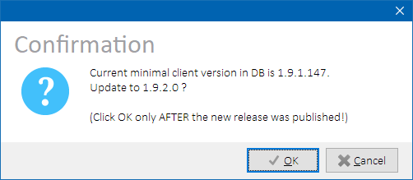  
*Announce update confirmation dialog*

1. After clicking on OK:
   * Version of the currently running client is stored to the database.
   * Other clients running during update announcement receive “VERSION_CHG” notification via Oracle DBMS Event Alerter, and Info Dock is displayed in them with information about available client update.
   * Other clients launched after update announcement check their version during startup process and if it’s lower than the version previously stored in the database, they will update themselves automatically by launching the application updater.
   * Session type previously flagged as PRIVATE is updated to RELEASE.
   * Announce Update button is hidden.

**NOTE**: Ensure that the new build is present in the update repository path before announcing the update to users. If the update is not found in the repository, newly launched clients will fail to start.

## Phoenix Updater

Phoenix Updater is a standalone executable (PHOENIX_UPDATER.EXE) used by Phoenix to download and update application files. It is automatically downloaded from the update repository and run during Phoenix initialization if there is a newer application version available for download.

The executable can also be used to download files from the repository during first Phoenix installation.

Following is the application update process that is started when:

1. A new application version is discovered during application startup
2. User clicks on Info Dock panel announcing availability of new application version

Phoenix:

1. Get updater URL from configuration database (GENERAL.UPDATER_URL)
2. Download updater executable from the repository to local Phoenix folder
3. Start **Phoenix Updater** executable

Phoenix Updater:

1. Download configuration file PHOENIX_UPDATER.INI from the repository. The plain text file contains list of filenames to be processed.
2. Check if there are currently running instances of **Phoenix** and **Outage Notifier** applications(to avoid having locked files PHOENIX.EXE and PHOENIX_OUTGTRAY.EXE)
3. Broadcast named Windows message that is intercepted by the running instances that will terminate themselves.
4. Wait until the instances are terminated.
5. For each filename in the list fetched in step 4:

* Download file from application repository to destination folder with additional .TMP file extension
* Delete old file in source folder
* Remove .TMP extension from the newly copied file

1. Restart **Outage Notifier** application, if previously terminated
2. Start **Phoenix** application
3. Log all update steps to<local_phoenix_folder>\PHOENIX_UPDATER.LOG

## Detailed Security Design

This chapter describes the security policies, procedures, and control solutions to help and identify vulnerabilities and the potential impact of the exposures of the application.

### Communication Ports and Firewall Settings

From the workstation where the application is installed, following targets on all testing environments must be accessible:

|  |  |
| --- | --- |
| **Traffic Type** | **Target** |
| **SSH** | 1. Kenan application server 2. Instant Link application server 3. eArchive application server |
| **SFTP** | 1. Kenan application server |
| **DB/ORA** | 1. BMG database 2. CIM database 3. DMA database 4. EBS database 5. IL database 6. KENAN admin database 7. KENAN customer database 3 8. KENAN customer database 4 9. KENAN customer database 5 10. MNP database 11. ODS database 12. OLC database 13. OMM database 14. OPMP database 15. OSK database 16. SIEBEL database 17. TIBCO database 18. UCM database (eArchive) |
| **HTTP/SOAP**  **(V4 Tibco)** | 1. SOAP_ASSETSVC_ENDPOINT (V4AssetServices) 2. SOAP_CASHREGSVC_ENDPOINT (CashRegisterServices) 3. SOAP_CURSVC_ENDPOINT (SubscriberServices) 4. SOAP_KENSVC_ENDPOINT (IntegrationManagement/KenanServices) 5. SOAP_PMSVC_ENDPOINT (PasswordManagementService) 6. SOAP_PTPSVC_ENDPOINT (PtpManagement/KenanServices) 7. SOAP_RESSVC_ENDPOINT (ResourceManagement/KenanServices) 8. SOAP_SMDPSVC_ENDPOINT (ConnectorsESim/SmdpServices) 9. SOAP_RCSSVC_ENDPOINT (ConnectorsESim/ MultiDeviceNotifications) 10. SOAP_SDSSVC_ENDPOINT (SDSAdapter/OneNumberManagement) 11. SOAP_SMSSVC_ENDPOINT (amr/trackingIF) |
| **HTTP/SOAP**  **(SMS SC)** | 1. HTTP_SMSSCSVC_ENDPOINT (SMS SC API) |
| **HTTP/SOAP**  **(LMG)** | 1. SOAP_LMGSVC_ENDPOINT (LMG API) |
| **HTTP/SOAP**  **(Location Dispatcher)** | 1. SOAP_LOCDISPSVC_ENDPOINT (Location Dispatcher API) |
| **HTTP/SOAP (IBM Outages)** | 1. SOAP_OUTAGESVC_ENDPOINT (IBM Outages API) |
| **HTTPS/REST**  **(eSIM Env Router)** | 1. ESIM_ENV_ROUTER_RELOAD_URLS (esim-env-router nodes API) |
| **HTTPS/REST**  **(VF Outages - Titus)** | 1. REST_VF_OUTAGE_ALL (Titus API - All Outages) 2. REST_VF_OUTAGE_ONGOING (Titus API - Ongoing Outages) |

For actual values (host, ports, endpoints, URL’s) per each testing environment, please see section External Interfaces, or look directly into configuration table RMSTOOL_CONFIG.

### Access Rights

Application can only be used by preconfigured named users. Unauthorized or unknown users are denied access. All application logins are logged (both successful and unsuccessful).

##### User Roles

User access rights inside the application vary per assigned user role. Users without pre-assigned role are not allowed access to the application. Following user roles are available:

|  |  |
| --- | --- |
| **Role name** | **Description** |
| ADMIN | Unlimited access to all functionalities |
| LEAD | Limited access for test leads from IBM testing team |
| TESTING-IBM | Limited access for testers from IBM testing team |
| TESTING-VF | Limited access for testers from V4 testing teams |
| TESTING-V2 | Limited access for testers from V2 team (currently not actively used) |

Roles are assigned to the users by Phoenix application administrator based on the respective Test Lead / Test Manager decision.

User-Role mapping is stored in configuration table RMSTOOL_USER_REF.

Function-Role mapping is hard-coded in the application and described in the respective function sections.

##### Domain Authorization

Upon application initialization, a Login form is presented to the user. User must enter their domain username, domain password, and domain name which are then authorized against domain controller using LDAP protocol and *DoAdsOpenObject* call. If *DoAdsOpenObject* fails, *LogonUser* is calledalternatively as a fallback solution.

Application will try to discover information about local domain controller automatically using native Win32 API *NTNetDsGetDcName* provided by *NETAPI32.DLL*. However, this only works on workstations that are part of the local domain.

If domain controller lookup fails (e.g. the workstation is outside of the domain), or if configuration parameter DOMAIN_FORCE_USE_CUSTOM_DC is set to 1, following manual configuration is used:

*Configuration:*

|  |  |  |  |
| --- | --- | --- | --- |
| ***Table RMSTOOL_CONFIG  (entries used during domain authorization)*** | | | |
| **SECTION** | **PARAM_NAME** | **PARAM_VALUE** | **Description** |
| GENERAL | DOMAIN_SUFFIX |  | Domain suffix |
| GENERAL | DOMAIN_CONTROLLER | ecczdc016vw.  internal.vodafone.com | Domain controller name |
| GENERAL | DOMAIN_NAME | vf-root | Domain name |
| GENERAL | DOMAIN_FORCE_USE_CUSTOM_DC | 1 | Set to 1 to force-use custom DC. |

***Update 19.1.2024*** – As user synchronization between local domain (oskarmobil.cz/ceskymobil) and global domain (vf-root) is about to be stopped, the above global domain controller was preconfigured to be used in all cases. This is to prevent the situation when user logs in from workstation belonging to local domain and authenticates against local domain controller that might hold outdated user data or no user data at all.

##### Inventory Authorization

Depending on their application role, the users may only be allowed to invoke cleansing operations on a restricted preconfigured set of inventory items (MSISDN’s and/or IMSI+ICCID’s). Each user with restricted inventory access must be assigned with a concrete whitelist inventory group. Furthermore, all users also share inventory blacklist group.

* **Inventory whitelist group** contains inventory items that the user is allowed to clean. There are several inventory whitelist groups configured.
* **Inventory blacklist group** contains inventory items that no users are allowed to clean, but users with ADMIN role can explicitly override this restriction in the application GUI.

See Inventory Groups Configuration for more details on how to configure the inventory groups.

##### User Views

User RMSTOOL_USR can access limited application logs via view RMSTOOL_LOG_VW_MEDIUM. The view does not contain extended data CLOB’s.

### Data Retention and Data Purging Policy

The application does not store any data except for application log.

Application log is kept in order to trace down operational issues and it’s stored in table RMSTOOL_LOG.

Old logs (usually older than 1 year) are archived manually by application administrator as needed in order to keep reasonable size of the live log table. Archived logs are stored in tables RMSTOOL_SESSION_ARCH and RMSTOOL_LOG_ARCH.

Old archived logs (usually older than 3 years) are manually deleted forever by application administrator as needed.

Neither the application nor any of its parts work with or have access to sensitive personal data that would require GDPR-compliant handling or similar restrictions.

## Configuration

### Application Configuration

Main application configuration is stored in table RMSTOOL_CONFIG.

The configuration is divided into following sections:

|  |  |
| --- | --- |
| Section | Description |
|
| GENERAL | General application configuration |
| EBS_SPECIFIC | EBS-related processing configuration |
| IL_SPECIFIC | InstantLink-related processing configuration |
| KENAN_SPECIFIC | Kenan- and RMS-related processing configuration |
| TIBCO_SPECIFIC | Tibco-related JMS processing configuration (topic and queue names) |
| SY2 | Particular testing environment (SYS2/UAT3) configuration |
| INT | Particular testing environment (INT/UAT2) configuration |
| PRE | Particular testing environment (PRE/ACC2) configuration |

Entries configured in specific testing environment sections are reloaded every time the environment is changed in the application.

##### Parameter Value Forwarding

In order to avoid repeated PARAM_VALUE configuration, a configuration forwarding prefix can be configured in CONFIG_FORWARD_PREFIX and then used to point on another parameter name within the same configuration section. Value of the target parameter will be used, as depicted in the example below:

|  |  |  |
| --- | --- | --- |
| *Table RMSTOOL_CONFIG* | | |
| SECTION | PARAM_NAME | PARAM_VALUE |
| GENERAL | CONFIG_FORWARD_PREFIX | -> |
| INT | TIBCO_DB | (DESCRIPTION=(ADDRESS_LIST=(ADDRESS=(PROTOCOL=TCP)(HOST=czint1hr.vfcz.dc-ratingen.de)(PORT=33001)))(CONNECT_DATA=(SERVER=DEDICATED)(SERVICE_NAME=V4TIINT.TEST.CZ))) |
| INT | STP_DB | ->TIBCO_DB |

In the example above, PARAM_VALUE configured for TIBCO_DB will also be used for STP_DB.

##### Parameter Value Commenting

If PARAM_VALUE begins with hash (#) or double slash (//), it’s considered as comment. Instead of such configured value, empty value is used in actual processing. See example below:

|  |  |  |
| --- | --- | --- |
| *Table RMSTOOL_CONFIG* | | |
| SECTION | PARAM_NAME | PARAM_VALUE |
| INT | WARNING_MESSAGE | #INT environment is locked down due to EBS DB migration (project EBS Upgrade). Please contact admin team for info about ETA. |

In the example above, warning message text will not be displayed on INT environment as it is commented out.

##### Configuration Entries – General Section

|  |  |
| --- | --- |
| *Table RMSTOOL_CONFIG*  (Configuration entries subset) | |
| PARAM_NAME | Description |
| AGILE_MIN_RECYCLING_AGE | Minimal age of agile inventory items to be considered as cleansing candidates |
| AGILE_NOTE | Peklo note representing agile inventory items |
| COLL_TIMEOUT_SEC | Collection timeout in seconds. If collection event is not processed during configured time, a warning will be displayed. |
| CONFIG_FORWARD_PREFIX | Prefix to use another configuration parameter’s value. |
| DOMAIN_CONTROLLER | Domain controller hostname for user authorization. |
| DOMAIN_FORCE_USE_CUSTOM_DC | Set to 1 to stop network discovery of local domain controller and force-use preconfigured domain controller. |
| DOMAIN_NAME | Domain name for user authorization. |
| DOMAIN_SUFFIX | Domain suffix for user authorization. |
| ENVIRONMENTS | Comma-separated list of available testing environments |
| ENVIRONMENTS_DEBUG | Comma-separated list of available testing environments if the application is started in debug mode |
| ENVIRONMENTS_DEBUG_USERS | Comma-separated list of domain usernames that can log into the application started in debug mode |
| ESIM_ENV_ROUTER_RELOAD_URLS | Comma-separated list of Reload API REST endpoints of all esim-env-router nodes E.g.:  https://czbff3vr.oskarmobil.cz:12025/tasks/reload,https://czltm2vr.oskarmobil.cz:12025/tasks/reload |
| ISDN_TYPE_BLU | Comma-separated list of prefixes for BLUE ISDN category in format  COLOR-BLUE:<list_of_prefixes> |
| ISDN_TYPE_GEO | Comma-separated list of prefixes for GEOGRAPHIC ISDN category in format  GEOGRAPHIC:<list_of_prefixes> |
| ISDN_TYPE_GRN | Comma-separated list of prefixes for GREEN ISDN category in format  COLOR-GREEN:<list_of_prefixes> |
| ISDN_TYPE_NGC | Comma-separated list of prefixes for NON-GEOGRAPHIC ISDN category in format  NON-GEOGRAPHIC:<list_of_prefixes> |
| ISDN_TYPE_NPC | Comma-separated list of prefixes for NON-PUBLIC ISDN category in format  NON-PUBLIC:<list_of_prefixes> |
| ISDN_TYPE_WHT | Comma-separated list of prefixes for WHITE ISDN category in format  COLOR-WHITE:<list_of_prefixes> |
| LICENCE_INFO | Hashed license key |
| MIN_CLIENT_VERSION | Minimal allowed version of the application to run. If currently installed version is older, Phoenix Updater is launched |
| MIN_RECYCLING_AGE | Minimal age of non-agile inventory items to be considered as cleansing candidates |
| QR_CODE_TEMPLATE | Message template to be encoded in payment QR code. Following variable placeholders are supported:   * + %SS% = specific symbol   + %VS% = variable symbol   + %AM% = amount |
| REPOSITORY_URL | URL of Phoenix update repository (if web-based, currently not used) |
| REST_VF_OUTAGE_ALL | REST endpoint of Titus API returning all outages |
| REST_VF_OUTAGE_ONGOING | REST endpoint of Titus API returning currently ongoing outages |
| SOAP_CONNECT_TIMEOUT | Connection timeout of SOAP connect operation in milliseconds. If the operation does not finish in configured time, error will be raised |
| SOAP_OUTAGESVC_ENDPOINT | SOAP endpoint of outages reported by IBM test environment admin team |
| SOAP_RECEIVE_TIMEOUT | Connection timeout of SOAP receive operation in milliseconds. If the operation does not finish in configured time, error will be raised |
| SOAP_SEND_TIMEOUT | Connection timeout of SOAP send operation in milliseconds. If the operation does not finish in configured time, error will be raised |
| UPDATER_URL | URL of Phoenix update repository where Updater executable is located |
| UPDATER_WARNING_MESSAGE | Custom error message displayed to user during outdated Phoenix client initialization instead of launching Updater. |

##### Configuration Entries – Environment Sections

Each testing environment configured in ENVIRONMENTS value has its own configuration section identified by SECTION=<ENV_NAME>.

|  |  |
| --- | --- |
| *Table RMSTOOL_CONFIG*  (Configuration entries subset) | |
| PARAM_NAME | Description |
| ACR_DB | ACR system database as Oracle TNS connect descriptor |
| ACR_DB_PASW | ACR system owner schema password |
| ACR_DB_USER | ACR system owner schema name |
| BMA_DB | BMA system database as Oracle TNS connect descriptor |
| BMA_DB_PASW | BMA system owner schema password |
| BMA_DB_USER | BMA system owner schema name |
| BMG_DB | BMG system database as Oracle TNS connect descriptor |
| CIM_DB | CIM system database as Oracle TNS connect descriptor |
| CIM_DB_PASW | CIM system owner schema password |
| CIM_DB_USER | CIM system owner schema name |
| CROSSREF_DB | Cross Reference system database as Oracle TNS connect descriptor |
| CROSSREF_DB_PASW | Cross Reference system owner schema password |
| CROSSREF_DB_USER | Cross Reference system owner schema name |
| DMA_DB | DMA system database as Oracle TNS connect descriptor |
| DMA_DB_PASW | DMA system owner schema password |
| DMA_DB_USER | DMA system owner schema name |
| EBS_DB | EBS system database as Oracle TNS connect descriptor |
| EBS_DB_PASW | EBS system owner schema password |
| EBS_DB_USER | EBS system owner schema name |
| EBS_QA_USER | EBS username used in APPS.QA_LOGIN |
| EHC_DB | EHC system database as Oracle TNS connect descriptor |
| EHC_DB_PASW | EHC system owner schema password |
| EHC_DB_USER | EHC system owner schema name |
| HARPAGON_DB | Harpagon system database as Oracle TNS connect descriptor |
| HARPAGON_DB_PASW | Harpagon system owner schema password |
| HARPAGON_DB_USER | Harpagon system owner schema name |
| HTTP_IMEIREPOSVC_ENDPOINT | IMEI Repository HTTP endpoint (for incoming EIR messages from PG) |
| HTTP_SMSSCSVC_ENDPOINT | BMG servlet endpoint published by SMS SC |
| IGNORE_MNP_CLEANSING_ERRORS | If set to 1, MNP cleansing thread status will be treated as Success even if there are MSISDN’s that were not successfully cleansed.  This is because MNP cleansing procedure returns “Incorrect data” error also for MSISDN’s that do not exist in MNP at all. Such errors are currently treated as attempts to clean already cleaned MSISDN’s and ignored. |
| ILB_DB | InstantLink Batch system database as Oracle TNS connect descriptor |
| ILB_DB_PASW | InstantLink Batch system owner schema password |
| ILB_DB_USER | InstantLink Batch system owner schema name |
| IL_DB | InstantLink system database as Oracle TNS connect descriptor |
| IL_DB_PASW | InstantLink system owner schema password |
| IL_DB_USER | InstantLink system owner schema name |
| IL_UNIX_HOST | InstantLink application server hostname |
| IL_UNIX_ILADAPTER_PATH | Path to InstantLink Adapter location on the InstantLink application server |
| IL_UNIX_ILADAPTER_PROCESS_NAME | Process name of InstantLink Adapter on the InstantLink application server |
| IL_UNIX_PORT | InstantLink application server SSH port |
| IL_UNIX_REFRESH_CMDS | Comma-separated list of InstantLink refresh commands  (currently not used) |
| IL_UNIX_USER | InstantLink application server username |
| IMEI_LOAD_DB | IMEI Loader system database as Oracle TNS connect descriptor |
| IMEI_LOAD_DB_PASW | IMEI Loader system owner schema password |
| IMEI_LOAD_DB_USER | IMEI Loader system owner schema name |
| IMEIREPO_CONFIG_FILE_PATH | Path to IMEI Repository configuration file configuration.xml |
| IMEIREPO_DB_HOST | IMEI Repository database (MySQL) host |
| IMEIREPO_DB_PORT | IMEI Repository database (MySQL) port |
| IMEIREPO_DB_NAME | IMEI Repository database (MySQL) name |
| IMEIREPO_DB_USER | IMEI Repository database (MySQL) user |
| IMEIREPO_DB_PASW | IMEI Repository database (MySQL) password |
| IMEIREPO_PROVIDER_URL | Tibco server that IMEI Repository uses on given test environment.  Use exactly the same value as present in IMEI Repository configuration.xml file under <provider-url> element.  E.g.: tibjmsnaming://aczfil10s-z1.vfcz.dc-ratingen.de:7222 |
| IMEIREPO_UNIX_HOST | IMEI Repository application server name |
| IMEIREPO_UNIX_PORT | SSH port fort accessing IMEI Repository application server |
| IMEIREPO_UNIX_USER | SSH user for accessing IMEI Repository application server |
| KENAN_ADMIN_DB | Kenan system admin database as Oracle TNS connect descriptor |
| KENAN_ADMIN_DB_SYNONYM | Synonym name on Kenan customer databases pointing to Kenan admin database |
| KENAN_CUST_DB_3 | Kenan system customer database 3 as Oracle TNS connect descriptor |
| KENAN_CUST_DB_4 | Kenan system customer database 4 as Oracle TNS connect descriptor |
| KENAN_CUST_DB_5 | Kenan system customer database 5 as Oracle TNS connect descriptor |
| KENAN_CUST_DB_COUNT | Number of Kenan system customer databases |
| KENAN_DB_PASW | Kenan system ARBOR database schema password |
| KENAN_DB_USER | Kenan system ARBOR database schema name |
| KENAN_RUN_SIPO_REPORT_AFTER | Defines Kenan process which SIPO report launcher is run after:   * BIP * KENAN |
| KENAN_UNIX_ARBORBIN_PATH | Kenan $ARBORBIN system variable value |
| KENAN_UNIX_ARBORDATA_PATH | Kenan $ARBORDATA system variable value |
| KENAN_UNIX_HOST | Kenan system application server hostname |
| KENAN_UNIX_PORT | Kenan system application server SSH port |
| KENAN_UNIX_USER | Kenan system application server username |
| MNP_DB | MNP system database as Oracle TNS connect descriptor |
| MNP_DB_PASW | MNP system owner schema password |
| MNP_DB_USER | MNP system owner schema name |
| MNP_MAINT_DB | MNP maintenance system database as Oracle TNS connect descriptor |
| MNP_MAINT_DB_PASW | MNP maintenance system owner schema password |
| MNP_MAINT_DB_USER | MNP maintenance system owner schema name |
| MTE_DB | MTE system database as Oracle TNS connect descriptor |
| MTE_DB_PASW | MTE system owner schema password |
| MTE_DB_USER | MTE system owner schema name |
| MVNO_DB | MVNO system database as Oracle TNS connect descriptor |
| MVNO_DB_PASW | MVNO system owner schema password |
| MVNO_DB_USER | MVNO system owner schema name |
| ODS_DB | ODS system database as Oracle TNS connect descriptor |
| OLC_DB | OLC system database as Oracle TNS connect descriptor |
| OLC_DB_PASW | OLC system owner schema password |
| OLC_DB_USER | OLC system owner schema name |
| OLCU_DB | OLC system database as Oracle TNS connect descriptor |
| OLCU_DB_PASW | OLC system Phoenix application user schema password |
| OLCU_DB_USER | OLC system Phoenix application user schema name |
| OMM_DB | OMM system database as Oracle TNS connect descriptor |
| OMM_DB_PASW | OMM system owner schema password |
| OMM_DB_USER | OMM system owner schema name |
| OPMP_DB | OPMP system database as Oracle TNS connect descriptor |
| OPMP_DB_PASW | OPMP system owner schema password |
| OPMP_DB_USER | OPMP system owner schema name |
| OSK_DB | OSK system database as Oracle TNS connect descriptor |
| PEKLO_DB | PEKLO system database as Oracle TNS connect descriptor |
| PEKLO_DB_PASW | PEKLO system owner schema password |
| PEKLO_DB_USER | PEKLO system owner schema name |
| PRC_DB | Profile Cache system database as Oracle TNS connect descriptor |
| PRC_DB_PASW | Profile Cache system owner schema password |
| PRC_DB_USER | Profile Cache system owner schema name |
| RCRPAY_DB | RCRPAY system database as Oracle TNS connect descriptor |
| RCRPAY_DB_PASW | RCRPAY system owner schema password |
| RCRPAY_DB_USER | RCRPAY system owner schema name |
| RMSAPI_DB | RMS API system database as Oracle TNS connect descriptor |
| RMSAPI_DB_PASW | RMS API system owner schema password |
| RMSAPI_DB_USER | RMS API system owner schema name |
| RSPROXY_DB | RSPROXY system database as Oracle TNS connect descriptor |
| RSPROXY_DB_PASW | RSPROXY system owner schema password |
| RSPROXY_DB_USER | RSPROXY system owner schema name |
| SIEBEL_DB | SIEBEL system database as Oracle TNS connect descriptor |
| SIEBEL_DB_PASW | SIEBEL system owner schema password |
| SIEBEL_DB_USER | SIEBEL system owner schema name |
| SMSSC_KEYWORDS | Comma-separated list of available SMS SC keywords |
| SOAP_ASSETSVC_ENDPOINT | Asset services SOAP endpoint URL |
| SOAP_ASSETSVC_PASW | AssetServices SOAP endpoint password |
| SOAP_ASSETSVC_USER | AssetServices SOAP endpoint username |
| SOAP_CASHREGSVC_ENDPOINT | CashRegisterServices SOAP endpoint URL |
| SOAP_CASHREGSVC_PASW | CashRegisterServices SOAP endpoint password |
| SOAP_CASHREGSVC_USER | CashRegisterServices SOAP endpoint username |
| SOAP_CURSVC_ENDPOINT | SubscriberServices SOAP endpoint URL |
| SOAP_CURSVC_PASW | SubscriberServices SOAP endpoint password |
| SOAP_CURSVC_USER | SubscriberServices SOAP endpoint username |
| SOAP_IMEIREPOSVC_ENDPOINT | IMEI Repository SOAP endpoint URL |
| SOAP_IMEIREPOSVC_PASW | IMEI Repository SOAP endpoint password |
| SOAP_IMEIREPOSVC_USER | IMEI Repository SOAP endpoint username |
| SOAP_KENSVC_ENDPOINT | IntegrationManagement/KenanServices SOAP endpoint URL |
| SOAP_KENSVC_PASW | IntegrationManagement/KenanServices SOAP endpoint password |
| SOAP_KENSVC_USER | IntegrationManagement/KenanServices SOAP endpoint username |
| SOAP_LMGSVC_ENDPOINT | Provisioning_submit SOAP endpoint URL |
| SOAP_LMGSVC_PASW | Provisioning_submit SOAP endpoint password |
| SOAP_LMGSVC_USER | Provisioning_submit SOAP endpoint username |
| SOAP_LOCDISPSVC_ENDPOINT | Location Dispatcher SOAP endpoint URL |
| SOAP_PMSVC_ENDPOINT | PasswordManagementService SOAP endpoint password |
| SOAP_PMSVC_PASW | PasswordManagementService SOAP endpoint username |
| SOAP_PMSVC_USER |  |
| SOAP_PTPSVC_ENDPOINT | PtpManagement/KenanServices SOAP endpoint URL |
| SOAP_PTPSVC_PASW | PtpManagement/KenanServices SOAP endpoint password |
| SOAP_PTPSVC_USER | PtpManagement/KenanServices SOAP endpoint username |
| SOAP_RCSSVC_ENDPOINT | ConnectorsESim/MultiDeviceNotifications SOAP endpoint URL |
| SOAP_RCSSVC_PASW | ConnectorsESim/MultiDeviceNotifications SOAP endpoint password |
| SOAP_RCSSVC_USER | ConnectorsESim/MultiDeviceNotifications SOAP endpoint username |
| SOAP_RESSVC_ENDPOINT | ResourceManagement/KenanServices SOAP endpoint URL |
| SOAP_RESSVC_PASW | ResourceManagement/KenanServices SOAP endpoint password |
| SOAP_RESSVC_USER | ResourceManagement/KenanServices SOAP endpoint username |
| SOAP_SDSSVC_ENDPOINT | AdaptersSds/OneNumberManagement SOAP endpoint URL |
| SOAP_SDSSVC_PASW | AdaptersSds/OneNumberManagement SOAP endpoint password |
| SOAP_SDSSVC_USER | AdaptersSds/OneNumberManagement SOAP endpoint username |
| SOAP_SMDPSVC_ENDPOINT | ConnectorsESim/SmdpServices SOAP endpoint URL |
| SOAP_SMDPSVC_PASW | ConnectorsESim/SmdpServices SOAP endpoint password |
| SOAP_SMDPSVC_USER | ConnectorsESim/SmdpServices SOAP endpoint username |
| SOAP_SMSSVC_ENDPOINT | BMG trackingIF SOAP endpoint URL |
| SOAP_SMSSVC_PASW | BMG trackingIF SOAP endpoint password |
| SOAP_SMSSVC_USER | BMG trackingIF SOAP endpoint username |
| STP_DB | STP system database as Oracle TNS connect descriptor |
| STP_DB_PASW | STP system owner schema password |
| STP_DB_USER | STP system owner schema name |
| SYS_DOC_URL | URL pointing to application system documentation |
| SYSTEMS_CLEAN | Comma-separated list of system names to be offered for system cleansing. |
| SYSTEMS_CLEAN_DEBUG | Comma-separated list of system names to be offered for system cleansing if application is running in debug mode. |
| SYSTEMS_CLEAN_ENABLED | Defines if system cleansing task is enabled on given environment.  1 = enabled  0 = disabled |
| SYSTEMS_FINALIZE | Comma-separated list of systems to be used during finalization task. |
| SYSTEMS_FINALIZE _DEBUG | Comma-separated list of systems to be used during finalization task if application is running in debug mode. |
| SYSTEMS_FINALIZE _ENABLED | Defines if finalization task is enabled on given environment.  1 = enabled  0 = disabled |
| SYSTEMS_NETWORK | Comma-separated list of InstantLink service names to be offered for network cleansing. |
| SYSTEMS_NETWORK_DEBUG | Comma-separated list of InstantLink service names to be offered for network cleansing if application is running in debug mode. |
| SYSTEMS_NETWORK_ENABLED | Defines if network cleansing task is enabled on given environment.  1 = enabled  0 = disabled |
| SYSTEMS_UPLOAD | Comma-separated list of system names to be offered for system upload. |
| SYSTEMS_UPLOAD_DEBUG | Comma-separated list of system names to be offered for system upload if application is running in debug mode. |
| SYSTEMS_UPLOAD_ENABLED | Defines if system upload task is enabled on given environment.  1 = enabled  0 = disabled |
| TIBCOLOG_BW_LOG_TABLE_SCHEMA | Schema name where TIBCO_LOG_BW table is located. |
| TIBCOLOG_DB | TIBCOLOG system database as Oracle TNS connect descriptor |
| TIBCOLOG_DB_PASW | TIBCOLOG system owner schema password |
| TIBCOLOG_DB_USER | TIBCOLOG system owner schema name |
| TIBCO_DB | TIBCO system database as Oracle TNS connect descriptor |
| TIBCO_EMS_AFF_HOST | Tibco EMS AFF hostname |
| TIBCO_EMS_AFF_PASW | Tibco EMS AFF password |
| TIBCO_EMS_AFF_PORT | Tibco EMS AFF port |
| TIBCO_EMS_AFF_USER | Tibco EMS AFF username |
| TIBCO_EMS_FOM_HOST | Tibco EMS FOM hostname |
| TIBCO_EMS_FOM_PASW | Tibco EMS FOM password |
| TIBCO_EMS_FOM_PORT | Tibco EMS FOM port |
| TIBCO_EMS_FOM_USER | Tibco EMS FOM username |
| UCM_DB | UCM system database as Oracle TNS connect descriptor |
| UCM_DB_PASW | UCM system owner schema password |
| UCM_DB_USER | UCM system owner schema name |
| UCM_UNIX_HOST | UCM application server hostname |
| UCM_UNIX_LOCK_FILENAMES | Comma-separated list of UCM downloader lock filenames for invoice downloaders (wildcards supported) |
| UCM_UNIX_LOCK_FILENAMES_DL | Comma-separated list of UCM downloader lock filenames for dunning letter downloaders (wildcards supported) |
| UCM_UNIX_LOCK_PATH | Path to UCM downloader lock file’s location on the UCM application server |
| UCM_UNIX_PASW | UCM application server password |
| UCM_UNIX_PORT | UCM application server SSH port |
| UCM_UNIX_USER | UCM application server username |
| VFCONFIG_DB | VF_CONFIG system database as Oracle TNS connect descriptor |
| VFCONFIG_DB_PASW | Kenan system VF_CONFIG schema password |
| VFCONFIG_DB_USER | Kenan system VF_CONFIG owner schema name |
| WARNING_MESSAGE | Environment warning message displayed in the Warning Dock |
| WDC_ADMIN_DB | WSC Data Cache system admin database as Oracle TNS connect descriptor |
| WDC_ADMIN_DB_PASW | WSC Data Cache system admin owner schema password |
| WDC_ADMIN_DB_USER | WSC Data Cache system admin owner schema name |
| WDC_CUST_DB_3 | WSC Data Cache system customer database 3 as Oracle TNS connect descriptor |
| WDC_CUST_DB_3_PASW | WSC Data Cache system customer database 3 owner schema password |
| WDC_CUST_DB_3_USER | WSC Data Cache system customer database 3 owner schema name |
| WDC_CUST_DB_4 | WSC Data Cache system customer database 3 as Oracle TNS connect descriptor |
| WDC_CUST_DB_4_PASW | WSC Data Cache system customer database 4 owner schema password |
| WDC_CUST_DB_4_USER | WSC Data Cache system customer database 4 owner schema name |

##### Configuration Entries – Kenan Specific Section

|  |  |
| --- | --- |
| *Table RMSTOOL_CONFIG*  (Configuration entries subset) | |
| PARAM_NAME | Description |
| IGNORED_COLL_ACTION_TYPES | Comma-separated list of Kenan collection action types which completion is ignored |
| MASS_PAIRING_MVNO_DISALLOW | Comma-separated list of MVNO operator identifiers for which Mass Pairing will not be allowed |
| MASS_PAIRING_MVNO_EBS_TEMPLATE | Default EBS template name for MVNO Mass Pairing |
| MASS_PAIRING_MVNO_INITIAL_CREDIT | Default initial credit value for MVNO Mass Pairing in CZK |
| NRC_DEFAULT_AMOUNT | Default NRC amount in CZK |
| UPLOAD_INVENTORY_STATUS_ESIM_PINLESS | Inventory status value used when uploading PINless-eSIM inventory items to RMS |
| UPLOAD_INVENTORY_STATUS_ESIM_VIRTUAL | Inventory status value used when uploading Virtual-eSIM inventory items to RMS |
| UPLOAD_INVENTORY_STATUS_ESIM_VOUCHER | Inventory status value used when uploading Voucher-eSIM inventory items to RMS |
| UPLOAD_INVENTORY_STATUS_V2 | Inventory status value used when uploading V4 inventory items to RMS |
| UPLOAD_INVENTORY_STATUS_V4 | Inventory status value used when uploading V2 inventory items to RMS |

##### Configuration Entries – EBS Specific Section

|  |  |
| --- | --- |
| *Table RMSTOOL_CONFIG*  (Configuration entries subset) | |
| PARAM_NAME | Description |
| ALLOWED_ORGANIZATIONS_E101 | Comma-separated list of allowed EBS organizations for inventory with E101 source |
| ALLOWED_ORGANIZATIONS_E103 | Comma-separated list of allowed EBS organizations for inventory with E103 source |
| ALLOWED_ORGANIZATIONS_ESIM | Comma-separated list of allowed EBS organizations for eSIM inventory items |
| ALLOWED_ORGANIZATIONS_ESIM_PINLESS | Comma-separated list of allowed EBS organizations for PINless-eSIM inventory items |
| ALLOWED_ORGANIZATIONS_ESIM_VIRTUAL | Comma-separated list of allowed EBS organizations for Virtual-eSIM inventory items |
| ALLOWED_ORGANIZATIONS_ESIM_VOUCHER | Comma-separated list of allowed EBS organizations for Voucher-eSIM inventory items |
| ALLOWED_ORGANIZATIONS_F200 | Comma-separated list of allowed EBS organizations for inventory with F200 source |
| ALLOWED_ORGANIZATIONS_F201 | Comma-separated list of allowed EBS organizations for inventory with F201 source |
| ALLOWED_ORGANIZATIONS_HW | Comma-separated list of allowed EBS organizations for hardware inventory items |
| ALLOWED_ORGANIZATIONS_S100 | Comma-separated list of allowed EBS organizations for inventory with S100 source |
| ALLOWED_ORGANIZATIONS_S102 | Comma-separated list of allowed EBS organizations for inventory with S102 source |
| ALLOWED_ORGANIZATIONS_S104 | Comma-separated list of allowed EBS organizations for inventory with S104 source |
| ALLOWED_ORGANIZATIONS_S105 | Comma-separated list of allowed EBS organizations for inventory with S105 source |
| ALLOWED_ORGANIZATIONS_S106 | Comma-separated list of allowed EBS organizations for inventory with S106 source |
| ALLOWED_ORGANIZATIONS_S107 | Comma-separated list of allowed EBS organizations for inventory with S107 source |
| ALLOWED_ORGANIZATIONS_S108 | Comma-separated list of allowed EBS organizations for inventory with S108 source |
| ALLOWED_ORGANIZATIONS_S109 | Comma-separated list of allowed EBS organizations for inventory with S109 source |
| ALLOWED_ORGANIZATIONS_V2 | Comma-separated list of allowed EBS organizations for inventory with V2 source |
| ALLOWED_ORGANIZATIONS_V4 | Comma-separated list of allowed EBS organizations for inventory with V4 source |
| ALLOWED_PRODUCTS_E101 | Comma-separated list of allowed EBS products for inventory with E101 source |
| ALLOWED_PRODUCTS_E103 | Comma-separated list of allowed EBS products for inventory with E103 source |
| ALLOWED_PRODUCTS_ESIM | Comma-separated list of allowed EBS products for eSIM inventory items |
| ALLOWED_PRODUCTS_ESIM_PINLESS | Comma-separated list of allowed EBS products for PINless-eSIM inventory items |
| ALLOWED_PRODUCTS_ESIM_VIRTUAL | Comma-separated list of allowed EBS products for Virtual-eSIM inventory items |
| ALLOWED_PRODUCTS_ESIM_VOUCHER | Comma-separated list of allowed EBS products for Voucher-eSIM inventory items |
| ALLOWED_PRODUCTS_F200 | Comma-separated list of allowed EBS products for inventory with F200 source |
| ALLOWED_PRODUCTS_F201 | Comma-separated list of allowed EBS products for inventory with F201 source |
| ALLOWED_PRODUCTS_HW | Comma-separated list of allowed EBS products for hardware inventory items |
| ALLOWED_PRODUCTS_S100 | Comma-separated list of allowed EBS products for inventory with S100 source |
| ALLOWED_PRODUCTS_S102 | Comma-separated list of allowed EBS products for inventory with S102 source |
| ALLOWED_PRODUCTS_S104 | Comma-separated list of allowed EBS products for inventory with S104 source |
| ALLOWED_PRODUCTS_S105 | Comma-separated list of allowed EBS products for inventory with S105 source |
| ALLOWED_PRODUCTS_S106 | Comma-separated list of allowed EBS products for inventory with S106 source |
| ALLOWED_PRODUCTS_S107 | Comma-separated list of allowed EBS products for inventory with S107 source |
| ALLOWED_PRODUCTS_S108 | Comma-separated list of allowed EBS products for inventory with S108 source |
| ALLOWED_PRODUCTS_S109 | Comma-separated list of allowed EBS products for inventory with S109 source |
| ALLOWED_PRODUCTS_V2 | Comma-separated list of allowed EBS products for inventory with V2 source |
| ALLOWED_PRODUCTS_V4 | Comma-separated list of allowed EBS products for inventory with V4 source |
| INIT_ORGANIZATIONS | Comma-separated list of all allowed EBS organizations |
| SIMTYPE_DEFAULT_PRODUCT | Comma-separated list of pairs in format <RMS_SIM_TYPE>=<EBS_PRODUCT>.  Defines default EBS products for inventory items with given SIM type. |
| SRC_DEFAULT_ORGANIZATION | Comma-separated list of pairs in format <RMS_SOURCE>=<EBS_ORG>.  Defines default EBS organization for inventory items with given source. |
| SRC_DEFAULT_PRODUCT | Comma-separated list of pairs in format <RMS_SOURCE>=<EBS_PRODUCT>.  Defines default EBS products for inventory items with given source. |
| UPLOAD_TIMEOUT_SEC | EBS Upload concurrent job processing timeout interval. If the operation does not finish in configured time, error will be raised.  If set to NULL or 0, default value 900 (15 minutes) will be used |

##### Configuration Entries – InstantLink Specific Section

|  |  |
| --- | --- |
| *Table RMSTOOL_CONFIG*  (Configuration entries subset) | |
| PARAM_NAME | Description |
| FAIL_REQUESTS_IN_DEBUG_MODE | Use to alter request status in InstantLink Batch API.  If set to 1, all requests are inserted with status = ‘F’ (Failed).  Only considered when the application was started in debug mode. |
| IMS_SUFFIX | Default IMS suffix value |
| ~~IMS_SUFFIX_V2~~ | ~~Default IMS suffix value for V2 inventory items~~  *2023-02-24: Deprecated* |
| IMS_SUFFIX_V4 | Default IMS suffix value for V4 inventory items |
| NE_MAPPING | Comma-separated list of pairs in format <IL_SERVICE_NAME>=<NE_ELEMENT_ID>.  Maps InstantLink services to network element ID’s. |
| START_PICK_TIMEOUT | InstantLink request pick interval in seconds.  If none of submitted network requests is picked by InstantLink Batch Receiver in configured time, an error will be raised.  *(Usually because InstantLink Batch Receiver is not running.)* |
| START_PROCESS_TIMEOUT | InstantLink request processing interval in seconds.  If none of submitted network requests is processed by InstantLink in configured time, an error will be raised.  *(Usually because InstantLink adapter is not running.)* |

##### Configuration Entries – Tibco Specific Section

|  |  |
| --- | --- |
| *Table RMSTOOL_CONFIG*  (Configuration entries subset) | |
| PARAM_NAME | Description |
| QUEUE_IMEI_DETECTION | IMEI detection queue name |
| QUEUE_STP_SOP_RESPONSE | STP SOP response queue name |
| TOPIC_BUSINESS_EVENT | Business Event topic name |

### Inventory Configuration

Inventory configuration is stored in following tables:

|  |  |
| --- | --- |
| **Table Name** | **Description** |
| RMSTOOL_RANGE_REF | Inventory ranges configuration |
| RMSTOOL_LIVE_REF | EBS product routing configuration |
| RMSTOOL_INV_GROUP | Inventory groups configuration (authorized inventory) |

**IMPORTANT:** Tables RMSTOOL_RANGE_REF and RMSTOOL_LIVE_REF are used also by **Peklo** application.

##### Inventory Ranges Configuration

Inventory items belonging to official test inventory ranges is considered *official test inventory*.

*Official test inventory ranges* are inventory ranges that

* + - are used by VF testing teams (MSISDN, ISDN or IMSI ranges – RMS-based inventory)
    - were handed over to IBM testing team (MSISDN, ISDN or IMSI ranges – RMS-based inventory)
    - configured in Siebel sequences (sequence-based external ID ranges e.g., FBB ID and similar)

In Phoenix GUI, a warning flag is displayed for inventory items that are out of configured ranges.

Some ranges are further split among testing environments (mostly for IBM test inventory) whereas others are used on all testing environments (e.g., VF AT/UAT or V2 ranges). Inventory items from environment-dependent ranges can be offered in Peklo application. Shared inventory must be blacklisted in Peklo application because it’s unknown which environment it’s going to be used on. That said, inventory items from shared ranges must be managed and allocated by testing teams themselves.

Test inventory range configuration is stored in table RMSTOOL_RANGE_REF.

**IMPORTANT:** Each new inventory range must be configured in this table.

##### EBS Product Routing Configuration

Configuration table RMSTOOL_LIVE_REF is used by both Phoenix and Peklo and contains mapping of environment and EBS products to expected InstantLink routing profile, so that different EBS products can be mapped to different InstantLink routing profiles.

**IMPORTANT:** Each new EBS warehouse or product code must be configured in this table.

##### Inventory Groups Configuration

Access of users to inventory items is restricted by user role, user identifier and inventory groups.

* **Whitelist inventory groups** specify inventory items that is available to a user.
* **Blacklist inventory group** specifies inventory items that is restricted to all users.

Users are not allowed to perform operations on unauthorized inventory items.

Following inventory groups are currently available:

|  |  |  |
| --- | --- | --- |
| **Table RMSTOOL_GROUP_REF** | | |
| **ID** | **Name** | **Description** |
| -1 | DUMMY WL | Dummy whitelist for users with TESTING-VF and TESTING-V2 roles without assigned inventory group in mapping table RMSTOOL_USER_GROUP.  **NOTE:** This inventory group is only used internally, it’s not accessible through GUI. |
| 0 | BLACKLIST | Global blacklist (valid for ALL USERS) **NOTE:** Users with ADMIN role can override the restriction in Phoenix GUI. |
| 1 | Whitelist for IBM | Allowed inventory for IBM QA **NOTE:** This inventory group is currently not used. |
| 2 | Whitelist for VF | Allowed inventory for VF AT. |
| 3 | Whitelist for V2 | Allowed inventory for V2 QA.  **NOTE:** This is currently only a preparation for when V2 testers will be allowed to use Phoenix. |

See below ER diagram of configuration tables related to inventory groups configuration:

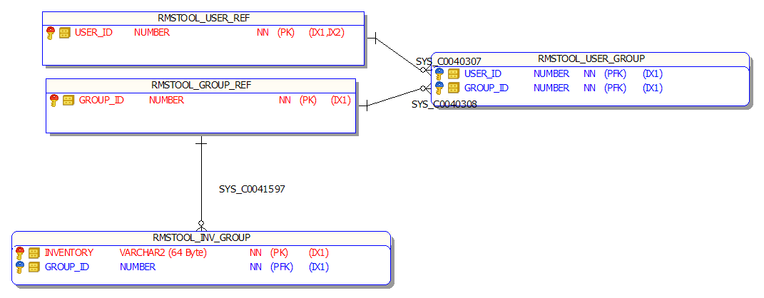

*Inventory Groups Configuration – ER Diagram*

|  |  |
| --- | --- |
| **Table Name** | **Description** |
| RMSTOOL_USER_REF | User configuration |
| RMSTOOL_GROUP_REF | Inventory group configuration |
| RMSTOOL_USER_GROUP | User / group mapping |
| RMSTOOL_INV_GROUP | Group / inventory mapping |

Mapping of inventory groups enforcement is dependent on user role as follows (hard-coded):

|  |  |  |
| --- | --- | --- |
| **User Role** | **Applied**  **Whitelist Inventory Group** | **Applied**  **Blacklist Inventory Group** |
| **ADMIN** | N/A (can use any inventory items) | 0 – BLACKLIST |
| **LEAD** | N/A (can use any inventory items) | 0 - BLACKLIST |
| **TESTING-IBM** | N/A (can use any inventory items) | 0 - BLACKLIST |
| **TESTING-VF** | Configured in RMSTOOL_USER_GROUP.GROUP_ID | 0 - BLACKLIST |
| **TESTING-V2** | Configured in RMSTOOL_USER_GROUP.GROUP_ID | 0 - BLACKLIST |

### User Configuration

User accounts are configured in table RMSTOOL_USER_REF and are linked with domain username used when logging into the application.

##### Adding New User

To add a new user account to the application, manually call stored procedure RMSTOOL_ADD_USER_PRC.

**NOTE:** Remember to assign correct inventory whitelist group to the user.

##### Suspending User

Suspend user in order to revoke their access from the application.

User account can be suspended by updating their SUSPENDED flag to “Y” in table RMSTOOL_USER_REF.

If suspended user tries to log into the application, following error message is displayed to them:

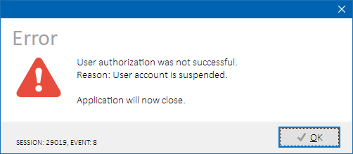

*Suspended user login failure*

### Bundled Applications Configuration

##### Outage Notifier Configuration

Outage data are fetched from two sources:

* IBM test environment admin team (SOAP API)
* VF test environment admin team (REST API)

Source configuration is stored in Phoenix configuration table RMSTOOL_CONFIG:

|  |  |
| --- | --- |
| *Table RMSTOOL_CONFIG*  (Configuration entries subset) | |
| PARAM_NAME | Description |
| REST_VF_OUTAGE_ALL | REST endpoint of Titus API returning all outages |
| REST_VF_OUTAGE_ONGOING | REST endpoint of Titus API returning currently ongoing outages |
| SOAP_OUTAGESVC_ENDPOINT | SOAP endpoint of outages reported by IBM test environment admin team |

##### Peklo Refresher Configuration

Following Phoenix configuration items stored configuration table RMSTOOL_CONFIG are re-used:

|  |  |
| --- | --- |
| *Table RMSTOOL_CONFIG*  (Configuration entries subset) | |
| PARAM_NAME | Description |
| DOMAIN_SUFFIX | Domain suffix |
| PEKLO_DB | PEKLO system database as Oracle TNS connect descriptor |
| PEKLO_DB_PASW | PEKLO system owner schema password |
| PEKLO_DB_USER | PEKLO system owner schema name |

## Licensing Model

Phoenix has incorporated time- and user-count-based licensing model:

|  |  |
| --- | --- |
| Licensing Attribute | Description |
|
| User Count | Number of configured active user accounts |
| End Date | License expiration date |

### Licence Key Configuration

License key in form of a string value comprising of pipe-separated (|) tokens is generated by the application development and stored in configuration table RMSTOOL_CONFIG as shown in the example below:

|  |  |  |
| --- | --- | --- |
| *Table RMSTOOL_CONFIG* | | |
| SECTION | PARAM_NAME | PARAM_VALUE |
| INT | LICENCE_INFO | IBM Česká republika, spol. s.r.o.|25|2021|12|31|4F44328A384D7983B3C7817E3B9546C1 |

Upon application initialization, stored license key is read, validated and authorized. If license key is missing, invalid or fails authorization, all users will have denied access to the application until license key is corrected.

### Licence Expiration Reminder

During two-weeks period before license key expiration, a warning message is displayed at every application launch to all users with ADMIN and LEAD roles:

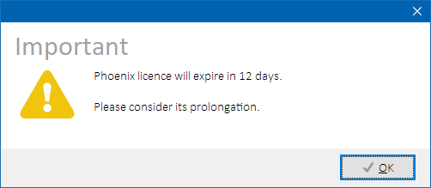

*Upcoming license expiration reminder*

Current best practice is automatic ongoing prolongation of the license expiration date every three months by the application development.